NexShop / EGF_POS Enterprise Platform
Unified Customer Activity & E-Commerce Growth Analytics Blueprint
Growth API Audit, Single-Page Tabbed Architecture, Feature Enhancements, Notifications, Weather Activity & Real-World AI Specification
CORE ARCHITECTURAL DIRECTIVES
1. POS & Sales Analytics (AdminAnalytics.tsx) remains completely independent for walk-in POS, landscaping quotes, and physical operations.
2. All online store customer interactions (Browsing, Searching, Carting, Purchasing) are consolidated into a single unified Tabbed Command Center under Growth.
3. Company configuration flags (hasWebsiteIntegration, hasServiceIntegration) default to false, hiding static website and service stats on initial load for standard tenants.
4. Real-world AI capabilities (Purchase Propensity Scoring, Anomaly Diagnostics, 1-Click Recovery Writer) empower store admins with actionable revenue insights. 5. Weather-based offers and messages run for each e-commerce location, and abandoned cart notifications can be sent automatically or by the admin.

1. Current Growth APIs Audit & Required Enhancements
A deep audit of all existing growth endpoints in the backend revealed that while core endpoints are operational, critical business aggregations and filters are missing:
API Endpoint | Current Operational Status | Required Enhancements for Unified Page
GET /growth/abandoned-carts | Operational. Returns active/reminded carts with email, phone, items list, and subtotal. | Add date range filtering (7d/30d), total potential revenue calculation, recovery rate %, and pagination metadata.
POST /growth/abandoned-cart | Operational for guest/customer upsert when contact information is present. | Track anonymous cart additions using sessionId so the admin knows the true cart abandonment rate.
GET /growth/search-analytics | Operational. Aggregates searchQueryLog by query term, day range, and location. | Add "Zero-Result Searches" filter (unmet demand discovery) and calculate Search-to-Cart conversion rate.
GET /growth/popular-searches | Operational. Computes top 3 searches with live threshold and best-seller fallback. | Return product click-through counts and thumbnail preview per trending search term.
POST /nus-shop/telemetry/event | CRITICAL GAP: Ingests raw events into activityLog with action: STOREFRONT_*. | Must implement atomic rollups for ProductViewSummary, CategoryViewSummary, and PageViewSummary.
GET /api/v1/activity/analytics | Operational for technical API requests and regex screen matching. | Scope strictly to tenant dbName; check company configuration to hide static website and service stats by default.
GET /dashboard-analytics | Operational for sales and financial KPIs. | Top Products only reflects completed sales; missing most viewed products and category traffic aggregations.

2. Page-by-Page Deep Dive: Gaps & Admin Business Value
Review of the five individual functional areas being unified into the Customer Activities command center:
Area | Current Deficiencies & Lacks | How Enhanced Data Empowers the Store Admin
Abandoned Carts | Sits in an isolated list. Does not show where the shopper abandoned (shipping vs payment). No total recoverable revenue KPI strip. Skips anonymous carts. | Provides instant visibility into recoverable dollars. Identifies high-friction checkout steps (e.g. shipping fee sticker shock). Powers 1-Click AI WhatsApp/Email recovery.
Search Activity | Search queries are disconnected from product sales. Zero-result searches are buried and unflagged. No search-to-cart conversion metric. | Uncovers unmet customer demand (e.g. "48 shoppers searched for vermicompost—stock it now!"). Identifies high-converting search keywords for hero banners.
Top Products | Currently calculates only past completed sales. Products viewed 1,000 times with zero sales are completely invisible to the admin! | Exposes high-interest, zero-conversion anomalies (pricing issues, broken photos, or missing variant sizes). Ranks products by true shopper interest.
Top Categories | Completely absent from analytics. Admin cannot see which categories draw traffic or cause drop-offs. | Enables data-driven category shelf placement on homepage grids. Highlights underperforming categories where visitors browse but never click into products.
Page Visits & Dwell Time | Measures server API hits instead of visitor UI page views. No dwell time, bounce rate, or exit page analytics. | Identifies high-bounce landing pages, average session duration, and the most engaging marketing content across the site.

3. Master Tabbed Architecture: Unified Customer Activities Page
Under Growth -> Customer Activities (/admin/customer-activity), the admin accesses a single high-performance command center organized into 8 tabs:
• Top Live Pulse Bar: Displays concurrent live shoppers online, views today, active carts, and total recoverable abandoned dollars in real time.
• Tab 1: Overview (landing view): All e-commerce counts from every API on one screen, with a comparison against the previous period.
• Tab 2: Orders & Revenue: The existing Ecommerce Analytics page, limited to e-commerce orders.
• Tab 3: Product Browsing & Purchase Intelligence: Side-by-side comparison of views vs. cart additions vs. units purchased, highlighting high-demand and zero-conversion items.
• Tab 4: Category Traffic & Shelf Flow: Category page views, product click-through rate (CTR), generated revenue, and category abandonment rates.
• Tab 5: Cart Health & Abandonment Recovery: Active and abandoned carts with the checkout step where shoppers left, reminder status, and three ways to send a notification: automatic, send now, or AI message then send, on Email, SMS or WhatsApp.
• Tab 6: Search Behavior & Unmet Demand: Trending searches widget, zero-result search opportunities alert, and search-to-cart conversion tracking.
• Tab 7: AI Growth Copilot & Behavioral Analytics: Real-time buying intent scoring (High Intent, Price Sensitive, Window Shopper), anomaly diagnostics, and autonomous conversion nudges.
• Tab 8: Weather Activity: How hot and cold days change shopper activity, plus weather offer rules and offer messages for each e-commerce location.

4. Real-World AI Integrations: Making NexShop Stand Out
To make NexShop uniquely powerful against Shopify, WooCommerce, and Magento, four Google Gemini-powered capabilities are embedded directly into this page:
AI Feature | Operational Logic & Mechanism | Merchant Business Impact
1. Live Purchase Intent Scoring | Analyzes browsing velocity, repeat product views (>2 in session), review inspection, and price checks to score sessions from 0-100. | Admin sees the 15 hottest buyers on site right now with 1-click personalized perk dispatch.
2. Zero-Conversion Anomaly Diagnostics | Automatically detects products with high views but zero purchases. Analyzes price points vs. catalog average, stock status, and shipping fees. | Eliminates guesswork; gives the merchant the exact root cause and 1-click suggested fix.
3. 1-Click AI Cart Recovery Writer | Generates hyper-personalized WhatsApp and Email recovery copy referencing the exact plant, pot, or item browsed, plus care tips. | Delivers 3x higher recovery conversion than generic "You left items in your cart" templates.
4. AI Semantic Search & Demand Discovery | Auto-corrects misspelled or synonym searches into closest catalog items and alerts merchant to unmet customer demand trends. | Recovers lost search traffic and directly guides inventory stocking decisions.

5. Tenant Scoping & Company Configuration Logic
To ensure strict tenant isolation and keep non-ecommerce sections hidden on initial load:
1. Company Model Property: Add ecommerceConfig.hasWebsiteIntegration (default: false) and ecommerceConfig.hasServiceIntegration (default: false) to Company schema.
2. Backend API Response: GET /api/v1/activity/analytics inspects company configuration. If hasWebsiteIntegration is false, it suppresses static website series. If hasServiceIntegration is false, it suppresses service series.
3. Frontend Page Load: The unified Customer Activities page conditionally hides static website and service accordions completely, presenting the merchant with a 100% relevant E-Commerce command center.

6. Wireframes & Enhancements
This section adds wireframes for the Unified Customer Activities page. The wireframe layout and labels follow the existing admin screens: green accent, grey table headers, and the KPI strip. Numbered red callouts mark each enhancement. Each wireframe has a table that explains every callout.
The page has 8 tabs: a new Overview tab is the landing view, the existing Ecommerce Analytics page is kept as the Orders & Revenue tab, and a new Weather Activity tab is added.
Numbers, names and amounts in the wireframes and screens, such as 96 searches, Snake Plant (Medium) or $96.40, are sample values. The live APIs replace them with real store data. Chart shapes are illustrative.

6.0 Navigation change
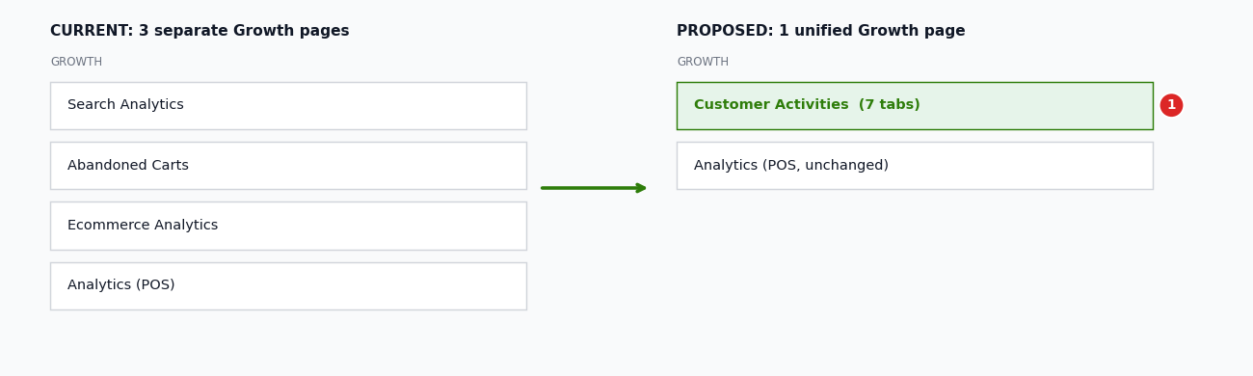
# | Enhancement (red callout) | Data source / API | Admin value
1 | Three Growth pages (Search Analytics, Abandoned Carts, Ecommerce Analytics) merge into one Customer Activities entry | Frontend routing; /admin/customer-activity | One place for all e-commerce activity; POS Analytics stays separate and unchanged

6.1 Tab 1: Overview (default landing view)
All e-commerce analytics on one screen: counts from every API, graphs, and a comparison with the previous month or period.
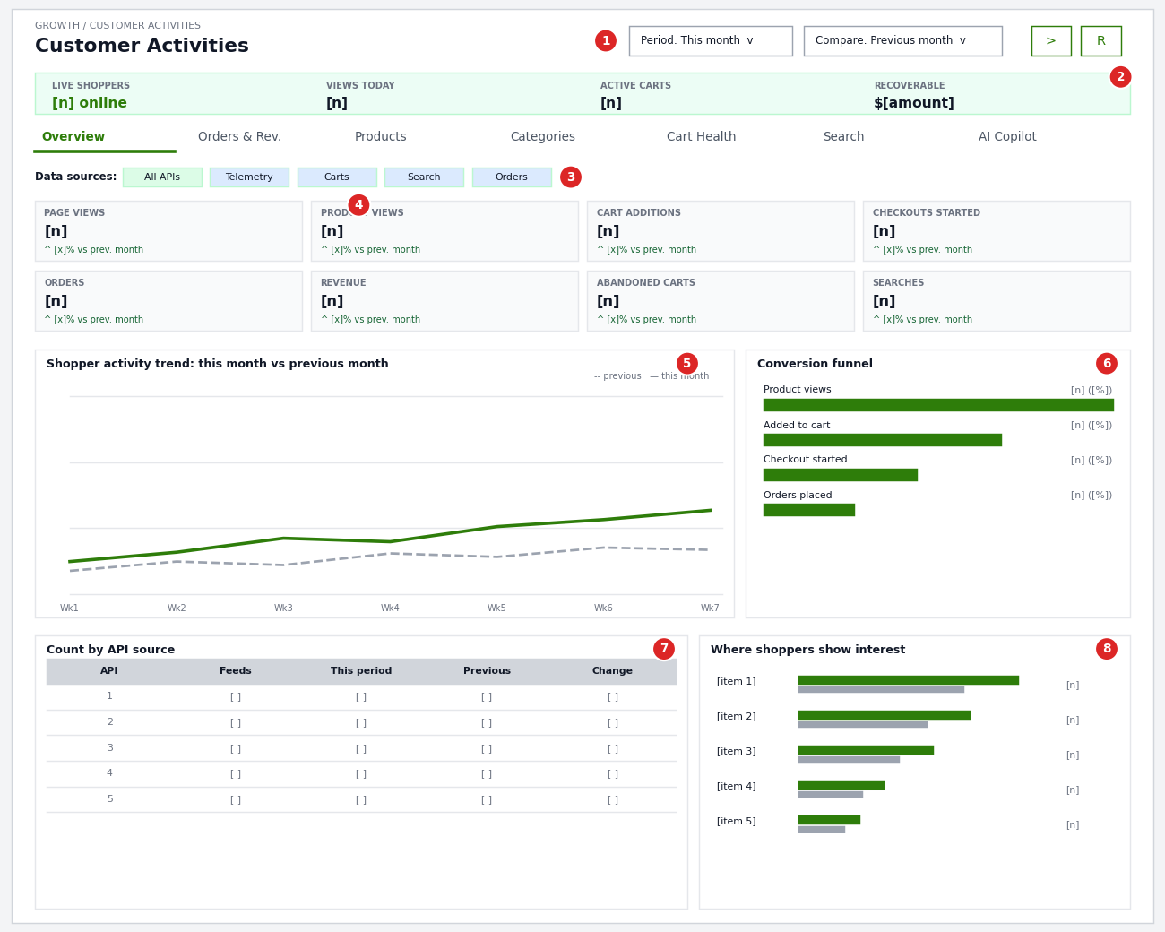
# | Enhancement (red callout) | Data source / API | Admin value
1 | Period and Compare-with selectors | Date range and compare params on every growth endpoint | Compare this month against the previous month, previous period or same month last year
2 | Live pulse bar (all tabs) | Telemetry heartbeat; GET /growth/abandoned-carts | Live shoppers, views today, active carts, recoverable dollars
3 | Data-source chips | Filters across all six APIs | Limit the page to Telemetry, Carts, Search or Orders
4 | KPI cards with change vs previous | ProductView, CategoryView, PageView summaries; GET /dashboard-analytics (e-commerce orders only) | Every count shows a rise or fall, so trends are visible at a glance
5 | Trend chart: this month vs previous | Daily and weekly rollups | Shows growth or dips over time
6 | Conversion funnel | Telemetry plus orders | Shows where shoppers drop between views, cart, checkout and order
7 | Count by API source | All six audited endpoints | One reconciled count per API, with this period, previous period and change
8 | Interest comparison bars | Rollups | Shows where shopper attention is moving

6.2 Tab 2: Orders & Revenue (existing page, retained)
The current Ecommerce Analytics page moves in as its own tab. It shows e-commerce orders only; POS and landscaping sales stay in POS Analytics. Every figure follows the Period selector in the page header.
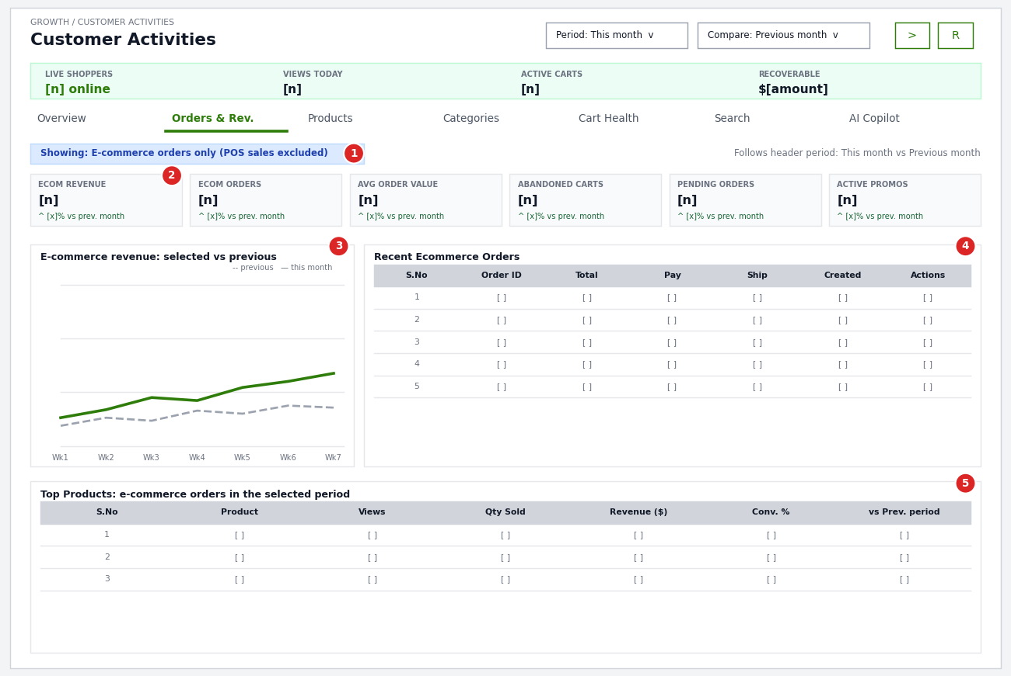
# | Enhancement (red callout) | Data source / API | Admin value
1 | Scope label: e-commerce orders only | Order filter source = e-commerce on GET /dashboard-analytics | POS sales are never mixed in; the label tells the admin what the numbers cover
2 | Existing KPI strip kept, with change vs previous | GET /dashboard-analytics (e-commerce orders in the selected period) | Revenue, orders, average order value, abandoned carts, pending orders, active promos for the chosen period
3 | Revenue comparison chart (new) | E-commerce order rollups | E-commerce revenue for the selected period against the compare period
4 | Recent orders table kept | GET /dashboard-analytics | Same columns and open-order action as today; lists e-commerce orders in the selected period only
5 | Top Products based on e-commerce orders in the selected period | E-commerce orders; product view rollups | Ranked by quantity and revenue from e-commerce orders for the header period; adds Views, Conv. % and change vs the compare period

6.3 Tab 3: Product Browsing & Purchase Intelligence
Compares views, cart additions and units purchased for each product.
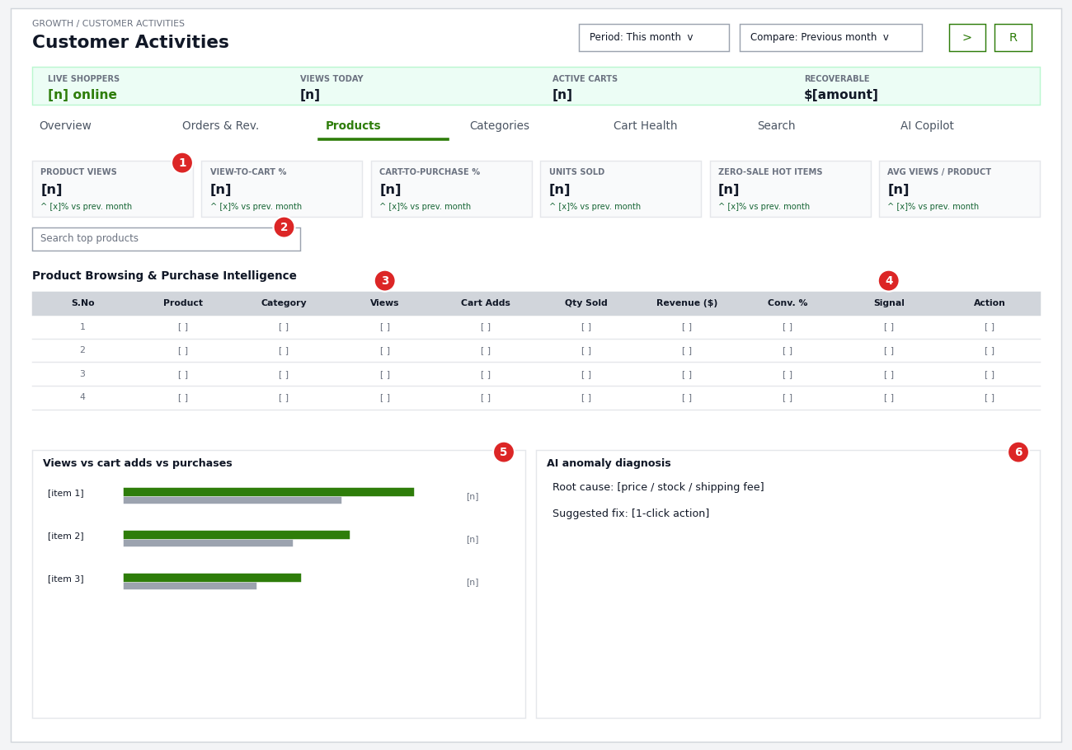
# | Enhancement (red callout) | Data source / API | Admin value
1 | KPI strip with views, view-to-cart, cart-to-purchase | ProductViewSummary | Measures how well interest turns into sales
2 | Product search kept | Client filter | Same search box as today
3 | Views and Cart Adds columns (new) | ProductViewSummary; cart events | Products viewed 1,000 times with zero sales become visible
4 | Signal chip: Converting, Zero-conversion, High demand | Derived from views and sales | Admin sees problem and winning products without reading numbers
5 | Views vs cart vs purchase bars | Rollups | Fast visual comparison of the top products
6 | AI anomaly diagnosis | Gemini on price, stock and shipping data | Shows the root cause and a 1-click suggested fix

6.4 Tab 4: Category Traffic & Shelf Flow
Category analytics, which are absent from the current system.
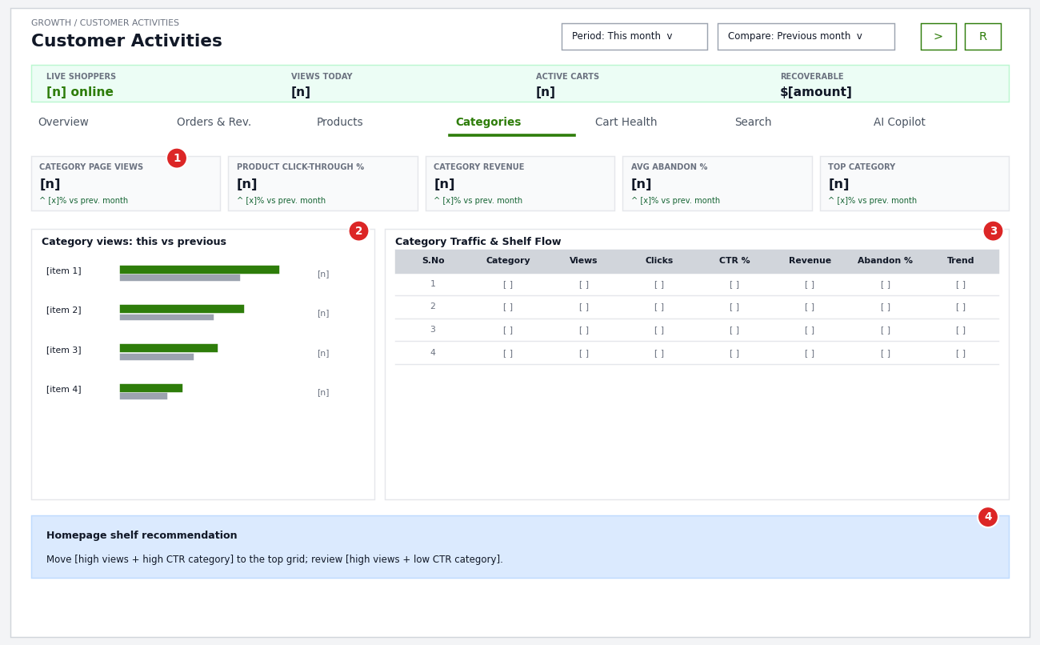
# | Enhancement (red callout) | Data source / API | Admin value
1 | KPI strip for category views, CTR, revenue, abandon % | CategoryViewSummary | Category performance with change vs previous
2 | Category views: this vs previous | CategoryViewSummary | Shows which shelves are gaining or losing traffic
3 | Category table with CTR, revenue, abandon %, trend | CategoryViewSummary; orders | Highlights categories visitors browse but never click into
4 | Homepage shelf recommendation | Derived from views and CTR | Data-driven category placement on the homepage grid

6.5 Tab 5: Cart Health & Abandonment Recovery
Extends the Abandoned Carts page with recovery metrics, a reminder status for every cart, three ways to send a notification (see 6.5.2) and a link to the automatic reminder settings (see 6.5.1).
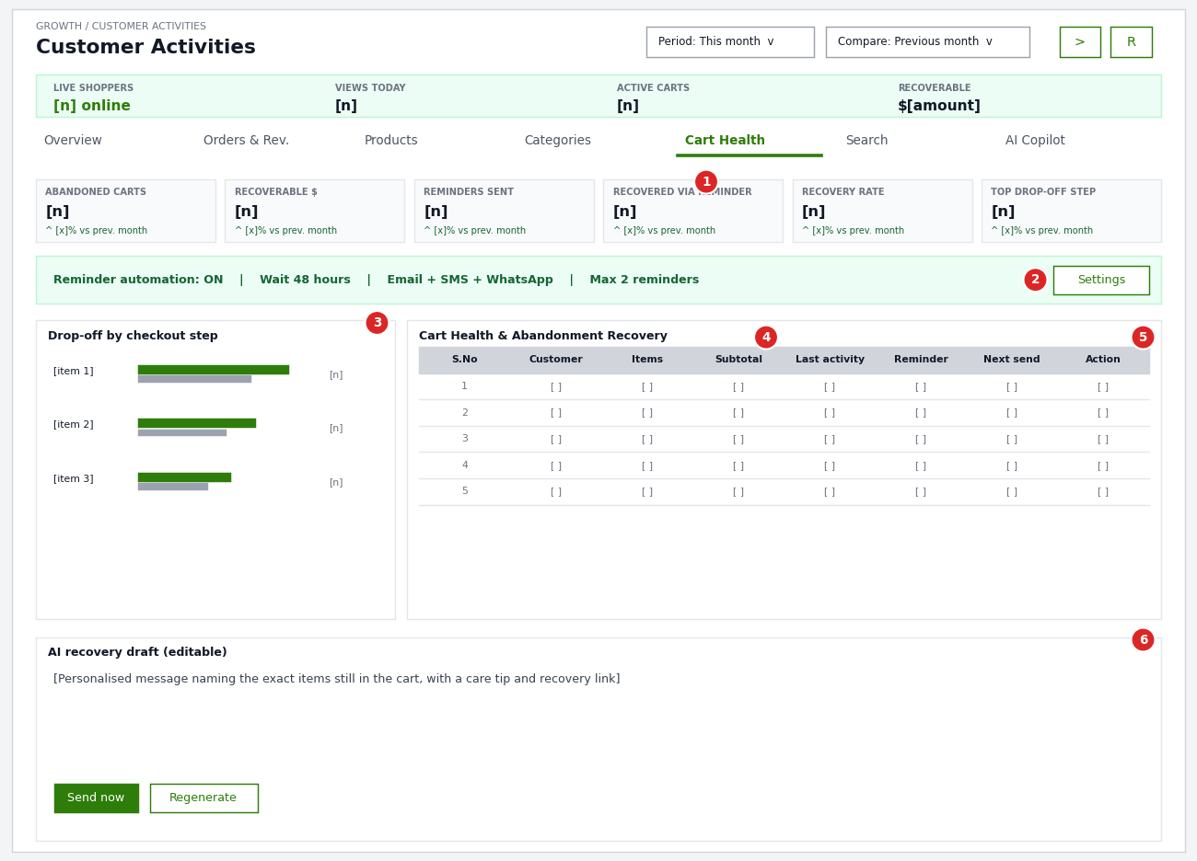
# | Enhancement (red callout) | Data source / API | Admin value
1 | KPI strip with recoverable $, reminders sent, recovered via reminder, recovery rate | GET /growth/abandoned-carts (add date filter, totals, pagination); reminder log | Turns a count of carts into recoverable revenue and shows whether reminders work
2 | Reminder bar with Settings button | GET /growth/abandoned-cart-settings | Shows at a glance if reminders are on, the channels used, the wait time and the maximum number of reminders
3 | Drop-off by checkout step | Cart and checkout events | Shows whether shoppers leave at cart, shipping or payment
4 | Cart table with Left at, Last activity, Reminder status and Next send | POST /growth/abandoned-cart (track sessionId); reminder fields on the cart record | Shows when each cart was last touched, which reminder it is on and when the next one goes out
5 | Send options per cart: channel choice (Email, SMS, WhatsApp), Remind now, Pause, Stop | POST /growth/abandoned-cart/:id/remind (with channels); POST .../pause | Admin can send a reminder early on the chosen channel, or stop reminders for one customer
6 | Message preview (editable) with channel tick boxes, Send now and Send test to me | Gemini | Message names the exact items still in the cart; admin chooses where it goes
7 | How reminders are sent panel and Notification channels table | Reminder settings; customer contact details | Explains the three send options and what each channel needs

6.5.1 Abandoned Cart Reminder Settings and Schedule
Logged-in customers who leave items in their cart receive a reminder by email, SMS or WhatsApp. The system waits a configurable time after the last cart activity before the first message, so customers are not messaged every hour.
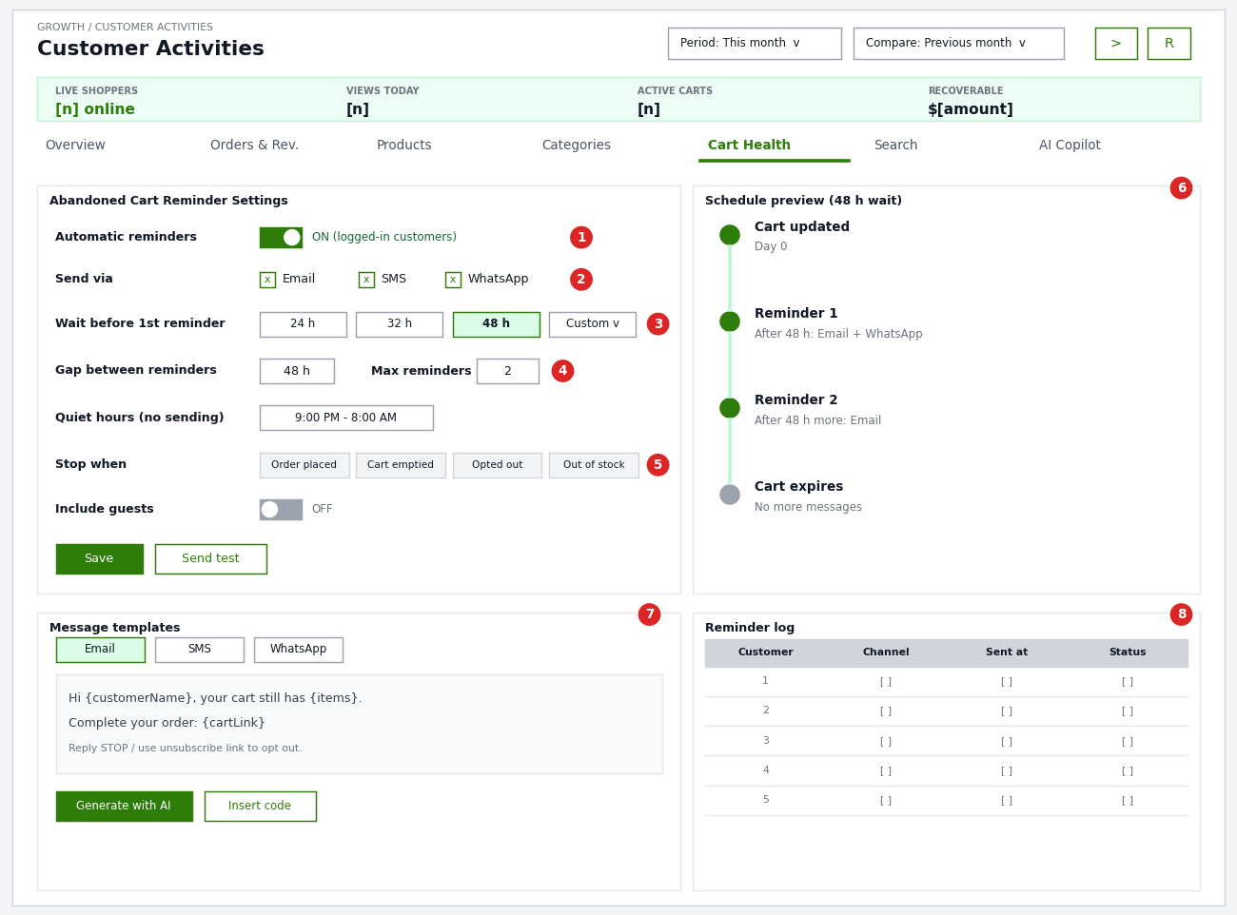
# | Enhancement (red callout) | Data source / API | Admin value
1 | Automatic reminders toggle | Tenant setting abandonedCartReminders.enabled | Turns the feature on or off for the store; applies to logged-in customers
2 | Channel selection: Email, SMS, WhatsApp | Setting channels[] | Admin chooses which channels to use; the customer receives a message only on channels with valid contact details
3 | Wait before first reminder: 24 h, 32 h, 48 h or custom | Setting firstReminderDelayHours | Nothing is sent until this many hours have passed since the last cart activity
4 | Gap between reminders and maximum reminders | Settings reminderGapHours, maxReminders | Prevents repeated messages; the cart stops receiving reminders after the maximum
5 | Stop conditions and quiet hours | Settings stopOn[], quietHours | No message after an order, an emptied cart, an opt-out or an out-of-stock item; none during quiet hours
6 | Schedule preview | Computed from the settings | Shows the admin exactly when reminders will go out for the chosen wait time
7 | Message templates per channel with variables | Templates for email, SMS and WhatsApp | Editable text such as: your cart still has {items}; Generate with AI uses the items in the cart
8 | Reminder log | Reminder log collection | Shows each message sent, its channel, time and status, including recovered orders

6.5.2 Abandoned Cart Notification Options
An admin can send an abandoned cart notification in three ways. All three use the same channels. Opt-outs are always honoured.
# | Send option | How it works | When to use it
1 | Automatic reminder | The system checks carts every hour. It sends a reminder after the wait time (default 48 hours with no cart activity) on the channels chosen in Settings, sends a second one after the gap, and stops at the maximum or a stop condition. | Hands-free recovery for logged-in customers
2 | Send now (one cart) | The admin picks Email, SMS or WhatsApp on a cart and presses Remind now. The message goes out at once and skips the wait time. | A high-value cart or a one-off follow-up
3 | AI message, then send | AI writes a message that names the items in the cart. The admin edits it, ticks the channels, optionally presses Send test to me, then presses Send now. | A personal message for a high-intent customer

# | Channel | Works when the customer has | Customer receives and can opt out
1 | Email | A valid email address | Subject line, message and a recover-cart link. Unsubscribe link in every email.
2 | SMS | A valid mobile number and SMS consent | Short text with a recover-cart link. Reply STOP to opt out.
3 | WhatsApp | A valid WhatsApp number and consent | Approved template message with a recover-cart link. Reply STOP to opt out.

6.6 Tab 6: Search Behavior & Unmet Demand
Joins search activity with product and cart data.
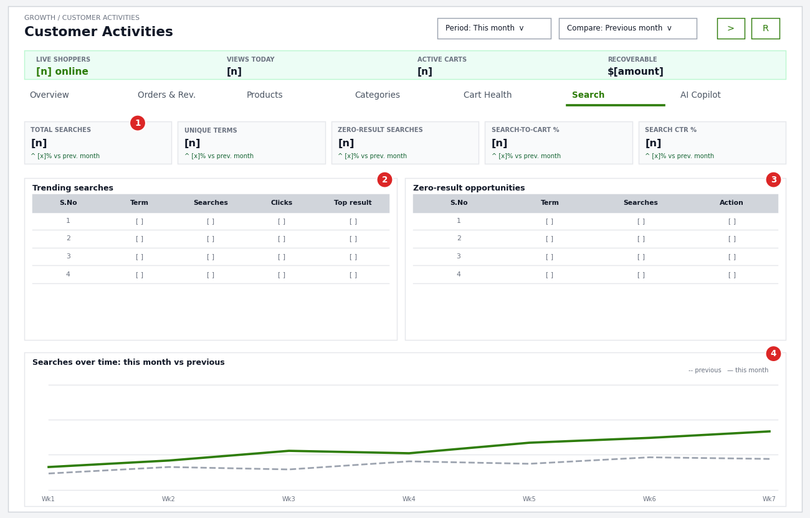
# | Enhancement (red callout) | Data source / API | Admin value
1 | KPI strip with zero-result and search-to-cart rate | GET /growth/search-analytics (add filter and conversion) | Shows how often a search leads to a sale
2 | Trending searches with product clicks and top result | GET /growth/popular-searches (add click counts and thumbnail) | Shows what shoppers want most right now
3 | Zero-result opportunities with Stock it and Add synonym actions | searchQueryLog | Reveals unmet demand and tells the admin what to stock
4 | Searches over time: this vs previous | Search rollups | Tracks search trends across periods

6.7 Tab 7: AI Growth Copilot
Four Gemini-powered capabilities in one place.
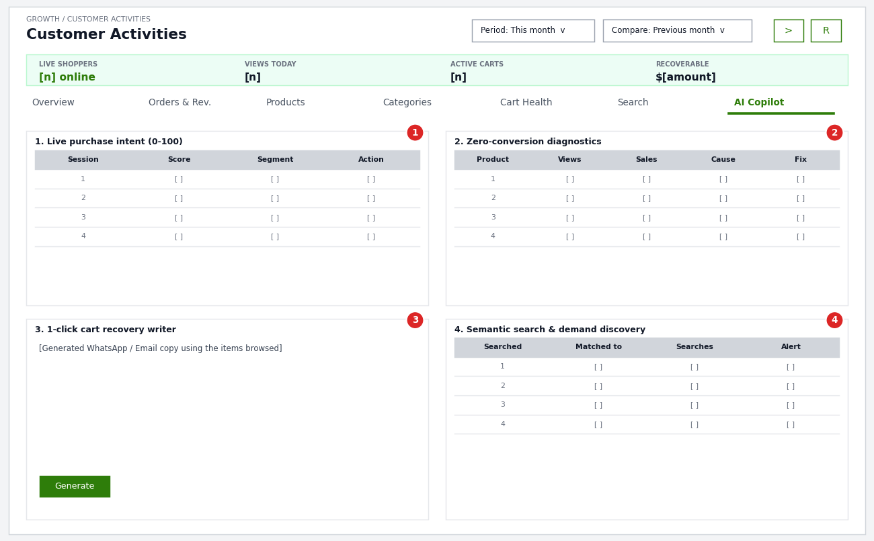
# | Enhancement (red callout) | Data source / API | Admin value
1 | Live purchase intent scoring (0-100) | Session behaviour from telemetry | Lists the hottest buyers online with a 1-click perk
2 | Zero-conversion diagnostics | Product views, price, stock, shipping | Exact root cause with a suggested fix
3 | 1-click cart recovery writer | Cart items browsed | Personalised WhatsApp and email copy
4 | Semantic search and demand discovery | searchQueryLog; catalog | Matches misspelt or synonym searches and flags unmet demand

6.8 Tab 8: Weather Activity
Shows how the weather changes shopper activity and lets the admin run offers and messages on hot or cold days. Everything is set for each e-commerce location. The weather comes from a weather provider, using the location’s city or postcode.
# | Enhancement | Data source / API | Admin value
1 | Location selector with today’s weather and a 3-day forecast | Weather provider API; e-commerce location list | Each location has its own weather, so offers match the local day
2 | KPI strip: orders, revenue and cart additions on hot, cold and normal days, with change vs previous | Orders and telemetry joined to daily weather | Shows how much weather moves sales
3 | Temperature vs orders chart | Daily weather history; order rollups | Shows the link between temperature and sales over the period
4 | Products by weather: top sellers on hot days and on cold days | Order items joined to daily weather | Tells the admin which products to promote for each type of day
5 | Weather offer rules: Hot and Cold, each with its own temperature limit, products, discount, audience, notify time and On/Off | Weather offer settings (Section 9) | Offers start by themselves when the day matches
6 | Offer message options: Email, SMS or WhatsApp, sent to the chosen audience at the notify time | Same channels and opt-out rules as 6.5.2 | Customers hear about the offer on the right day
7 | Weather offer results: messages sent, orders, revenue and coupon use | Weather offer log | Shows which rules earn money
8 | Weather note in cart reminders (optional) | Abandoned cart reminder; active weather offer | If a cart holds an item from an active weather offer, the reminder mentions the offer

7. Gap Analysis & Enhancement Register
Gaps found by comparing the blueprint with the current admin screens and the audited APIs.
# | Area | Gap | Enhancement | Wireframe
1 | Overview | The blueprint has no landing view with charts or previous-period comparison. | Add an Overview tab with a period selector and a change vs previous on every KPI. | 6.1
2 | Navigation | Growth shows three separate pages. | Merge them into Customer Activities. | 6.0
3 | Existing page | Ecommerce Analytics (orders, pending, promos) has no place in the 5-tab layout. | Keep it as the Orders & Revenue tab, limited to e-commerce orders and driven by the header period. | 6.2
4 | Telemetry | POST /nus-shop/telemetry/event stores raw events only. | Add atomic rollups for ProductViewSummary, CategoryViewSummary and PageViewSummary. Tabs 1 to 3 depend on this. | 6.1, 6.3, 6.4
5 | Live data | Nothing supplies concurrent live shoppers. | Add a session heartbeat or live counter for the pulse bar. | All tabs
6 | Top Products | Counts completed sales only and ignores the selected period. | Rank products from e-commerce orders in the header period; show views and cart adds next to units sold, plus a Signal chip. | 6.2, 6.3
7 | Categories | No category analytics exist. | Add category views, CTR, revenue and abandon %. | 6.4
8 | Abandoned carts | No date filter, recoverable total, recovery rate or drop-off step; anonymous carts are skipped. | Add the filter and totals, and track anonymous carts by sessionId. | 6.5
9 | Search | Zero-result searches are unflagged and there is no search-to-cart rate. | Add the zero-result filter and the conversion metric. | 6.6
10 | Popular searches | Returns only the top terms. | Return product click counts and a thumbnail per term. | 6.6
11 | Activity API | GET /api/v1/activity/analytics measures API hits, not visitor page views. | Scope to the tenant dbName; add page views, dwell time, bounce and exit pages from telemetry. | 6.1
12 | Tenant config | Static website and service stats show for every tenant. | Add hasWebsiteIntegration and hasServiceIntegration (default false) and hide those series. | 5
13 | AI features | Four capabilities are described but not placed on screen. | Place intent scoring, diagnostics, recovery writer and semantic search in Tab 7 and the Cart and Product tabs. | 6.3, 6.5, 6.7
14 | Reminders | No automatic reminder exists for logged-in customers who leave items in the cart. | Add configurable email, SMS and WhatsApp reminders with a wait time, a maximum count and stop conditions. | 6.5, 6.5.1, 6.5.2, 8
15 | Weather | Offers and messages ignore the weather, and the admin cannot see how weather changes shopper activity. | Add the Weather Activity tab: weather vs sales, Hot and Cold offer rules for each location, and weather offer messages. | 6.8, 9

8. Abandoned Cart Reminder Automation: Specification
This section describes how the reminders in 6.5.1 behave. Defaults marked proposed are suggestions for you to confirm.

8.1 How it works
- A customer who is logged in adds items to the cart and leaves without ordering. The cart records its last activity time.
- A scheduled job runs every hour. Running hourly does not mean sending hourly: the job only picks carts whose wait time has passed.
- A cart is eligible when last activity + wait time has passed, the reminder count is below the maximum, the next-send time has arrived, and no stop condition applies.
- The system sends the reminder on each selected channel that has valid contact details, then records the time and sets the next-send time using the gap setting.
- If the customer places an order, empties the cart, opts out, or the cart reaches the maximum, reminders stop and the cart status updates.
- Besides automatic reminders, the admin can send a reminder now for one cart, or send an AI message after editing it (see 6.5.2).

8.2 Configurable settings
Setting | Options | Default (proposed)
Automatic reminders | On / Off | Off until the store enables it
Channels | Email, SMS, WhatsApp (any combination) | Email
Wait before first reminder | 24 h, 32 h, 48 h, or a custom number of hours | 48 hours
Gap between reminders | Hours, custom | 48 hours
Maximum reminders per cart | 1 to 3 | 2
Quiet hours | Start and end time, store time zone | 9:00 PM to 8:00 AM
Stop conditions | Order placed, cart emptied, customer opted out, item out of stock | All on
Include guests with contact info | On / Off | Off (logged-in customers only)
Optional incentive | Coupon code added to the message | None
Send options | Automatic, Send now, AI message then send | Automatic is off until the store enables it; Send now and AI message are always available to admins

8.3 Sending rules
Rule | Behaviour
Wait time | Counted from the last cart activity. Any new add, remove or quantity change resets the clock.
No hourly messaging | The hourly job only checks eligibility. A cart is messaged at most once per reminder step.
Frequency cap | Maximum reminders per cart, plus a minimum gap between reminders.
Quiet hours | Messages due inside quiet hours are held and sent when quiet hours end.
Channel fallback | If a channel has no valid contact detail, it is skipped and the other channels still send.
Opt-out | Email carries an unsubscribe link; SMS and WhatsApp honour a STOP reply. Opted-out customers are never messaged.
Recovery tracking | An order placed from the cart link marks the cart Recovered and credits the reminder.
Send now | Skips the wait time and the gap. Opt-outs are always honoured. The send counts as a reminder and is written to the reminder log.

8.4 Cart record fields (additions)
Field | Purpose
customerId | Links the cart to the logged-in customer
lastActivityAt | Time of the last cart change; start of the wait
reminderCount | Reminders sent so far
lastReminderAt / nextReminderAt | When the last reminder went out and when the next is due
channelsSent[] | Channels used for each reminder
status | Active, Reminder 1 sent, Reminder 2 sent, Recovered, Expired, Opted out, Paused
recoveredOrderId | Order that recovered the cart

8.5 API changes
Endpoint | Purpose
GET / PUT /growth/abandoned-cart-settings | Read and save the reminder settings for the tenant
GET /growth/abandoned-carts | Add reminderCount, lastReminderAt, nextReminderAt, status and a date filter
POST /growth/abandoned-cart/:id/remind | Send a reminder now for one cart. The request lists the channels to use: email, sms or whatsapp
POST /growth/abandoned-cart/:id/pause | Pause or stop reminders for one cart
GET /growth/abandoned-cart-reminders | Reminder log with channel, time and status
POST /growth/abandoned-cart-settings/test | Send a test message to the admin

8.6 Compliance and delivery notes
- Obtain and record customer consent for each channel before sending marketing-style reminders.
- WhatsApp reminders must use pre-approved message templates from the WhatsApp Business provider.
- SMS may require sender and template registration under local regulations; confirm this for each market.
- Every message must be identifiable as coming from the store and include a way to opt out.

9. Weather-Based Activities: Specification
This section describes how the weather offers in 6.8 behave. Defaults marked proposed are suggestions for you to confirm. Weather offers are also an optional step in the dashboard setup card, next to festival and holiday offers.

9.1 How it works
- The admin turns on weather offers for an e-commerce location and adds a Hot rule, a Cold rule, or both. Each rule has its own products.
- A scheduled job reads the weather for each location every hour and stores the day’s high and low temperature.
- At the check time (default 7:00 AM store time) the job compares today’s forecast with each rule. If the day is hot or cold enough, the rule becomes active for that day.
- An active rule applies its discount to its products and sends the offer message at the notify time on the chosen channels.
- The rule switches off when the day no longer matches, or at midnight. Messages, orders and revenue are written to the offer log.

9.2 Configurable settings
Setting | Options | Default (proposed)
Weather offers | On / Off for each e-commerce location | Off
Hot rule | Daily high at or above a chosen temperature, with its own products | 35 °C
Cold rule | Daily low at or below a chosen temperature, with its own products | 15 °C
Discount | Percentage, fixed amount or coupon code | 10%
Audience | All customers, past buyers or customers with abandoned carts | Customers who opted in
Channels | Email, SMS, WhatsApp (any combination) | Email
Notify time | Time of day, store time zone | 9:00 AM
Maximum messages | Per customer per day | 1
Weather check time | Time of day, store time zone | 7:00 AM

9.3 API changes
Endpoint | Purpose
GET /growth/weather/current | Today’s weather and a 3-day forecast for one location
GET / PUT /growth/weather-offers | Read and save the Hot and Cold rules for each location
GET /growth/weather-activity | Orders, views, cart additions and revenue grouped by hot, cold and normal days
GET /growth/weather-offers/log | Offers sent, orders and revenue for each rule
POST /growth/weather-offers/test | Send a test message to the admin

9.4 Notes
- A weather provider account is needed. Each e-commerce location must have a city or postcode. If the weather cannot be read, no rule starts that day and the admin sees a warning.
- The consent, opt-out and template rules in 8.6 also apply to weather offer messages.
- Other conditions, such as rain, can be added later as extra rules.

