AFC Enterprise
Product Handbook
Overview & Reference Guide — Including All Workflow & Sequence Diagrams

Document Type | Product Handbook — Business & Technical Reference
Platform | AFC Enterprise Field Services Management Platform
Modules Covered | AUT-01 · ADM-01 · CMP-01 · CRM-01/02 · SAL-01 · EST-01 · JOB-01 · INV-01 · EXP-01 · VEN-01 · DOC-01 · NOT-01 · ACT-01 · CAT-01 · TMP-01
Diagrams | 9 Flowcharts + 7 Sequence Diagrams (rendered)
Version | 1.1 — With Rendered Diagrams
Date | 2026-06-25
Classification | Confidential — Internal Use Only

AFC Platform · Confidential · All Rights Reserved · 2026

Table of Contents

1. About the AFC Enterprise Platform
1.1 Executive Product Description
1.2 Core Capabilities
1.3 Target Audience

2. How the Platform Works

3. AUT-01 — Authentication & Login Management
3.1 Business Purpose & Security Model
3.2 Login Workflow Diagram & Sequence Diagram
3.3 Forgot Password Workflow & Sequence Diagram
3.4 Screen Catalogue & UI Components
3.5 Permissions, Notifications & Audit Trail

4. ADM-01 — User Management
4.1 Business Purpose & Security Model
4.2 User Journey Workflows
4.3 BPMN Workflow Diagram & Sequence Diagram
4.4 Screen Catalogue & UI Components
4.5 Permissions, Rules & Audit Trail

5. CMP-01 — Company Profile & Configuration
5.1 Global Configuration Matrix
5.2 Delivery Gating Engine
5.3 Payment Key Scrubbing & Audit Trail

6. CRM-01 — Customer Management
6.1 Customer Lifecycle Flow Diagram
6.2 Dashboard Analytics & Screen Catalogue
6.3 Validation, Deletion Logic & Field Documentation
6.4 Notifications, Audit Trail & Module Map

7. CRM-02 — Enquiry Management
7.1 Business Purpose & Lifecycle
7.2 High-Level Process Flow & Creation Workflow Diagrams
7.3 Screen Catalogue, Fields & Validation
7.4 Notifications, Rules & Audit Trail

8. SAL-01 — Request Management
8.1 Service Decision Engine Flow Diagram
8.2 Service Configuration Matrix
8.3 Create Request Sequence Diagram
8.4 Screen Catalogue, Measurement & Product Rules

9. EST-01 — Quote Management
9.1 Business Purpose & Configuration Matrix
9.2 Pricing, Margin & Tax Engine
9.3 Quote Acceptance Sequence Diagram & Status Lifecycle
9.4 Module Relationship Map

10. JOB-01 — Job Management
10.1 Business Purpose & Configuration Matrix
10.2 Job Instantiation & Crew Scheduling
10.3 Evidence, Delta Reconciliation & Status Lifecycle
10.4 Module Relationship Map

11. INV-01 — Invoice Management
11.1 Invoice Configuration Matrix
11.2 Customer Payment Sequence Diagram
11.3 Status State Machine & Document Handling
11.4 Module Relationship Map

12. EXP-01 — Expense Management

13. VEN-01 — Vendor Management
13.1 Business Purpose & Vendor Typology
13.2 Vendor Invoice Capture Sequence Diagram

14. DOC-01 — Project Documentation

15. NOT-01 — Notification Management
15.1 Subscription Assignment Flow Diagram

16. ACT-01 — Activity Audit Logging

17. CAT-01 — Catalog Management
17.1 Operations Workflow Diagram

18. TMP-01 — Template Management

1. About the AFC Enterprise Platform

1.1 Executive Product Description
The AFC Enterprise Platform is a comprehensive, multi-tenant business operations and customer relationship management (CRM) platform designed to orchestrate the entire life cycle of service delivery, procurement, and financial settlement. Engineered to standardize complex operational workflows, it unifies B2B/B2C lead ingestion, dynamic quotation templates, vendor payout management, and multi-tier catalogue administration into a single, cohesive ecosystem.

Built with an audit-first philosophy, the platform provides deep-dive telemetry into user activities, precise vendor performance metrics (such as payment velocity and overdue liabilities), and strict procurement synchronization. By centralizing these disparate business functions, the AFC platform enables executive stakeholders to make data-driven decisions while ensuring strict compliance, operational transparency, and data governance across the organization.

1.2 Core Capabilities
- Centralized CRM & Sales: Streamlines the transition from marketing leads to formalized Service Jobs through an integrated Enquiry, Request, and Quotation pipeline.
- Enterprise Procurement: Automates Vendor tracking, Service Vendor Job linkage, and complex multi-payment orchestration.
- Unified Catalogue: Maintains a strict three-tier taxonomy (Category → Subcategory → Product) mapped to historical supplier data.

1.3 Target Audience
User Group | Primary Responsibilities
Super Admins & System Managers | Platform console for organizational configuration, global notification management, systemic oversight, and RBAC enforcement.
Sales & Estimators | Rapidly generate B2B quotes using tax-exempt flags and service-bound templates; manage enquiries and requests.
Finance & Procurement | Seamlessly process complex vendor invoices, monitor enterprise liabilities, and reconcile payments.
Field Staff & Dispatchers | Execute jobs, upload evidence photos, log expenses, and manage crew schedules.
All Staff | Access reminders, sticky notes, and personal notification subscriptions.

2. How the Platform Works

2.1 The Merchant & Operations Core
The central operational hub for all staff. Managers and owners use this module to manage the catalogue, orchestrate inventory, assign field staff to jobs, and generate complex B2B financial workflows including Quotes and Invoices. Different team members see different tools depending on their assigned role and permission level.

2.2 The Platform Console
The administrative dashboard for multi-tenant organization management. It facilitates the creation of global Notification architectures, Company branding profiles, Role-Based Access Controls (RBAC), and system-wide configuration without requiring code deployments.

3. AUT-01 — Authentication & Login Management
Document Control
Version | Date | Author | Changes
1.0 | 2026-06-25 | Enterprise Architecture Team | Initial baseline specification.

3.1 Business Purpose & Security Model
Module Overview: The Authentication & Login Management module acts as the primary security gateway for the AFC Enterprise Application. It governs user access, session instantiate, role determination, and global multi-tenant context initialisation.

Business Purpose: To securely authenticate authorised users, protect sensitive business data, and automatically load the appropriate organisational context (Company Profile) and user permissions prior to dashboard access.

Business Objectives
- Ensure secure, encrypted credential validation.
- Prevent un authorised access to all application routes.
- Establish a global user session that dictates subsequent system privileges.
- Retrieve and bind the Tenant (Company) profile for data segregation.

Tier 1 Critical System: If the Authentication module becomes unavailable: no user can access the system; all dashboards, request processing, job tracking, invoicing, POS transactions, administration, and reporting become entirely inaccessible.

Security Considerations
- Password Storage: Encrypted at rest using secure hashing algorithms on the backend. Client-side 'Remember Me' uses Base64 encoding and should be migrated to secure cookie storage.
- JWT Expiration: Tokens are cryptographically signed with explicit expiration horizons, configurable per tenant via tokenExpireTime in the Company Profile.
- Session Timeout: If the JWT expires, the API responds with 401 Unauthorised, prompting a forced system logout.
- Brute Force Protection: Managed backend-side via request throttling to prevent rapid password guessing.

3.2 Login Workflow Diagram & Sequence Diagram

Login Execution Steps
- User Action: Clicks 'Login' button on /login.
- Frontend Validation (LoginForm.tsx): Validates username using Yup email regex. Validates password minimum length (6 characters).
- Local Storage — Remember Me: If checked, stores rememberedUsername and Base64-encodes password in localStorage.
- API Payload Construction: Sends { username, password } to backend.
- Backend API (POST /api/v1/users/login): Checks presence of username and password (returns 400 if missing). Queries DB via User.findOne({ username }).select('+password'). Verifies password via user.comparePasswordInDB. Checks user.userActive === false (returns 400 'Your Account is Deactivated' if false).
- JWT & Tenant Configuration (signToken): Backend queries the Companies model, reads tenant-specific tokenExpireTime, signs JWT payload { username, role } using process.env.SECRET_STR.
- Return Response: Sends 200 OK with token and user object (password field removed).
- Frontend State Hydration: Stores token in cookies/localStorage. Dispatches Redux actions to store User and Company Profile context.
- Dashboard Navigation: Redirects user to /dashboard.

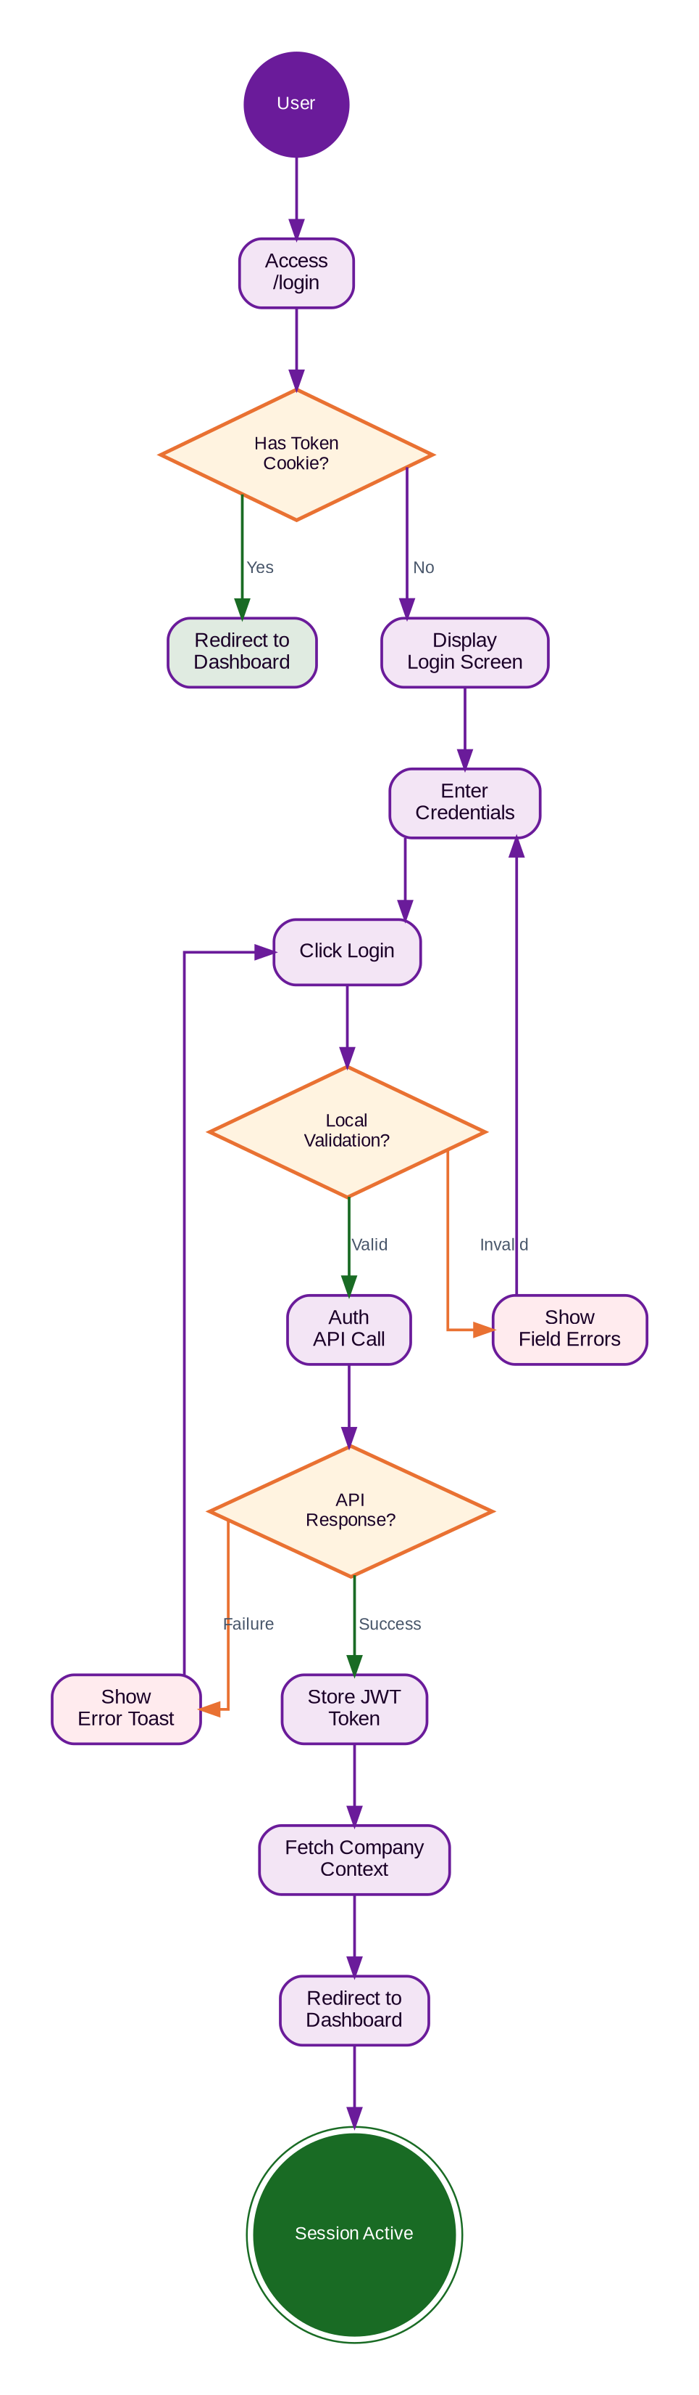
Figure 3.1 — AUT-01 Login Process Flow Diagram

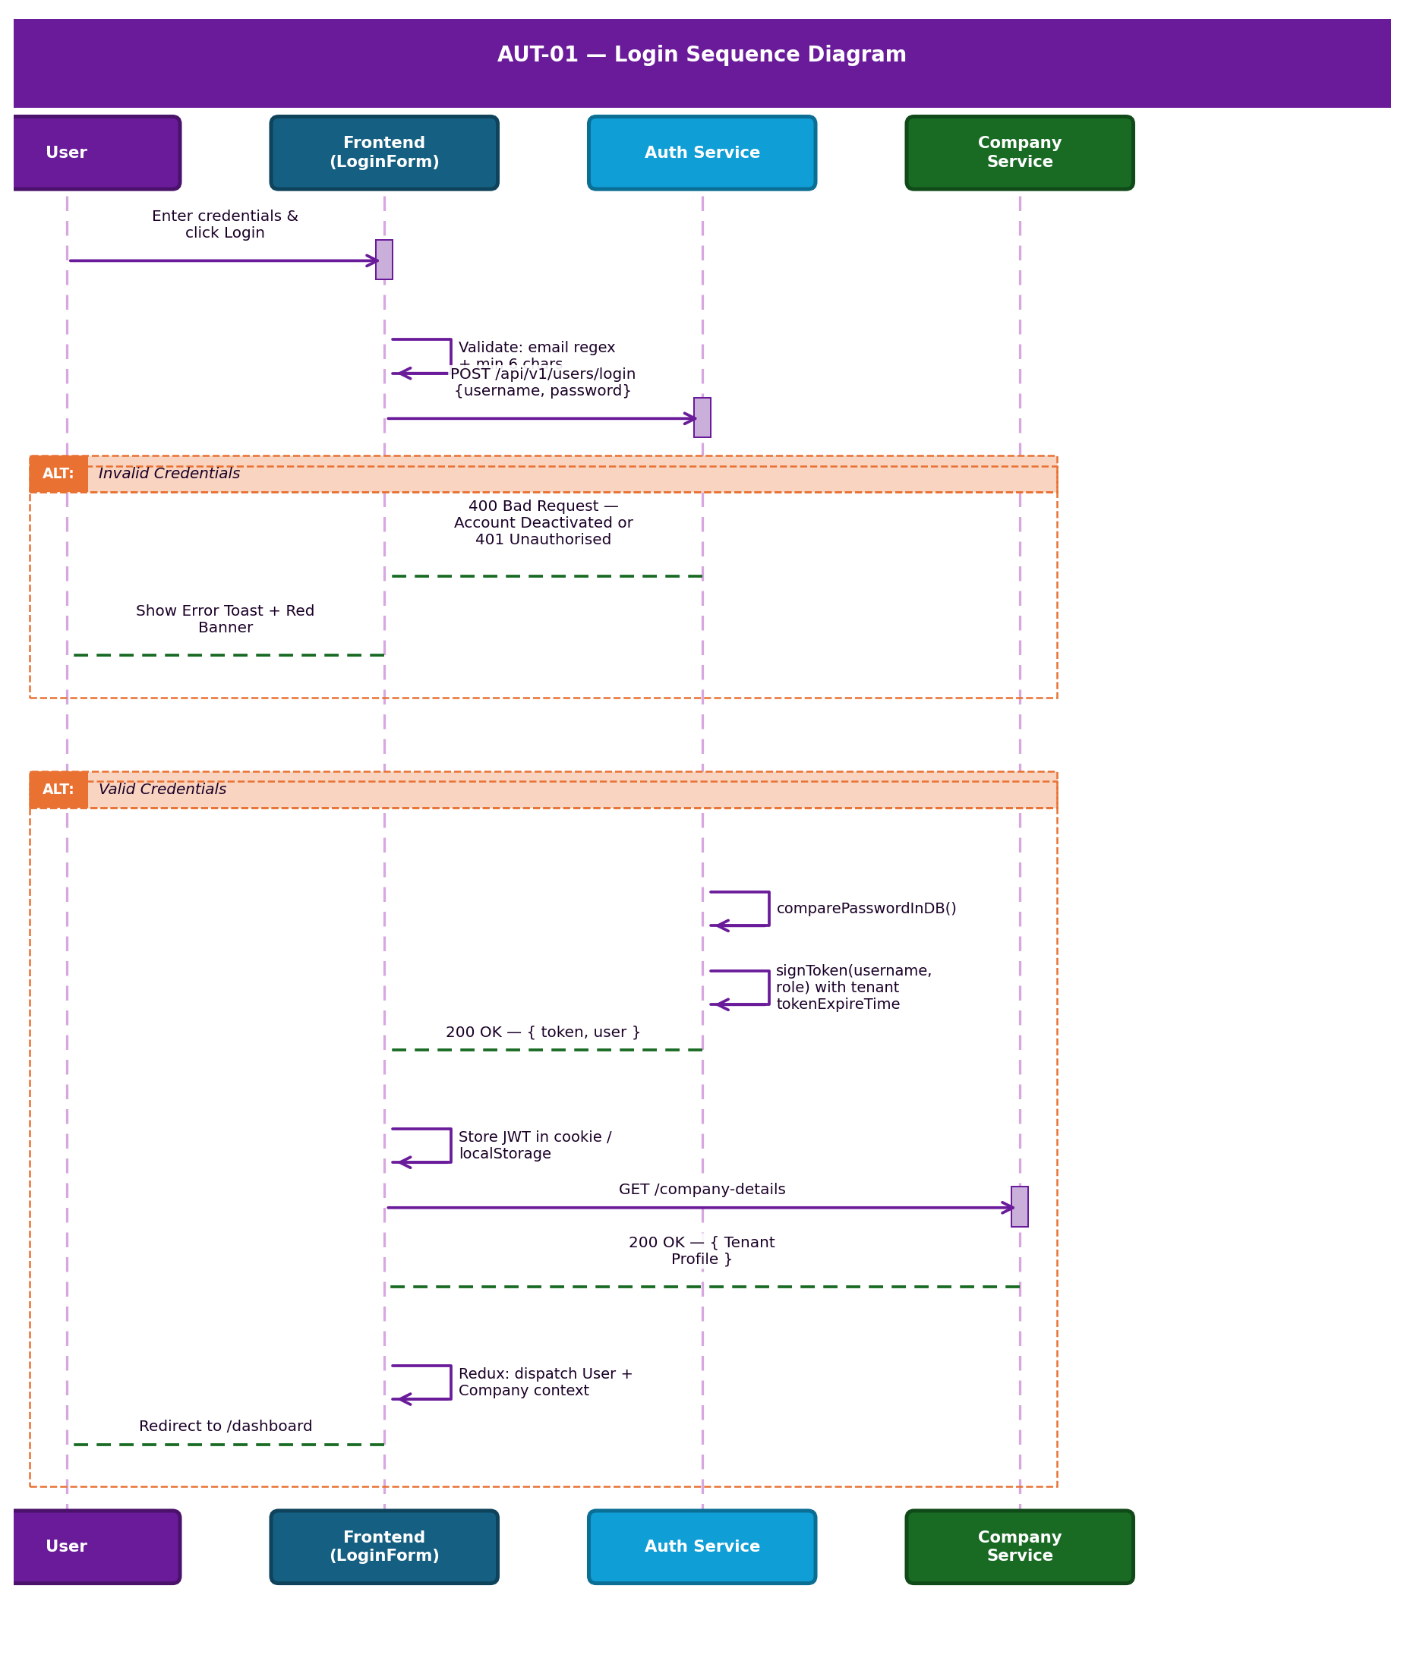
Figure 3.2 — AUT-01 Login System Sequence Diagram

3.3 Forgot Password Workflow & Sequence Diagram
- User Action: Clicks 'Forgot Password?' link on /login.
- Frontend Validation: Form checks email format before dispatch.
- API Call (POST /api/v1/users/forgotPassword): Queries DB for email via User.findOne({ email }). Generates a random reset token using user.createResetPasswordToken(). Token expires in 10 minutes.
- Email Dispatch (sendEmail utility): Sends email with subject 'Password change request received'.
- Database Update: Saves passwordResetToken and passwordResetTokenExpires to the User document.
- Frontend Outcome: Displays success toast confirming the email has been sent.

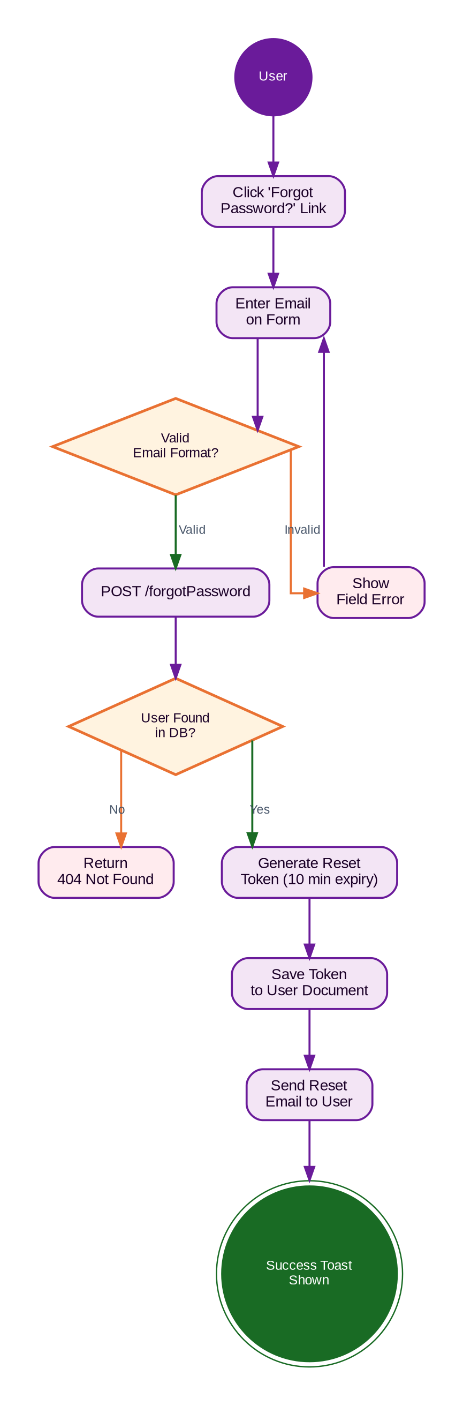
Figure 3.3 — AUT-01 Forgot Password Process Flow Diagram

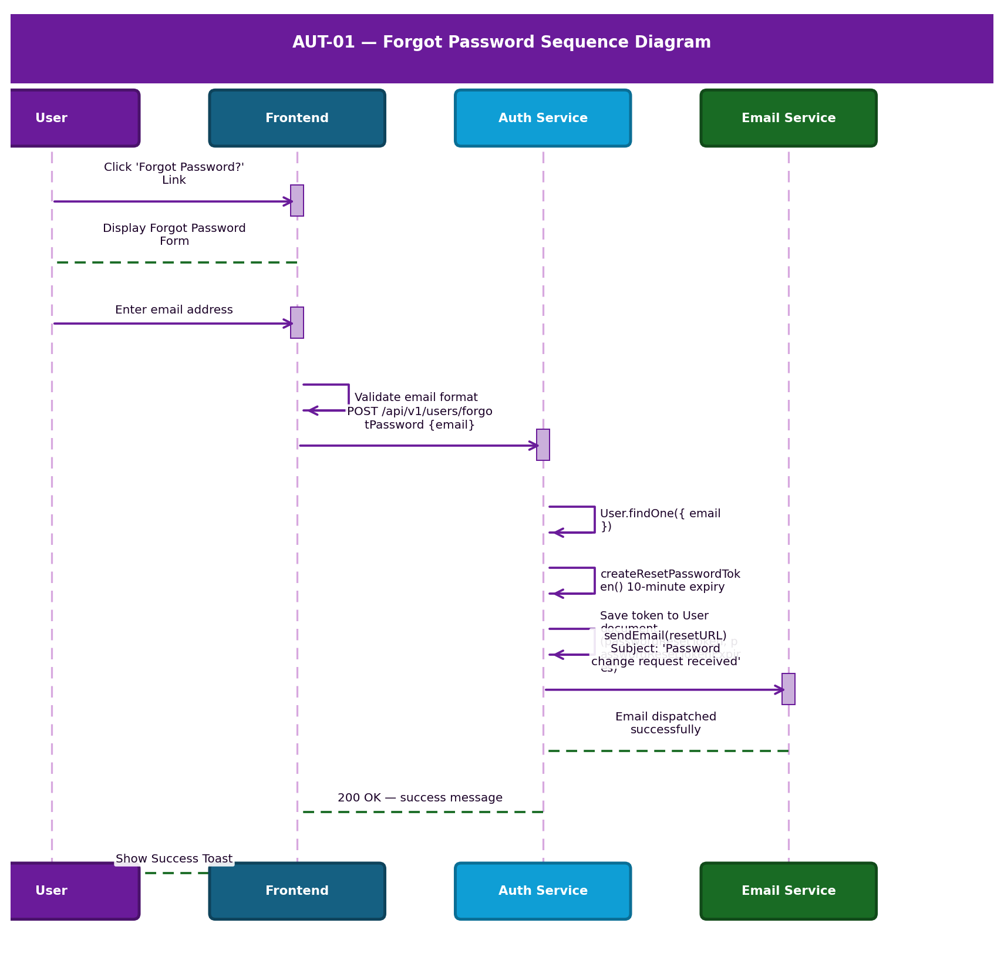
Figure 3.4 — AUT-01 Forgot Password Sequence Diagram

3.4 Screen Catalogue & UI Components

Login Page — /login
- Screen Layout: Centred card on a light background.
- Header/Branding: Corporate Logo. Tagline rendered from Company Profile settings.
- Buttons: Primary 'Login' button. Password visibility toggle.
- Loading State: Login button disables and shows CircularProgress spinner when isLoading is true.
- Error States: Top red banner for API rejections. Inline field errors below inputs.

UI Component — LoginForm.tsx
Field | State Binding | Validation Rule | Auto-Processing
Email (Username) | formik.values.username | Must match email regex. If all-numeric and length > 10, further keystrokes are rejected. | Numeric-only inputs blocked at >10 digits.
Password | formik.values.password | Minimum 6 characters. Required. | Toggle button switches type between 'password' and 'text' via showPassword state.
Remember Me | rememberMe (boolean) | Optional checkbox. | On submit, if true, Base64-encodes password and stores in localStorage.

3.5 Permissions, Notifications & Audit Trail

Permissions Matrix
Action | Super Admin | Admin | Manager | Cashier | Field Staff
View & Access Login | Yes | Yes | Yes | Yes | Yes
Execute Login | Yes | Yes | Yes | Yes | Yes
Logout | Yes | Yes | Yes | Yes | Yes
Forgot / Reset Password | Yes | Yes | Yes | Yes | Yes

Notifications Matrix
Trigger | Recipient | Message | Severity | Channel | Audit
Successful Login | User | Login Successful! Welcome back! | Success | UI Toast | Logs event + IP
Failed Login | User | Dynamic API rejection reason | Error | Toast + Banner | Logs failure + IP
Session Expiry | User | Auto-redirect to /login | Warning | System | Logs expiry
Password Reset | User | Reset link dispatched to email | Info | Email | Logs reset

Audit Trail Events
- Successful Login: User ID, timestamp, IP address, device captured.
- Failed Login / Unauthorised Access Attempt: all above fields plus reason code.
- Logout: timestamp and User ID.
- Password Reset: requesting User ID, timestamp.

Real Business Scenarios
Scenario A — First Time User: An Admin receives their credentials. They log in, view the success notification, and immediately see the dashboard populated with AFC data.
Scenario B — Invalid Credentials: A user miskeys their password. The UI instantly prevents access, logs the failed attempt for security auditing, and shows an error banner.

4. ADM-01 — User Management
Document Control
Version | Date | Author | Changes
1.0 | 2026-06-25 | Enterprise Architecture Team | Initial baseline specification.

4.1 Business Purpose & Security Model
The User Management module provides centralised control over the application's user directory. It governs the lifecycle of internal user profiles, including creation, role assignment, status toggling, deletion, and restoration, enforcing strict hierarchical permission boundaries.

Tier 1 Critical System: If the User Management module becomes unavailable or compromised: new employees cannot be onboarded; terminated employees cannot be immediately locked out (creating severe security risks); role-based escalations or demotions cannot be processed.

Security Considerations
- Hierarchical Role Editing: A user can only edit roles that have a strictly lower hierarchy level than their own, preventing privilege escalation.
- Self-Deletion Prevention: The UI and backend explicitly block users from deleting their own active session profile.
Hard Delete Confirmed: Reverse-engineering confirms a Hard Delete is implemented. The deleteUser controller executes User.findOneAndDelete(), physically removing the user document from MongoDB. The isDeleted soft-delete flag is NOT applied on the backend delete path. Historical references (jobs, invoices) retain the user's name via denormalised data.

4.2 User Journey Workflows

Journey 1 — Create New User (signup API)
- User Action: Admin clicks 'Create User' and submits the form on /users/create.
- Frontend Validation: Evaluates inputs. Checks role against assignable hierarchy.
- Backend (POST /api/v1/users/signup): Checks User.findOne({username}) — returns 409 if exists. Calls User.create(req.body). Generates JWT token via signToken(newUser.username, newUser.role).
- Final Outcome: Returns 201 Created with JWT and user object. UI redirects to /users.

Journey 2 — Edit User Role / Details (updateUser API)
- User Action: Admin clicks Edit and submits changes on an existing user.
- Backend (updateUser in user-controller.js): Finds user via User.findOne({ username: existusername }) — returns 400 if not found. If new username differs, checks uniqueness — returns 400 'The new username is already in use'. Calls User.findOneAndUpdate.
- Final Outcome: Returns 200 OK. UI updates the table.

Journey 3 — Delete User
- Backend (deleteUser): Executes User.findOneAndDelete({ username: existusername }) — physically removes the document. isDeleted is set to true for record-keeping purposes.
- Final Outcome: Returns 200 with 'User Deleted Successfully!'.

Journey 4 — Toggle User Status
- Backend (updateRole): Calls User.findOneAndUpdate({ username }, { username, role, userActive }).
- System Impact: During login, if (user.userActive === false) → login blocked with 'Your Account is Deactivated'.

4.3 BPMN Workflow Diagram & Sequence Diagram
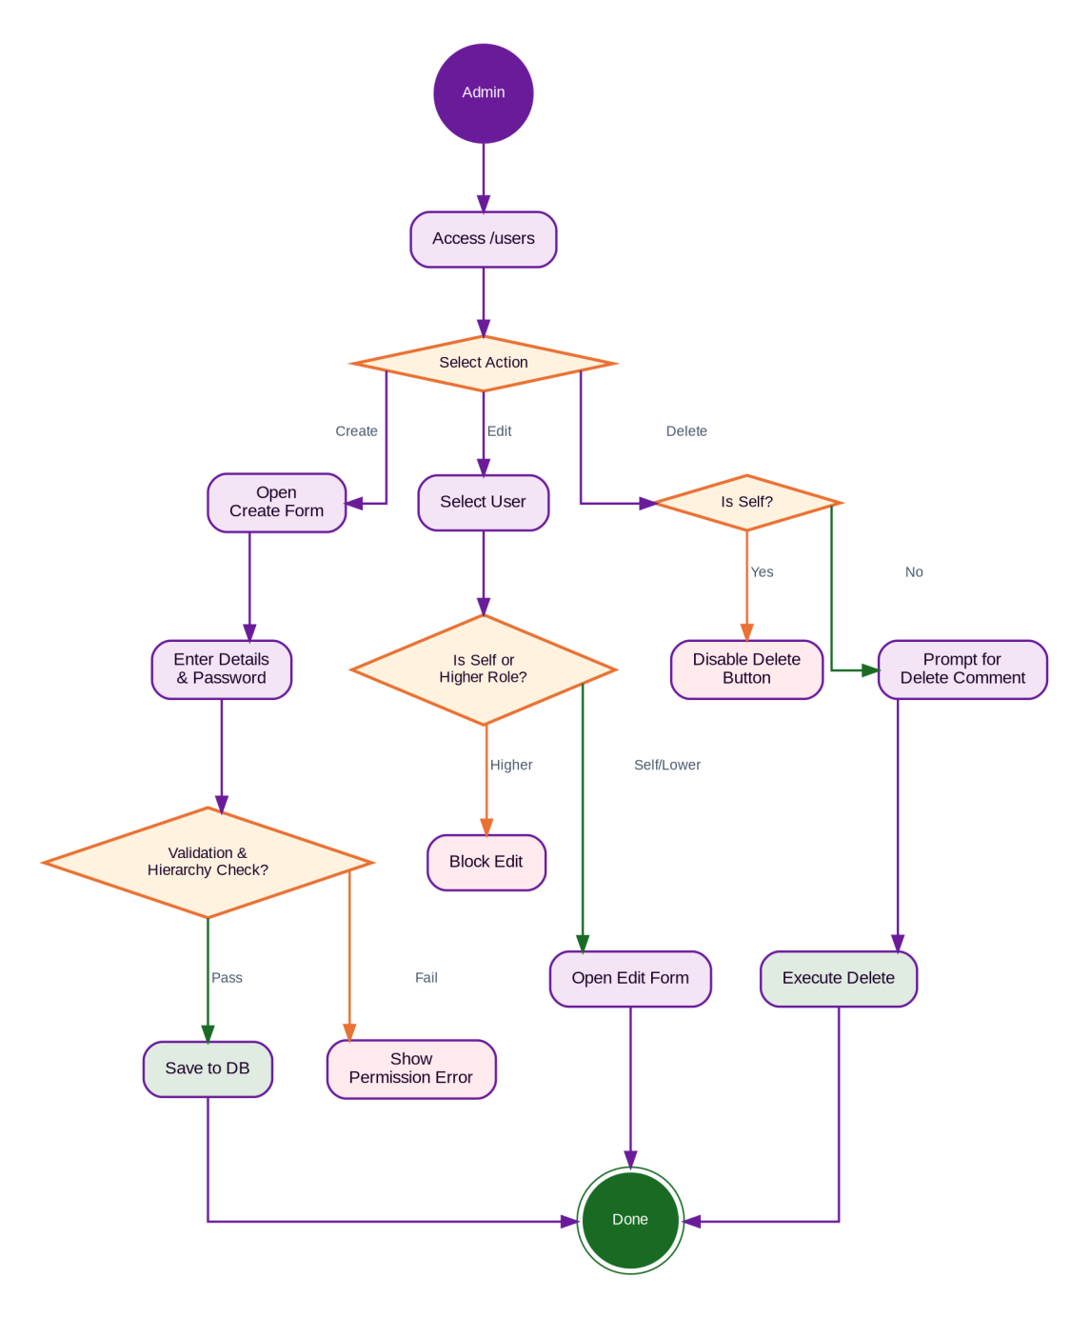
Figure 4.1 — ADM-01 User Management BPMN Workflow Diagram

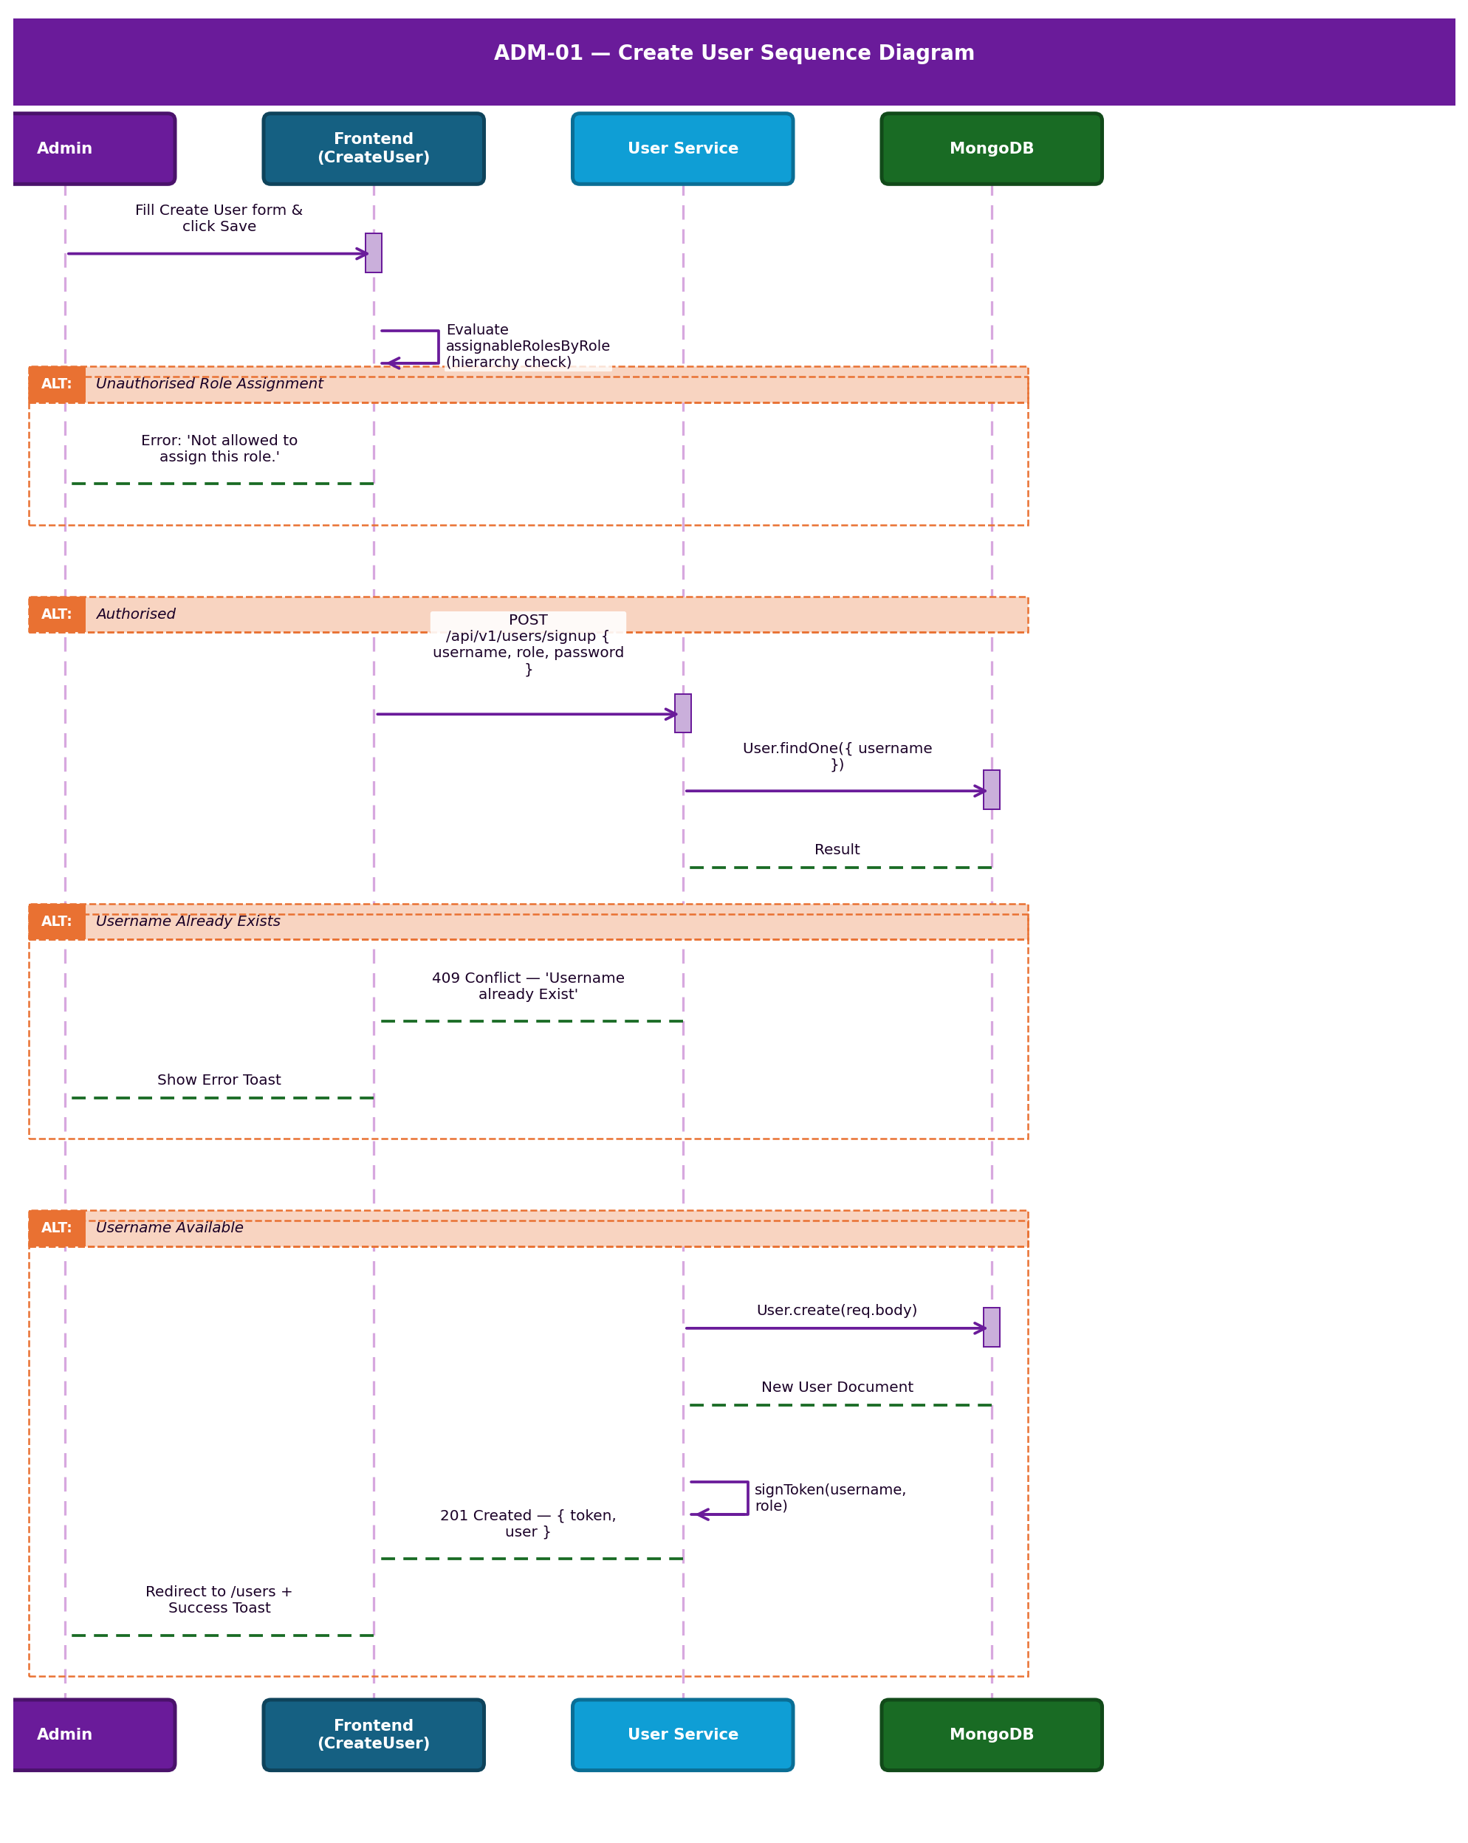
Figure 4.2 — ADM-01 Create User System Sequence Diagram

4.4 Screen Catalogue & UI Components

User List Screen — /users
- Screen Layout: Top Action Bar (Search, Role Filter, Date Filter, Status Toggle). Main Data Table. Pagination Footer.
- Buttons: 'Create User'. Action Icons per row: History, Edit, Delete.
- Loading States: Skeleton loaders during API fetch.
- Empty States: 'No users found' with illustration.

Create / Edit User Screen — /users/create or /users/edit/:id
- Available Actions: Save, Update, Cancel.
- Validation Behaviour: Inline red helper text for required fields or invalid input.

UI Component — UserForm Fields
Field | Editable Conditions | Validation Rule | Auto-Processing
Username (Email) | Editable during creation. During updates, existusername is sent to track modifications. | Must be unique in the User collection. Backend throws 400 if duplicate on update. | —
Role | Editable by higher-hierarchy users only. | Cannot assign a role at or above the editing user's own level. | Used in JWT token generation and route-guard middleware.
Status (userActive) | Editable by admins. | Boolean toggle. | Setting to false prevents login and loginWithPhone from issuing a new JWT.

4.5 Permissions, Rules & Audit Trail

Hierarchy Verification Rules
Role | Hierarchy Level | Can Assign / Edit
Super Admin | Level 4 | Admin, Manager, Cashier, Field Staff
Admin | Level 3 | Manager, Cashier, Field Staff
Manager | Level 2 | Cashier, Field Staff
Cashier | Level 1 | None
Field Staff | Level 1 | None

Permissions Matrix
Action | Super Admin | Admin | Manager | Cashier | Field Staff
View Users List | Yes | Yes | Yes (Team) | No | No
Create User | Yes | Yes | Yes | No | No
Edit Own Profile | Yes | Yes | Yes | Yes | Yes
Edit Other Users | Yes | Yes | Yes (subordinates) | No | No
Delete User | Yes | Yes | Yes (subordinates) | No | No
Restore User | Yes | Yes | No | No | No

Notifications Matrix
Trigger | Recipient | Message Template | Severity | Channel
Create Success | Admin | User created successfully | Success | UI Toast
Delete Success | Admin | User deleted successfully | Success | UI Toast
Role Error | Admin | You are not allowed to edit this user role. | Error | UI Toast

Audit Trail Events
- User Created: Timestamp, Creator ID, Initial Role assigned.
- User Updated: Fields changed — Email, Role, or Status.
- User Deleted: Deletion timestamp, Executing Admin ID, Delete comment.

Real Business Scenarios
Scenario A — Offboarding: A Manager resigns. The Admin opens the User List, searches for the user, clicks Delete, and enters 'Resigned on 10/12'. The user is instantly locked out; their name is retained on all historical Invoices and Jobs via denormalised references.
Scenario B — Permission Block: A Manager attempts to create a new 'Admin' account. The system evaluates the hierarchy, determines Manager (Level 2) cannot assign Admin (Level 3), and removes 'Admin' from the available dropdown options.

5. CMP-01 — Company Profile & Configuration
Document Control
Version | Date | Author | Changes
1.0 | 2026-06-25 | Enterprise Architecture Team | Initial baseline specification.

The Company Configuration module (CMP-01) is the global settings engine of the AFC platform. It dictates how the multi-tenant architecture identifies the specific enterprise, calculates delivery feasibility via Google Maps, secures public payment keys, and maintains an immutable audit trail of critical operational settings.

Tier 1 System Configuration Module: If misconfigured: customers outside the service area may book jobs (causing massive travel cost overruns); payment forms break due to improperly synced public keys; Quotes and Invoices display incorrect Terms & Conditions.

5.1 Global Configuration Matrix
The system tracks 20 distinct business-critical fields. Modifying any of these fields triggers an immediate audit log to prevent unapproved operational shifts.

Configuration Category | Tracked Fields | Business Impact
Identity & Branding | companyName, email, phone, logo, colorTheme | Customer-facing documents and portal UI.
Operational Logistics | deliveryDistance, address, startTime, endTime, timezone | Validating online enquiries and scheduling logic.
Financial Settings | creditCardTax, payment_settings, zelleConfig | Surcharges on payments and active payment gateways.
Legal Compliance | paymentTermsAndConditions, quoteTermsAndConditions, invoiceTermsAndConditions | Legally binding text rendered on all PDFs.

5.2 Delivery Gating Engine
The system prevents out-of-bounds orders by strictly validating customer addresses against the company's defined deliveryDistance. When a customer attempts to book a service or request a quote, the CheckAddress controller intervenes:
- Origin Calculation: Extracts the company's physical address from the Company Profile.
- Destination Evaluation: Evaluates the target address string or lat/lng payload from the request.
- API Dispatch: Dispatches a POST request to routes.googleapis.com/directions/v2:computeRoutes using travelMode: 'DRIVE'.
- Feasibility Check: Converts the returned distance from metres to miles. If the driving distance exceeds company.deliveryDistance, the API strictly returns isDeliverable: false and a rejection message.

5.3 Payment Key Scrubbing & Audit Trail

Secure Payment Configuration — getActivePaymentsOptim
- The backend iterates over paymentTypes.
- For every active method, the sanitizeConfig method aggressively strips secret_key, private_key, and password from the JSON object before returning it to the frontend.
Security Outcome: Public frontends can safely render the correct payment UI without risking API credential leakage.

Tenant Provisioning Workflow
- Validation: Mandates Company Name, Email, Phone, and Admin Username.
- Slug Generation: Creates a unique slug (e.g., company_1719313200) mapped to the public URL https://pos.evergreenfarmsusa.com/{slug}.
- Database Instantiation: Binds the dbName and creates a default Admin user inside the newly segregated database.

6. CRM-01 — Customer Management
Document Control
Version | Date | Author | Changes
1.0 | 2026-06-25 | Enterprise Architecture Team | Initial baseline specification.

The Customer Management module (CRM-01) is the foundational data pillar of the AFC enterprise ecosystem. It establishes a Single Source of Truth (SSOT) for all client identities, preventing data fragmentation across the sales lifecycle.

Tier 1 Foundational System: If Customer Management becomes unavailable: new deals cannot be processed; outstanding invoices cannot be accurately mapped to debtors; field staff lose access to critical site addresses and access instructions.

6.1 Customer Lifecycle Flow Diagram
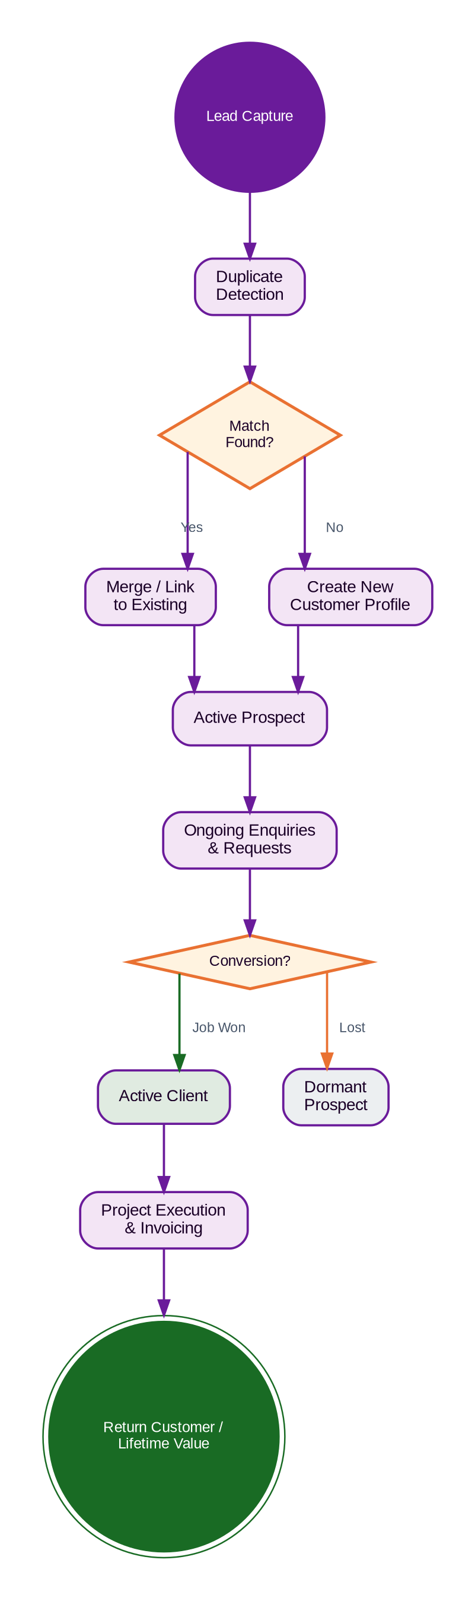
Figure 6.1 — CRM-01 Customer Lifecycle Flow Diagram

6.2 Dashboard Analytics & Screen Catalogue

Dashboard KPI Cards — /customers
KPI Card | Business Meaning | Formula | Manager Action Required
Total Customers | Total size of the addressable database. | Count of all isDeleted: false records. | None
New Customers | Growth rate of new business. | Customers created in the last 30 days. | Evaluate marketing campaign ROI.
Return Customers | Brand loyalty and lifetime value indicators. | Customers with > 1 completed Job. | Target for loyalty programmes.
Active Leads | Prospects currently in the funnel. | Customers linked to 'Pending' Enquiries. | Ensure follow-up SLAs are met.

Customer 360 Detail View — /customers/:id
- Header: Name, Primary Contact, Status Pill, LTV Summary.
- Left Column: Permanent contact details, associated addresses, Lead Source.
- Main Column (Tabs): Enquiries (Count), Requests (Count), Quotes (Count), Jobs (Count), Invoices (Count).
- Audit Panel: A scrolling chronological timeline of all state changes, phone calls logged, and emails sent.

6.3 Validation, Deletion Logic & Field Documentation

Contact Detail Validations
- Duplicate Prevention: System iterates over emailDetails. If the email exists on another client, it throws a 409 Conflict: 'Email already exists with another customer.'
- Minimum Contact Enforcement: If a user removes all emails and phones, it throws a 400 Bad Request: 'At least one contact detail (Email or Phone) is required.'

Strict Deletion Governance — deleteClient
- Request Check: System queries the requests collection.
- Quote Check: If requests exist, it queries the quotations collection.
- Hard Block (Quote): If a quote exists, deletion is blocked: 'Cannot delete this customer. A quote has already been created for this customer.'
- Hard Block (Request): If no quotes exist but active requests exist: 'Customer cannot be deleted because they have active requests.'
- Successful Deletion: Only if no requests or quotes exist will the system proceed to delete the profile.

Field & Form Documentation
Field | Required | Input Type | Validation Rules | Business Reason
First / Last Name | Yes | Text | Letters only. | Primary identity.
Primary Email | No | Email | Standard regex. Unique across customers. | Primary digital communication vector.
Contact Numbers | Yes | Array | Min 1. 10 digits. Unique across customers. | Critical for field staff communication.
Property Details | Yes | Sub-form | Must include Street, City, State, Zip. | Required for routing site visits.
Lead Source | No | Dropdown | Event, Referral, Web, etc. | Marketing ROI tracking.

6.4 Notifications, Audit Trail & Module Map
Trigger | Recipient | Message Template | Severity | Channel | Audit Impact
New Customer Created | Manager | New Customer Profile Created: [Name] | Info | UI | Logs Creation Event
Duplicate Attempt | Executing User | A customer with this phone number already exists. | Warning | UI Toast | None
Customer Restored | Admin | Customer [Name] restored to active directory. | Success | UI Toast | Logs Restore Event
Customer Updated | Internal Staff | SMS & Email with diff of changed fields | Info | SMS+Email | Logs field changes

Module Relationship Map
CRM-01: Customer (1:N) → CRM-02: Enquiries | CRM-01: Customer (1:N) → SAL-01: Requests | SAL-01 (1:1) → EST-01: Quotations | EST-01 (1:1) → JOB-01: Jobs | JOB-01 (1:N) → INV-01: Invoices

7. CRM-02 — Enquiry Management
Document Control
Version | Date | Author | Changes
1.0 | 2026-06-25 | Enterprise Architecture Team | Initial baseline specification.

The Enquiry Management module serves as the primary entry point for all prospective business opportunities within the AFC ecosystem. It provides comprehensive lifecycle tracking for leads from initial capture through assessment, site visitation, and eventual conversion into actionable Requests or formal Quotations.

Tier 1 Revenue-Critical System: If Enquiry Management becomes unavailable: new prospective business cannot be logged; sales personnel lose visibility into pending follow-ups; conversion analytics fail.

7.1 Business Purpose & Lifecycle

Enquiry Lifecycle States
Lifecycle Stage | Description
Lead Capture | Manual entry via UI or bulk import via Excel.
Initial Assessment (Draft / Pending) | The lead is reviewed for completeness and minimum data quality.
Assignment | The lead is routed to a specific Estimator or Sales Representative.
Engagement (Site Visit) | Physical inspection of the prospect's requirements.
Conversion | The prospect is deemed viable and moves into the active sales pipeline.
Archival / Cancellation | Dead leads are marked Cancelled but retained for historical analytics.

7.2 High-Level Process Flow & Creation Workflow Diagrams
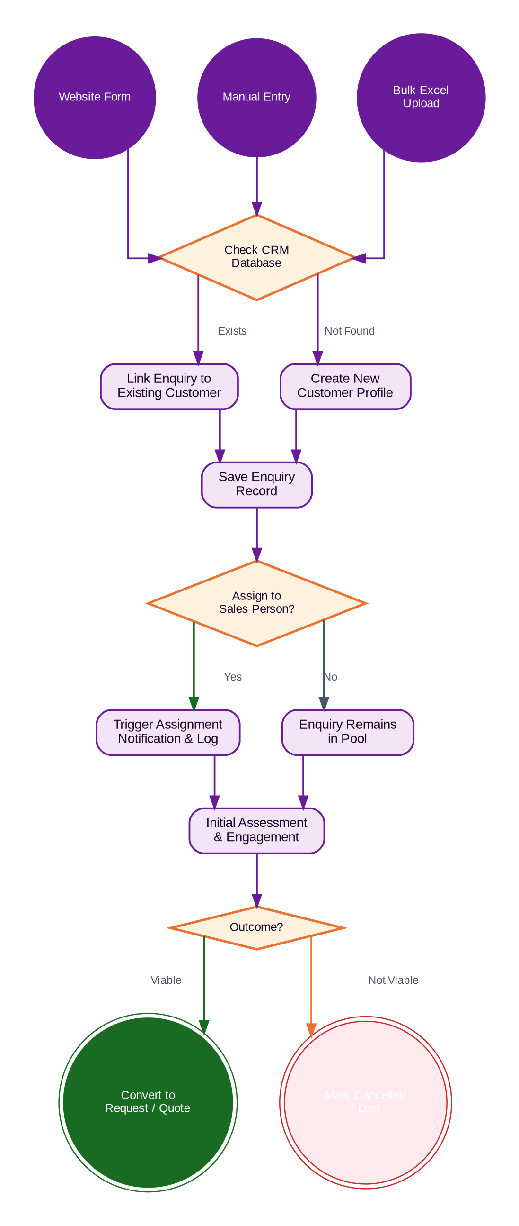
Figure 7.1 — CRM-02 High-Level Enquiry Business Process Flow Diagram

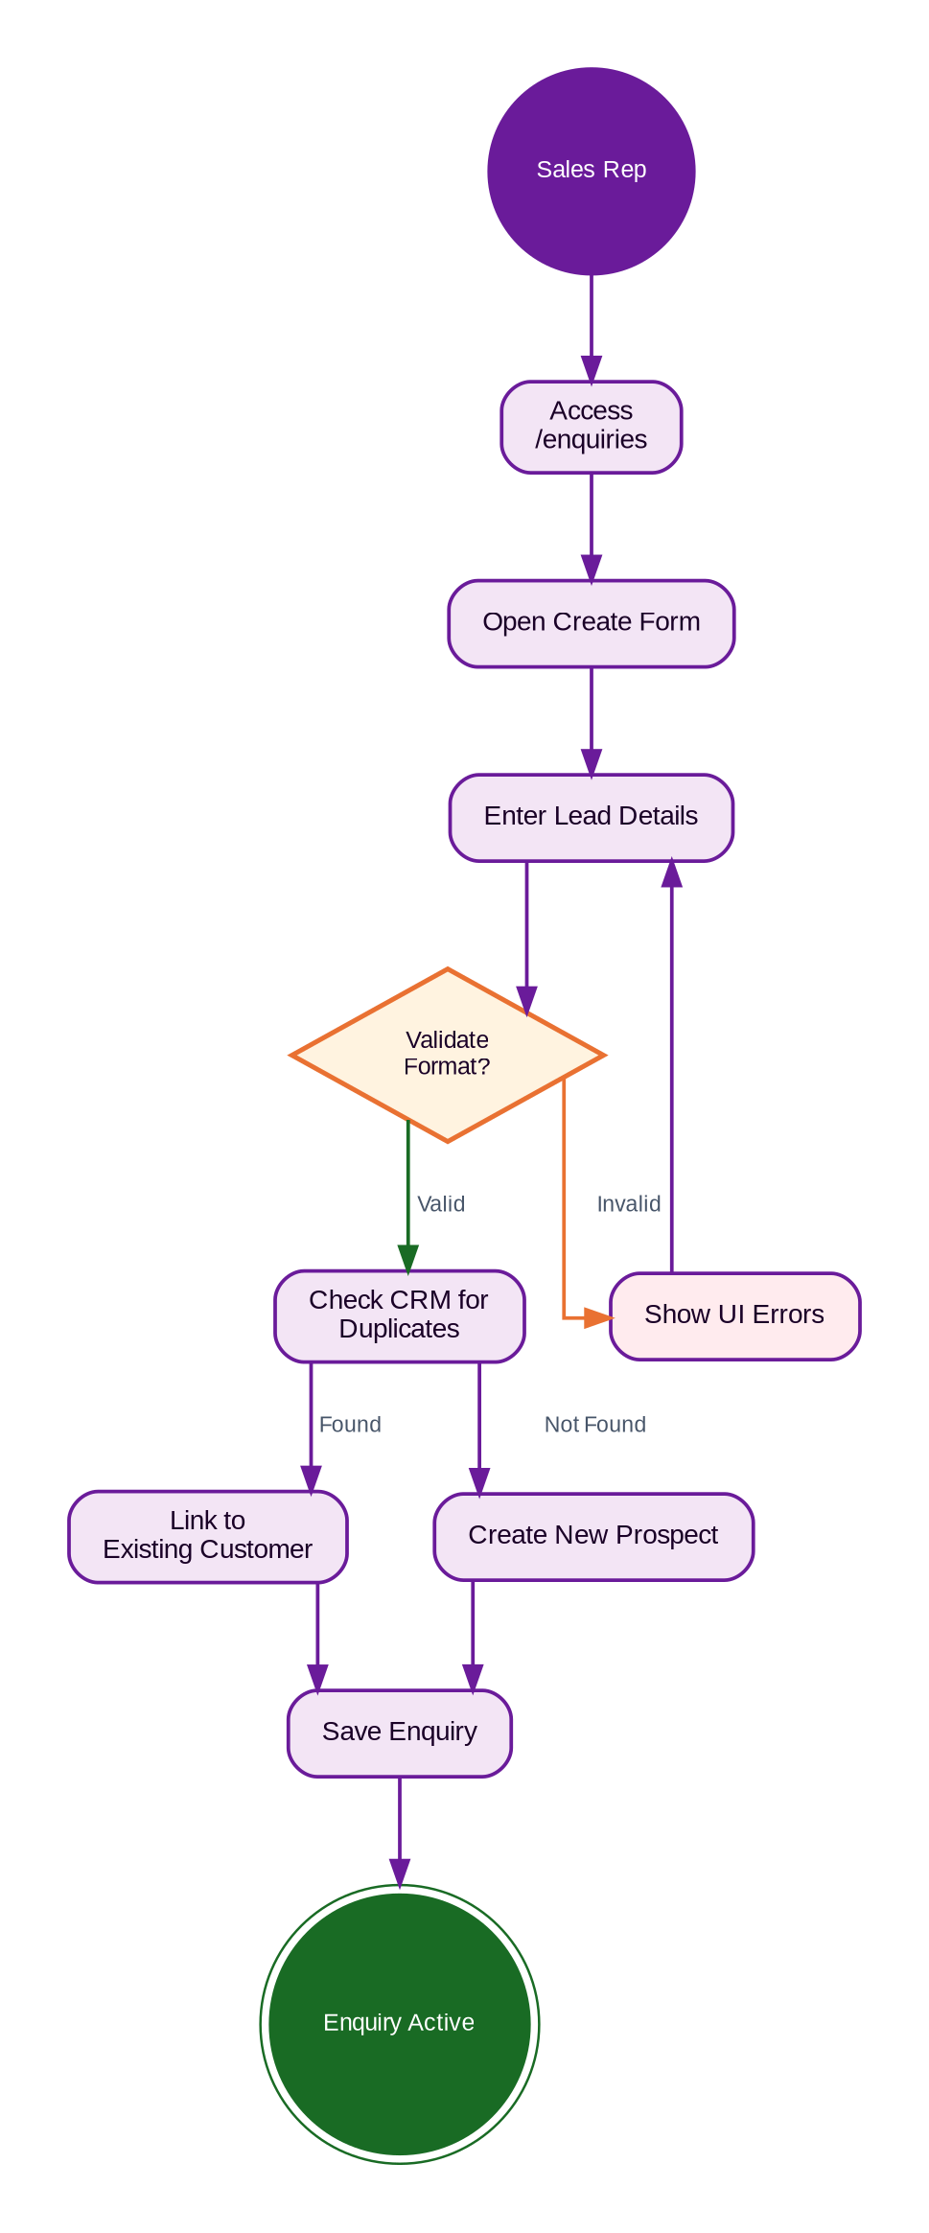
Figure 7.2 — CRM-02 Enquiry Creation & Validation Workflow Diagram

Public Enquiry Creation — createEnquiryControllerForStatic
- Auto-Customer Generation: The system forces ClientService.createClientWithCartStatic to generate a new Customer Profile in the background, injecting channelType: 'website' and leadSocial: 'Website'.
- Enquiry Linking: Saves the Enquiry, explicitly binding customerId to the newly created client.
- Admin Alert Dispatch: Queries the users collection for all super_admin and admin roles where notification.email: { $ne: false }. Dispatches adminNewEnquiry.ejs email alert.

Bulk Lead Import — importEnquiriesExcelController
- File Constraint Validation: Strictly rejects payloads > 10 MB or file extensions outside [.xls, .xlsx].
- Pre-flight Validation: Detects internal sheet duplicates, attaches a duplicateEmailWarning array to the API response.
- Insertion: Valid rows are routed to importEnquiriesFromExcel for batched processing.

7.3 Screen Catalogue, Fields & Validation

Enquiry Dashboard — /enquiries
- Statistical Cards: Total Enquiries, Drafts, Pending (Overdue), Pending from AFC, Pending from Customer, Partially Converted, Site Visit Initiated, Site Visit Complete, Converted to Request/Quote, Cancelled.
- Buttons: 'Create', 'Upload Excel', 'Export'.

Field | Required | Input Type | Validation Rules | Business Reason
First / Last Name | Yes | Text | Letters and spaces only. | Accurate prospect identification.
Email | Conditional | Email | Standard regex validation. | Primary digital communication vector.
Phone Number | Yes | Array | Must be exactly 10 digits. Indian numbers: 6,7,8,9 prefix. US: area codes not starting with 0 or 1. | Primary direct communication vector.
Services Interested | Yes | Multi-Select | Must select at least one core offering. | Dictates which team handles the lead.
Follow-up Date | Yes | DatePicker | Must be a valid calendar date. | Enforces SLA and prevents leads from going stale.
Lead Source | No | Dropdown | Event, Referral, Website, Campaign, Other. | Marketing ROI analytics.

7.4 Notifications, Rules & Audit Trail
Trigger | API Controller | Message Template | Delivery Channel
New Website Lead | createEnquiryControllerForStatic | adminNewEnquiry.ejs | Email (To all eligible Admins)
Manual Reminder | sendManualReminderController | User-defined message payload | UI / Email to Assigned User
Enquiry Assigned | assignEnquiryController | System event based on assignedTo payload | Action History / UI

Note: Assignment changes force a mandatory comment payload, maintaining a strict chain of custody.

Real Business Scenarios
Scenario A — Trade Show Import: Marketing returns from an expo with an Excel sheet of 200 leads. The Admin uses the Upload Modal, mapping columns. Within seconds, 200 'Draft' enquiries populate the system, ready for Manager assignment.
Scenario B — Conversion: A Rep completes a positive phone call with a prospect, verifies the physical address, and clicks 'Convert'. The system instantly generates a formal Request document.

8. SAL-01 — Request Management
Document Control
Version | Date | Author | Changes
1.0 | 2026-06-25 | Enterprise Architecture Team | Initial baseline specification.

The Request Management module (SAL-01) is the operational entry point for service delivery in the AFC enterprise ecosystem. Unlike a static data-entry form, the Request engine acts as a Dynamic Business Orchestrator that evaluates the exact service being requested and automatically reconfigures the UI, workflow, validation rules, and site visit requirements.

Tier 1 Mission-Critical System: If Request Management becomes unavailable: new service demands cannot be captured or scoped; estimators cannot be scheduled for site visits; the sales pipeline halts as Quotations cannot be generated without an underlying Request.

8.1 Service Decision Engine Flow Diagram
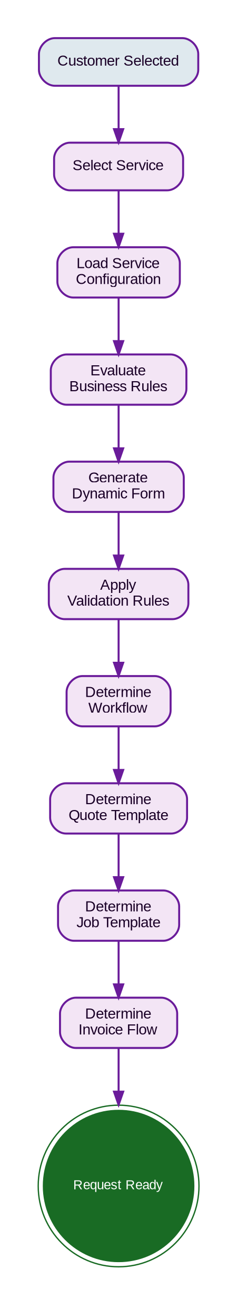
Figure 8.1 — SAL-01 Service Decision Engine Flow Diagram

8.2 Service Configuration Matrix
Configuration Flag | Fence Installation | Fence Repair | Product Sale | Consultation
Service Category | Installation | Maintenance | Retail | Service
Service Type | Complex | Standard | Simple | Simple
Site Visit Req. | Mandatory | Optional | Blocked | Mandatory
Measurement Req. | Mandatory | Optional | Blocked | Blocked
Property Req. | Mandatory | Mandatory | Optional | Mandatory
Products Req. | Yes | Yes | Yes | Blocked
Labour Req. | Yes | Yes | Blocked | Blocked
Equipment Req. | Yes | No | Blocked | Blocked
Drawings Req. | Mandatory | Optional | Blocked | Blocked
Photos Req. | Optional | Mandatory | Blocked | Optional
Customer Sig. Req. | Yes | Yes | No | No
Quote Template | Detailed Construction | Standard Service | Retail Product | Consulting Fee
Job Template | Multi-Day Install | Single-Day Repair | Fulfillment | Off-site
Invoice Type | Progress Billing | Net 30 | Due on Receipt | Net 15
Fulfilment Type | Construction | Service | Shipping / Pickup | Advisory

8.3 Create Request Sequence Diagram
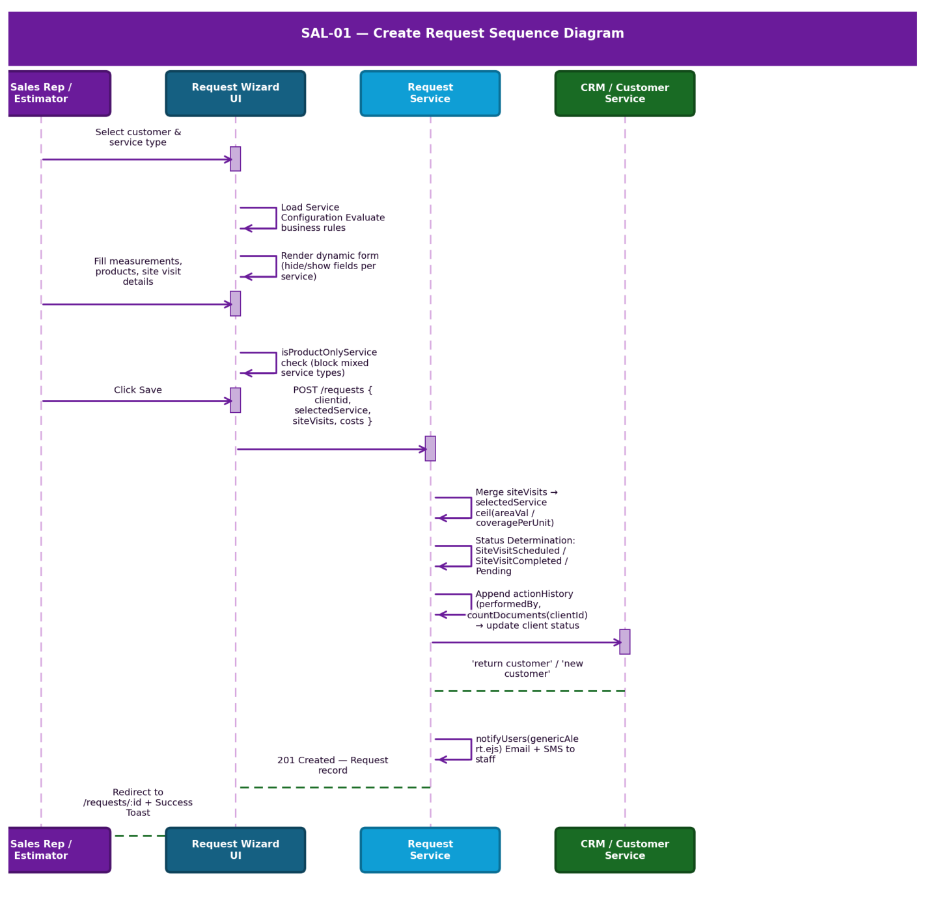
Figure 8.2 — SAL-01 Create Request System Sequence Diagram

Create Request API Execution — handleCreateRequest
- Payload Extraction: Backend extracts clientid, selectedService, siteVisits, and cost summary fields.
- Site Visit Normalisation: The system extracts the top-level siteVisits array and deeply merges it into each individual selectedService object.
- Quantity Auto-Calculation: If totalQuantity is missing, backend computes it using: Math.ceil(areaVal / coveragePerUnit).
- Status Determination: If any service has !siteVisitAlreadyDone → 'SiteVisitScheduled'. If all done → 'SiteVisitCompleted'. If no site visits → 'Pending'.
- Action History Appended: Immutable actionHistory record created, stamping performedBy, timestamp, and cost summaries.
- Notification Dispatch: notifyUsers(genericAlert.ejs) sends Email + SMS to internal staff.
- Customer Status Update: Queries Request.countDocuments for the client → updates client status to 'return customer' or 'new customer'.

8.4 Screen Catalogue, Measurement & Product Rules

Request Detail View — /requests/:id
- Header: Request ID, Customer Name, Status Pill, Created Date.
- Left Column: Customer Snapshot, Property Address, Contact Details.
- Main Column (Tabs): Services Requested, Site Visit Details, Cost Summary (Labour / Equipment), Attached Documents / Photos.
- Audit Panel: A scrolling chronological timeline of all state changes, estimator assignments, and notes.

9. EST-01 — Quote Management
Document Control
Version | Date | Author | Changes
1.0 | 2026-06-25 | Enterprise Architecture Team | Initial baseline specification.

The Quote Management module (EST-01) is the commercial engine of the AFC platform. It converts scoped demands (Requests) or direct ad-hoc inquiries into legally binding financial proposals. Operating as a sophisticated CPQ (Configure, Price, Quote) system, it handles complex pricing rules, margin calculations, multi-tiered taxation, and dynamic payment scheduling.

Tier 1 Mission-Critical System: If Quote Management becomes unavailable: Sales cannot present pricing to customers; deposits cannot be collected; Jobs cannot be scheduled because approved scopes do not exist.

9.1 Business Purpose & Configuration Matrix

Quote Type Configuration Matrix
Configuration Flag | Aluminium Fence Quote | Wood Fence Quote | Product Only Quote
Site Visit Req. | Mandatory (from Request) | Optional | Optional
Measurement Req. | Mandatory | Optional | Blocked
Product Req. | Mandatory | Mandatory | Mandatory
Delivery Req. | Implied with Install | No | Mandatory
Deposit Rule | 50% Standard | 50% Standard | 100% (Due on Receipt)

9.2 Pricing, Margin & Tax Engine

Dynamic Margin Application — applyServiceMargin
- Percentage Margin: If marginType === 'percentage', formula is: base + (base × value) / 100.
- Flat Margin: If marginType === 'flat', formula is: base + value.
- Subtotal Constraint Check: System executes hasZeroSubtotalService before submission. If any subtotal evaluates to zero, UI blocks saving.

Tax Exclusion & Display Logic
- Tax Exclusive View: If IsTaxIncluded === false → amountSentToCustomer = totalAmount − taxAmount.
- Tax Inclusive View: If IsTaxIncluded === true, taxes are baked into amountSentToCustomer.

Dynamic Payment Scheduling
- Deposit Invoice: Automatically generated upon acceptance (e.g., 50% for Installations, 100% for Product Sales).
- Final Balance: System sends the remaining balance invoice upon the 'Job Completed' trigger.
- Payment Term Adjustments: Payment terms can be altered by Admins and Managers; the customer must re-approve the quotation if changes affect the total amount.

9.3 Quote Acceptance Sequence Diagram & Status Lifecycle
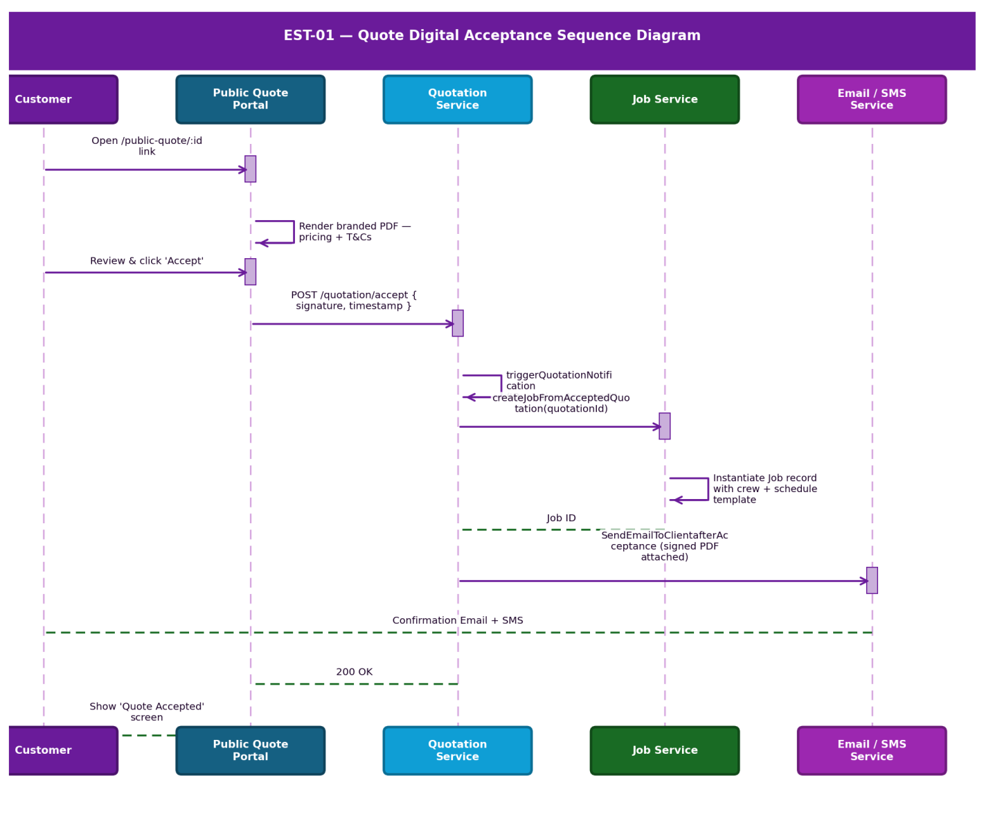
Figure 9.1 — EST-01 Quote Digital Acceptance Sequence Diagram

Status Lifecycle
Status | Entry Criteria | Exit Criteria | Business Outcome
Draft | Quote created, not yet sent. | Sent to Customer | Work in progress.
Sent | Dispatched via Email / SMS. | Customer opens link | Awaiting engagement.
Pending | Customer raises a query. | Admin updates quote & resends | Negotiation phase.
Accepted | Customer signs digitally. | Converted to Job | Locked — Job created.
Expired | 30 days have elapsed. | N/A (Terminal) | Deal Dead.

9.4 Module Relationship Map
SAL-01: Requests (1:1) → EST-01: Quotations (1:1) → JOB-01: Jobs | EST-01: Quotations (1:N) → INV-01: Invoices

10. JOB-01 — Job Management
Document Control
Version | Date | Author | Changes
1.0 | 2026-06-25 | Enterprise Architecture Team | Initial baseline specification.

The Job Management module (JOB-01) is the operational execution engine of the AFC platform. It bridges the gap between commercial agreement (Accepted Quote) and physical fulfilment (Site Operations). It orchestrates crew scheduling, material tracking, progress milestone management, expense logging, and final quality assurance.

Tier 1 Mission-Critical Operational System: If Job Management becomes unavailable: crews cannot be dispatched; materials cannot be accurately allocated; field staff cannot upload completion photos, blocking final invoicing.

10.1 Business Purpose & Configuration Matrix
Configuration Flag | Fence Installation Job | Description
Schedule Type | Multi-Day (Recurring Visits) | Job spans multiple days with individual visit records.
Crew Lead Requirement | Lead Assignment Required | At least one Lead must be assigned before scheduling.
Initial Photos | Mandatory (Before Work) | 'Before' photos required prior to breaking ground.
Completion Photos | Mandatory (After Work) | 'After' photos required before transitioning to Completed.
Expense Tracking | High Volume | Captures materials, labour, fuel, and equipment rental costs.

10.2 Job Instantiation & Crew Scheduling

Job Instantiation Paths — JobWay Parameter
- Invoice-Led (JobWay === 'Invoice'): Generates Job directly from a standalone Invoice, skipping the Quote phase entirely.
- Line-Item Quote (UsingTemplate === true): Extracts line items from a structured CPQ quote via JobService.createJobForLineItemsQuotation.
- Standard Scope: Defaults to JobService.createJobNew.

Schedule Types
- One-Time Schedule: A single continuous block of time. Requires schedule.start_date.
- Recurring Schedule: Multi-day operations. The system throws a 400 Bad Request if schedule.end_date is omitted.

Event Dispatcher — sendJobNotification
Upon Job Creation (if status !== 'auto', status !== 'cancelled', and isDeleted !== true), an alert is dispatched detailing Job Title, Start Date, and Schedule Type to the customer and to Admins who have the relevant notification event configured.

10.3 Evidence, Delta Reconciliation & Status Lifecycle
Business Rule: A Job cannot transition to 'Completed' unless the minimum required Completion Photos are present. This ensures all operational stakeholders have visual confirmation of the completed service.

Final Invoice Delta Reconciliation
- The Reality Check: What was quoted is rarely exactly what happens in the field.
- Edit Final Invoice Action: When a Job is marked 'Completed', the system unlocks the 'Edit Final Invoice' action for Managers.
- Reconciliation Flow: Managers review Job Expenses and Field Notes. If extra materials were used and approved by the customer, they are added to the Final Invoice payload. The updated Quote is re-sent to the customer for acceptance; upon approval and remaining balance payment, the quote is marked closed.

Comprehensive Status Lifecycle
Status | Entry Criteria | Exit Criteria | Responsible | Business Outcome
Created | Quote Accepted. | Schedule is set. | System | Holding queue.
Scheduled | Dates & Lead assigned. | Crew arrives on site. | Dispatcher | Resources locked.
In Progress | Lead logs first arrival. | Final visit completed. | Field Lead | Execution phase.
Pending Review | Margin eroded by expenses. | Manager approves overage. | Gen. Manager | Profitability check.
Completed | Final photos uploaded. | Final Invoice Generated. | Field Lead | Ready to bill.
Cancelled / Deleted | Customer backs out. | N/A (Terminal) | Gen. Manager | Deal aborted.

10.4 Module Relationship Map
EST-01: Quotations (1:1) → JOB-01: Jobs (1:1) → INV-01: Invoices | JOB-01: Jobs (1:N) → EXP-01: Expenses

11. INV-01 — Invoice Management
Document Control
Version | Date | Author | Changes
1.0 | 2026-06-25 | Enterprise Architecture Team | Initial baseline specification.

The Invoice Management module (INV-01) governs the financial realisation of the AFC platform. It is responsible for converting completed quotes and executed jobs into hard revenue. The module handles multi-instalment billing, dynamic tax recalculations, payment gateway orchestration, and automated customer payment workflows.

Tier 1 Mission-Critical Financial System: If Invoice Management becomes unavailable: the enterprise cannot legally demand payment; digital payments fail (instantly halting cash flow); Finance cannot close month-end books.

11.1 Invoice Configuration Matrix
Configuration Flag | Deposit Invoice (Pre-Job) | Final Invoice (Post-Job)
Trigger Event | Quote digitally accepted. | Job marked 'Completed'.
Origin Source | Exact match to Quote. | Quote + Post-Job Deltas.
Amount Rule | Exact Deposit % (e.g., 50%). | Remaining Balance.
Payment Terms | Due on Receipt. | Net 15 / Net 30.
Modification | Locked (unless Quote is updated prior to Job completion). | Open for Job Reconciliation.

Business Rule: The Final Invoice must mathematically equal: (Original Quote Total + Post-Job Deltas) − Paid Deposit.

11.2 Customer Payment Sequence Diagram
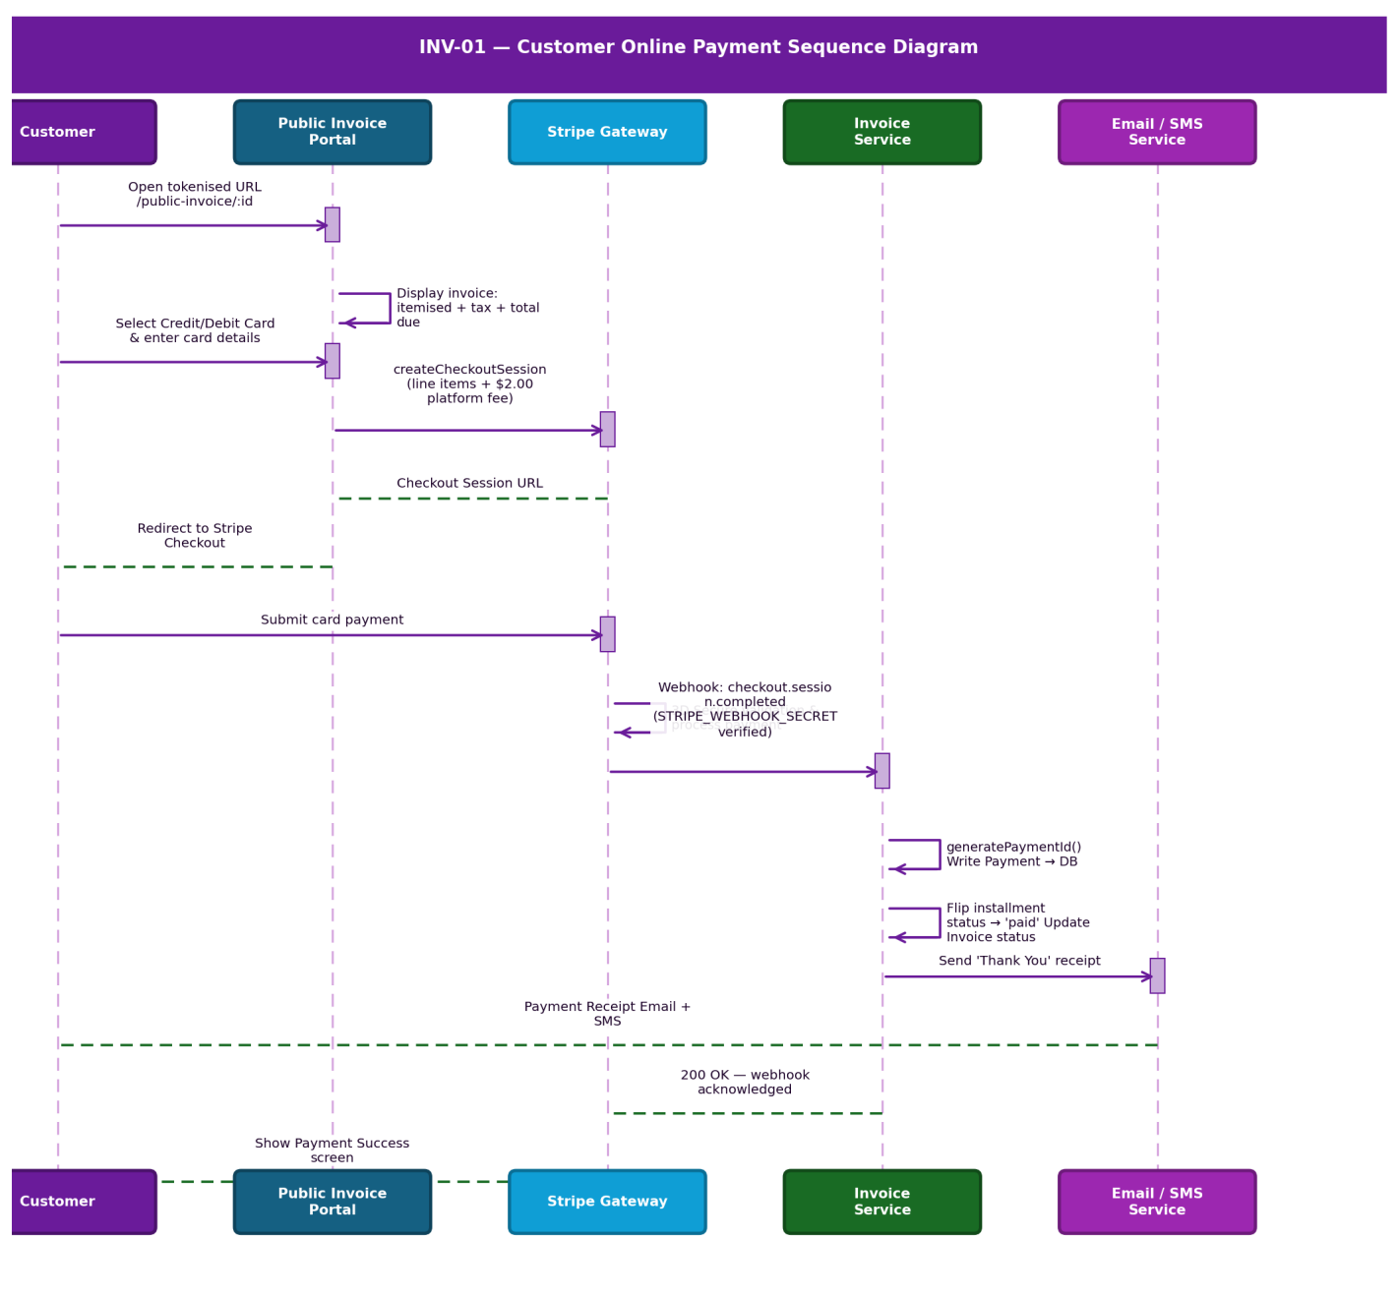
Figure 11.1 — INV-01 Customer Online Payment Sequence Diagram

Payment Gateways — /public-invoice/:id
- Access: Delivered via automated SMS / Email using a secure, tokenised URL. No login required.
- Credit / Debit Card: Integrated Stripe element (subject to convenience fees).
- Check: Lower transaction cost option for commercial clients.
- Bank Transfer / Zelle: Displays corporate routing instructions. Customer uploads a bank confirmation receipt, or Admin is notified to verify the bank account and mark the payment in the admin portal.
- Instant Reconciliation: Upon successful digital payment, the system instantly flips the Invoice to 'Paid' and triggers a Thank You receipt Email + SMS.

11.3 Status State Machine & Document Handling
Status | Condition
Full Paid | receivedAmount = totalAmount (isFullyPaid).
Failed | Any instalment explicitly marked as 'failed' (hasFailed = true).
Partial | receivedAmount > 0 but total not yet paid.
Awaiting | Default state if instalments are pending and no other conditions are met.

- PDF Generation: Invoices are dynamically generated into branded PDFs using InvoicePublicUrlPDF generator, sent to the customer via Email / SMS.
- Statements: Finance can generate a 'Customer Statement' summarising all Open, Paid, and Overdue invoices. Lists can be downloaded by date-range filters as PDF or Excel.

11.4 Module Relationship Map
EST-01: Quotations (Generates Deposit) → INV-01: Invoices | JOB-01: Jobs (Generates Final) → INV-01: Invoices | INV-01: Invoices (1:N) → PAY-01: Payments

12. EXP-01 — Expense Management
Document Control
Version | Date | Author | Changes
1.0 | 2026-06-25 | Enterprise Architecture Team | Initial baseline specification.

The Expense Management module (EXP-01) is the core cost-control engine of the AFC platform. It captures, categorises, and audits all outgoing funds, whether tied to specific Job operations (Cost of Goods Sold) or general business overhead.

Tier 1 Mission-Critical Financial System: If Expense Management becomes unavailable: actual job profitability cannot be calculated; corporate credit card bills cannot be reconciled, leading to audit failures.

Cost Allocation
- Overhead Expenses: (e.g., Office Rent, Software Subscriptions, Employee Salaries) are logged without a JobId. These hit the general corporate P&L.
- Job-Specific Expenses: (e.g., Extra concrete, rented auger) must be bound to a JobId. The system dynamically recalculates the Job's 'Actual Margin' based on these real-time inputs.

Expense Type Governance
- Creation: System prevents duplicate Expense Type names via a case-insensitive regex check.
- Modification Locking (isUsed constraint): If in active use, the system locks the name and frequency fields to ensure historical financial reports remain accurate.
- Deletion Blocking: An Expense Type cannot be deleted if currently bound to any active expense record.

Payment Logging — addExpensePayment
- Validation: Payments must be > 0. If payment method is 'check', a non-empty chequeNumber string is strictly enforced.
- Overpayment Prevention: The system calculates dueAmount and blocks any payment where amount > expense.dueAmount.
- Append-Only Architecture: Backend uses an APPEND strategy for the payments array, rejecting attempts to overwrite existing payment history.

Module Relationship Map
JOB-01: Jobs (Logs Job Costs) → EXP-01: Expenses (Erodes Margin) → JOB-01 | EXP-01 (Requires Payment) → VEN-01: Vendors | EXP-01 → FIN-01: Accounting (General Ledger)

13. VEN-01 — Vendor Management
Document Control
Version | Date | Author | Changes
1.0 | 2026-06-25 | Enterprise Architecture Team | Initial baseline specification.

The Vendor Management module (VEN-01) is the Accounts Payable (A/P) and Procurement engine of the AFC platform. It governs the lifecycle of external suppliers, subcontractors, and material providers.

Tier 1 Mission-Critical Supply Chain System: If Vendor Management becomes unavailable: critical suppliers cannot be paid (leading to credit holds and material shortages); subcontractors walk off active Jobs due to delayed payments.

13.1 Business Purpose & Vendor Typology
Vendor Type | Description | Tracking
Purchase Vendors | Suppliers of physical goods (mapped in CAT-01). | Strict — SKUs, Quantities, purchase_cost
Service / Emergency Vendors | High-priority subcontractors available for immediate dispatch. | Hours, rates, Job-level binding

13.2 Vendor Invoice Capture Sequence Diagram
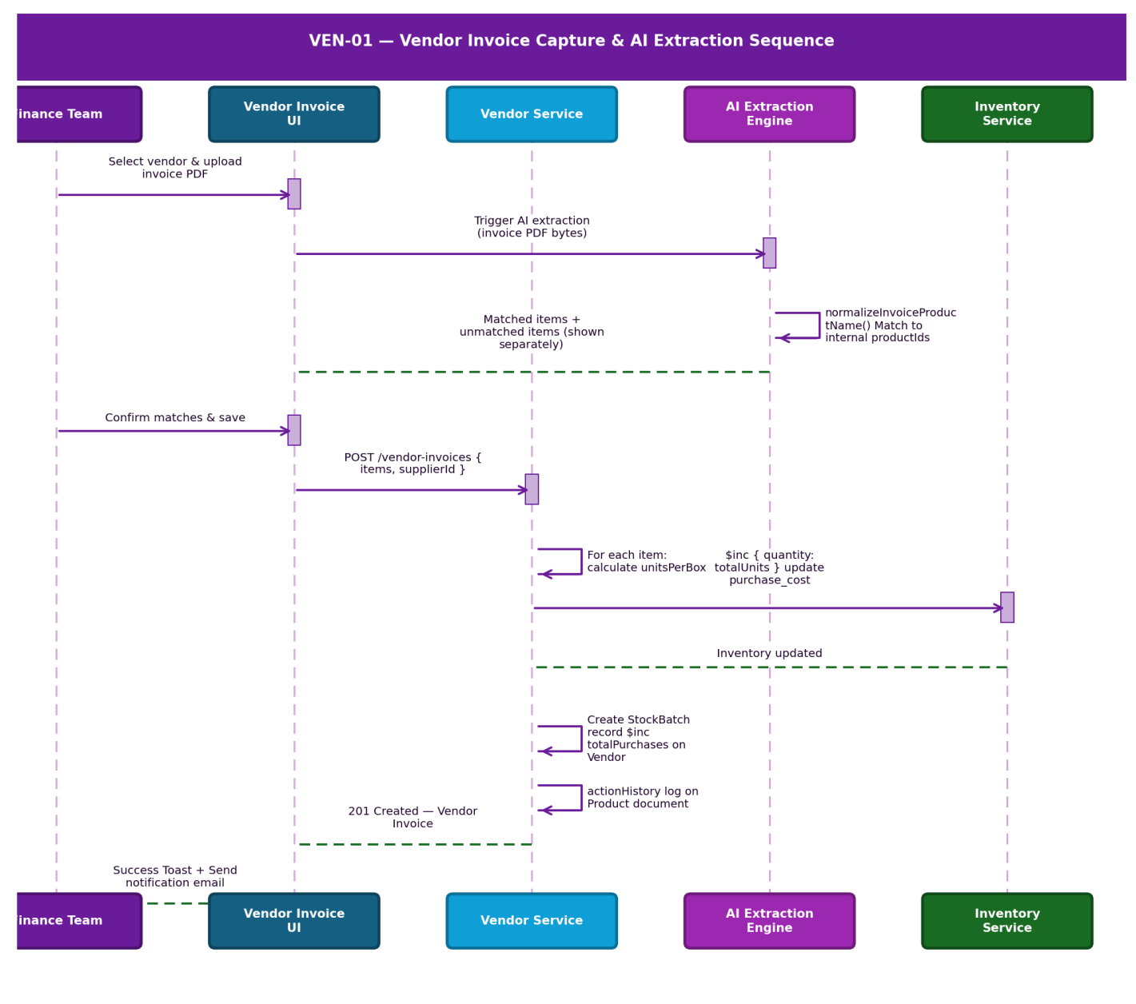
Figure 13.1 — VEN-01 Vendor Invoice Capture & AI Extraction Sequence Diagram

Invoice Capture — createVendorInvoiceService
- Item Processing: For each item, system calculates unitsPerBox. Increments Product model's inventory ($inc: { quantity: totalUnits }) and updates purchase_cost if changed.
- AI Invoice Extraction: Upon selecting a vendor and uploading a vendor invoice PDF, the AI engine extracts all products. Items already in the database are matched automatically; unmatched items are shown separately. Confirmed matches are saved for future automatic matching.
- ML Preparation: System runs normalizeInvoiceProductName to map vendor raw text names to internal productIds inside invoiceProductMappings.
- Lot Tracking: A StockBatch record is created for every line item.
- Audit Triggers: Any change to product cost or quantity triggers an immutable actionHistory log on the Product document.

Payout Engine — paytoVendor
- Single Payment: Can execute against a specific jobId with an amount and chequeNumber.
- Multi-Payment (Batching): Accepts a payments array, allowing Finance to cut a single physical cheque that satisfies multiple outstanding Service Jobs for the same subcontractor simultaneously.

Status Lifecycle
Status | Entry Criteria | Exit Criteria | Business Outcome
Draft | AP logs invoice. | Submitted for Approval | Work in progress.
Pending Approval | Invoice exceeds limit. | Manager Approves | Liability verified.
Unpaid | Approved, awaiting terms. | Payment Logged | Cash flow aging.
Partially Paid | AP logs < 100%. | Balance cleared. | Terms managed.
Paid | 100% funds disbursed. | N/A (Terminal) | Debt settled.
Disputed | Discrepancy found. | Resolved with Vendor. | Payment frozen.

14. DOC-01 — Project Documentation
Document Control
Version | Date | Author | Changes
1.0 | 2026-06-25 | Enterprise Architecture Team | Initial baseline specification.

The Project Documentation module (DOC-01) is the central knowledge repository and compliance archive for the AFC platform. It organises unstructured data (Contracts, Permits, Drawings, Site Photos, Rich Text notes) and binds them systematically to Customers, Jobs, and Quotes.

Tier 1 Mission-Critical Compliance System: If Project Documentation becomes unavailable: field crews dig without utility maps (risking catastrophic safety incidents); sales reps cannot reference historical contracts; the enterprise fails compliance audits.

Entity Binding
A single document (e.g., a 'Master Service Agreement') can be bound to Customer A, Quote Q-100, and Job J-200 simultaneously. The file exists once in the database (AWS S3), preventing version conflicts.

The 'Delete With Comment' Workflow
The Problem: A disgruntled employee deletes a crucial legal permit.
The Solution: A document is never physically deleted. The deleteDocumentation service sets isDeleted: true, deletedAt: new Date(), and captures the exact deletionReason provided in the DeleteWithCommentModal. An entry is forcibly pushed to the UpdateAuditModel.

Access Governance & RBAC Inheritance
- Direct Access: Users see documents they created, documents explicitly shared with them (sharedUsers), or documents shared with their role (sharedRoles).
- Inherited Access: checkInheritedPermission recursively traverses up the CategoryModel tree. If they can view the parent folder, they inherit view access to the document.
- View-Only Locking: If a document is shared with enableViewAccess: true, the updateDocumentation service throws a 403 error blocking edits.

Business Scenarios
Scenario 1 — Municipal Permit Management: Operations secures Dig-Safe permit → Uploads PDF → Categorises as 'Permits' → Binds to Job #404 → Field Crew arrives on site, opens mobile app, views Permit, begins safe digging.
Scenario 2 — Contract Dispute Resolution: Customer disputes quoted price 6 months later → Sales Manager opens DOC-01 → Filters by Customer & 'Contracts' → Retrieves digitally signed PDF → Emails customer → Dispute resolved instantly.

15. NOT-01 — Notification Management
Document Control
Version | Date | Author | Changes
1.0 | 2026-06-25 | Enterprise Architecture Team | Initial baseline specification.

The Notification Management module (NOT-01) orchestrates all internal communication, alerts, and task-tracking within the AFC platform. It dictates a 'Publish/Subscribe' architecture that allows the system to route operational events strictly to the users or roles that have explicitly subscribed to them.

15.1 Subscription Assignment Flow Diagram
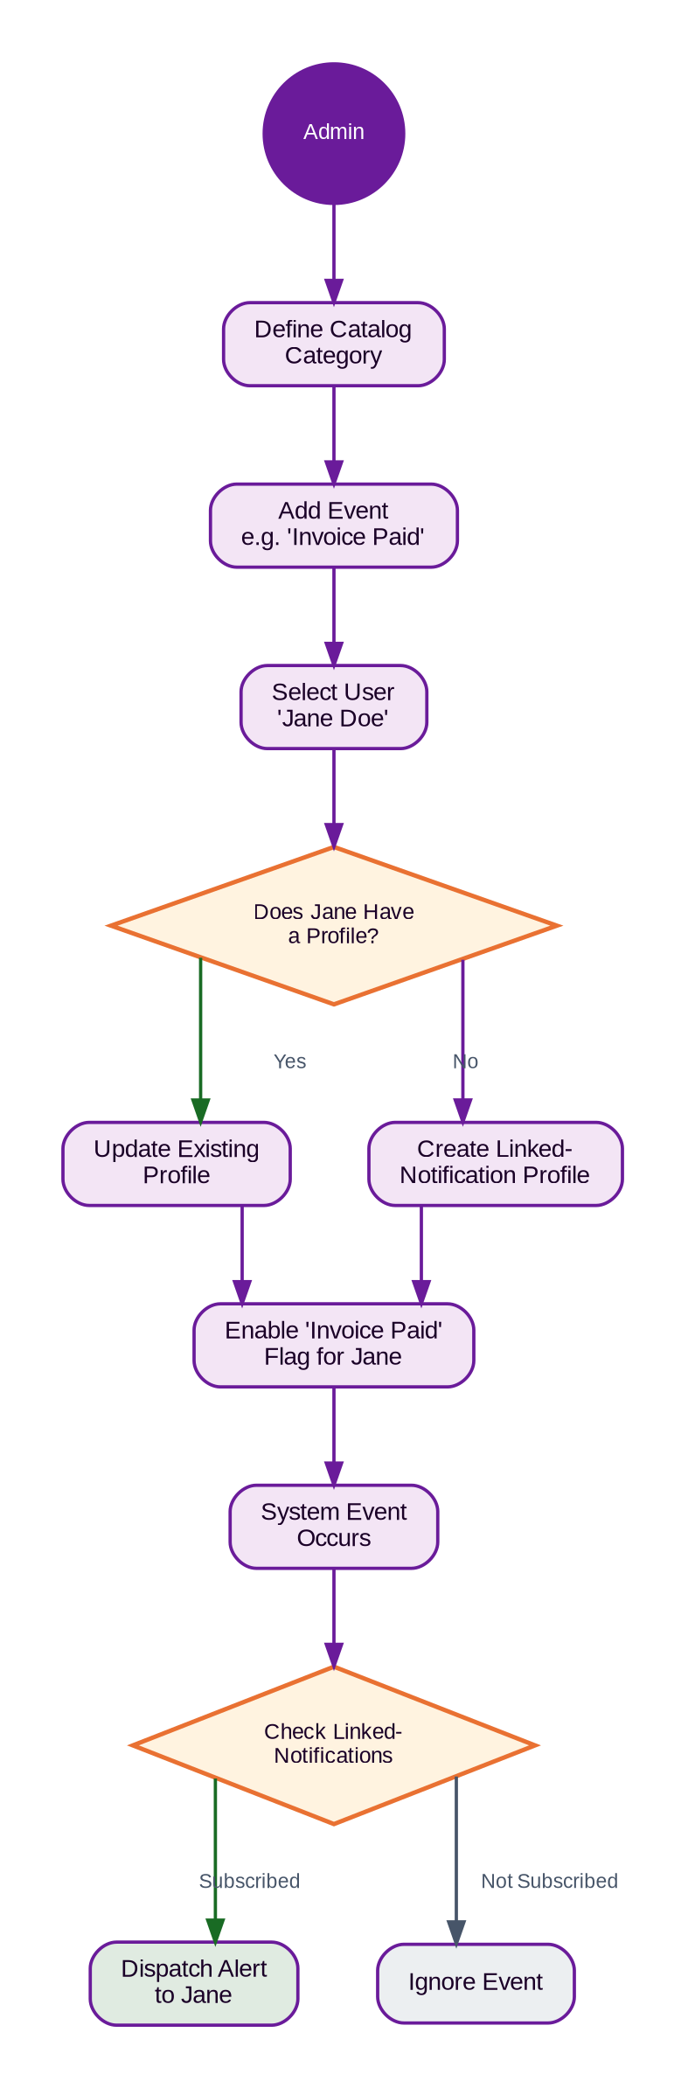
Figure 15.1 — NOT-01 Notification Subscription Assignment Flow Diagram

The Subscription Engine — linkedNotifications.controller.js
- Target Resolution: A subscription can target an explicit userId or a broader userRole.
- Uniqueness Constraint: A User or Role can only have ONE active LinkedNotification profile. Duplicate creation throws: 'Linked notification for this user already exists'.
- Event Resolution: The service cross-references ObjectIds against the Global Catalog to append human-readable eventName strings for the UI.

Productivity Engine — Reminders & Sticky Notes
- Reminders: Users generate reminders bound to their userId with states 'Pending' or 'Completed'. Completion halts any pending system alerts related to that task.
- Threaded Comments: Reminders support ongoing dialogue via addComment and removeComment.
- Sticky Notes: The getStickyNotes controller filters by the authenticated userId — users cannot view each other's private notes.

16. ACT-01 — Activity Audit Logging
Document Control
Version | Date | Author | Changes
1.0 | 2026-06-25 | Enterprise Architecture Team | Initial baseline specification.

The Activity Audit Logging module (ACT-01) is the global surveillance engine of the AFC platform. It captures, normalises, and aggregates telemetry across three primary channels: Internal Staff Operations (service), the B2B/B2C E-Commerce Portal (ecom), and the Public Marketing Website (static).

Telemetry Aggregation Engine
- User Forensics (getUserActivityLogs): Calculates deviceCount (unique ipHashes) and activeSessions (unique sessionIds). If deviceCount > 1 or activeSessions > 1, sets hasMultipleSystems: true — immediately alerting Administrators to potential credential sharing.
- Global Traffic Mapping (getActivityAnalytics): Enumerates dates over a 30-day window, calculating total apiCalls and uniqueUsers per day. Groups ipHash records to a physical Country.
- E-Commerce Screen Profiling (getEcomScreenWiseVisitors): Maps raw URL routes to friendly screen names (Pre-order, Cart, Checkout, Catalogue, Wishlist) using a custom $switch expression.
- Security Interception (trackStaticActivity): Captures public traffic (lacking JWT) via req.headers['x-forwarded-for'] or req.socket.remoteAddress.
- IP Hashing: Raw IPs are hashed into an ipHash for aggregation, ensuring PII identifiers are not exposed in UI dashboards.

17. CAT-01 — Catalog Management
Document Control
Version | Date | Author | Changes
1.0 | 2026-06-25 | Enterprise Architecture Team | Initial baseline specification.

The Catalogue Management module (CAT-01) governs the hierarchical structure of all physical products and billable services within the AFC platform. It dictates the three-tier taxonomy (Main Category → Subcategory → Product) and strictly enforces denormalised database constraints.

17.1 Three-Tier Architecture & Operations Workflow Diagram

Tier 1 — Main Category (maincategoryController.js)
- Purpose: Root classification (e.g., 'Fencing', 'Hardware').
- Logic: Simple CRUD. Enforces global uniqueness on categoryName to prevent UI duplication.

Tier 2 — Subcategory (subCategory.js)
- Integrity Validation: When creating a Subcategory, the controller checks MainCategory.findOne({categoryId}). If the parent does not exist, creation is hard-blocked with a 404 error.
- Denormalisation Array: The Subcategory schema contains a products array holding strings of its children's names.

Tier 3 — Product (productcontroller.js)
- Dual-Save: When a Product is created, the system saves the Product entity and pushes the new product name string into the parent scategory.products array.
- Update Propagation: If a product's name is updated, the controller performs an array-search on the Subcategory and rewrites the string index.
- Category Migration: If a product is moved to a different subcategoryId, the system pulls the string from the old parent and pushes it to the new parent.
- Hard Deletion Protection: When a product is deleted, the system pulls the orphaned product name from the parent Subcategory array, preventing 'Ghost Items'.

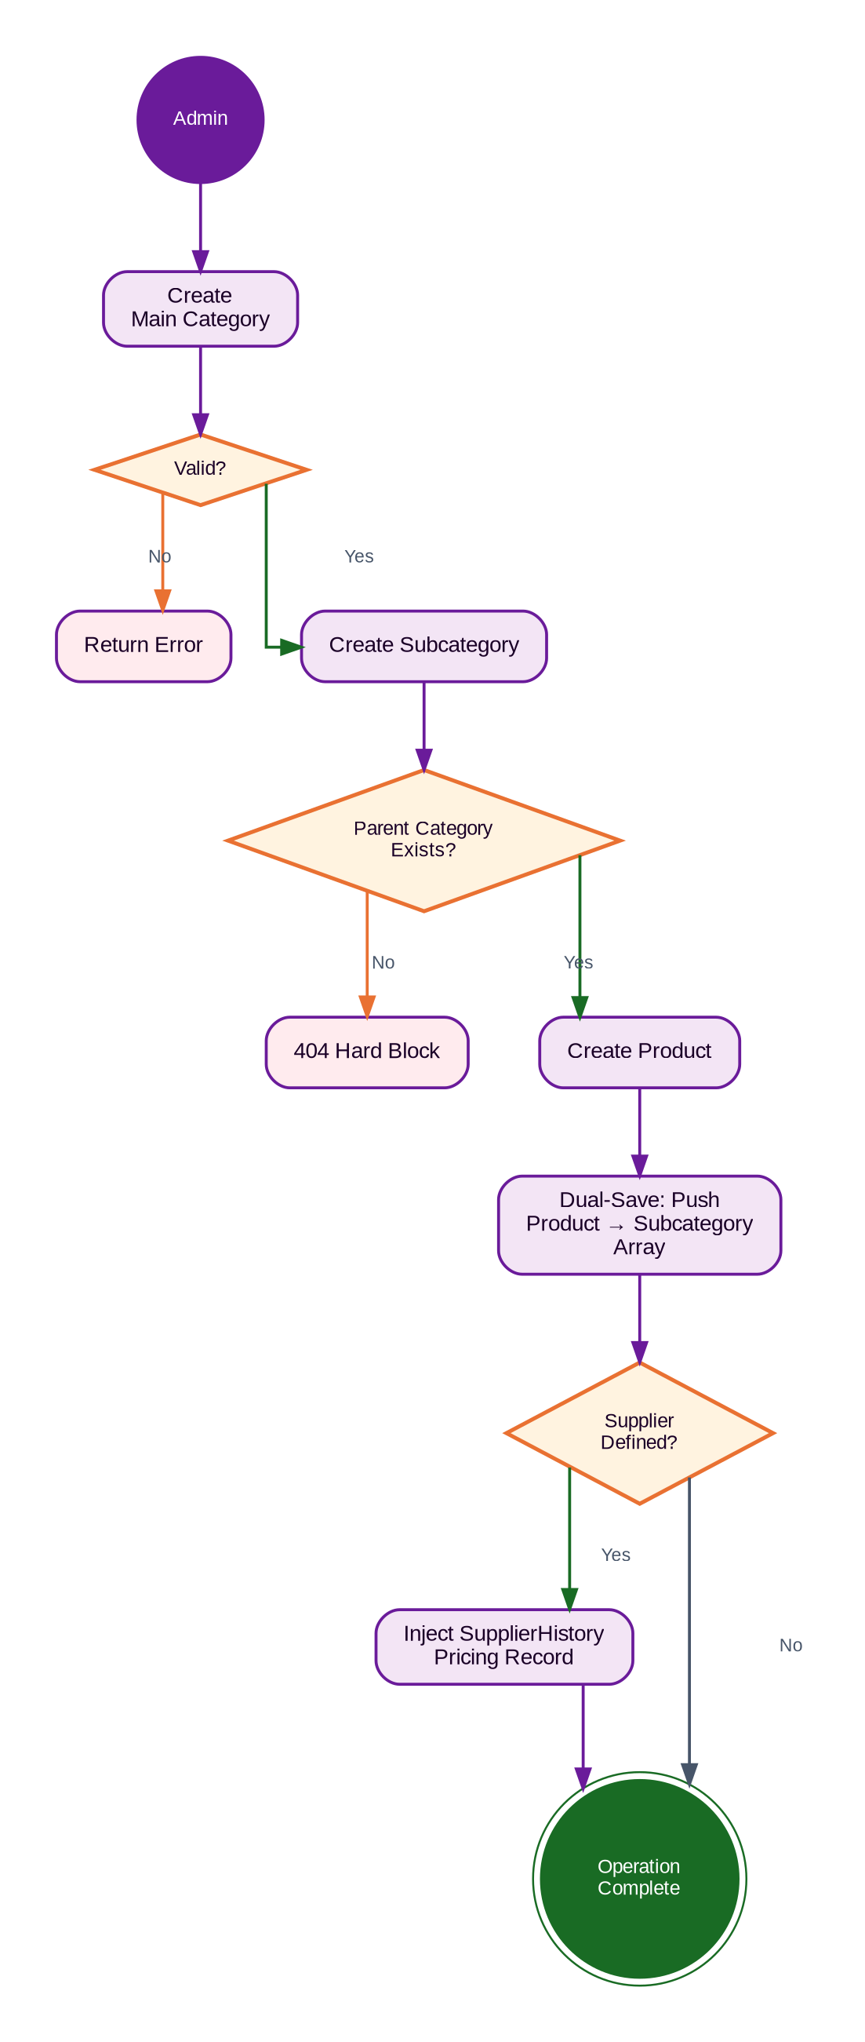
Figure 17.1 — CAT-01 Three-Tier Catalog Operations Workflow Diagram

18. TMP-01 — Template Management
Document Control
Version | Date | Author | Changes
1.0 | 2026-06-25 | Enterprise Architecture Team | Initial baseline specification.

The Template Management module (TMP-01) dictates the standardised formatting and pre-configured line items for outbound enterprise documents. This module allows estimators to generate complex, multi-line quotes instantly by binding reusable templates to specific parent Services.

Key Clarification: Templates differ from Products in that they are not bound to physical inventory items. A Template entry contains a description of service and unit price only — ideal for standardising billable labour and consultancy services that do not require inventory tracking.

Business Impact: Without this module: estimators would have to manually type out 50+ line-item quotes (increasing human error); standardised margins could be compromised due to forgotten baseline costs.

18.1 Template Architecture, Compliance & Sorting

Compliance Deletion Workflow — Soft Delete with Comment
- Physical Deletion is Blocked: The findByIdAndUpdate method is invoked rather than deleteOne.
- State Mutation: Sets isDeleted: true and logs the deletedAt timestamp alongside the deletedBy user ID.
- Mandatory Auditing: Captures the comments payload from the UI (defaulting to 'No comment provided' if bypassed).

The Reversion Protocol — restoreQuotationTemplateService
- Validation: Checks if (!template.isDeleted) throw new Error('Template is already active'); to prevent redundant database writes.
- Restoration: Nullifies the deletedAt and deletedBy fields, instantly reinstating the template for the sales team.

Advanced Backend Sorting — getQuotationTemplateService
- The Problem: Sorting by 'Created By' requires sorting by a user's First and Last name, but the template document only stores an ObjectId reference.
- The Solution: If sortBy === 'createdBy', the controller retrieves the entire collection (lean()), manually maps createdBy.firstname and lastname to a lowercased string, and executes a JavaScript localeCompare() sort.

