AFC Enterprise Product Handbook
Product Overview & Reference Guide
Date: 2026-06-25

Table of Contents
Note: If the Table of Contents below is empty, please right-click on it and select 'Update Field' to generate the page numbers.

1. About AFC Enterprise Product

Executive Project Description
The AFC Enterprise Product is a comprehensive, multi-tenant business operations and customer relationship management (CRM) platform designed to orchestrate the entire lifecycle of service delivery, procurement, and financial settlement. Engineered to standardize complex operational workflows, it unifies B2B/B2C lead ingestion, dynamic quotation templates, vendor payout management, and multi-tier catalog administration into a single, cohesive ecosystem.
Built with an audit-first philosophy, the platform provides deep-dive telemetry into user activities, precise vendor performance metrics (such as payment velocity and overdue liabilities), and strict procurement synchronization. By centralizing these disparate business functions, the AFC platform enables executive stakeholders to make data-driven decisions while ensuring strict compliance, operational transparency, and data governance across the organization.

Core Capabilities
- Centralized CRM & Sales: Streamlines the transition from marketing leads to formalized Service Jobs through an integrated Enquiry, Request, and Quotation pipeline.
- Enterprise Procurement: Automates Vendor tracking, Service Job linkage, and complex multi-payment orchestration.
- Unified Catalog: Maintains a strict three-tier taxonomy (Category -> Subcategory -> Product) mapped to historical supplier data.

Target Audience
- Super Admins & Managers: Platform console for organizational configuration, global subscription management, and systemic oversight.
- Sales & Estimators: Rapidly generate B2B quotes utilizing tax-exempt flags and service-bound templates.
- Finance & Procurement: Seamlessly process complex vendor invoices and monitor enterprise liabilities.

2. How the Platform Works

2.1 The Merchant & POS Core
The central nervous system for operational staff. Managers and owners utilize this module to manage the catalog, orchestrate inventory, assign field staff to jobs, and generate complex B2B financial workflows (Quotes and Invoices).

2.2 The Platform Console
The administrative dashboard for multi-tenant organizations. Facilitates the creation of global Notification architectures, Company branding profiles, and Role-Based Access Controls (RBAC).

ADM-01: User Management

Overview
The User Management module provides centralized control over the application's user directory. It governs the lifecycle of internal user profiles, including creation, role assignment, status toggling, deletion (soft), and restoration, enforcing strict hierarchical permission boundaries.

Purpose
To securely manage workforce access to the AFC ecosystem, ensuring that employees are assigned the correct roles, permissions, and system contexts to perform their daily operational duties while preventing unauthorized escalations.

Business Objectives
- Facilitate the onboarding and offboarding of employees.
- Enforce a strict Role-Based Access Control (RBAC) hierarchy.
- Prevent accidental self-deletion or unauthorized role escalation.
- Maintain a comprehensive audit trail of all user directory modifications.

Module Scope
This module covers the `/users` list view, the `/users/create` and `/users/edit` forms, role-level validations, "deleted" view filtering, and user restoration capabilities. It does not govern external customer portals or public authentication routing.

Business Impact
If the User Management module becomes unavailable or compromised:
- Terminated employees cannot be immediately locked out, creating severe security risks.
- Role-based escalations or demotions cannot be processed, stalling operations.
This module is a Tier 1 Critical System.

Other Module Dependencies
- AUT-01 - Login: User profiles created here determine the credentials evaluated during authentication.
- ADM-02 - Company Profile: Users are bound to the active tenant environment.
- GLB-06 - Activity Timeline: All user mutations generate tracking events.

Security Considerations
- Hierarchical Role Editing: A user can only edit roles that have a strictly lower hierarchy level than their own, preventing privilege escalation.
- Self-Deletion Prevention: The UI and backend explicitly block users from deleting their own active session profile.
- Soft Deletion: "Deleted" users are flagged as `isDeleted: true` rather than physically dropped from the database, preserving historical audit trails on related jobs and invoices.

Complete User Journeys

Create New User (`signup` API)
1. User Action: Admin clicks "Create User" and submits the form on `/users/create`.
2. Front end Validation: Evaluates inputs. Checks role against assignable hierarchy.
3. API Call (`POST /api/v1/users/signup`):
Back end extracts `username` from `req.body`.
Validation: Checks `User.findOne({username})`. If exists, returns `409 Username is already Exist`.
Database Update: Calls `User.create(req.body)`.
Auto-Processing: Generates JWT token via `signToken(newUser.username, newUser.role)`.
4. Final Outcome: Returns 201 Created with JWT and user object. UI redirects to `/users`.

Edit User Role / Details (`updateUser` API)
1. User Action: Admin clicks Edit and submits changes on an existing user.
2. API Payload: Sends `existusername` (the original username) and the updated payload.
3. Backend API (`updateUser` in `user-controller.js`):
Finds user: `User.findOne({ username: existusername })`. Returns 400 if not found.
Username Change Validation: If `username` is provided and !== `existusername`, checks if the new `username` is already taken. If so, returns 400 "The new username is already in use".
Database Update: Calls `User.findOneAndUpdate({ username: existusername }, req.body)`.
4. Final Outcome: Returns 200 OK. UI updates table.

Delete User
1. User Action: Admin executes delete action.
2. API Payload: Sends `{ existusername }` in `req.body`.
3. Backend API (`deleteUser` in `user-controller.js`):
Finds user: `User.findOne({ username: existusername })`.
Database Update: Executes `User.findOneAndDelete({ username: existusername })`.
There is soft-delete `isDeleted` flag updated here as true.
4. Final Outcome: Returns 200 with "User Deleted Successfully !".

Toggle User Status
1. User Action: Admin updates a user's status to "InActive".
2. API Call (`updateRole` in `user-controller.js`):
Payload: `{ username, role, userActive }`.
Database Update: `User.findOneAndUpdate({ username }, { username, role, userActive })`.
System Impact: During login, `exports.login` checks `if (user.userActive === false)`. If false, login is blocked with "Your Account is Deactivated".

Workflow Diagram
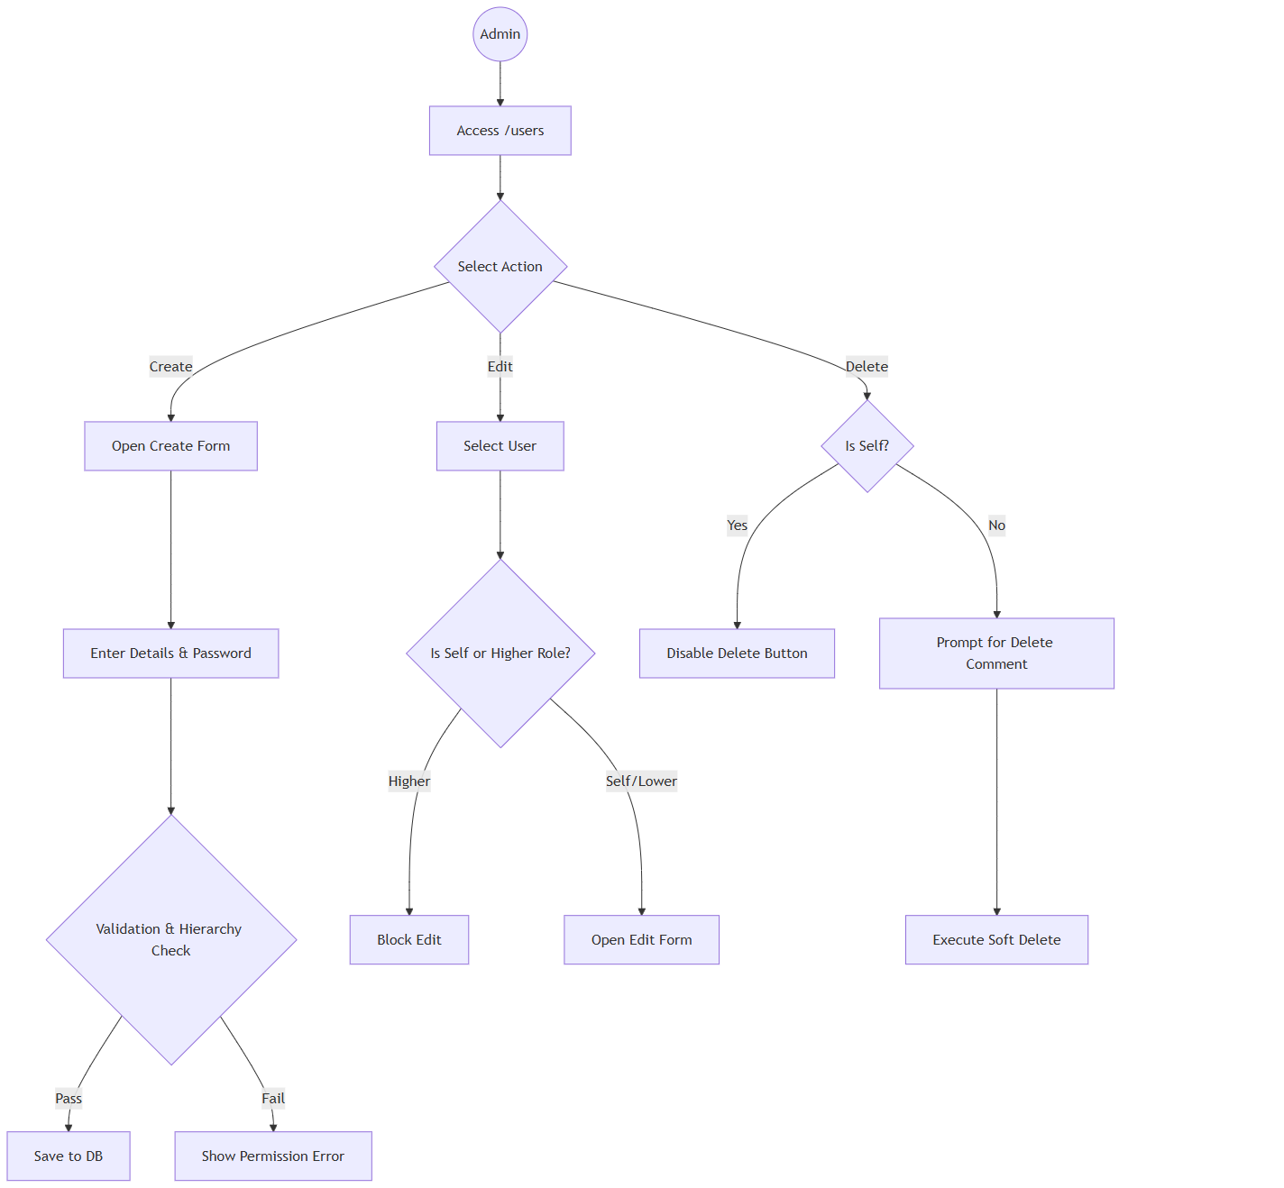
Start((Admin)) --> A[Access /users]
A --> B{Select Action}
B -- Create --> C[Open Create Form]
C --> D[Enter Details & Password]
D --> E{Validation & Hierarchy Check}
E -- Pass --> F[Save to DB]
E -- Fail --> G[Show Permission Error]
B -- Edit --> H[Select User]
H --> I{Is Self or Higher Role?}
I -- Higher --> J[Block Edit]
I -- Self/Lower --> K[Open Edit Form]
B -- Delete --> L{Is Self?}
L -- Yes --> M[Disable Delete Button]
L -- No --> N[Prompt for Delete Comment]
N --> O[Execute Soft Delete]

Sequence Diagram (System Interactions)
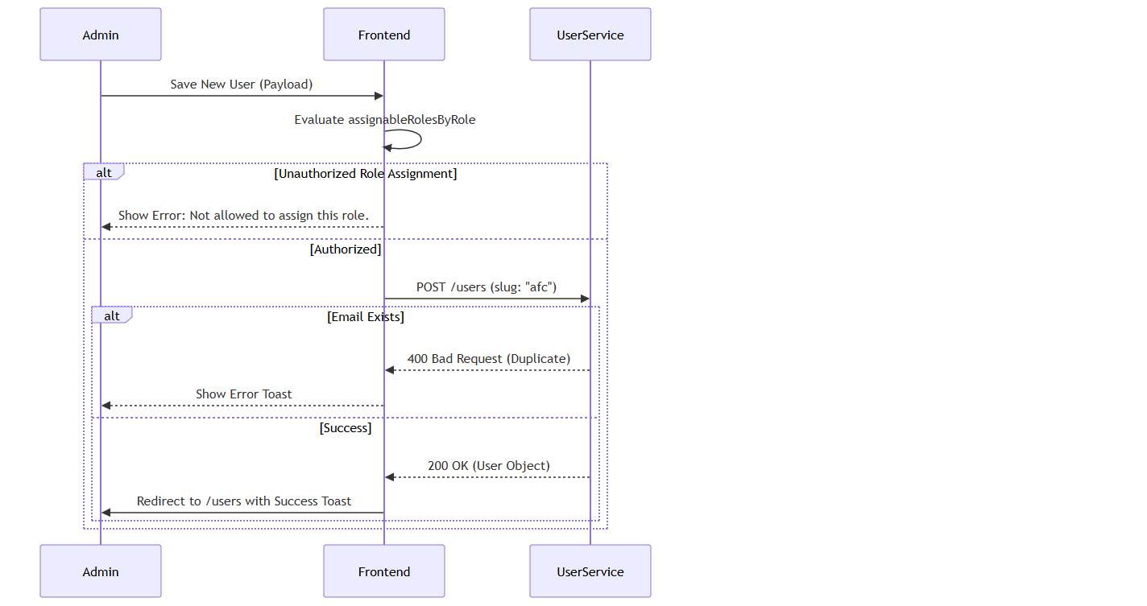
sequenceDiagram
participant Admin
participant Frontend
participant UserService

Admin->>Frontend: Save New User (Payload)
Frontend->>Frontend: Evaluate assignableRolesByRole
alt Unauthorized Role Assignment
Frontend-->>Admin: Show Error: Not allowed to assign this role.
else Authorized
Frontend->>UserService: POST /users (slug: "afc")
alt Email Exists
UserService-->>Frontend: 400 Bad Request (Duplicate)
Frontend-->>Admin: Show Error Toast
else Success
UserService-->>Frontend: 200 OK (User Object)
Frontend->>Admin: Redirect to /users with Success Toast
end
end

Screen Catalogue: User Management

11.1 User List Screen
- Business Purpose: Central dashboard for managing the internal directory.
- Navigation Path: `/users`
- Screen Layout: Top Action Bar (Search, Role Filter, Date Filter, Status Toggle). Main Data Table. Pagination Footer.
- Buttons: "Create User", Action Icons (History, Edit, Delete).
- Loading States: Skeleton loaders during API fetch.
- Empty States: "No users found" with illustration.
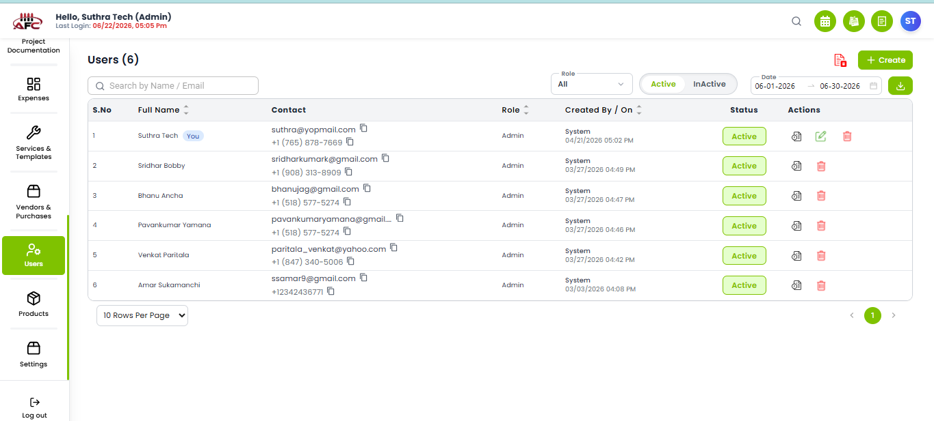
Figure: User List Mockup

Create/Edit User Screen
- Business Purpose: Form to input user profile metadata.
- Navigation Path: `/users/create` or `/users/edit/:id`
- Available Actions: Save, Update, Cancel.
- Validation Behavior: Inline red helper text for required fields or invalid emails.

UI Component Catalog
Component: `UserForm`

Fields
1. Username (Email)
Editable Conditions: Editable during creation. During updates, the original username is sent as `existusername` to allow the backend to track username modifications.
Validation Rule: Must be unique in the `User` collection. If changed to an existing username, backend throws 400.
2. Role
Editable Conditions: Editable by higher-hierarchy users.
Auto-Processing: Used in the JWT token generation (`signToken(username, role)`) and parsed by `exports.restrict(...role)` middleware to guard protected API routes.
3. Status (userActive)
State Bound: `userActive` boolean.
Auto-Processing: Setting to `false` does not delete the user, but prevents the `login` and `loginWithPhone` controllers from issuing a new JWT.

Buttons & Actions
1. Save User Button
API Bound: Triggers `signup` or `updateUser` / `updateRole` based on form context.
2. Delete User Action
API Bound: Triggers `POST` to `deleteUser`.
Auto-Processing: Physically drops the record from the MongoDB collection (`findOneAndDelete`). No soft-delete logic is executed on the backend.

Business Actions

Toggle User Status
- Business Purpose: To temporarily suspend a user without deleting their profile.
- Trigger: Changing the Status toggle in the Edit form to "InActive".
- Business Outcome: User's JWT tokens are invalidated by the backend, immediately preventing login.

14. System & Business Rules
- Hierarchy Verification:
Super Admin (Level 4) can assign/edit: Admin, Manager.
Admin (Level 3) can assign/edit: Manager
- Self-Edit Exception (Not Implemented): A user can always edit their own profile (First Name, Last Name), but the system locks the "Role" and "Status" fields to prevent self-escalation or self-suspension.

Notifications Matrix
Trigger | Recipient | Message Template | Severity | Delivery Channel | Audit Impact
Create Success | Admin | "User created successfully" | Success | UI Toast | Logs Create event.
Delete Success | Admin | "User deleted successfully" | Success | UI Toast | Logs Soft Delete with Note.
Role Error | Admin | "You are not allowed to edit this user role." | Error | UI Toast | Null

Permissions Matrix
Action | Super Admin | Admin | Manager
View Users List | Yes | Yes | Yes
Create User | Yes | Yes | Yes
Edit Own Profile | Yes | Yes | Yes
Delete User | Yes | Yes | Yes
Restore User | Yes | Yes | No

Audit Trail
The following events are recorded centrally for security and compliance:
- User Created: Timestamp, Creator ID, Initial Role.
- User Updated: Changes to Email, Role, or Status.
- User Deleted: Deletion timestamp, Executing Admin ID, Mandatory Delete Comment.

Accessibility
- Status Badges: Use explicit text ("Active" vs "InActive") combined with color (Green/Red) to support color-blind users.

Configuration
- System Roles: Enums configured in `global.constants.ts` (`super_admin`, `admin`, `manager`).

Real Business Scenarios
- Scenario A (Offboarding): A Manager resigns. The Admin opens the User List, searches for the Cashier, clicks Delete, and types "Resigned on 10/12". The user is instantly locked out, but their name remains on all historical Invoices.
- Scenario B (Permission Block): A Manager attempts to create a new "Admin" account. The system evaluates the hierarchy, sees Manager (Level 2) < Admin (Level 3), and removes "Admin" from the available dropdown options.

Business Glossary
- RBAC: Role-Based Access Control.
- Soft Delete: Hiding a record from active views without destroying the underlying database row.
- Hierarchy Level: The mathematical weight assigned to a role (e.g., Super Admin = 4, Cashier = 1).

Traceability References
- Code Evidence: `g:/AFC/afc_react_fe/src/features/users/pages/UserList.tsx`
- Code Evidence: `g:/AFC/afc_react_fe/src/features/users/pages/CreateUser.tsx`
- Code Evidence: `g:/AFC/afc_react_fe/src/constants/global.constants.ts`
- Module Matrix: `ADM-01`

AUT-01: Authentication & Login Management

Overview
The Authentication & Login Management module acts as the primary security gateway for the AFC Enterprise Application. It governs user access, session instantiation, role determination, and global multi-tenant context initialization.

Business Purpose
To securely authenticate authorized users, protect sensitive business data, and automatically load the appropriate organizational context (Company Profile) and user permissions prior to dashboard access.

Business Objectives
- Ensure secure, encrypted credential validation.
- Prevent unauthorized access to the application routes.
- Establish a global user session that dictates subsequent system privileges.
- Retrieve and bind the Tenant (Company) profile for data segregation.

Module Scope
This module covers the initial entry point of the application (`/login`), credential validation API interactions, session cookie establishment, Redux state hydration, and the immediate routing to the Dashboard.

Business Impact
If the Authentication module becomes unavailable:
- No user can access the system.
- Dashboards are entirely unavailable.
- Request and Quote processing halts.
- Job execution tracking halts.
- Invoicing and POS transactions cannot be processed.
- Administration and reporting become inaccessible.
This module is a Tier 1 Critical System.

Other Module Dependencies
Upstream Dependencies (Required to Login)
- ADM-01 - User Management: Dictates the active status and credentials of the user.
- ADM-02 - Company Profile: Provides the tenant context required to route data.
- Authentication API: The back end verification service.
Downstream Dependencies (Impacted by Login)
- CRM-01 - Dashboard: The landing zone post-login.
- CRM / SAL / JOB / INV: All subsequent business workflows rely on the session token generated here.
- ADM-08 - Activity Logs: Audit history depends on the User ID extracted during authentication.

Security Considerations
- Password Storage: Encrypted at rest using secure hashing algorithms (Back end). Client-side "Remember Me" utilizes simple encoding and should be migrated to secure cookie storage.
- JWT Expiration: Tokens are cryptographically signed with explicit expiration horizons.
- Cookie Security: `auth_token` is stored in cookies to persist sessions across browser tabs.
- Session Timeout: If the JWT expires, the API responds with 401 Unauthorized, prompting a forced system logout.
- Brute Force Protection: Managed backend-side via request throttling to prevent rapid password guessing.
- Account Lock Policy: Enforced after consecutive failed attempts.

Reverse-Engineered User Interactions

Execute Login Sequence
Documenting the exact execution flow when a user clicks the "Login" button.
1. User Action: Clicks "Login" button on `/login`.
2. Front end Validation (`LoginForm.tsx`):
Validates `username` using `Yup` email regex (`/^[^\s@]+@[A-Za-z]{3,}\.[A-Za-z]{2,}$/`).
Validates `password` minimum length (6 characters).
3. Local Storage (Remember Me):
If `rememberMe` is checked, stores `rememberedUsername` and encrypts password using `btoa(unescape(encodeURIComponent(text)))`. Stores `rememberMe="true"`.
If unchecked, removes these keys from `localStorage`.
4. API Payload Construction:
`{ username: "...", password: "..." }`
5. Backend API (`POST /api/v1/users/login` in `user-controller.js`):
Checks if `username` and `password` are present (returns 400 if missing).
Queries DB: `User.findOne({ username }).select("+password")`.
Verifies password using `user.comparePasswordInDB`.
Checks `user.userActive === false` (Returns 400 "Your Account is Deactivated" if false).
6. JWT & Tenant Configuration (`signToken`):
Backend queries the `Companies` model: `await Companies.findOne().lean()`.
Reads tenant-specific `tokenExpireTime` from the Company profile.
If exists, sets `expiresIn = ${company.tokenExpireTime}h`. Fallback is `process.env.LOGIN_EXPIRES` or "24h".
Signs JWT payload with `{ username, role }` using `process.env.SECRET_STR`.
7. Return Response:
Sends 200 OK with `token` and `user` object (password removed).
8. Frontend State Hydration:
Stores token in cookies/localStorage.
Dispatches Redux actions to store User and Company Profile context.
9. Dashboard Navigation:
Redirects user to `/dashboard`.

Forgot Password Sequence
1. User Action: Clicks "Forgot Password?" link.
2. Frontend Validation: Form checks email format.
3. API Call (`POST /api/v1/users/forgotPassword`):
Queries DB for email: `User.findOne({ email })`.
Generates random reset token using `user.createResetPasswordToken()`.
Constructs reset URL: `${req.protocol}://${req.get("host")}/api/v1/users/resetPassword/${resetToken}`.
4. Email Dispatch (`sendEmail` utility):
Sends email with subject "Password change request received". Expires in 10 mins.
5. Database Update:
Saves `passwordResetToken` and `passwordResetTokenExpires` to the User document.
6. Frontend Outcome: Displays success toast to user.

WorkflowDiagram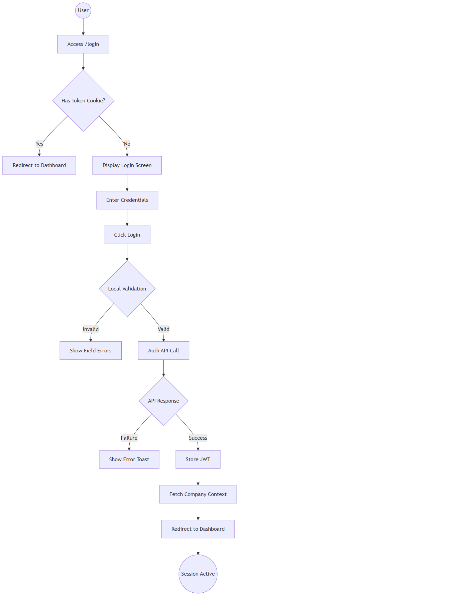
Start((User)) --> A[Access /login]
A --> B{Has Token Cookie?}
B -- Yes --> C[Redirect to Dashboard]
B -- No --> D[Display Login Screen]
D --> E[Enter Credentials]
E --> F[Click Login]
F --> G{Local Validation}
G -- Invalid --> H[Show Field Errors]
G -- Valid --> I[Auth API Call]
I --> J{API Response}
J -- Failure --> K[Show Error Toast]
J -- Success --> L[Store JWT]
L --> M[Fetch Company Context]
M --> N[Redirect to Dashboard]
N --> End((Session Active))

Sequence Diagram (System Interactions)
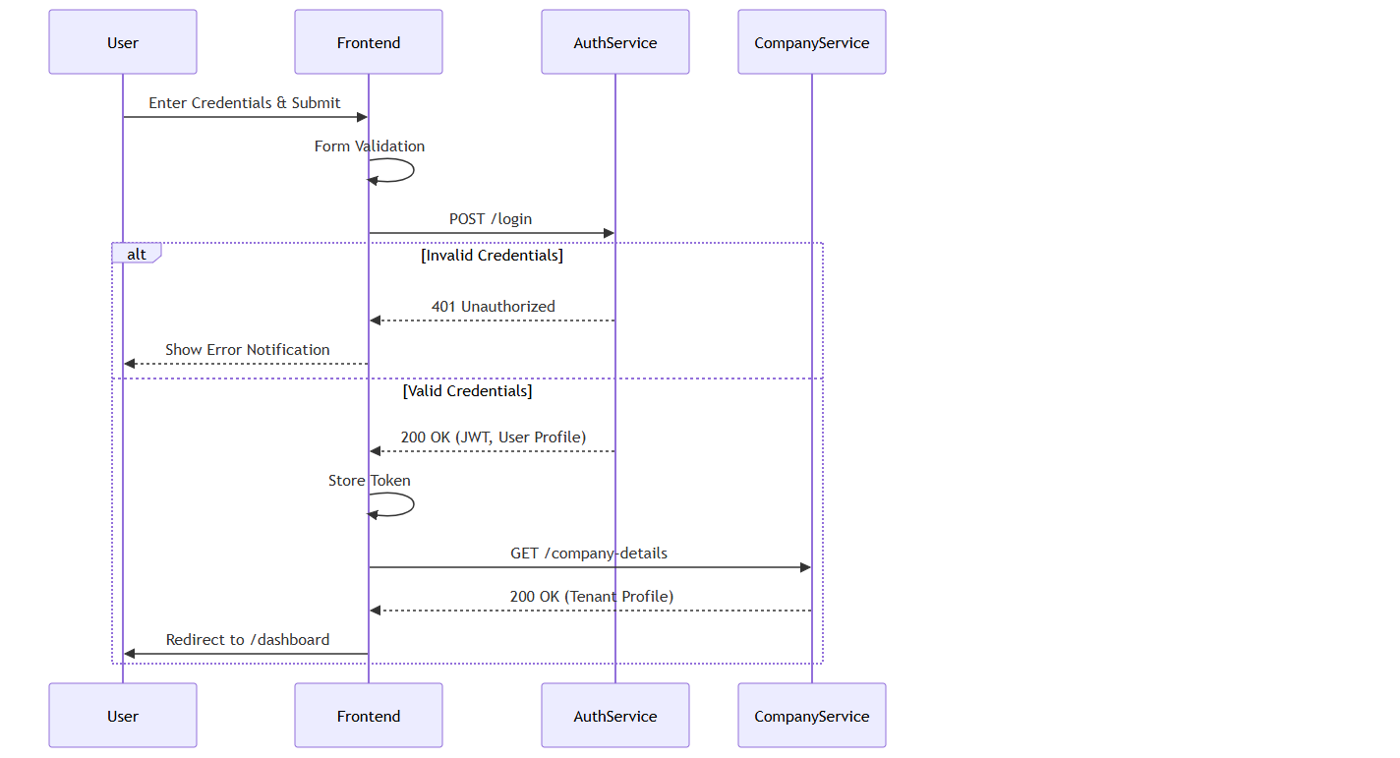
sequenceDiagram
participant User
participant Frontend
participant AuthService
participant CompanyService

User->>Frontend: Enter Credentials & Submit
Frontend->>Frontend: Form Validation
Frontend->>AuthService: POST /login
alt Invalid Credentials
AuthService-->>Frontend: 401 Unauthorized
Frontend-->>User: Show Error Notification
else Valid Credentials
AuthService-->>Frontend: 200 OK (JWT, User Profile)
Frontend->>Frontend: Store Token
Frontend->>CompanyService: GET /company-details
CompanyService-->>Frontend: 200 OK (Tenant Profile)
Frontend->>User: Redirect to /dashboard
end

Screen Catalogue: Login Page
- Business Purpose: Secure credential collection.
- Navigation Path: `/login`
- Screen Layout: Centered white card on a light background.
- Header/Branding: Corporate Logo. Tagline: "Your trusted partner for fencing solutions."
- Buttons: Primary "Login" button. Visibility toggle on password.
- Links: "Forgot Password?".
- Loading States: Login button disables and shows progress spinner when submitting.
- Error States: Top red banner displays API rejection messages. Inline field errors.
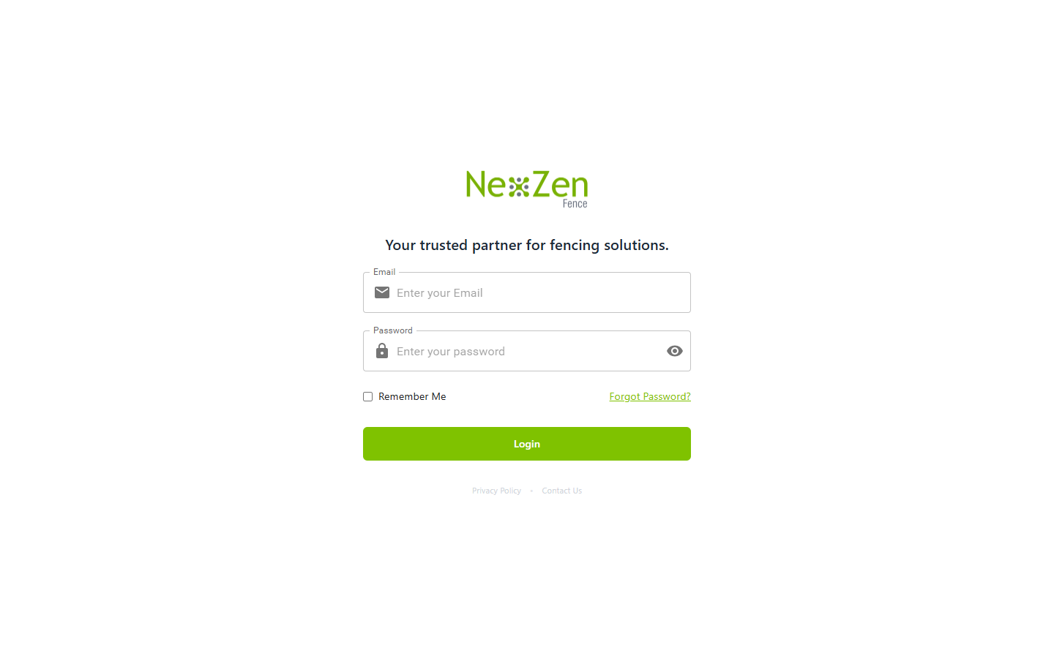

Figure: Login Screen Mockup

UI Component Catalog
Component: `LoginForm.tsx`

Fields
1. Email (Username)
State Bound: `formik.values.username`
Validation Rule: Must match standard Email regex (`/^[^\s@]+@[A-Za-z]{3,}\.[A-Za-z]{2,}$/`). Note: Phone regex is currently commented out in source code (`// phoneRegex.test(value)`).
Auto-Processing: If user types numbers and length > 10, the input rejects further keystrokes (`if (/^\d$/.test(value) && value.length > 10) return;`).
2. Password
State Bound: `formik.values.password`
Validation Rule: Minimum 6 characters. Required.
UI Interaction: Includes a toggle button to switch `type` between "password" and "text" using the `showPassword` state.
3. Remember Me (Checkbox)
State Bound: `rememberMe`
Auto-Processing: On submit, if true, executes simple Base64 `encrypt()` on password and stores it in browser `localStorage` along with username.

Buttons & Links
1. Login Button
Visible Conditions: Always visible.
Permissions: Public.
Action Bound: `formik.handleSubmit`.
Auto-Processing: Disables itself and shows `<CircularProgress />` when `isLoading` is true.
2. Forgot Password? Link
Visible Conditions: Always visible.
Action Bound: React Router `<CustomLink>` routing to `/forgot-password`.

Business Actions

Execute Login
- Business Purpose: Authenticate user against the directory.
- Trigger: Click "Login" button.
- Permissions: Public.
- Validation: Form validates inputs before dispatch.
- Business Outcome: JWT received, Company Context hydrated, user granted access.

System & Business Rules
- Tenant Context Initialization: During authentication, the application automatically associates the user with the correct company environment to ensure that all subsequent data access is restricted to that organization's records. The current implementation is configured for a single tenant ("AFC"). Future SaaS deployments should support dynamic tenant selection without requiring application-specific builds.
- Pre-flight Error Cleanup: Navigating away from the page instantly flushes errors so stale alerts don't persist on return.

Notifications Matrix
Trigger | Recipient | Message Template | Severity | Delivery Channel | Retry Behavior | Audit Impact
Success | User | "Login Successful! Welcome back!" | Success | UI Toast | N/A | Logs success event.
Failure | User | Dynamic API Reason | Error | UI Toast & Banner | Manual Retry | Logs failure event.

Permissions Matrix
Action | Super Admin | Admin | Manager
View Login | Yes | Yes | Yes
Execute Login | Yes | Yes | Yes
Logout | Yes | Yes | Yes
Use "Remember Me" | Yes | Yes | Yes
Forgot Password | Yes | Yes | Yes
Reset Password | Yes | Yes | Yes
View Company Context | Yes | Yes | Yes

Audit Trail
The following events are recorded centrally for security and compliance:
- Successful Login
- Failed Login / Unauthorized Access Attempt
- Logout
- Session Expiry
- Password Reset
- Remember Me Enabled
- IP Address & Device Capture

Accessibility
- Keyboard Navigation: Fully supported (Tab to navigate fields, Enter to submit).
- Screen Readers: ARIA labels applied to password visibility toggle.
- Focus Management: Input fields outline with primary brand color on focus.

Configuration
- Password Policy: Managed via backend configurations.
- Session Timeout: JWT Expiry duration (Back end).
- Tenant Slug: "AFC" (Front end) based on company .
- Redirect URL: `/dashboard` (Frontend).

Real Business Scenarios
- Scenario A (First Time User): An Admin receives their credentials. They log in, view the success notification, and immediately see the dashboard populated with AFC data.
- Scenario B (Invalid Credentials): A user fat-fingers their password. The UI instantly prevents access, logs the failed attempt for security auditing, and shows an error banner.
- Scenario C (Network Failure): A user loses Wi-Fi while submitting. The system times out after 30 seconds and cleanly displays a retry prompt.

Business Glossary
- JWT: JSON Web Token used for secure transmission of authentication claims.
- Tenant / Company Context: The specific organizational boundary isolating business data.
- Session: The active period of authorized engagement with the application.
- Authentication: Verifying user identity.
- Authorization: Verifying user access privileges.

Traceability References
- Code Evidence: `g:/AFC/afc_react_fe/src/features/auth/pages/LoginPage.tsx`
- Code Evidence: `g:/AFC/afc_react_fe/src/features/auth/components/LoginForm.tsx`
- Module Matrix: `AUT-01`

CMP-01: Company Profile & Configuration

Overview
The Company Configuration module (CMP-01) is the global settings engine of the AFC platform. It dictates how the multi-tenant architecture identifies the specific enterprise, calculates delivery feasibility via Google Maps, secures public payment keys, and maintains an immutable audit trail of critical operational settings.
This module governs the enterprise's root configuration. It details the `Company-controller.js` logic including multi-tenant database provisioning, the Google Maps API distance calculator, and the `UpdateAuditModel` integration for configuration tracking.
- Key Business Value: Centralizes global variables (taxes, delivery radii, branding) ensuring consistency across all operational modules.
- Primary Users: Admins
- Critical Success Factor: Maintaining absolute separation of sensitive payment gateway keys while exposing active payment methods to public front ends.

Business Purpose
To provide a secure, centralized configuration hub that dictates how the AFC platform behaves operationally, financially, and visually for a specific tenant without requiring code deployments.

Module Scope
This module encompasses:
- Tenant Creation & Initialization
- Global Profile Data (Address, Contact, Logo)
- Delivery Distance Gating (Google Maps Routing)
- Secure Payment Gateway Configuration
- Immutable Configuration Audit Trail

Global Configuration Matrix
The system tracks 20 distinct business-critical fields. Modifying any of these fields triggers an immediate audit log to prevent unapproved operational shifts.
Configuration Category | Tracked Fields | Business Impact
Identity & Branding | `companyName`, `email`, `phone`, `logo`, `colorTheme` | Customer-facing documents and portal UI.
Operational Logistics | `deliveryDistance`, `address`, `startTime`, `endTime`, `timezone` | Validating online enquiries
Financial Settings | `creditCardTax`, `payment_settings`, `zelleConfig` | Surcharges on payments and active gateways.
Legal Compliance | `paymentTermsAndConditions`, `quoteTermsAndConditions`, `invoiceTermsAndConditions` | Legally binding text rendered on PDFs.

Delivery Gating Engine (`CheckAddress`)
The system prevents out-of-bounds orders by strictly validating customer addresses against the company's defined `deliveryDistance`.

Google Maps Route Computation
When a customer attempts to book a service or request a quote, the `CheckAddress` controller intervenes:
1. Origin Calculation: Extracts the company's physical address.
2. Destination Evaluation: Evaluates the target string or `lat/lng` payload.
3. API Dispatch: Dispatches a `POST` request to `routes.googleapis.com/directions/v2:computeRoutes` using `travelMode: "DRIVE"`.
4. Feasibility Check: Converts meters to miles. If the driving distance exceeds `company.deliveryDistance`, the API strictly returns `isDeliverable: false` and a rejection message.

Secure Payment Configuration (`getActivePaymentsOptim`)
AFC supports multiple payment modalities (Zelle, Bank Transfer, Credit Card).

Key Scrubbing Architecture
Public portals (like Quote Acceptance) need to know which payment methods are active, but must never be exposed to the private API keys.
- The backend iterates over `paymentTypes`.
- For every active method, the `sanitizeConfig` method aggressively strips `secret_key`, `private_key`, and `password` from the JSON object before returning it to the frontend.
- Business Result: Public frontends can safely render the correct payment UI without risking API credential leakage.

Immutable Audit Trail (`getCompanyHistory`)
Modifying global variables is dangerous. The system enforces strict accountability.

Multi-Tenant Auditing
- When `updateCompanyDetails` fires, the backend dynamically connects to the tenant's specific `UpdateAuditModel`.
- It iterates through the 20 tracked fields using a `valuesDiffer` comparator.
- If a change is detected (e.g., `deliveryDistance` changed from `50` to `75`), it pushes an immutable log containing `updatedBy`, `changedFields`, and `previousValues`.
- The `getCompanyHistory` controller synthesizes this raw JSON into a human-readable timeline for Administrators to review.

Tenant Provisioning Workflow
When a new enterprise is onboarded (`createCompany`):
1. Validation: Mandates Company Name, Email, Phone, and Admin Username.
2. Slug Generation: Creates a unique `slug` (e.g., `company_1719313200`) mapped to their public URL `https://pos.evergreenfarmsusa.com/{slug}`.
3. Database Instantiation: Binds the `dbName` and creates a default Admin user (`sampleData`) inside the newly segregated database.

CRM-01: Customer Management

Overview
The Customer Management module (CRM-01) is the foundational data pillar of the AFC enterprise ecosystem. It establishes a Single Source of Truth (SSOT) for all client identities, preventing data fragmentation across the sales lifecycle. By rigorously linking Enquiries, Requests, Quotations, Jobs, and Invoices back to a centralized customer profile, this module ensures accurate financial reporting, cohesive communication, and deep longitudinal analytics.
The Customer Management module governs the creation, enrichment, and tracking of client records. It provides a view of all historical interactions, from their very first Enquiry to their latest paid Invoice.
- Key Business Value: Prevents duplicate lead entry, aggregates lifetime customer value, and enables precise territory/property management.
- Primary Users: Sales Managers, Admins.
- Critical Success Factor: Maintaining a zero-duplication database via strict phone/email uniqueness constraints at the point of entry.

Business Purpose
To maintain a unified, highly accurate directory of clients that serves as the relational anchor for every transaction entity within the AFC platform.

Module Scope
This module covers the `/customers` directory view, the `/customers/create` and `/customers/edit` forms, the comprehensive `/customers/:id` detail view, and the automated duplicate detection engine.

Expanded Dashboard Analytics
The `/customers` dashboard provides real-time statistical cards reflecting the health of the CRM database.
KPI Card | Business Meaning | Formula | Manager Action Required
Total Customers | Total size of the addressable database. | Count of all `isDeleted: false` records. | None
New Customers | Growth rate of new business. | Customers created in the last 30 days. | Evaluate marketing campaign ROI.
Return Customers | Brand loyalty and lifetime value indicators. | Customers with > 1 completed Job. | Target for loyalty programs.
Active Leads | Prospects currently in the funnel. | Customers linked to "Pending" Enquiries. | Ensure follow-up SLAs are met.

Drill-down behavior: Clicking any card instantly applies the corresponding filter to the main data table below.

Customer Lifecycle
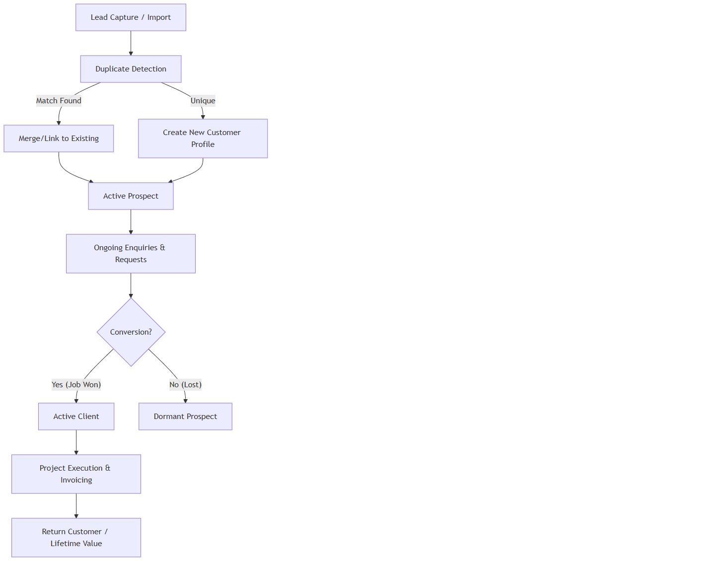
A[Lead Capture / Import] --> B[Duplicate Detection]
B -- Match Found --> C[Merge/Link to Existing]
B -- Unique --> D[Create New Customer Profile]
C --> E[Active Prospect]
D --> E
E --> F[Ongoing Enquiries & Requests]
F --> G{Conversion?}
G -- Yes (Job Won) --> H[Active Client]
G -- No (Lost) --> I[Dormant Prospect]
H --> J[Project Execution & Invoicing]
J --> K[Return Customer / Lifetime Value]

Customer Validations & Deletion Logic
A core capability of CRM-01 is preventing database fragmentation and protecting transactional integrity, enforced by `Client-controller.js`.

Contact Detail Validations
- Duplicate Prevention: When editing (`editClient`) or creating, the system iterates over `emailDetails`. If the email exists on another client, it throws a `409 Conflict`: "Email already exists with another customer."
- Minimum Contact Enforcement: The backend enforces that a customer must have at least one active contact vector. If a user tries to delete all emails and phones, it throws a `400 Bad Request`: "At least one contact detail (Email or Phone) is required."

Strict Deletion Governance
Contrary to standard soft-delete models, AFC enforces strict deletion blocking based on relational integrity (`deleteClient`):
1. Request Check: The system queries the `requests` collection.
2. Quote Check: If requests exist, it queries the `quotations` collection.
3. Hard Block (Quote): If a quote exists, deletion is blocked: "Cannot delete this customer. A quote has already been created for this customer (Quote #[ID]). Please delete the quote first..."
4. Hard Block (Request): If no quotes exist, but active requests exist, it throws: "Customer cannot be deleted because they have active requests."
5. Successful Deletion: Only if no requests or quotes exist will the system proceed to delete the profile.

Screen Catalogue: Customer Management

Customer Detail View
- Business Purpose: Provide a unified timeline of every interaction the company has ever had with the client.
- Navigation Path: `/customers/:id`
- Screen Layout:
Header: Name, Primary Contact, Status Pill, LTV Summary.
Left Column: Permanent contact details, associated addresses, Lead Source.
Main Column (Tabs): Enquiries (Count), Requests (Count), Quotes (Count), Jobs (Count), Invoices (Count).
- Audit Panel: A scrolling chronological timeline of all state changes, phone calls logged, and emails sent.

Field & Form Documentation
Field | Required | Input Type | Validation Rules | Business Reason
First/Last Name | Yes | Text | Letters only. | Primary identity.
Primary Email | No | Email | Standard regex. Unique. | Primary digital vector.
Contact Numbers | Yes | Array | Min 1. 10 digits. Unique. | Critical for field staff communication.
Property Details | Yes | Sub-form | Must include Street, City, State, Zip. | Required for routing site visits and scheduling Jobs.
Lead Source | No | Dropdown | Event, Referral, Web, etc. | Marketing ROI tracking.

Assignment & Follow-up Workflow
While individual Enquiries are assigned to Reps, the Customer profile itself has an "Account Manager" (Owner).
- Follow-up Reminders: The system scans the `followUpDate` of all related Enquiries. If overdue, the Customer is flagged in red on the dashboard & everyday admin will get notified based on their notification settings on over due enquiries.

Customer Property Management
Customers can have multiple properties (e.g., Commercial landlords).
- Each Property contains distinct lat/long coordinates, gate codes, and access notes.
- When generating a Request or Job, the specific Property must be selected from the Customer's array.

Notifications & Audit Trail
When a customer profile is updated, the backend strictly orchestrates audit logging and notifications:
- Diff Tracking: The system calculates a diff between `previousValues` and `latestValues`.
- Action History: A new record is pushed to the `actionHistory` array on the client document detailing exactly which fields changed.
- Audit Collection: A secondary push is sent to the `UpdateAudit` model for system-wide compliance tracking.
- Alert Dispatch: `notifyUsers("Customer_Updated")` fires an SMS and Email to staff detailing the specific field changes using the `genericAlert.ejs` template.

Validation Rules
- Address Geocoding: The system attempts to validate the entered Zip Code against the State.
- Phone Standardization: All numbers are stripped of special characters `+()-` before saving to ensure database uniformity.

Notifications & Alerts
Trigger | Recipient | Message Template | Severity | Delivery Channel | Audit Impact
New Customer Created | Manager | "New Customer Profile Created : [Name]" | Info | UI | Logs Creation Event
Duplicate Attempt | Executing User | "A customer with this phone number already exists." | Warning | UI Toast | Null
Customer Restored | Admin | "Customer [Name] restored to active directory." | Success | UI Toast | Logs Restore Event

Reporting & Exports
The `/export/customers` facility generates a comprehensive CSV.
- Business Purpose: Monthly marketing newsletter synchronization and offline backup.
- Audience: Marketing Manager, Super Admin.
- Filters Applied: Date Range, Status, Lead Source.

Accessibility
- Contrast Compliance: All status pills (New, Return, Lead) exceed WCAG AA contrast ratios against their backgrounds.
- Mobile Usability: The Customer view stacks the Left Column (Contact Info) above the Main Tabs for field staff viewing on mobile devices.

Technical Design Appendix (Traceability References)
- Component Evidence: `g:/AFC/afc_react_fe/src/features/clients/pages/ClientList.tsx`
- Component Evidence: `g:/AFC/afc_react_fe/src/features/clients/pages/ClientDetails.tsx`
- API Binding: `customerService.getClients(params)`
- Module Identifier: `CRM-01`

Visual Module Relationship Map
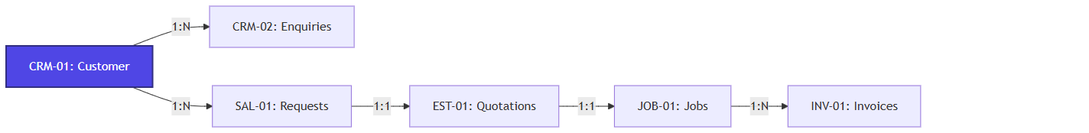
A[CRM-01: Customer] -->|1:N| B[CRM-02: Enquiries]
A -->|1:N| C[SAL-01: Requests]
C -->|1:1| D[EST-01: Quotations]
D -->|1:1| E[JOB-01: Jobs]
E -->|1:N| F[INV-01: Invoices]

style A fill:#4f46e5,stroke:#312e81,stroke-width:2px,color:#fff

CRM-02: Enquiry Management

Overview
The Enquiry Management module serves as the primary entry point for all prospective business opportunities within the AFC ecosystem. It provides comprehensive lifecycle tracking for leads from initial capture through assessment, site visitation, and eventual conversion into actionable Requests or formal Quotations.

Business Purpose
To systematically capture, assign, and mature prospective business leads into revenue-generating projects, ensuring no opportunity is lost due to communication breakdowns or missed follow-ups.

Business Objectives
- Centralize all inbound prospect communications.
- Enforce standardized data collection (contact details, address, service interests).
- Facilitate lead routing to appropriate sales personnel.
- Monitor lead maturation through explicit status gating and follow-up SLAs.

Module Scope
This module covers the `/enquiry` dashboard, dynamic statistical analysis of lead health, creation and modification forms, bulk import facilities, and the mechanisms for converting enquiries into downstream Sales Requests.

Business Impact
If the Enquiry Management module becomes unavailable:
- New prospective business cannot be logged, directly impacting revenue pipelines.
- Sales personnel lose visibility into pending follow-ups, resulting in lost deals.
- Conversion analytics fail, obscuring marketing ROI.
This module is a Tier 1 Revenue-Critical System.

Other Module Dependencies
- AUT-01 - Login: Verifies the user attempting to log or manage the enquiry.
- CRM-01 - Customer Management: Matches incoming enquiries against existing client profiles to prevent duplication.
- SAL-01 - Requests: Enquiries successfully validated are converted into formal Requests.
- EST-01 - Quotations: Direct pipeline for pricing estimation.

8. High-Level Business Process
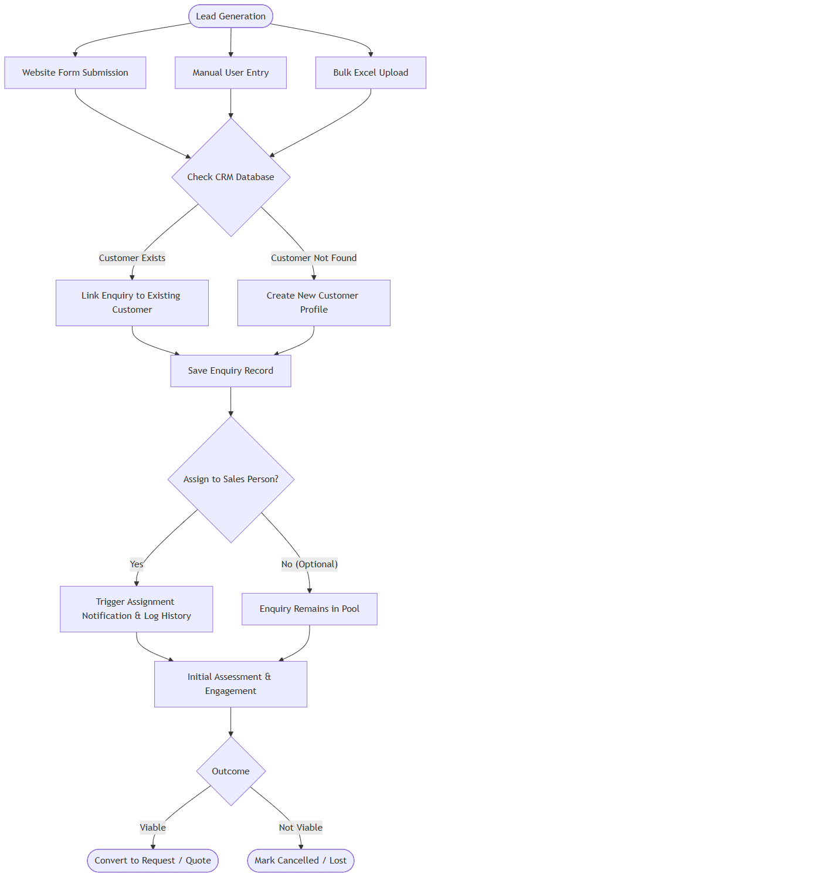
A1([Lead Generation]) --> A2[Website Form Submission]
A1 --> A3[Manual User Entry]
A1 --> A4[Bulk Excel Upload]

A2 --> B{Check CRM Database}
A3 --> B
A4 --> B

B -- Customer Exists --> C[Link Enquiry to Existing Customer]
B -- Customer Not Found --> D[Create New Customer Profile]

C --> E[Save Enquiry Record]
D --> E

E --> F{Assign to Sales Person?}
F -- Yes --> G[Trigger Assignment Notification & Log History]
F -- No (Optional) --> H[Enquiry Remains in Pool]

G --> I[Initial Assessment & Engagement]
H --> I

I --> J{Outcome}
J -- Viable --> K([Convert to Request / Quote])
J -- Not Viable --> L([Mark Cancelled / Lost])

Expanded Enquiry Lifecycle
- Lead Capture: Manual entry via UI or bulk import via Excel.
- Initial Assessment (Draft/Pending): The lead is reviewed for completeness.
- Assignment: The lead is routed to a specific Estimator or Sales Representative.
- Engagement (Site Visit Initiated/Complete): Physical inspection of the prospect's requirements.
- Conversion (Converted to Request/Quote): The prospect is deemed viable and moves into the active sales pipeline.
- Archival/Cancellation: Dead leads are marked as Cancelled but retained for historical analytics.

Complete User Journeys

Reverse-Engineered Public Enquiry Creation (`createEnquiryControllerForStatic`)
When a lead is generated from the public website, the system executes a sophisticated multi-step creation flow:
1. Auto-Customer Generation: The system intercepts the enquiry data and immediately forces `ClientService.createClientWithCartStatic` to generate a new Customer Profile behind the scenes, injecting `channelType: 'website'` and `leadSocial: 'Website'`.
2. Enquiry Linking: It then saves the Enquiry, explicitly binding `customerId` to the newly minted client.
3. Admin Alert Dispatch: The controller queries the `users` collection for all `"super_admin"` and `"admin"` roles where `"notification.email": { $ne: false }`. It dispatches an `adminNewEnquiry.ejs` email alert to these admins and the main company email.
Note: Manual internal creation (`createEnquiryController`) bypasses auto-customer generation but enforces a strict `11000` duplicate key catch on the email field, throwing: "An enquiry with this email already exists".

Bulk Lead Import
The `/importEnquiriesExcelController` and `validateExcelController` govern mass ingestion:
1. File Constraint Validation: The system strictly rejects payloads `> 10MB` or extensions outside of `[.xls, .xlsx]`.
2. Pre-flight Validation: Before inserting rows, it runs a validation check. If it detects internal sheet duplicates, it attaches a `duplicateEmailWarning` array to the API response.
3. Insertion: Valid rows are routed to `importEnquiriesFromExcel` for batched processing.

Enquiry Conversion
1. User Actions: User views an Enquiry detail. Clicks "Convert to Request".
2. System Behavior: System locks the Enquiry status and generates a linked Request entity.
3. Business Rules: An Enquiry cannot be converted if it lacks mandatory contact definitions or service interests.
4. Final Outcome: The record status changes to "Converted to Request".

Workflow Diagram(Creation & Validation)
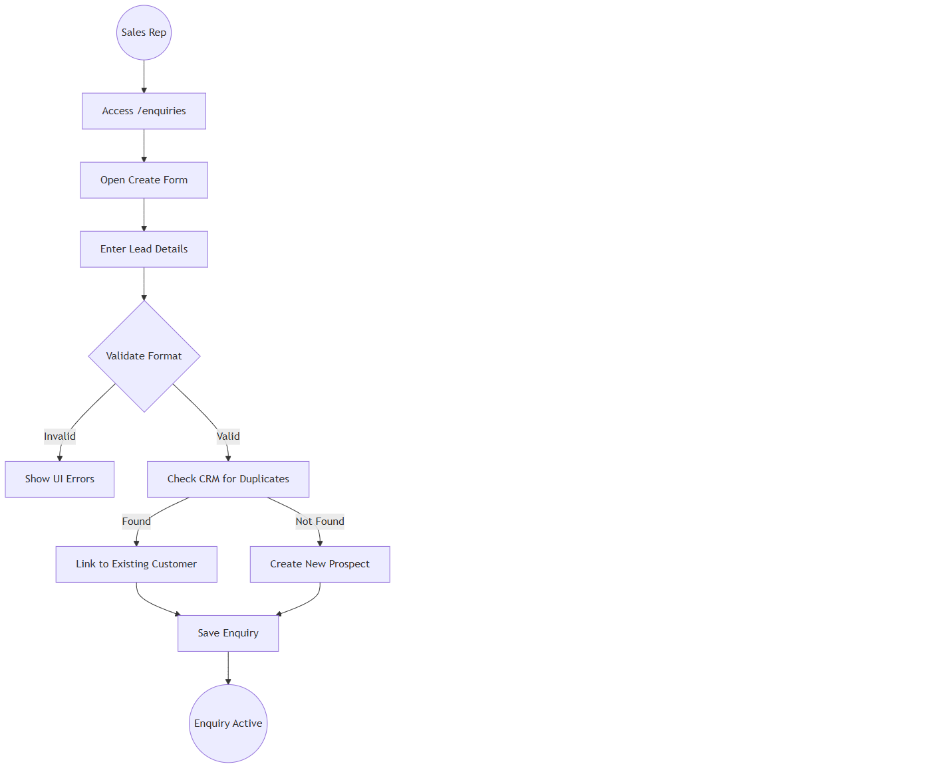
Start((Sales Rep)) --> A[Access /enquiries]
A --> B[Open Create Form]
B --> C[Enter Lead Details]
C --> D{Validate Format}
D -- Invalid --> E[Show UI Errors]
D -- Valid --> F[Check CRM for Duplicates]
F -- Found --> G[Link to Existing Customer]
F -- Not Found --> H[Create New Prospect]
G --> I[Save Enquiry]
H --> I
I --> End((Enquiry Active))

Screen Catalogue: Enquiry Management

Enquiry Dashboard
- Business Purpose: Provide a macro-view of the sales funnel.
- Navigation Path: `/enquiries`
- Screen Layout: Collapsible Statistical Overview Cards at the top. Advanced Filtering Bar. Main Data Table.
- Statistical Cards: Total Enquiries, Drafts, Pending (Overdue), Pending from AFC, Pending from Customer, Partially Converted, Site Visit Initiated, Site Visit Complete, Converted to Request/Quote, Cancelled.
- Buttons: "Create", "Upload Excel", "Export".
- Loading States: Skeleton grid for stats cards and table rows.

Enquiry Form
- Business Purpose: Data entry for prospect details.
- Available Actions: Save, Link Customer, Assign Rep.

Field & Form Documentation
Field | Required | Input Type | Validation Rules | Business Reason
First/Last Name | Yes | Text | Letters and spaces only. | Accurate prospect identification.
Email | Conditional | Email | Standard regex validation. | Primary digital communication vector.
Phone Number | Yes | Array | Must be exactly 10 digits (US/India normalized). Cannot be identical repeating digits. | Primary direct communication vector.
Services Interested | Yes | Multi-Select | Must select at least one core offering. | Dictates which operational team handles the lead.
Follow-up Date | Yes | DatePicker | Must be a valid calendar date. | Enforces SLA and prevents leads from going stale.
Lead Source | No | Dropdown | Event, Referral, Website, Campaign, Other. | Crucial for marketing ROI analytics.

Business Actions
- Assign user: Transfers ownership of the lead. Generates an assignment history log.
- Log Interaction: Records a call, email, or meeting note against the lead.
- Convert: Transitions the lead into the Sales Request pipeline.

Validation Rules
- Duplicate Prevention: Before creating an entirely new customer profile, the system evaluates the provided phone and email against the existing CRM database. If a match is found, the Enquiry is automatically linked to the existing customer, preventing database pollution.
- Phone Number Integrity: Indian numbers must start with 6,7,8,9. US numbers cannot have area codes starting with 0 or 1.

System & Business Rules
- Status Exclusivity: An enquiry can only exist in one primary state at a time. Once converted, it cannot revert to "Pending" without administrative override.
- Assignment Logging: Every time the "Assignee" field changes, a mandatory comment must be provided, creating a permanent chain of custody in the Action History.

Notifications & Assignment Logic
Based on the controller logic, the system triggers the following specific alerts:
Trigger | API Controller | Message Template | Delivery Channel
New Website Lead | `createEnquiryControllerForStatic` | `adminNewEnquiry.ejs` | Email (To Admins)
Manual Reminder | `sendManualReminderController` | User-defined `message` payload. | UI/Email to Assigned User
Enquiry Assigned | `assignEnquiryController` | System event based on `assignedTo` payload | Action History / UI

Note: Assignment changes force a mandatory `comment` payload, maintaining a strict chain of custody.

Role Matrix & Permissions
- Super Admin / Admin: Complete control. Can view all enquiries, assign to any rep, export data, and delete records.
- Manager: Can view assigned enquiries, reassign within their hierarchy, and monitor conversion SLAs.

Audit Trail
The following events are recorded in the Enquiry Action History:
- Creation: Timestamp and originating user.
- Assignment Change: Previous Rep, New Rep, Executing User, Timestamp, Mandatory Reason.
- Status Change: Draft -> Pending -> Converted, including the timestamp.
- Updates: Changes to contact details or service interests.

Accessibility
- Screen Readers: ARIA labels applied to dynamic statistical cards.
- Focus Indicators: Active statistical filters are highlighted with a 2px primary color border for high visibility.
- Responsive Behavior: Data tables collapse horizontally on mobile devices, displaying an optimized "Card View" for Field Staff on tablets.

Operational Guidelines
- Daily Routine: Sales Reps must clear the "Pending (Overdue)" queue daily before processing new drafts.
- Data Hygiene: Avoid using "Others" for Lead Source unless absolutely necessary, to ensure accurate marketing analytics.

Configuration
- System Values: Enquiry Statuses and Lead Sources are centrally defined lists.
- Pagination Constraints: Dashboard defaults to 10 rows per page, expandable based on user preference.

Real Business Scenarios
- Scenario A (Trade Show Import): Marketing returns from an expo with an Excel sheet of 200 leads. The Admin uses the Upload Modal, mapping the columns. Within seconds, 200 "Draft" enquiries populate the system, ready for Manager assignment.
- Scenario B (Conversion): A Rep completes a positive phone call with a prospect. They update the notes, verify the physical address, and click "Convert". The system instantly generates a formal Request document, transitioning the prospect into the active operational pipeline.

Technical Design Appendix (Traceability References)
- The `/export/enquiries` endpoint aggregates CSV generation.
- Component Evidence: `g:/AFC/afc_react_fe/src/features/enquiry/EnquiryListNew.tsx`
- Component Evidence: `g:/AFC/afc_react_fe/src/features/enquiry/components/EnquiryForm.tsx`
- Module Identifier: `CRM-02`

SAL-01: Request Management

Overview
The Request Management module (SAL-01) is the operational entry point for service delivery in the AFC enterprise ecosystem. Unlike a static data-entry form, the Request engine acts as a Dynamic Business Orchestrator. It evaluates the exact service being requested and automatically reconfigures the UI, workflow, validation rules, and site visit requirements to match. By transforming an unqualified Enquiry into a highly structured demand, this module ensures that every Quotation is based on accurate, field-verified data that explicitly fits the selected service type.
The Request Management module governs the end-to-end process of capturing a client's specific service needs. It covers the `/requests` dashboard, the highly dynamic `/requests/create` scoping engine, and the 360-degree `/requests/:id` detail view.

- Key Business Value: Prevents scoping errors by forcing context-aware data collection; coordinates field estimator dispatches only when required; dynamically links customer demands directly to quoting engines.
- Primary Users: Estimators, Sales Representatives, Field Service Managers.
- Critical Success Factor: Accurately routing requests through conditional workflows (e.g., immediate quoting for "Products Only" vs mandatory site visits for "Installation").

Business Purpose
To standardize how AFC evaluates and scopes incoming client demands, ensuring that all necessary site data, product measurements, and service configurations are collected prior to pricing via an intelligent, service-aware intake process.

Module Scope
This module encompasses:
- Dynamic Request Intake & Triage
- Context-Aware Service & Product Configuration
- Conditional Site Visit Scheduling & Dispatch
- Labor Cost
- Dynamic Price Measurement & Formula Engine
- Request-to-Quote Conversion Logic

The Service Decision Engine
The heart of Request Management is the Service Decision Engine. Requests do not follow a static path; instead, they are orchestrated dynamically.

6.1 Decision Engine Logic Flow
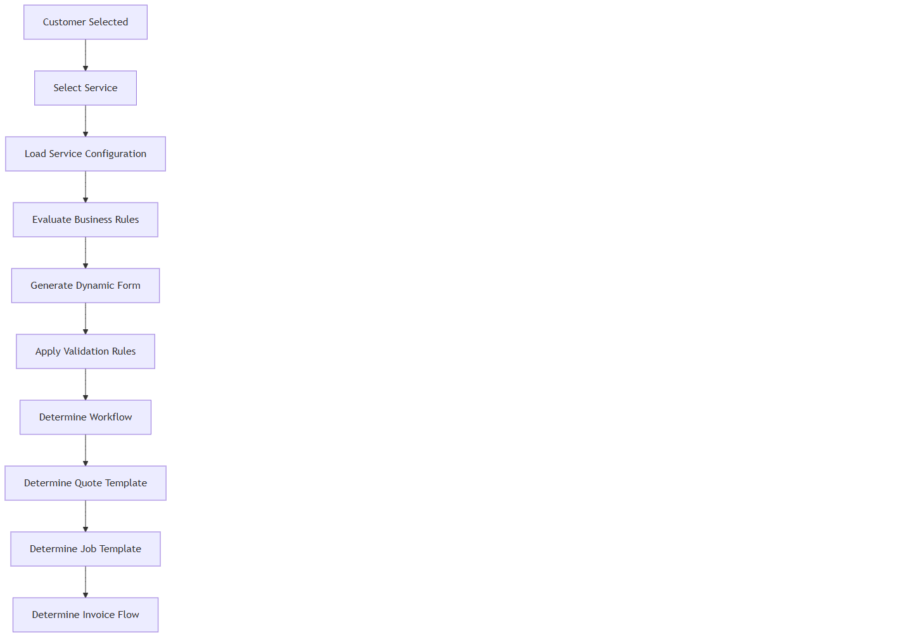
A[Customer Selected] --> B[Select Service]
B --> C[Load Service Configuration]
C --> D[Evaluate Business Rules]
D --> E[Generate Dynamic Form]
E --> F[Apply Validation Rules]
F --> G[Determine Workflow]
G --> H[Determine Quote Template]
H --> I[Determine Job Template]
I --> J[Determine Invoice Flow]

7. Master Service Configuration Matrix
Every Service type dictates downstream operational behaviour. This matrix is the master business configuration reference.
Configuration Flag | Fence Installation | Fence Repair | Product Sale | Consultation
Service Category | Installation | Maintenance | Retail | Service
Service Type | Complex | Standard | Simple | Simple
Site Visit Req. | Mandatory | Optional | Blocked | Mandatory
Measurement Req. | Mandatory | Optional | Blocked | Blocked
Property Req. | Mandatory | Mandatory | Optional | Mandatory
Products Req. | Yes | Yes | Yes | Blocked
Labour Req. | Yes | Yes | Blocked | Blocked
Equipment Req. | Yes | No | Blocked | Blocked
Drawings Req. | Mandatory | Optional | Blocked | Blocked
Photos Req. | Optional | Mandatory | Blocked | Optional
Customer Sig. Req. | Yes | Yes | No | No
Quote Template | Detailed Construction | Standard Service | Retail Product | Consulting Fee
Job Template | Multi-Day Install | Single-Day Repair | Fulfillment | Off-site
Invoice Type | Progress Billing | Net 30 | Due on Receipt | Net 15
Fulfilment Type | Construction | Service | Shipping/Pickup | Advisory

Request Form Behaviour & Validation Rules
The Request Wizard (`CreateorEditRequest.tsx`) acts as an orchestrator, altering validation based on the selected service data.

Mixed Service Validation Rules (Frontend Enforcement)
The application evaluates the `isProductOnlyService` flag on all selected services via `getRequestServiceTypeState`.
- Constraint: If a user selects both a regular service and a product-only service, the UI blocks progression.
- Warning Message: "You can create or update a request with only one service type at a time. Please choose either Product Only services or Regular services."
- Business Justification: Product sales are taxed immediately (Due on Receipt), whereas installations use progress billing and labor tracking.

Execution Sequence: Create Request API (`handleCreateRequest` in `request.service.js`)
When a user clicks "Save" on the Request form, the following exact sequence occurs on the backend:
1. Payload Extraction: Backend extracts `clientid`, `selectedService`, `siteVisits`, and cost summary fields (`productTotalAmount`, `totalLabourCost`, etc.).
2. Site Visit Normalization: The system extracts the top-level `siteVisits` array and deeply merges it into each individual `selectedService` object (e.g., matching `visitedBy`, `siteVisitPreferredDate`, and `siteVisitComments`).
3. Quantity Auto-Calculation: For each selected product option, if `totalQuantity` is missing from the payload, the backend automatically computes it using the formula: `Math.ceil(areaVal / coveragePerUnit)`.
4. Status Determination Engine:
If any service has `!siteVisitAlreadyDone && siteVisitStatus !== "Completed"`, Request status becomes "SiteVisitScheduled".
If all site visits are `siteVisitAlreadyDone`, Request status becomes "SiteVisitCompleted".
If there are no site visits configured, it defaults to the frontend status or "Pending".
5. Action History Appended: An immutable `actionHistory` record is created, stamping the user ID (`performedBy`), timestamp, and cost summaries into the request document.
6. Notification Dispatch: The system uses `notifyUsers` (via `genericAlert.ejs`) to send an email/SMS to internal staff: "New request created: Request #[ID] - [Company Name]".
7. Customer Status Update: Queries `Request.countDocuments` for the client. If > 0 previous requests exist, updates the client status to "return customer", otherwise "new customer".

Expanded Property Logic
Different services require different property intelligence.
- Property Mandatory: Installation and Repair services cannot proceed without a valid, geocoded Property record.
- Property Optional: Over-the-counter Product Sales can bypass property selection if it's a cash-and-carry transaction.
- Multiple Properties: For commercial accounts, the specific Property must be selected from a dropdown. The Service Address is passed to the Estimator, while the Billing Address remains hidden from field staff.
- Access Instructions: Gate codes and security notes are dynamically pulled into the Request for the assigned Estimator.

Measurement Engine
The frontend uses utilities in `utils/requestValidation` and `utils/formulaEvaluation` to compute measurements dynamically.
- Frontend Calculation (`evaluateFormula`): When linear footage or sides are inputted, the React app automatically resolves `basePriceCalculation` (e.g., formula logic attached to product options).
- Tax Calculation: `getProductTotalAmountWithStateTax` and `getStateTaxAmount` apply a hardcoded `STATE_TAX_RATE` variable to compute exact tax burdens dynamically on the frontend before submitting the payload.

Expanded Product Selection Rules
Product selection logic is service-aware.
- Allowed Categories: A "Fence " service only exposes their category materials (brackets, touch-up paint, individual pickets), hiding bulk pallets.
- Mandatory Products: If a specific fence style is selected, the corresponding post caps are flagged as mandatory products.
- Inventory Validation: The UI visually warns the user if the requested quantity exceeds currently available inventory.

Labour Cost
- Estimated Hours: System calculates base hours based on the configured formula.

Request Revision Workflow
Requests usually evolve before quotation. Revisions are strictly managed.
- Reschedule Site Visit: Modifying a scheduled visit triggers a timeline event and sends a notification to Admin.
- Change Measurements: Altering linear footage automatically triggers a recalculate the total price.
- Version History: All scoping changes (e.g., "Added 10ft of fencing") are immutably logged in the Audit Timeline.

Screen Catalogue & Visual Details
- Navigation Path: `/requests/:id`
- Screen Layout:
Header: Request ID, Customer Name, Status Pill, Created Date.
Left Column: Customer Snapshot, Property Address, Contact Details.
Main Column (Tabs): Services Requested, Site Visit Details, Cost Summary (Labor/Equipment), Attached Documents/Photos.
- Audit Panel: A scrolling chronological timeline of all state changes, estimator assignments, and notes.

Technical Design Appendix (Traceability References)
- Component Evidence: `g:/AFC/afc_react_fe/src/features/requests/pages/RequestList.tsx`
- Component Evidence: `g:/AFC/afc_react_fe/src/features/requests/pages/CreateorEditRequest.tsx`
- API Binding: `requestService.getRequests(queryParams)`
- Module Identifier: `SAL-01`

EST-01: Quote Management

Overview
The Quote Management module (EST-01) is the commercial engine of the AFC platform. It converts scoped demands (Requests) or direct ad-hoc inquiries into legally binding financial proposals. Operating as a sophisticated CPQ (Configure, Price, Quote) system, it handles complex pricing rules, margin calculations, multi-tiered taxation, and dynamic payment scheduling.
This module governs the end-to-end quoting life cycle. It details the `/quotes` dashboard, the highly complex `/quotes/create` pricing engine, and the customer-facing `/public-quote/:id` acceptance portal. It defines the strict boundary between internal scoping and external commercial presentation.
- Key Business Value: Ensures margin protection through locked pricing rules, automates complex tax calculations, and secures upfront cash flow via deposit requirements.
- Primary Users: Sales Representatives, Estimators, General Managers.
- Critical Success Factor: Maintaining 100% pricing accuracy across diverse service types (Retail vs Construction) and securing customer acceptance with digital signatures.

Business Purpose
To provide a secure, standardized, and highly flexible pricing engine that allows Sales Representatives to quickly generate accurate proposals, apply approved margins, capture deposits, and formally lock in customer commitment while protecting enterprise profitability.

4. Module Scope
This module encompasses:
- Quote Type Orchestration & Configuration
- Complex Formula-Based Pricing Engine
- Margin Protection & Discount Governance
- Quote Approval Hierarchies
- Deposit Payment Scheduling
- Quote Revision Management
- Status Lifecycle & Expiration Logic

6. Quote Type Configuration Matrix
The Quote Engine re configures its commercial logic based on the underlying service. This matrix represents the master commercial decision engine.
Configuration Flag | Aluminium Fence Quote | Wood Fence Quote | Product Only Quote
Site Visit Req. | Mandatory (from Request) | Optional | Optional
Measurement Req. | Mandatory | Optional | Blocked
Product Req. | Mandatory | Mandatory | Mandatory
Delivery Req. | Implied with Install | No | Mandatory
Deposit Rule | 50% Standard | 50% Standard | 100% (Due on Receipt)

Pricing & Margin Engine
The core of the Quote module calculates financial proposals sequentially, enforced by frontend utilities in `CreateQuote.tsx`.

Dynamic Margin Application (`applyServiceMargin`)
The UI strictly applies user-defined margins before yielding the final subtotal.
- Percentage Margin: If `marginType === "percentage"`, the formula is `base + (base value) / 100`.
- Flat Margin: If `marginType === "flat"`, the formula is `base + value`.
- Subtotal Constraint Check: The system executes `hasZeroSubtotalService` before submission. If any service subtotal evaluates to “0”, the UI blocks saving with error: "Services Sub Total / Products Total cannot be zero. Please check your costs."

Quote Status Alert Dispatcher
When the Quote state changes, the backend `QuotationController.js` invokes `triggerQuotationNotification`, firing both SMS and Emails (via `genericAlert.ejs`) for the following exact events:
- `Quotation_Created`, `Quotation_Updated`, `Quotation_Deleted`, `Quotation_Rejected`, `Quotation_Approved`.

Discount Governance
- Maximum Discount: Sales Reps are capped at a specific % discount (e.g., 5% automatic).
- Audit Trail: Every applied discount generates an immutable log entry tracking Who applied it, and the Amount.

Tax Exclude & Display Logic
Taxes are orchestrated dynamically based on the boolean flag `IsTaxIncluded`.
- Tax Exclusive View: `getQuotationSummaryValues` determines that if `quotation.IsTaxIncluded === false`, then `amountSentToCustomer` is calculated as `totalAmount - taxAmount` (stripping out tax liability from the customer's face value).
- Tax Inclusive View: If `IsTaxIncluded === true`, taxes are baked into the `amountSentToCustomer` variable.
- Component Rendering: The React UI leverages `QuotePreviewNoRequestSummaryTable` to build the grid view dynamically, calculating "Balance Due (50%)" against `amountSentToCustomer - depositAmount`.

Dynamic Payment Scheduling
The Quote dictates the financial milestones for the resulting Job.
- Deposit Invoice: Automatically generated upon acceptance (e.g., 50% for Installations, 100% for Product Sales).
- Final Balance: The system sends the remaining balance invoice for the "Job Completed" trigger.
- Customer Adjustments: Payment terms can be altered by Admins/Managers and customer will approve the quotation again

Public PDF & Portal Generation
The quote presentation layer is heavily customized before reaching the customer.

11.1 Native PDF Generation (`buildQuotationPdfBuffer`)
Rather than relying on frontend print dialogs, AFC generates native PDFs entirely on the backend via `PDFDocument` (pdfkit).
- Media Resolution Engine: The system parses `layoutimages`, stripping queries and dynamically loading them into a `sharp` buffer. It falls back to `localCandidates` (searching `public/` and `process.cwd()`) if HTTP loading fails or times out.
- Rich Text Sanitization: Terms & Conditions are processed through `sanitizeDocumentationHtml` (allowing only `p, div, span, br, ol, ul, li, b, strong, em, i`) and stripped into `trimDocumentationSegments` to render accurately within the PDF coordinates.

Digital Acceptance Lifecycle
When a customer accepts via the public link:
1. `triggerQuotationNotification("Quotation_Approved")` fires.
2. `createJobFromAcceptedQuotation` executes, acting as the bridge to `JOB-01`.
3. `SendEmailToClientafterAcceptance` dispatches the legally binding PDF.

13. Expiration Management & Status Lifecycle
Quotes transition through a highly audited state machine.

13.1 Expiration Management
- Quote Expiry Date: Default 30 days from creation.
- Auto-Expiration: At midnight on day 30, the status shifts to `Expired` and the public link disables itself.

13.2 Status Lifecycle
Status | Entry Criteria | Exit Criteria | Business Outcome
Draft | Quote created, unsent. | Sent to Customer | Work in progress.
Sent | Dispatched via Email/SMS. | Customer opens link | Awaiting engagement.
Pending | Customer asks query | Admin will update the quote & resend | Negotiation phase.
Accepted | Customer signs digitally. | Converted to Job | Locked, Job created.
Expired | 30 days elapse. | N/A (Terminal) | Deal Dead.

14. Document & Attachment Handling
- Inherited Context: Measurement sheets, property boundaries, and site photos automatically flow from the Request to the Quote.
- Terms & Conditions: Legally approved T&Cs are dynamically injected into the PDF generation from company settings.
- Downstream Flow: Once accepted, all signed PDFs, terms, and site photos are cloned and pushed directly into the `JOB-01` execution module, ensuring installation crews see what the customer bought.

19. Technical Design Appendix (Traceability References)
- Component Evidence [EST-UI-01]: `CreateQuote.tsx` (Pricing Engine)
- Component Evidence [EST-UI-02]: `QuotationPublicPreview.tsx` (Customer Portal)
- Component Evidence [EST-UI-03]: `QuoteDetail.tsx` (Status & Analytics)
- API Binding [EST-API-01]: `quotationService.createQuote(payload)`
- Module Identifier: `EST-01`

20. Visual Module Relationship Map

A[SAL-01: Requests] -->|1:1| B[EST-01: Quotations]
B -->|1:1| C[JOB-01: Jobs]
B -->|1:N| D[INV-01: Invoices]

style B fill:#059669,stroke:#064e3b,stroke-width:2px,color:#fff

Cross-Chapter Navigation
- Previous Chapter: [SAL-01: Request Management](#)
- Next Chapter: [JOB-01: Job Management](#)
- Related Chapters: [INV-01: Invoice Management](#)

JOB-01: Job Management

Overview
The Job Management module (JOB-01) is the operational execution engine of the AFC platform. It bridges the gap between commercial agreement (Accepted Quote) and physical fulfillment (Site Operations).
This module governs the end-to-end execution lifecycle. It details the `/jobs` operational dashboard, the complex `/job/:id` central command center, and the field-level `/job-public/:id` tracking portal. It defines the strict boundary between theoretical scoping (Quotes) and physical reality (Jobs).
- Key Business Value: Ensures flawless field execution, prevents margin leakage through strict expense tracking, and guarantees that the customer receives exactly what was quoted.
- Primary Users: Dispatchers, Field Crews, General Managers.
- Critical Success Factor: Maintaining real-time visibility into crew locations, job expenses, and schedule adherence to protect operational profitability.

Business Purpose
To provide a centralized, highly structured operational hub that allows Dispatchers to efficiently track job progress via daily visits, capture real-time expenses, and accumulate photographic evidence of completed work prior to final invoicing.

4. Module Scope
This module encompasses:
- Job Template Orchestration
- Upstream Inheritance (Quote -> Job)
- Dynamic Visit Management
- Job Expense Tracking & Profitability Impact
- Photographic Evidence Capture (Initial & Final)
- Status Lifecycle & Milestones
- Post-Job Final Invoice Delta Reconciliation

6. Job Configuration Matrix
The Job module dynamically reconfigures its operational logic based on the underlying service sold in the Quote.
Configuration Flag | Fence Installation Job
Schedule Type | Multi-Day (Recurring Visits)
Crew Size Req. | Lead
Initial Photos | Mandatory (Before Work)
Completion Photos | Mandatory (After Work)
Expense Tracking | High Volume (Concrete, etc.)

Inheritance & Instantiation
A Job is never created in a vacuum; its creation path is dynamically determined by the `JobWay` parameter passed to `createJob` because our system have different types of invoices as with quotation & without quotation
we can create an invoice with out quotation also & will create a job for that invoice also
- Invoice-Led (`JobWay === "Invoice"`): The system routes to `JobService.createJobForInvoiceWay`, meaning the Job was generated directly from a standalone Invoice, skipping the Quote phase entirely.
- Line-Item Quote (`jobquotation?.UsingTemplate === true`): The system routes to `JobService.createJobForLineItemsQuotation`, extracting line items from a structured CPQ quote.
- Standard Scope: The system defaults to `JobService.createJobNew`.
- Cross-Object Population: Regardless of the origin path, `getJobById` attempts deep population, first looking for a linked `quotation` and resolving the customer profile from `quotation.client`. If no quote exists, it falls back to resolving the customer from `invoice.client`.

Crew (Leads) Scheduling & Notifications
Execution is managed through atomic "Visits", allowing complex jobs to be split across multiple days.

Schedule Types (`scheduleType`)
The backend strictly enforces the following schema validation during `createJob`:
- One-Time Schedule (`"OneTime"`): A single continuous block of time. Requires `schedule.start_date`.
- Recurring Schedule (`"Recurring"`): Multi-day operations. The system throws a `400 Bad Request` if `schedule.end_date` is omitted.

Event Dispatcher (`sendJobNotification`)
The system employs a unified helper to dispatch SMS and Email (`genericAlert.ejs`) alerts.
- Upon Job Creation (if `status !== "auto"` && `status !== “cancelled”` && `isDeleted!==true`), an alert is dispatched detailing the `Job Title`, `Start Date`, and `Schedule Type` before a day to the customer as well as admins who had that event configuration enabled.
- The system attempts to resolve the `Customer Name`, `Email`, and `Phone` deeply by traversing the Quotation, then the Invoice, then the explicit `client_id` reference to ensure the alert payload is populated correctly.

Job Expense Tracking & Profitability
While Quotes estimate profitability, Jobs track actuals. The Expense module is critical for preventing margin leakage.
- Expense Logging: Field staff and managers log ad-hoc expenses directly against the Job (e.g., "Extra bags of concrete purchased at Home Depot").
- Expense Categorization: Categorized by Type (Materials, Labour, Fuel, Equipment Rental).
- Profitability Impact: Expenses logged against the Job are mapped against the Quoted Costs. If Actual Costs > Quoted Costs, the Job is flagged for "Margin Erosion Review" upon completion.

Evidence & Quality Assurance
To protect the enterprise from liability and ensure customer satisfaction, strict evidence workflows are enforced.

Photographic Evidence
- Layout Images (Inherited): Drawings from the Quote will upload the layout images will send to the customer at the time of quotation sending .
- Initial Work Images & Work Completed Images: leads must upload "Before" photos prior to breaking ground (verifying site condition) & future purpose also & for advertisement purpose also .
- Business Rule: A Job cannot transition to `Completed` unless the minimum required Completion Photos are present because all admins knows about that fence/flooring…ect service .

Final Invoice Delta Reconciliation
A critical commercial checkpoint occurs when a Job finishes.
- The Reality Check: What was quoted is rarely exactly what happens. (e.g., 2 extra posts were needed due to terrain).
- Edit Final Invoice Action: When a Job is marked `Completed`, the system unlocks the "Edit Final Invoice" action.
- Reconciliation: Managers review the Job Expenses and Field Notes. If extra materials were used (and approved by the customer), they are added to the Final Invoice payload before it is dispatched via the INV-01 module.
Again quote will update & send to customer if any extra amount added , then customer will review & accept it pay the remaining balance amount then quote will be closed .

Comprehensive Status Lifecycle
Jobs transition through a strictly enforced operational state machine.
Status | Entry Criteria | Exit Criteria | Responsible | Business Outcome
Created | Quote Accepted. | Schedule is set. | System | Holding queue.
Scheduled | Dates & Crew assigned. | Crew arrives on site. | Dispatcher | Resources locked.
In Progress | Crew logs first arrival. | Final visit completed. | Field Lead | Execution phase.
Pending Review | Margin eroded by expenses. | Manager approves overage. | Gen. Manager | Profitability check.
Completed | Final photos uploaded. | Final Invoice Generated. | Field Lead | Ready to bill.
Cancelled/Deleted | Customer backs out. | N/A (Terminal) | Gen. Manager | Deal aborted.

Operational Dashboard
The `/jobs` dashboard (`getAllJobs` / `getAllJobsPagination`) aggregates execution analytics via MongoDB aggregation pipelines:
- Late Jobs: Count of all jobs currently in the `"InProgress"` state.
- End in 30 days: Count of all jobs in the `"action required"` state (Completed but pending final processing).
- Deep Resolvers: The list view intelligently maps the Customer Name by hunting through `job.quotation.client`, then `job.invoice.client`, then `job.client_id`. It maps the Created By field to `${job.createdBy.firstname} ${job.createdBy.lastname}`.

A Completed Job triggers the final financial workflows.
Completed Job
↓
Final Expense Reconciliation
↓
Final Invoice Generation (INV-01)
↓
Payment Collection (PAY-01)
↓
Quote Complete

Technical Design Appendix (Traceability References)
- Component Evidence [JOB-UI-01]: `JobDetail.tsx` (Command Center)
- Component Evidence [JOB-UI-02]: `JobExpensesTable.tsx` (Margin Tracking)
- Component Evidence [JOB-UI-03]: `VisitsList.tsx` (Execution Tracking)
- Component Evidence [JOB-UI-04]: `InitialWorkImagesUploader.tsx` (Evidence)
- API Binding [JOB-API-01]: `jobService.getJobById(id)`
- Module Identifier: `JOB-01`

18. Visual Module Relationship Map

A[EST-01: Quotations] -->|1:1| B[JOB-01: Jobs]
B -->|1:1| C[INV-01: Invoices]
B -->|1:N| D[EXP-01: Expenses]

style B fill:#0284c7,stroke:#0369a1,stroke-width:2px,color:#fff

Cross-Chapter Navigation
- Previous Chapter: [EST-01: Quote Management](#)
- Next Chapter: [INV-01: Invoice Management](#)
- Related Chapters: [EXP-01: Expense Management](#)

INV-01: Invoice Management

Overview
The Invoice Management module (INV-01) governs the financial realization of the AFC platform. It is responsible for converting completed quotes and executed jobs into hard revenue. The module handles multi-installment billing, dynamic tax recalculations, payment gateway orchestration, and automated customer payments (collections).
This module governs the end-to-end billing lifecycle. It details the `/invoices` financial dashboard, the complex `/invoices/create` billing engine, the internal `/invoice/:id` reconciliation view, and the critical customer-facing `/public-invoice/:id` payment portal.
- Key Business Value: Accelerates cash flow via automated digital payment links, reduces Days Sales Outstanding (DSO), and ensures 100% accurate tax (Tax exclude/include )compliance prior to general ledger syncing.
- Primary Users:Admins

3. Business Purpose
To provide a highly secure, automated billing engine that generates accurate financial demands (Deposit, Progress, and Final Invoices), delivers them instantly to customers, captures digital payments, and permanently locks financial records to prevent unauthorized post-payment tampering.

Module Scope
This module encompasses:
- Invoice Generation (From Quote, From Job)
- Payment Gateway Integration (Credit /Debit Card, Zelle, Bank Transfer)
- Financial Status Life cycle (Awaiting,Partial paid,Full paid)
- Document Generation (PDFs, Statements)

Invoice Configuration Matrix
The billing logic drastically alters based on the origin of the Invoice.
Configuration Flag | Deposit Invoice (Pre-Job) | Final Invoice (Post-Job)
Trigger Event | Quote digitally accepted. | Job marked 'Completed'.
Origin Source | Exact Match to Quote. | Quote + Post-Job Deltas.
Amount Rule | Exact Deposit % (e.g., 50%). | Remaining Balance.
Payment Terms | Due on Receipt. | Net 15 / Net 30.
Modification | Strictly Locked. (only update if quote update any changes ) | Open for Job Reconciliation.

The "Post-Job Delta"
An Invoice is the financial snapshot of operational reality.
- Inherited and Locked (Deposit): When a Quote is signed, the Deposit Invoice is a mathematical 50% . No line items can be altered.Customer will pay 50% on quote amount , there is no change
- The Post-Job Delta (Final Invoice): The Final Invoice is not just the remaining 50%. It inherits the original Quote, but then merges in the "Delta" from JOB-01 (e.g., "Added 2 extra fence posts due to terrain"). Then in this case deposit value will change , but customer already paid then will adjust the remaining balance
- Business Rule: The Final Invoice must mathematically equal: (Original Quote Total + Post-Job Deltas) - Paid Deposit.

The Financial Calculation Engine
The system recalculates the bottom line before generating the PDF to ensure absolute compliance.
1. Gross Subtotal: Sum of all active line items (accounting for Job Deltas).
2. Margin Verification: Confirms no manual overrides broke the margin floor.
3. Discount Lock: Verifies the original quoted discount.
4. Tax Recalculation: Re-runs the tax exclude/ include , service tax which we given in the company settings .
5. Less Previous Payments: Subtracts the paid Deposit.
6. Total Amount Due: The final demand amount.

Customer Public Payment Links
The `/public-invoice/:id` interface is optimized for rapid payment conversion.
- Access: Delivered via automated SMS/Email using a secure, tokenized URL (No login required).
- Customer View: Displays branded invoice, itemized breakdown, tax details, and clear "Total Due".
- Payment Gateways:
Credit /Debit Card: Integrated Stripe element (Subject to convenience fees).
Check : Lower transaction cost for commercial clients.
Bank Transfer /Zelle : Displays corporate routing instructions; requires customer to upload a confirmation receipt. Or Admin will notify that customer choose Bank Transfer/ Zelle for payment
check the account & update the invoice from admin portal & upload requrired document then will automatically move to paid transaction .
- Instant Reconciliation: Upon successful digital payment, the system instantly flips the Invoice to `Paid` and triggers a Thank You receipt.

Manual Payment & Bank Transfers
Not all payments are digital. The system supports manual Accounts Receivable (A/R) reconciliation from admin panel invoice list page .
- Bank Transfer Dialog: If a customer wires money, Finance uses the `BankTransferConfirmationDialog` to manually clear the invoice.
- Cheque Processing: Finance can manually log a cheque payment, requiring a Cheque Number .This option will visible for only admin’s not for the customer .

Status State Machine
The system runs `updateInvoiceStatus(invoice)` recursively to calculate the master status based on its underlying `installments` array.
- Full Paid: `receivedAmount = totalAmount` (isFullyPaid).
- Failed: Any installment explicitly marked as `failed` (`hasFailed = true`).
- Partial: `receivedAmount > 0` but not fully paid.
- Awaiting: The default state if installments are pending and no other conditions are met.

Financial Document & Attachment Handling
- PDF Generation: Invoices are dynamically generated into clean, branded PDFs using the `InvoicePublicUrlPDF` generator which are send to the customer as a email / sms .
- Immutability: Once an Invoice hits `Paid` status, it is Fully paid . No line item, tax rate, or total can be altered.But we can update the quote until job to be finish , so automatically invoice value dynamically update if it already full paid .After job completion also we can add some extra amount then quote will be edit and amount will be altered.
- Statements: Finance can generate a "Customer Statement" summarizing all Open, Paid, and Overdue invoices for a specific account & we can download the invoices list by filters also as pdf/excel .

Technical Design Appendix (Traceability References)
- Component Evidence [INV-UI-01]: `CreateOrEditInvoice.tsx` (Billing Engine)
- Component Evidence [INV-UI-02]: `InvoicePublicUrlPDF.tsx` (Customer Portal)
- Component Evidence [INV-UI-03]: `InvoicePaymentModal.tsx` (Payment Gateway)
- API Binding [INV-API-01]: `invoiceService.getIndividualInvoice(id)`
- Module Identifier: `INV-01`

Visual Module Relationship Map

A[EST-01: Quotations] -->|Generates Deposit| C[INV-01: Invoices]
B[JOB-01: Jobs] -->|Generates Final| C
C -->|1:N| D[PAY-01: Payments]

style C fill:#b91c1c,stroke:#7f1d1d,stroke-width:2px,color:#fff

EXP-01: Expense Management

Overview Summary
The Expense Management module (EXP-01) is the core cost-control engine of the AFC platform. It captures, categorizes, and audits all outgoing funds, whether tied to specific Job operations (Cost of Goods Sold) or general business overhead. Operating as a strict financial gatekeeper, it handles manual receipt logging, bulk credit bill imports, approval hierarchies, and dynamic job-profitability reconciliation.
This module governs the end-to-end expense lifecycle. It details the `/expenses` global dashboard, the field-level `ExpenseForm` for ad-hoc job costs, the `CreditBillUploadModal` for bulk financial reconciliation, and the immutable audit trails required for corporate tax compliance.
- Key Business Value: Prevents margin erosion by tracking actual job costs in real-time, automates corporate card reconciliation, and enforces financial accountability across all field and office staff.
- Primary Users: Admins
- Critical Success Factor: Frictionless receipt capture in the field coupled with strict, immutable management approval workflows to prevent fraudulent or duplicate claims.

Business Purpose
To provide a secure, standardized, and highly audited cost-tracking engine that allows the enterprise to capture every dollar spent, bind those dollars to specific Jobs (where applicable) to calculate true profitability, and formally approve employee reimbursements and vendor payables while protecting corporate cash flow.

Module Scope
This module encompasses:
- Expense Type Orchestration & Configuration
- Complex Cost Allocation Engine (Overhead vs. Job-Specific)
- Expense Payment & calculate total expenses within date range
- Mobile Receipt Capture & OCR Parsing (Future-ready)

Business Impact
If the Expense Management module becomes unavailable:
- Actual job profitability cannot be calculated.
- Corporate credit card bills cannot be reconciled, leading to audit failures.
This is a Tier 1 Mission-Critical Financial System.

Expense Type Governance (`createExpenseType`, `editExpenseType`, `deleteExpenseTypeById`)
The Expense Engine relies on dynamically configured `ExpenseType` records. The system enforces strict relational integrity constraints on these types:
- Creation: When a new `ExpenseType` is created, the system prevents duplicate names via a case-insensitive regex check (`$regex: new RegExp('^'+name+'$', 'i')`).
- Modification Locking (`isUsed` constraint): If an admin attempts to edit an Expense Type (`editExpenseType`), the system checks if any existing Expense records are actively using this type. If `isUsed === true`, the system locks the `name` and `frequency` fields, preventing changes to ensure historical financial reports remain accurate.
- Deletion Blocking: An Expense Type cannot be deleted (`availableStatus: false`) if it is currently bound to any active expense record (`EXPENSE_TYPE_IN_USE` error is thrown).

The Comprehensive Cost Allocation Engine
Expenses in AFC are not just numbers; they are mathematically allocated to calculate true business health.

Overhead vs. Job-Specific Allocation
- Overhead Expenses: (e.g., Office Rent, Software Subscriptions, Office Rents, Employee salaries…ect) are logged without a `JobId`. These hit the general corporate P&L but do not affect individual project margins.
- Job-Specific Expenses: (e.g., Extra concrete, rented auger) must be bound to a `JobId`. The system dynamically recalculates the Job's "Actual Margin" based on these real-time inputs.

7.2 The Bulk Import Engine (Credit Bill Upload)
To manage corporate credit cards (e.g., Home Depot Pro Xtra), Finance uses the `CreditBillUploadModal`.
- Inputs: CSV/OFX imports from the bank.
- Calculation Rules: The engine parses the statement, attempts to auto-match transactions to existing open expense categories or create new categories & matched to those will attached for those categories & update the database with those transactions based on dates and amounts, and flags unmatched items as "Pending".

Expense Payment & Revision Workflow
Mistakes happen, but financial records must remain clean. The backend enforces strict payment logging rules:

Payment Logging (`addExpensePayment`)
- Validation: Payments must be `> 0`. If the payment method is `check`, a non-empty `chequeNumber` string is strictly enforced.
- Overpayment Prevention: The system calculates the `dueAmount` and blocks any payment payload where `amount > expense.dueAmount`.
- Append-Only Architecture: In `editExpense`, the backend utilizes an `APPEND` strategy for the `payments` array (`$push.payments = { $each: newPayments }`). It mathematically rejects attempts to overwrite existing payment history.

Action History Auditing
- Immutable Logs: Every operation (`create`, `update`, `payment`, `delete`, `restore`) pushes a structured record into the `actionHistory` array, tracking `performedBy`, `previous` values, and `latest` values to construct an unbreakable audit trail.

15. Business Scenarios
Real-world examples of Expense orchestration:
- Scenario 1: Unexpected Job Material (Margin Impact)
Crew on site runs out of screws&Buys at Home Depot on Corp Card Snaps receipt to Job #123 will update through job create expenses & it shows in the list with a new expense with job name in the table

Operational Dashboard & Commercial KPIs
The `/expenses` dashboard provides cost analytics:
- Total Spend MTD: Sum (Total) of all created /uploaded expenses selected month, paid , due amount out of all total amount .

Technical Design Appendix (Traceability References)
- Component Evidence [EXP-UI-01]: `ExpenseForm.tsx` (Capture Engine)
- Component Evidence [EXP-UI-02]: `CreditBillUploadModal.tsx` (Bulk Import Engine)
- Component Evidence [EXP-UI-03]: `ExpenseDetail.tsx` (Audit Trail & Status)
- API Binding [EXP-API-01]: `expenseService.createExpense(payload)`
- Module Identifier: `EXP-01`

Visual Module Relationship Map
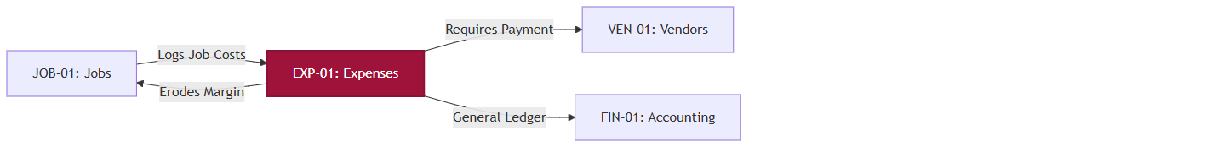
A[JOB-01: Jobs] -->|Logs Job Costs| B[EXP-01: Expenses]
B -->|Erodes Margin| A
B -->|Requires Payment| C[VEN-01: Vendors]
B -->|General Ledger| D[FIN-01: Accounting]

style B fill:#9f1239,stroke:#881337,stroke-width:2px,color:#fff

VEN-01: Vendor Management

Overview
The Vendor Management module (VEN-01) is the Accounts Payable (A/P) and Procurement engine of the AFC platform. It governs the lifecycle of external suppliers, subcontractors, and material providers. It tracks vendor profiles, processes incoming vendor invoices, logs outbound payments, and orchestrates complex purchase returns.
This module governs the external supply chain lifecycle. It details the `/vendors` and `/servicevendors` directories, the `/vendor-invoices` payable engine, and the `PurchaseReturnModal` workflow for rejecting substandard materials.
- Key Business Value: Centralizes supply chain data, prevents duplicate or fraudulent vendor payments, and enforces strict Accounts Payable terms to optimize corporate cash flow.
- Primary Users: Procurement Team, Accounts Payable (Finance), Project Managers.
- Critical Success Factor: Maintaining a strict, auditable boundary between Vendor Invoice receipt and actual funds disbursement, supported by three-way matching against Jobs and Purchase Orders.

Business Purpose
To provide a secure, standardized registry for all external partners, allowing the enterprise to formally process their invoices, schedule outgoing payments according to negotiated terms (e.g., Net 30), and meticulously track supplier performance and product returns.

Module Scope
This module encompasses:
- Vendor Profiling (Material Suppliers(purchase vendors) vs Service Subcontractors)
- Vendor Invoice Capture & Verification (Accounts Payable)
- A/P Payment Scheduling & Logging
- Purchase Returns Tracking
- Vendor Notes & Audit Trails
- Service vendor with job management
- Vendor Typology: Categorizing vendors into `Purchase`, `Service`.
- Deep Profiles: Aggregating granular notes, catalogs (`purchase_details`), and activity history.
- Job Integration: Linking operational Jobs to vendor payouts (`getVendorJobs`).
- Multi-Payment Orchestration: Disbursing funds across multiple vendor invoices (`paytoVendor`).
- Dashboard Analytics: Aggregating overdue balances and calculating vendor payment velocity.

Business Impact
If the Vendor Management module becomes unavailable:
- Critical suppliers cannot be paid, leading to credit holds and material shortages.
- Subcontractors walk off active Jobs due to delayed payments.
This is a Tier 1 Mission-Critical Supply Chain System.

Vendor Typology & Categorization
The `calculateVendorStats` service dynamically groups vendors into operational buckets:
- Purchase Vendors: Suppliers of physical goods (mapped in `CAT-01`).
- Service Emergency Vendors: High-priority subcontractors available for immediate dispatch.
This categorization powers specialized views (e.g., `getEmergencyVendors`), allowing dispatchers to bypass standard CRM lists during critical escalations.

Service Job & Payment Orchestration
Vendors who perform labor (Subcontractors) operate on a specialized workflow.

Job Tracking (`getVendorJobs`)
The controller isolates all Jobs assigned to a specific `vendorId`.
- Filters: Supports real-time filtering by `payment_status` and `date`, ensuring Finance only sees completed, unpaid labor tasks.

The Payout Engine (`paytoVendor`)
To accommodate enterprise finance, the payout controller supports polymorphism:
- Single Payment: Can execute against a specific `jobId` with an `amount` and `chequeNumber`.
- Multi-Payment (Batching): Accepts a `payments` array. This critical logic allows the Finance team to cut a single physical check that satisfies multiple outstanding Service Jobs for the same subcontractor simultaneously, significantly reducing accounting overhead.

Vendor Invoice Dashboards
The `getVendorInvoiceDashboardService` provides the CFO-level overview of vendor liabilities.

Timeframe Aggregation
The dashboard dynamically adjusts based on the requested `timeframe` (week, month, quarter, year), calculating the base `$gte` lookup query.

Real-Time Liability Tracking
It parses the entire invoice collection to generate:
- Recent Invoices: The last 5 invoices loaded into the system.
- Overdue Liabilities: Scans for `dueDate < now` where the `status` is `$in: ["pending", "partial", "overdue"]`.

Vendor Performance Pipeline
A highly complex MongoDB aggregation pipeline evaluates vendor health:
1. Groups by `vendor_id`.
2. Calculates Financials: `$sum` of `totalAmount` versus `paidAmount`.
3. Calculates Velocity (`avgPaymentDays`): For all `"paid"` invoices, it calculates the mathematical difference between the `invoiceDate` and the `updatedAt` stamp (when it was marked paid). This metric tells Finance exactly how long, on average, the enterprise takes to pay a specific supplier.
4. Calculates Risk (`paymentRate`): A percentage representation of settled debt versus total generated debt for that vendor.

Payable Engine (`createVendorInvoiceService`)
VEN-01 flips the dynamic of INV-01: instead of demanding money, the enterprise is receiving demands for money. The core logic executes in `createVendorInvoiceService`:

Vendor Invoice Capture & Inventory Sync
When a supplier bills AFC, the backend strictly orchestrates the financial and inventory impact:
- Item Processing: For each item, the system calculates `unitsPerBox` (using the `weight` parameter). It increments the `Product` model's inventory (`$inc: { quantity: totalUnits }`) and updates the `purchase_cost` if it has changed from previous orders.
- Audit Triggers: Any change to product cost or quantity triggers an immutable `actionHistory` log on the `Product` document.
- Lot Tracking: A `StockBatch` record is created for every line item to track exact incoming shipments.
- Vendor Profiling: The `Vendor` model is updated dynamically (`$inc: { totalPurchases: totalAmount }`).
- Machine Learning Preparation: The system runs `normalizeInvoiceProductName` to scrub the vendor's raw text name and maps it to the internal `productId` inside `invoiceProductMappings`. This builds historical data for future AI invoice parsing.
- Notifications: Successfully processed invoices trigger a background email/SMS dispatcher (`vendorInvoiceCreated.ejs`).
- Vendor Invoice AI extraction: Successfully selection of an vendor, upload a vendor invoice
then AI will extract all the products in the database which already there and if not will show separate section as new unmatched products with multiple options . Manually will check the matched option & save then next time AI will automatically attach that product.
- Will Record payments by different payment methods and update the list page with total amount, paid,due based on the date range filters.

The Adjustment & Purchase Return Workflow
If AFC previously returned damaged materials, the supplier owes AFC a credit. The system handles this via `appliedAdjustments` during invoice creation:
- Credit Verification: The system verifies the `VendorReturn` document is valid and not already `completed`.
- State Mutation: It marks the `VendorReturn` as `completed`, appending the newly created `vendorInvoice._id` as the resolving document.
- Payment Injection: The backend automatically generates an internal "Payment" array object of type `paymentMode: "adjustment"`. This mathematically deducts the credit from the total amount owed, allowing Finance to only cut a cheque for the net remaining balance.

Technical Design Appendix (Traceability References)
- Component Evidence [VEN-UI-01]: `VendorInvoiceForm.tsx` (AP Entry)
- Component Evidence [VEN-UI-02]: `PurchaseReturnModal.tsx` (RMA Engine)
- Component Evidence [VEN-UI-03]: `PaymentFormModal.tsx` (Disbursement)
- Module Identifier: `VEN-01`

DOC-01: Project Documentation

Overview
The Project Documentation module (DOC-01) is the central knowledge repository and compliance archive for the AFC platform. It organizes unstructured data (Contracts, Permits, Drawings, Site Photos, Rich Text notes)
This module governs unstructured data management. It details the `/documentation` central hub, the `CategoryModal` for taxonomy enforcement, the `DocumentGrid` visualization, and the strict `DeleteWithCommentModal` compliance workflow.

- Key Business Value: Eliminates siloed information, ensures legal compliance (storing signed contracts/permits), and drastically reduces operational errors by ensuring field crews have immediate access to the "single source of truth."
- Primary Users: All Internal Staff (Sales, Operations, Finance, Legal).
- Critical Success Factor: A rigid categorization taxonomy combined with an immutable audit trail for document deletion.

Business Purpose
To provide a highly organized, searchable, and legally compliant file management system that prevents critical project assets (like signed municipal permits or dig-safe approvals) from being lost on local hard drives, binding them permanently to their respective business entities.

4. Module Scope
This module encompasses:
- Universal Taxonomy & Category Enforcement
- Rich Text Internal Wiki Management
- File Upload, Virus Scanning & Storage
- Document-to-Entity Binding (Job, Quote, Customer)
- Immutable Deletion & Compliance Workflows
- Grid & List Visualization
- Expiration & Status Lifecycle (Archiving)
- Legal & Operational Risk Management

5. Business Impact
If the Project Documentation module becomes unavailable:
- Field crews dig without utility maps, risking catastrophic safety incidents.
- Sales reps cannot reference historical contracts to defend against pricing disputes.
- The enterprise fails compliance audits.
This is a Tier 1 Mission-Critical Compliance System.

The Centralized Knowledge Engine
Documents in AFC are not just isolated files; they form a relational web.

Category Panels
To prevent the "folder chaos" typical of shared drives, AFC enforces a strict taxonomy via the `CategoryPanel` and `CategoryModal`.
- Categories: E.g., "Permits", "Drawings", "Contracts", "Change Orders".
- Enforcement: A user cannot upload a file without assigning it to a category.

Entity Binding
A single document (e.g., a "Master Service Agreement") can be bound to multiple entities.
- Logic: Bound to Customer A, Quote Q-100, and Job J-200 simultaneously.
- Benefit: If the Finance team views the Customer, they see the MSA. If the Field crew views the Job, they see the MSA. The file exists once in the database (S3), preventing version conflicts.

Rich Text Documentation
Not all documentation is a PDF. The `documentationRichText.ts` engine allows users to author internal Wiki pages, SOPs (Standard Operating Procedures), or complex Job handover notes directly in the browser, storing them as HTML blobs with full formatting.

Margin Protection & Compliance Governance
While documents don't directly impact margins, losing them causes massive financial liability.

The "Delete With Comment" Workflow
In enterprise software, "Delete" is a dangerous concept. The `deleteDocumentation` controller enforces strict soft-deletion:
- The Problem: A disgruntled employee deletes a crucial legal permit.
- The Solution: A document is never physically deleted. The `deleteDocumentation` service sets `isDeleted: true`, `deletedAt: new Date()`, and captures the exact `deletionReason` provided in the `DeleteWithCommentModal`.
- Audit Injection: An entry is forcibly pushed to the `UpdateAuditModel` recording `{ action: "delete", reason: data.comments }`, ensuring the deletion event and justification are permanently immutably linked to the actor.

Access Governance & RBAC Inheritance
The `getAllDocumentation` and `getDocumentationById` services evaluate a complex, multi-layered visibility tree:
- Direct Access: Users see documents they created (`createdBy`), documents explicitly shared with them (`sharedUsers`), or shared with their role (`sharedRoles`).
- Inherited Access: If a user cannot access the document directly, `checkInheritedPermission` recursively traverses up the `CategoryModel` tree (`parentProject`) to see if the user has access to a parent folder. If they can view the parent folder, they inherit view access to the document.
- View-Only Locking: If a document is shared via `sharedUsers` or `sharedRoles`, but `enableViewAccess` is `true`, the `updateDocumentation` service throws a 403 error blocking any edits.

12. Document Revision & Audit History
- File Versioning: Uploading a file with the identical name to the identical category automatically iterates the version (e.g., v1 -> v2).
- Audit Payload Optimization: The `updateDocumentation` service utilizes `compactAuditValue()` to prevent database bloat. Instead of storing massive HTML blobs every time a Rich Text document is saved, the backend strips HTML tags and stores a summarized 160-character plaintext preview (`summarizeTextChange`) alongside `changedFields` and `previousValues` in the `UpdateAuditModel`. Link arrays are similarly compacted to just store `count` and `labels`.

13. Expiration Management & Status Lifecycle
Files transition through a lifecycle to prevent storage bloat.

Status Lifecycle
Status | Entry Criteria | Exit Criteria | Responsible | Business Outcome
Active | File Uploaded. | Soft Deleted or Archived. | System | Standard availability.
Soft Deleted | User executes Delete. | Restored by Admin. | Any User | Hidden from UI.

14. Document & Attachment Handling
- Grid Visualization: The `DocumentGrid` component provides a highly visual, thumbnail-based layout for quickly finding architectural drawings or site photos.
- Virus Scanning: All incoming PDFs/Images pass through a lightweight sanitization check to prevent malicious payload execution within the AFC platform.

15. Business Scenarios
Real-world examples of Document orchestration:
- Scenario 1: Municipal Permit Management
Operations secures Dig-Safe permit -> Uploads PDF -> Categorizes as 'Permits' -> Binds to Job #404 -> Field Crew arrives on site, opens mobile app, views Permit, begins safe digging.
- Scenario 2: Contract Dispute Resolution
Customer disputes quoted price 6 months later -> Sales Manager opens DOC-01 -> Filters by Customer & 'Contracts' -> Retrieves digitally signed PDF -> Emails customer -> Dispute resolved instantly.

Technical Design Appendix (Traceability References)
- Component Evidence [DOC-UI-01]: `DocumentationForm.tsx` (Upload Engine)
- Component Evidence [DOC-UI-02]: `DeleteWithCommentModal.tsx` (Compliance Engine)
- Component Evidence [DOC-UI-03]: `DocumentGrid.tsx` (Visualization)
- Module Identifier: `DOC-01`

NOT-01: Notification Management

Overview
The Notification Management module (NOT-01) orchestrates all internal communication, alerts, and task-tracking within the AFC platform. It dictates the "Publish/Subscribe" architecture that allows the system to route operational events (e.g., "New Job Created", "Invoice Paid") strictly to the users or roles that have explicitly subscribed to them. It also encompasses a personal productivity suite for users via the Reminders and Sticky Notes sub-systems.
This module reverse-engineers three distinct backend controllers:
1. `notificationSetting.controller.js`: Defines the global taxonomy of Categories and Events.
2. `linkedNotifications.controller.js`: Manages the explicit subscription of Users or Roles to those global Events.
3. `reminder-contoller.js`: Handles ad-hoc, user-generated tasks, comments, and Sticky Notes.

- Key Business Value: Prevents notification fatigue while ensuring critical operational triggers are routed to the correct personnel.
- Primary Users: All Users (Reminders), Administrators (Event Subscriptions).

Business Purpose
To ensure that system events (triggers) result in actionable awareness for the correct staff, without spamming the entire enterprise, while also providing users with a native toolset to track their daily priorities.

Module Scope
- Global Notification Catalog: Creation of master Categories and available Events.
- Subscription Engine: Linking Users or Roles to specific events (`LinkedNotifications`).
- Personal Reminders: Task creation, completion tracking, and threaded comments.
- Sticky Notes: Quick-access personal memos bound to the user's dashboard.

Business Impact
If Notification Management fails:
- Operations staff will miss SLA targets because they are not alerted to new Jobs or Enquiries.
- Users may be overwhelmed by irrelevant alerts, leading to critical system warnings being ignored.

The Publish-Subscribe Architecture

The Global Catalog (`notificationSetting.controller.js`)
Administrators first define the dictionary of available alerts.
- Categories: E.g., "Customers", "Jobs", "Quotations".
- Events: Specific triggers within a Category. E.g., `invoice_paid`, `job_scheduled`.
- Database Action: `createCategory` provisions these global definitions.

The Subscription Engine (`linkedNotifications.controller.js`)
Once the Catalog exists, the system must map who gets what.
- Target Resolution: A subscription (`LinkedNotification`) can target an explicit `userId` (e.g., John Doe) or a broader `userRole` (e.g., "Estimator").
- Constraint: The backend enforces a strict uniqueness constraint. A User or Role can only have one active `LinkedNotification` profile. If an administrator attempts to create a duplicate subscription profile for "John Doe", the `createLinkedNotification` service explicitly throws: `"Linked notification for this user already exists"`.
- Event Resolution (`mapEventNamesForNotifications`): To optimize database queries, the database stores the subscription using lightweight ObjectIds. Before transmitting the payload to the frontend, the service cross-references the IDs against the Global Catalog to append human-readable strings (`eventName`), ensuring the UI can render friendly labels without performing heavy aggregate joins.

Productivity Engine: Reminders & Sticky Notes
The `reminder-contoller.js` provides user-centric task management.

7.1 Reminders
- Creation & Status: Users generate reminders bound to their `userId`. Reminders have explicit states (e.g., "Pending", "Completed").
- Completion Workflow: Invoking `markCompleted` transitions the status and halts any pending system alerts related to that task.
- Collaboration (Threaded Comments): Reminders support ongoing dialogue via `addComment` and `removeComment`. This allows teams to leave audit trails on specific tasks without generating entirely new reminder objects.

Sticky Notes
- Implementation: A highly simplified memo engine.
- Fields: `content` and an optional `link`.
- Behavior: Sticky notes are strictly isolated. The `getStickyNotes` controller inherently filters by the authenticated `userId`, ensuring users cannot view each other's private notes.

Immutable Auditing & Soft Deletion

Linked Notification Auditing
Because subscription mappings dictate who receives sensitive alerts (like payment notifications), the system maintains a strict chain of custody.
- Creation Log: When a `LinkedNotification` is generated, an initial object is pushed to the `actionHistory` array (`{ action: "create", performedBy: userId }`).
- Deletion & Reversion: Subscriptions are never physically destroyed. Invoking `deleteLinkedNotification` sets `isDeleted: true` and logs the executing administrator. Invoking `revertLinkedNotification` sets it back to `false` and pushes a `"revert"` action to the history array, ensuring that accidental unsubscriptions can be tracked and reversed.

Process Workflow
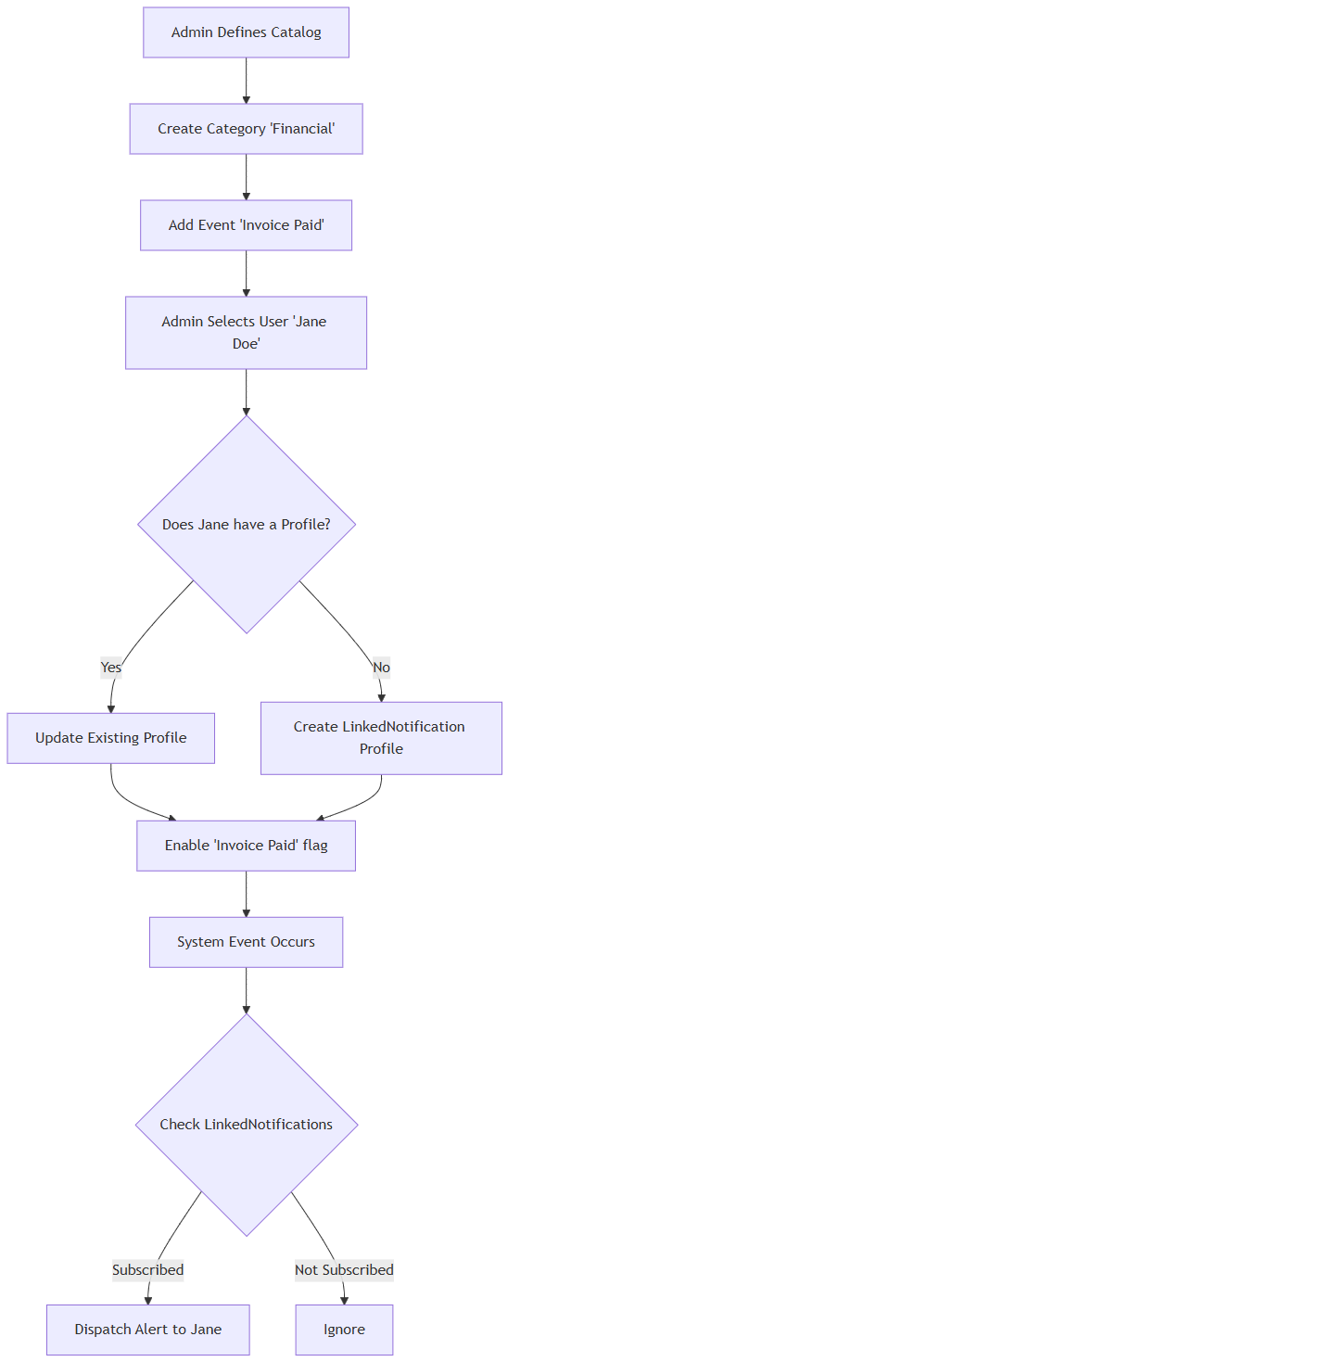
A[Admin Defines Catalog] --> B[Create Category 'Financial']
B --> C[Add Event 'Invoice Paid']
C --> D[Admin Selects User 'Jane Doe']
D --> E{Does Jane have a Profile?}
E -- Yes --> F[Update Existing Profile]
E -- No --> G[Create LinkedNotification Profile]
F --> H[Enable 'Invoice Paid' flag]
G --> H
H --> I[System Event Occurs]
I --> J{Check LinkedNotifications}
J -- Subscribed --> K[Dispatch Alert to Jane]
J -- Not Subscribed --> L[Ignore]

Cross-Chapter Navigation
- Previous Chapter: [CMP-01: Company Configuration](#)
- Next Chapter: [ACT-01: Activity Audit Logging](#)
- Related Chapters: [INV-01: Invoice Management](#) (Generates triggers)

ACT-01: Activity Audit Logging

1. Overview Summary
The Activity Audit Logging module (ACT-01) is the global surveillance engine of the AFC platform. It captures, normalizes, and aggregates telemetry across three primary channels: Internal Staff Operations (`service`), the B2B/B2C E-Commerce Portal (`ecom`), and the Public Marketing Website (`static`). It provides administrators with forensic data regarding user IP behavior, geographical traffic mapping, and multi-device session concurrency.
This chapter reverse-engineers the `userActivity.controller.js` backend, detailing the aggregation pipelines and event tracking mechanisms used to power the platform's security and traffic dashboards.
- Key Business Value: Detects unauthorized access, measures E-Commerce conversion funnels, and ensures employee operational compliance.
- Primary Users: System Administrators, Security Officers, Marketing Managers.

Business Purpose
To maintain a permanent, immutable record of who did what, from where, and on which device, ensuring the platform meets strict enterprise compliance and security auditing standards.

Module Scope
- Session Forensics: Tracking `sessionId`, `ipHash`, and `userAgent` per user.
- Geographical Analytics: Mapping IPs to `Country`, `Region`, and `City`.
- E-Commerce Funnel Tracking: Granular tracking of cart, catalog, and checkout screens.
- System Abuse Detection: Flagging accounts with simultaneous multi-device logins.

5. Business Impact
Without this module:
- Security breaches cannot be traced to an originating IP.
- Marketing teams lose visibility into which countries are driving public website traffic.
- Multi-device account sharing (password abuse) goes undetected.

The Telemetry Aggregation Engine
The system captures raw events and utilizes MongoDB Aggregation Pipelines to synthesize the data into actionable intelligence.

User Forensics (`getUserActivityLogs`)
This controller analyzes internal staff behavior. It runs a `$group` aggregation against the `TenantActivityLogModel` based on `userId`:
- Device Tracking: It calculates `deviceCount` by capturing unique `ipHashes`.
- Session Tracking: It calculates `activeSessions` by counting unique `sessionIds` over a given timeframe.
- Security Flagging: If `deviceCount > 1` or `activeSessions > 1`, the system automatically sets the boolean `hasMultipleSystems: true`. This immediately alerts Administrators to potential credential sharing or compromised accounts.
- State Detection: It accurately calculates `latestLoginAt` and `latestLogoutAt` by running regex matches (`/login/i`, `/logout/i`) against the user's `route` history.

Global Traffic Mapping (`getActivityAnalytics`)
This engine groups data across the `service`, `ecom`, and `static` channels.
- Time-Series Analysis: Enumerates dates over a 30-day default window, calculating total `apiCalls` and `uniqueUsers` per day.
- Geographical Grouping: Uses a `$group` pipeline to map `ipHash` records to a physical `Country` (or "Unknown"). It returns arrays of user density sorted by location.

E-Commerce Screen Profiling (`getEcomScreenWiseVisitors`)
The system provides a conversion funnel perspective by mapping raw URL routes to friendly screen names using a custom `$switch` expression:
- `/preorder/i` $\rightarrow$ Pre-order
- `/(?:^|\/)cart(?:\/|$)/i` $\rightarrow$ Cart
- `/checkout/i` $\rightarrow$ Checkout
- `/catalog/i` $\rightarrow$ Catalog
- `/wish[-_]?list/i` $\rightarrow$ Wishlist
This allows marketing managers to see exactly how many unique users hit the "Cart" versus how many actually hit "Checkout".

Security Interception (`trackStaticActivity`)
To capture public traffic (which lacks an authenticated JWT), the system utilizes an open telemetry endpoint.
- It extracts the physical origin using `req.headers["x-forwarded-for"]` or `req.socket.remoteAddress`.
- Captures the `user-agent` device string.
- Forwards the payload to the `trackPublicStaticEvent` service for hashing and storage.

Data Privacy & Compliance
- IP Hashing: Raw IPs are hashed into an `ipHash` for aggregation, ensuring that broad reporting does not inadvertently expose exact PII identifiers in UI dashboards, while still allowing the system to track unique devices accurately.

Cross-Chapter Navigation
- Previous Chapter: [NOT-01: Notification Management](#)
- Next Chapter: [CAT-01: Catalog Management](#)
- Related Chapters: [AUT-01: Login](#) (Generates login/logout events)

CAT-01: Catalog Management

Overview
The Catalog Management module (CAT-01) governs the hierarchical structure of all physical products and billable services within the AFC platform. It dictates the three-tier taxonomy (Main Category -> Subcategory -> Product) and strictly enforces de normalized database constraints to ensure real-time read performance.
This chapter reverse-engineers the tri-level backend architecture comprising:
1. `maincategoryController.js` (Tier 1)
2. `subCategory.js` (Tier 2)
3. `productcontroller.js` (Tier 3)

Business Purpose
To provide a highly scalable, searchable catalog that populates both the internal CPQ (Configure, Price, Quote) engine and the external B2C/B2B E-Commerce portals.

Module Scope
- Taxonomy Enforcement: Linking Categories to Subcategories.
- Product Provisioning: Managing Products, pricing, stock levels, and descriptive metadata.
- Supplier Audit Logging: Automatically tracking which vendor provided which product at what price point.

Business Impact
If the Catalog module fails:
- The E-Commerce portal displays empty categories, stopping online revenue.
- Estimators cannot build Quotes because the item picker fails to load.
- Vendor historical pricing is lost, preventing procurement negotiation.

The Three-Tier Architecture
The backend strictly enforces a relational taxonomy using MongoDB references.

Tier 1: Main Category
Managed by `maincategoryController.js`.
- Purpose: The root classification (e.g., "Fencing", "Hardware").
- Logic: Simple CRUD. The system enforces global uniqueness on `categoryName` to prevent UI duplication.

Tier 2: Subcategory
Managed by `subCategory.js`.
- Purpose: The secondary classification (e.g., "Vinyl Fencing", "Gate Hardware").
- Integrity Validation: When creating a Subcategory, the controller explicitly checks `MainCategory.findOne({categoryId})`. If the parent does not exist, creation is hard-blocked with a `404` error.
- Denormalization Array: The `Subcategory` schema contains a `products` array, which holds strings of its children's names.

Tier 3: Product
Managed by `productcontroller.js`.
- Creation Mutability: When a Product is created, the system performs a dual-save operation. It saves the `Product` entity, then actively pushes the new `product` (name string) into the parent `scategory.products` array.
- Update Propagation: If a product's name is updated, the controller performs an array-search on the `Subcategory` and rewrites the string index.
- Category Migration: If a product is moved to a different `subcategoryId`, the system actively `pull`s the string from the old parent and `push`es it to the new parent.

Supplier Pricing Injection (Procurement Link)
Products in AFC aren't just display items; they are procurement entities.

Automated Supplier Auditing
During `createProduct`, if the user provides a `supplierId`, the system executes automated historical tracking:
1. Validation: It verifies the `supplierId` against the `getSupplierModel`.
2. Audit Generation: It immediately spawns a `SupplierHistory` record.
3. Payload: The record permanently binds the `supplierId`, `productid`, `quantity`, and `price` together.
4. Business Result: This allows procurement officers to query historical price fluctuations from specific vendors without having to cross-reference raw vendor purchase invoices.

8. High-Level Operations Workflow
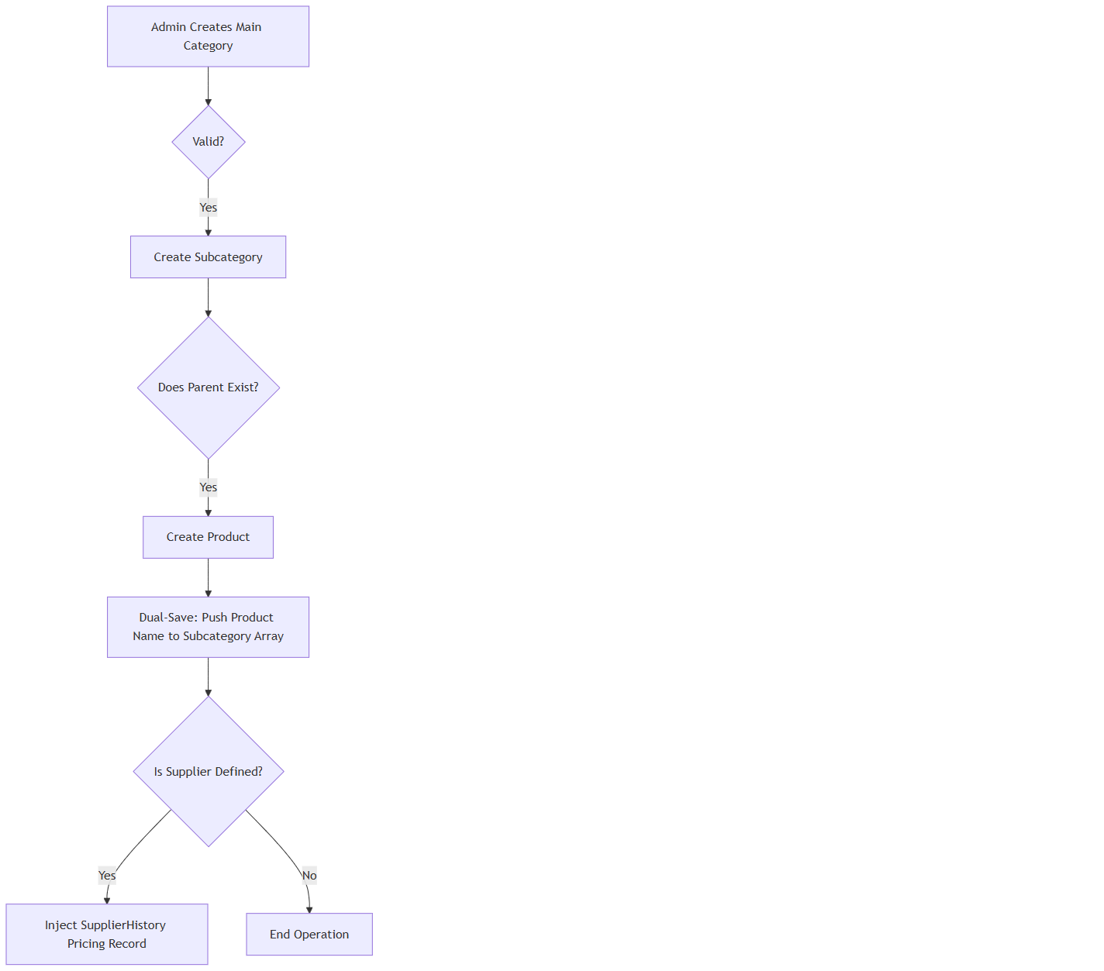
A[Admin Creates Main Category] --> B{Valid?}
B -- Yes --> C[Create Subcategory]
C --> D{Does Parent Exist?}
D -- Yes --> E[Create Product]
E --> F[Dual-Save: Push Product Name to Subcategory Array]
F --> G{Is Supplier Defined?}
G -- Yes --> H[Inject SupplierHistory Pricing Record]
G -- No --> I[End Operation]

Data Integrity & Validation Rules
- Unique Constraints: The system forbids duplicate `product` names within the exact same `categoryId` and `subcategoryId` pairing.

Cross-Chapter Navigation
- Previous Chapter: [ACT-01: Activity Audit Logging](#)
- Next Chapter: [TMP-01: Template Management](#)
- Related Chapters: [EST-01: Quote Management](#) (Consumes Catalog Data), [VEN-01: Vendor Management](#) (Provides Supplier Data)

TMP-01: Template Management

Overview
The Template Management module (TMP-01) dictates the standardized formatting and pre-configured line items for outbound enterprise documents. Specifically reverse-engineered for Quotation Templates, this module allows estimators to generate complex, multi-line quotes instantly by binding reusable templates to specific parent Services.
This chapter reverse-engineers the `Quotation.template.controller.js` and its corresponding service layer, mapping the data structures used to construct dynamic templates and the compliance logic that protects them. Those are same like services but these are not binded with any products just will gave a description of service , unit price .
- Key Business Value: Drastically reduces the manual data-entry time required to generate an estimate while ensuring brand consistency.
- Primary Users: Estimators, Field Sales Staff, General Managers.

Business Purpose
To enforce standardization across all outbound commercial proposals. By utilizing templates, the enterprise guarantees that mandatory line items, localized tax flags (`excludeTax`), and standard service descriptions are never accidentally omitted by field staff.

Module Scope
- Template Creation: Binding structural templates to global `Services`.
- Dynamic Sorting: Client-side style sorting executed dynamically on the backend to handle populated user reference strings.
- Compliance Deletion: Mandatory comment injection upon soft deletion, allowing for seamless recovery.

Business Impact
Without this module:
- Estimators would have to manually type out 50+ line-item quotes, increasing human error.
- Standardized margins could be compromised due to forgotten baseline costs.

Template Architecture & Service Binding
Templates in AFC are not standalone entities; they are highly contextualized.
- When `createQuotationTemplateService` is executed, the template must be created as a new Template
- Business Logic: An estimator quoting a "Vinyl Fence" will only see templates explicitly mapped to the "Vinyl Fence" service. This prevents UI clutter and eliminates the risk of an estimator using a "Roofing" template for a "Fencing" job.

The `excludeTax` Flag
The `getQuotationTemplateService` accepts an `excludeTax` boolean. This allows the creation of specialized templates specifically for B2B Wholesale or Government clients who possess tax-exempt status, allowing the CPQ engine to automatically zero out the taxation arrays.

The Compliance Deletion Workflow
Template definitions form the backbone of the sales pipeline. As such, they are protected by the same strict soft-deletion paradigm as Legal Documents (DOC-01).

Soft Delete with Comment
The `deleteQuotationTemplateService` intercepts the `DELETE` request:
1. Physical Deletion is Blocked: The `findByIdAndUpdate` method is invoked rather than `deleteOne`.
2. State Mutation: It sets `isDeleted: true` and logs the `deletedAt` timestamp alongside the `deletedBy` user ID.
3. Mandatory Auditing: Crucially, it captures the `comments` payload from the UI (defaulting to `"No comment provided"` if bypassed) to explain why the template was retired.

The Reversion Protocol
Because deletion is "Soft", the system provides a `restoreQuotationTemplateService`.
- Validation: It checks `if (!template.isDeleted) throw new Error("Template is already active");` to prevent redundant database writes.
- Restoration: It nullifies the `deletedAt` and `deletedBy` fields, instantly reinstating the template for the sales team.

Advanced Backend Sorting (`getQuotationTemplateService`)
Because templates are heavily populated (referencing `createdBy` and `serviceId`), standard MongoDB sorting fails on referenced fields. The backend implements a specialized sorting algorithm:
- The Problem: Sorting by "Created By" requires sorting by a user's First and Last name, but the template only stores a `ObjectId`.
- The Solution: If `sortBy === 'createdBy'`, the controller retrieves the entire collection (`lean()`), manually maps the `createdBy.firstname` and `lastname` to a lowercased string, and executes a JavaScript `localeCompare()` before returning the payload.

Cross-Chapter Navigation
- Previous Chapter: [CAT-01: Catalog Management](#)
- Next Chapter: [VEN-02: Vendor Deep-Dive](#)
- Related Chapters: [EST-01: Quote Management](#) (Consumes the Quotation Templates)

