AFC Enterprise Product Handbook
Product Overview & Reference Guide
Date: 2026-06-25

Table of Contents
Note: If the Table of Contents below is empty, please right-click on it and select 'Update Field' to generate the page numbers.

1. About AFC Enterprise Product

Executive Project Description
The AFC Enterprise Product is a comprehensive, multi-tenant business operations and customer relationship management (CRM) platform designed to orchestrate the entire lifecycle of service delivery, procurement, and financial settlement. Engineered to standardize complex operational workflows, it unifies B2B/B2C lead ingestion, dynamic quotation templates, vendor payout management, and multi-tier catalog administration into a single, cohesive ecosystem.
Built with an audit-first philosophy, the platform provides deep-dive telemetry into user activities, precise vendor performance metrics (such as payment velocity and overdue liabilities), and strict procurement synchronization. By centralizing these disparate business functions, the AFC platform enables executive stakeholders to make data-driven decisions while ensuring strict compliance, operational transparency, and data governance across the organization.

Core Capabilities
- Centralized CRM & Sales: Streamlines the transition from marketing leads to formalized Service Jobs through an integrated Enquiry, Request, and Quotation pipeline.
- Enterprise Procurement: Automates Vendor tracking, Service Job linkage, and complex multi-payment orchestration.
- Unified Catalog: Maintains a strict three-tier taxonomy (Category -> Subcategory -> Product) mapped to historical supplier data.

Target Audience
- Super Admins & Managers: Platform console for organizational configuration, global subscription management, and systemic oversight.
- Sales & Estimators: Rapidly generate B2B quotes utilizing tax-exempt flags and service-bound templates.
- Finance & Procurement: Seamlessly process complex vendor invoices and monitor enterprise liabilities.

2. How the Platform Works

2.1 The Merchant & POS Core
The central nervous system for operational staff. Managers and owners utilize this module to manage the catalog, orchestrate inventory, assign field staff to jobs, and generate complex B2B financial workflows (Quotes and Invoices).

2.2 The Platform Console
The administrative dashboard for multi-tenant organizations. Facilitates the creation of global Notification architectures, Company branding profiles, and Role-Based Access Controls (RBAC).

ADM-01: User Management

Overview
The User Management module provides centralized control over the application's user directory. It governs the lifecycle of internal user profiles, including creation, role assignment, status toggling, deletion (soft), and restoration, enforcing strict hierarchical permission boundaries.

Purpose
To securely manage workforce access to the AFC ecosystem, ensuring that employees are assigned the correct roles, permissions, and system contexts to perform their daily operational duties while preventing unauthorized escalations.

Business Objectives
- Facilitate the onboarding and offboarding of employees.
- Enforce a strict Role-Based Access Control (RBAC) hierarchy.
- Prevent accidental self-deletion or unauthorized role escalation.
- Maintain a comprehensive audit trail of all user directory modifications.

Module Scope
This module covers the `/users` list view, the `/users/create` and `/users/edit` forms, role-level validations, "deleted" view filtering, and user restoration capabilities. It does not govern external customer portals or public authentication routing.

Business Impact
If the User Management module becomes unavailable or compromised:
- Terminated employees cannot be immediately locked out, creating severe security risks.
- Role-based escalations or demotions cannot be processed, stalling operations.
This module is a Tier 1 Critical System.

Other Module Dependencies
- AUT-01 - Login: User profiles created here determine the credentials evaluated during authentication.
- ADM-02 - Company Profile: Users are bound to the active tenant environment.
- GLB-06 - Activity Timeline: All user mutations generate tracking events.

Security Considerations
- Hierarchical Role Editing: A user can only edit roles that have a strictly lower hierarchy level than their own, preventing privilege escalation.
- Self-Deletion Prevention: The UI and backend explicitly block users from deleting their own active session profile.
- Soft Deletion: "Deleted" users are flagged as `isDeleted: true` rather than physically dropped from the database, preserving historical audit trails on related jobs and invoices.

Complete User Journeys

Create New User (`signup` API)
1. User Action: Admin clicks "Create User" and submits the form on `/users/create`.
2. Front end Validation: Evaluates inputs. Checks role against assignable hierarchy.
3. API Call (`POST /api/v1/users/signup`):
Back end extracts `username` from `req.body`.
Validation: Checks `User.findOne({username})`. If exists, returns `409 Username is already Exist`.
Database Update: Calls `User.create(req.body)`.
Auto-Processing: Generates JWT token via `signToken(newUser.username, newUser.role)`.
4. Final Outcome: Returns 201 Created with JWT and user object. UI redirects to `/users`.

Edit User Role / Details (`updateUser` API)
1. User Action: Admin clicks Edit and submits changes on an existing user.
2. API Payload: Sends `existusername` (the original username) and the updated payload.
3. Backend API (`updateUser` in `user-controller.js`):
Finds user: `User.findOne({ username: existusername })`. Returns 400 if not found.
Username Change Validation: If `username` is provided and !== `existusername`, checks if the new `username` is already taken. If so, returns 400 "The new username is already in use".
Database Update: Calls `User.findOneAndUpdate({ username: existusername }, req.body)`.
4. Final Outcome: Returns 200 OK. UI updates table.

Delete User
1. User Action: Admin executes delete action.
2. API Payload: Sends `{ existusername }` in `req.body`.
3. Backend API (`deleteUser` in `user-controller.js`):
Finds user: `User.findOne({ username: existusername })`.
Database Update: Executes `User.findOneAndDelete({ username: existusername })`.
There is soft-delete `isDeleted` flag updated here as true.
4. Final Outcome: Returns 200 with "User Deleted Successfully !".

Toggle User Status
1. User Action: Admin updates a user's status to "InActive".
2. API Call (`updateRole` in `user-controller.js`):
Payload: `{ username, role, userActive }`.
Database Update: `User.findOneAndUpdate({ username }, { username, role, userActive })`.
System Impact: During login, `exports.login` checks `if (user.userActive === false)`. If false, login is blocked with "Your Account is Deactivated".

Workflow Diagram
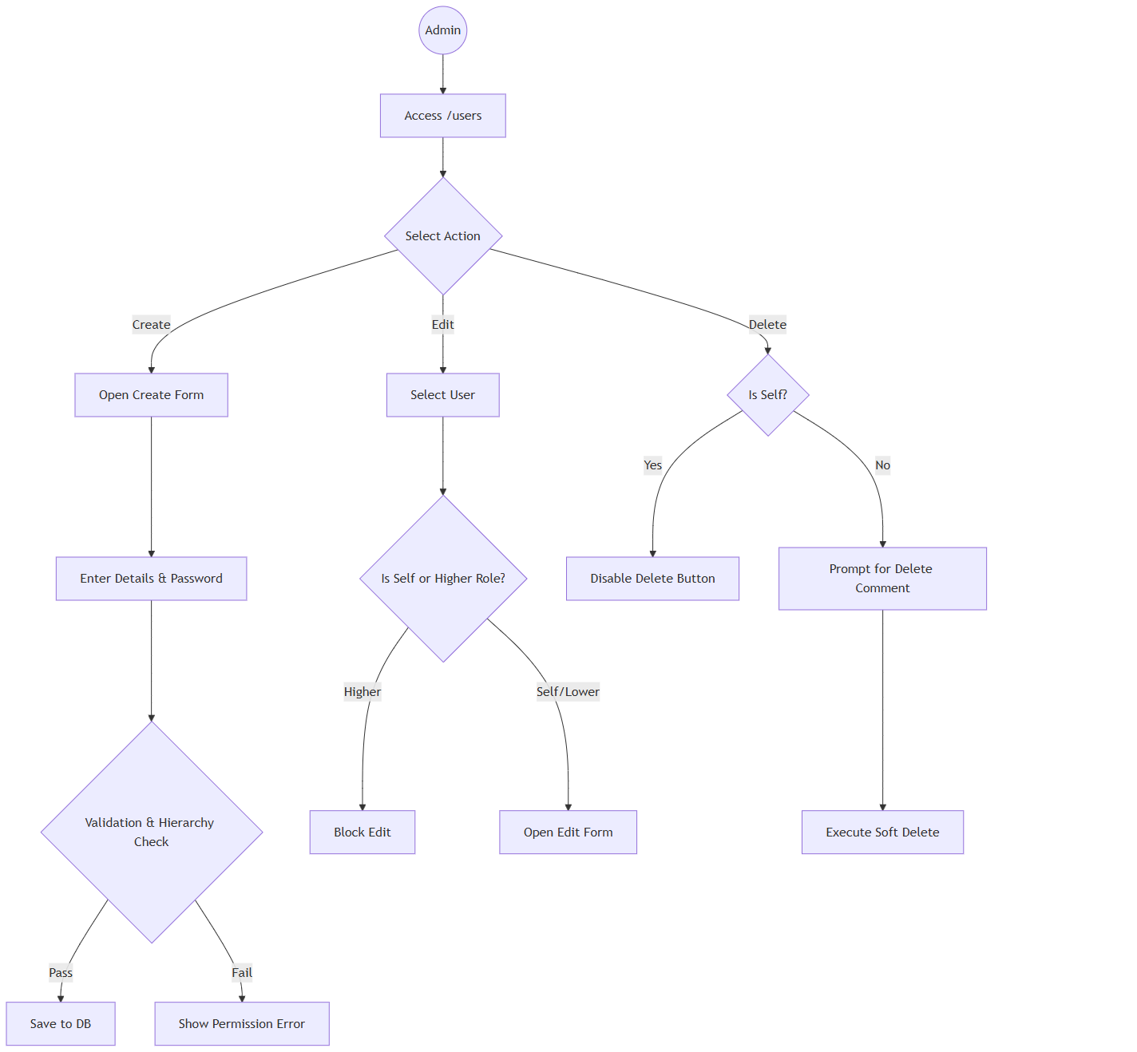
Start((Admin)) --> A[Access /users]
A --> B{Select Action}
B -- Create --> C[Open Create Form]
C --> D[Enter Details & Password]
D --> E{Validation & Hierarchy Check}
E -- Pass --> F[Save to DB]
E -- Fail --> G[Show Permission Error]
B -- Edit --> H[Select User]
H --> I{Is Self or Higher Role?}
I -- Higher --> J[Block Edit]
I -- Self/Lower --> K[Open Edit Form]
B -- Delete --> L{Is Self?}
L -- Yes --> M[Disable Delete Button]
L -- No --> N[Prompt for Delete Comment]
N --> O[Execute Soft Delete]

Sequence Diagram (System Interactions)
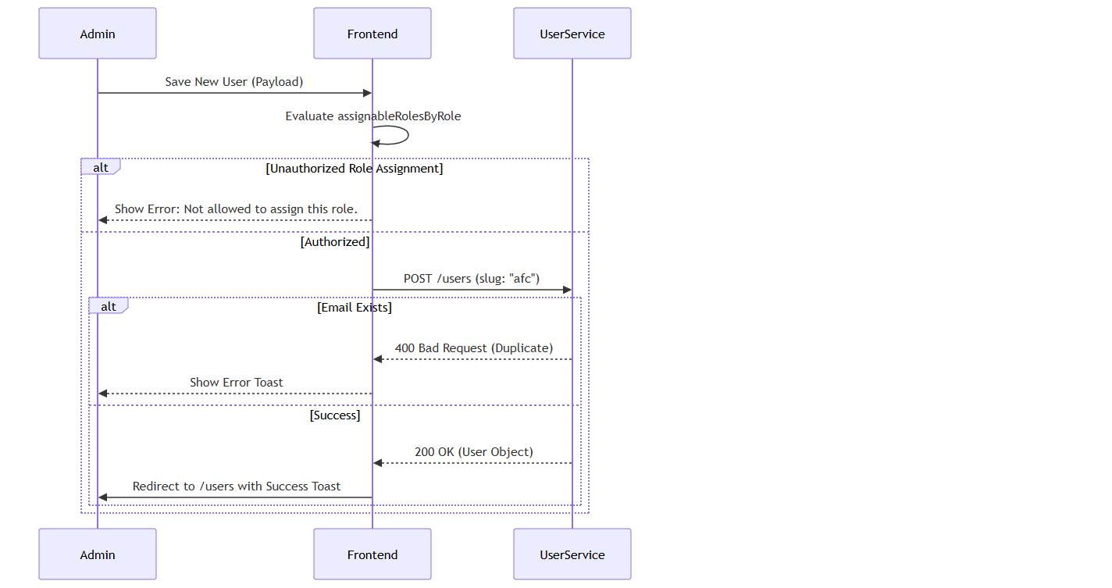
sequenceDiagram
participant Admin
participant Frontend
participant UserService

Admin->>Frontend: Save New User (Payload)
Frontend->>Frontend: Evaluate assignableRolesByRole
alt Unauthorized Role Assignment
Frontend-->>Admin: Show Error: Not allowed to assign this role.
else Authorized
Frontend->>UserService: POST /users (slug: "afc")
alt Email Exists
UserService-->>Frontend: 400 Bad Request (Duplicate)
Frontend-->>Admin: Show Error Toast
else Success
UserService-->>Frontend: 200 OK (User Object)
Frontend->>Admin: Redirect to /users with Success Toast
end
end

Screen Catalogue: User Management

11.1 User List Screen
- Business Purpose: Central dashboard for managing the internal directory.
- Navigation Path: `/users`
- Screen Layout: Top Action Bar (Search, Role Filter, Date Filter, Status Toggle). Main Data Table. Pagination Footer.
- Buttons: "Create User", Action Icons (History, Edit, Delete).
- Loading States: Skeleton loaders during API fetch.
- Empty States: "No users found" with illustration.
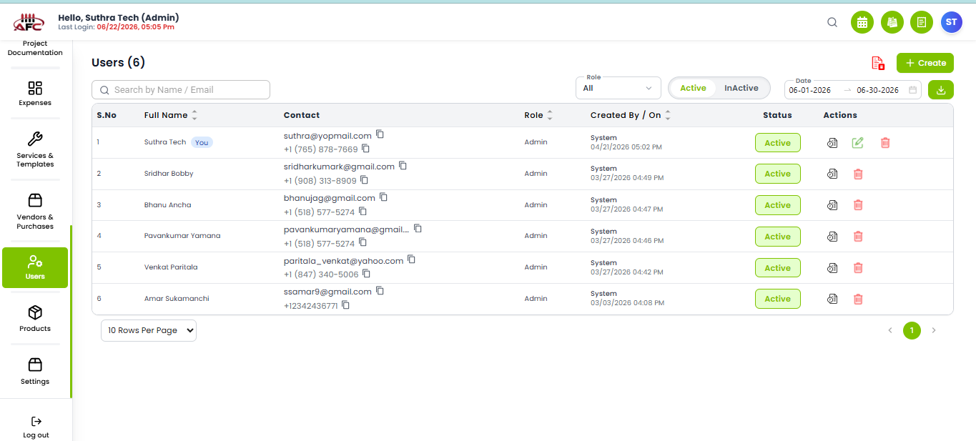
Figure: User List Mockup

Create/Edit User Screen
- Business Purpose: Form to input user profile metadata.
- Navigation Path: `/users/create` or `/users/edit/:id`
- Available Actions: Save, Update, Cancel.
- Validation Behavior: Inline red helper text for required fields or invalid emails.

UI Component Catalog
Component: `UserForm`

Fields
1. Username (Email)
Editable Conditions: Editable during creation. During updates, the original username is sent as `existusername` to allow the backend to track username modifications.
Validation Rule: Must be unique in the `User` collection. If changed to an existing username, backend throws 400.
2. Role
Editable Conditions: Editable by higher-hierarchy users.
Auto-Processing: Used in the JWT token generation (`signToken(username, role)`) and parsed by `exports.restrict(...role)` middleware to guard protected API routes.
3. Status (userActive)
State Bound: `userActive` boolean.
Auto-Processing: Setting to `false` does not delete the user, but prevents the `login` and `loginWithPhone` controllers from issuing a new JWT.

Buttons & Actions
1. Save User Button
API Bound: Triggers `signup` or `updateUser` / `updateRole` based on form context.
2. Delete User Action
API Bound: Triggers `POST` to `deleteUser`.
Auto-Processing: Physically drops the record from the MongoDB collection (`findOneAndDelete`). No soft-delete logic is executed on the backend.

Business Actions

Toggle User Status
- Business Purpose: To temporarily suspend a user without deleting their profile.
- Trigger: Changing the Status toggle in the Edit form to "InActive".
- Business Outcome: User's JWT tokens are invalidated by the backend, immediately preventing login.

14. System & Business Rules
- Hierarchy Verification:
Super Admin (Level 4) can assign/edit: Admin, Manager.
Admin (Level 3) can assign/edit: Manager
- Self-Edit Exception (Not Implemented): A user can always edit their own profile (First Name, Last Name), but the system locks the "Role" and "Status" fields to prevent self-escalation or self-suspension.

Notifications Matrix
Trigger | Recipient | Message Template | Severity | Delivery Channel | Audit Impact
Create Success | Admin | "User created successfully" | Success | UI Toast | Logs Create event.
Delete Success | Admin | "User deleted successfully" | Success | UI Toast | Logs Soft Delete with Note.
Role Error | Admin | "You are not allowed to edit this user role." | Error | UI Toast | Null

Permissions Matrix
Action | Super Admin | Admin | Manager
View Users List | Yes | Yes | Yes
Create User | Yes | Yes | Yes
Edit Own Profile | Yes | Yes | Yes
Delete User | Yes | Yes | Yes
Restore User | Yes | Yes | No

Audit Trail
The following events are recorded centrally for security and compliance:
- User Created: Timestamp, Creator ID, Initial Role.
- User Updated: Changes to Email, Role, or Status.
- User Deleted: Deletion timestamp, Executing Admin ID, Mandatory Delete Comment.

Accessibility
- Status Badges: Use explicit text ("Active" vs "InActive") combined with color (Green/Red) to support color-blind users.

Configuration
- System Roles: Enums configured in `global.constants.ts` (`super_admin`, `admin`, `manager`).

Real Business Scenarios
- Scenario A (Offboarding): A Manager resigns. The Admin opens the User List, searches for the Cashier, clicks Delete, and types "Resigned on 10/12". The user is instantly locked out, but their name remains on all historical Invoices.
- Scenario B (Permission Block): A Manager attempts to create a new "Admin" account. The system evaluates the hierarchy, sees Manager (Level 2) < Admin (Level 3), and removes "Admin" from the available dropdown options.

Business Glossary
- RBAC: Role-Based Access Control.
- Soft Delete: Hiding a record from active views without destroying the underlying database row.
- Hierarchy Level: The mathematical weight assigned to a role (e.g., Super Admin = 4, Cashier = 1).

Traceability References
- Code Evidence: `g:/AFC/afc_react_fe/src/features/users/pages/UserList.tsx`
- Code Evidence: `g:/AFC/afc_react_fe/src/features/users/pages/CreateUser.tsx`
- Code Evidence: `g:/AFC/afc_react_fe/src/constants/global.constants.ts`
- Module Matrix: `ADM-01`

AUT-01: Authentication & Login Management

Overview
The Authentication & Login Management module acts as the primary security gateway for the AFC Enterprise Application. It governs user access, session instantiation, role determination, and global multi-tenant context initialization.

Business Purpose
To securely authenticate authorized users, protect sensitive business data, and automatically load the appropriate organizational context (Company Profile) and user permissions prior to dashboard access.

Business Objectives
- Ensure secure, encrypted credential validation.
- Prevent unauthorized access to the application routes.
- Establish a global user session that dictates subsequent system privileges.
- Retrieve and bind the Tenant (Company) profile for data segregation.

Module Scope
This module covers the initial entry point of the application (`/login`), credential validation API interactions, session cookie establishment, Redux state hydration, and the immediate routing to the Dashboard.

Business Impact
If the Authentication module becomes unavailable:
- No user can access the system.
- Dashboards are entirely unavailable.
- Request and Quote processing halts.
- Job execution tracking halts.
- Invoicing and POS transactions cannot be processed.
- Administration and reporting become inaccessible.
This module is a Tier 1 Critical System.

Other Module Dependencies
Upstream Dependencies (Required to Login)
- ADM-01 - User Management: Dictates the active status and credentials of the user.
- ADM-02 - Company Profile: Provides the tenant context required to route data.
- Authentication API: The back end verification service.
Downstream Dependencies (Impacted by Login)
- CRM-01 - Dashboard: The landing zone post-login.
- CRM / SAL / JOB / INV: All subsequent business workflows rely on the session token generated here.
- ADM-08 - Activity Logs: Audit history depends on the User ID extracted during authentication.

Security Considerations
- Password Storage: Encrypted at rest using secure hashing algorithms (Back end). Client-side "Remember Me" utilizes simple encoding and should be migrated to secure cookie storage.
- JWT Expiration: Tokens are cryptographically signed with explicit expiration horizons.
- Cookie Security: `auth_token` is stored in cookies to persist sessions across browser tabs.
- Session Timeout: If the JWT expires, the API responds with 401 Unauthorized, prompting a forced system logout.
- Brute Force Protection: Managed backend-side via request throttling to prevent rapid password guessing.
- Account Lock Policy: Enforced after consecutive failed attempts.

Reverse-Engineered User Interactions

Execute Login Sequence
Documenting the exact execution flow when a user clicks the "Login" button.
1. User Action: Clicks "Login" button on `/login`.
2. Front end Validation (`LoginForm.tsx`):
Validates `username` using `Yup` email regex (`/^[^\s@]+@[A-Za-z]{3,}\.[A-Za-z]{2,}$/`).
Validates `password` minimum length (6 characters).
3. Local Storage (Remember Me):
If `rememberMe` is checked, stores `rememberedUsername` and encrypts password using `btoa(unescape(encodeURIComponent(text)))`. Stores `rememberMe="true"`.
If unchecked, removes these keys from `localStorage`.
4. API Payload Construction:
`{ username: "...", password: "..." }`
5. Backend API (`POST /api/v1/users/login` in `user-controller.js`):
Checks if `username` and `password` are present (returns 400 if missing).
Queries DB: `User.findOne({ username }).select("+password")`.
Verifies password using `user.comparePasswordInDB`.
Checks `user.userActive === false` (Returns 400 "Your Account is Deactivated" if false).
6. JWT & Tenant Configuration (`signToken`):
Backend queries the `Companies` model: `await Companies.findOne().lean()`.
Reads tenant-specific `tokenExpireTime` from the Company profile.
If exists, sets `expiresIn = ${company.tokenExpireTime}h`. Fallback is `process.env.LOGIN_EXPIRES` or "24h".
Signs JWT payload with `{ username, role }` using `process.env.SECRET_STR`.
7. Return Response:
Sends 200 OK with `token` and `user` object (password removed).
8. Frontend State Hydration:
Stores token in cookies/localStorage.
Dispatches Redux actions to store User and Company Profile context.
9. Dashboard Navigation:
Redirects user to `/dashboard`.

Forgot Password Sequence
1. User Action: Clicks "Forgot Password?" link.
2. Frontend Validation: Form checks email format.
3. API Call (`POST /api/v1/users/forgotPassword`):
Queries DB for email: `User.findOne({ email })`.
Generates random reset token using `user.createResetPasswordToken()`.
Constructs reset URL: `${req.protocol}://${req.get("host")}/api/v1/users/resetPassword/${resetToken}`.
4. Email Dispatch (`sendEmail` utility):
Sends email with subject "Password change request received". Expires in 10 mins.
5. Database Update:
Saves `passwordResetToken` and `passwordResetTokenExpires` to the User document.
6. Frontend Outcome: Displays success toast to user.

WorkflowDiagram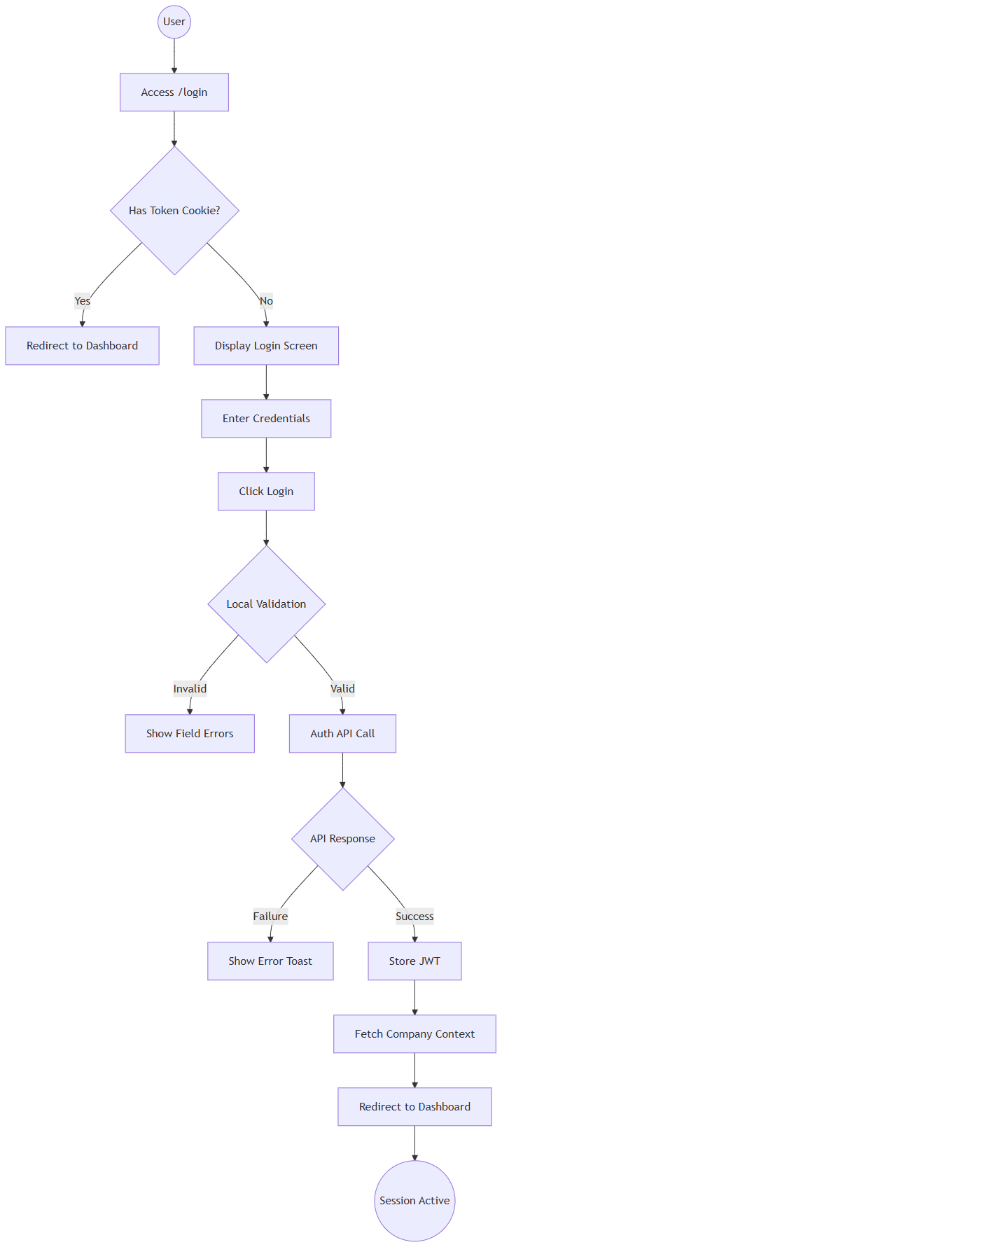
Start((User)) --> A[Access /login]
A --> B{Has Token Cookie?}
B -- Yes --> C[Redirect to Dashboard]
B -- No --> D[Display Login Screen]
D --> E[Enter Credentials]
E --> F[Click Login]
F --> G{Local Validation}
G -- Invalid --> H[Show Field Errors]
G -- Valid --> I[Auth API Call]
I --> J{API Response}
J -- Failure --> K[Show Error Toast]
J -- Success --> L[Store JWT]
L --> M[Fetch Company Context]
M --> N[Redirect to Dashboard]
N --> End((Session Active))

Sequence Diagram (System Interactions)
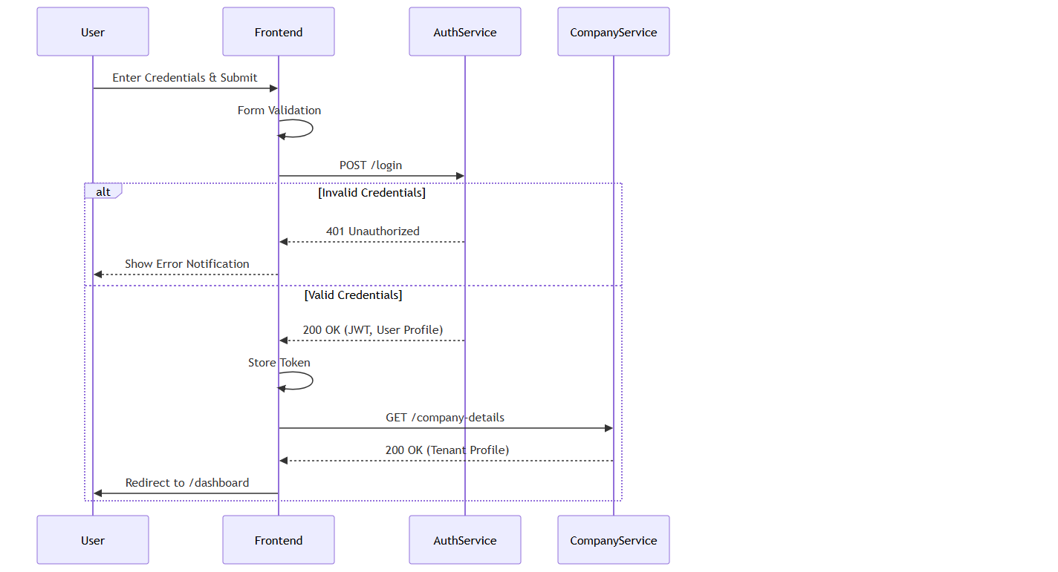
sequenceDiagram
participant User
participant Frontend
participant AuthService
participant CompanyService

User->>Frontend: Enter Credentials & Submit
Frontend->>Frontend: Form Validation
Frontend->>AuthService: POST /login
alt Invalid Credentials
AuthService-->>Frontend: 401 Unauthorized
Frontend-->>User: Show Error Notification
else Valid Credentials
AuthService-->>Frontend: 200 OK (JWT, User Profile)
Frontend->>Frontend: Store Token
Frontend->>CompanyService: GET /company-details
CompanyService-->>Frontend: 200 OK (Tenant Profile)
Frontend->>User: Redirect to /dashboard
end

Screen Catalogue: Login Page
- Business Purpose: Secure credential collection.
- Navigation Path: `/login`
- Screen Layout: Centered white card on a light background.
- Header/Branding: Corporate Logo. Tagline: "Your trusted partner for fencing solutions."
- Buttons: Primary "Login" button. Visibility toggle on password.
- Links: "Forgot Password?".
- Loading States: Login button disables and shows progress spinner when submitting.
- Error States: Top red banner displays API rejection messages. Inline field errors.
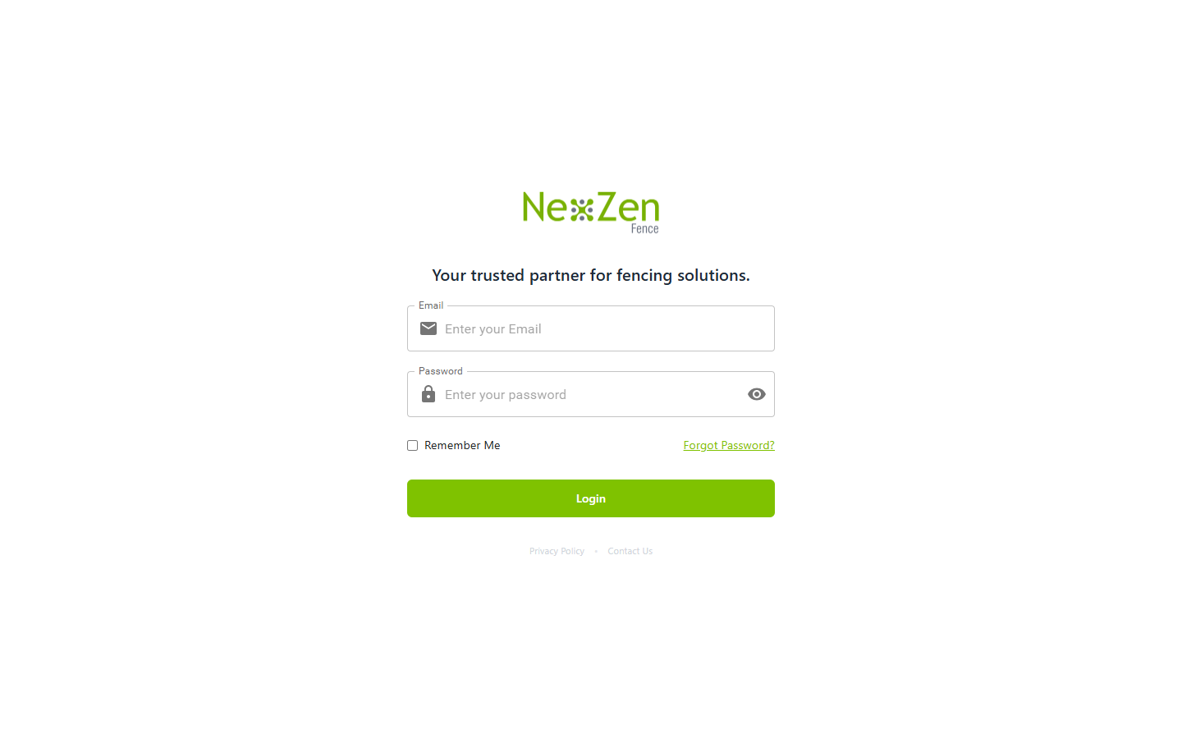

Figure: Login Screen Mockup

UI Component Catalog
Component: `LoginForm.tsx`

Fields
1. Email (Username)
State Bound: `formik.values.username`
Validation Rule: Must match standard Email regex (`/^[^\s@]+@[A-Za-z]{3,}\.[A-Za-z]{2,}$/`). Note: Phone regex is currently commented out in source code (`// phoneRegex.test(value)`).
Auto-Processing: If user types numbers and length > 10, the input rejects further keystrokes (`if (/^\d$/.test(value) && value.length > 10) return;`).
2. Password
State Bound: `formik.values.password`
Validation Rule: Minimum 6 characters. Required.
UI Interaction: Includes a toggle button to switch `type` between "password" and "text" using the `showPassword` state.
3. Remember Me (Checkbox)
State Bound: `rememberMe`
Auto-Processing: On submit, if true, executes simple Base64 `encrypt()` on password and stores it in browser `localStorage` along with username.

Buttons & Links
1. Login Button
Visible Conditions: Always visible.
Permissions: Public.
Action Bound: `formik.handleSubmit`.
Auto-Processing: Disables itself and shows `<CircularProgress />` when `isLoading` is true.
2. Forgot Password? Link
Visible Conditions: Always visible.
Action Bound: React Router `<CustomLink>` routing to `/forgot-password`.

Business Actions

Execute Login
- Business Purpose: Authenticate user against the directory.
- Trigger: Click "Login" button.
- Permissions: Public.
- Validation: Form validates inputs before dispatch.
- Business Outcome: JWT received, Company Context hydrated, user granted access.

System & Business Rules
- Tenant Context Initialization: During authentication, the application automatically associates the user with the correct company environment to ensure that all subsequent data access is restricted to that organization's records. The current implementation is configured for a single tenant ("AFC"). Future SaaS deployments should support dynamic tenant selection without requiring application-specific builds.
- Pre-flight Error Cleanup: Navigating away from the page instantly flushes errors so stale alerts don't persist on return.

Notifications Matrix
Trigger | Recipient | Message Template | Severity | Delivery Channel | Retry Behavior | Audit Impact
Success | User | "Login Successful! Welcome back!" | Success | UI Toast | N/A | Logs success event.
Failure | User | Dynamic API Reason | Error | UI Toast & Banner | Manual Retry | Logs failure event.

Permissions Matrix
Action | Super Admin | Admin | Manager
View Login | Yes | Yes | Yes
Execute Login | Yes | Yes | Yes
Logout | Yes | Yes | Yes
Use "Remember Me" | Yes | Yes | Yes
Forgot Password | Yes | Yes | Yes
Reset Password | Yes | Yes | Yes
View Company Context | Yes | Yes | Yes

Audit Trail
The following events are recorded centrally for security and compliance:
- Successful Login
- Failed Login / Unauthorized Access Attempt
- Logout
- Session Expiry
- Password Reset
- Remember Me Enabled
- IP Address & Device Capture

Accessibility
- Keyboard Navigation: Fully supported (Tab to navigate fields, Enter to submit).
- Screen Readers: ARIA labels applied to password visibility toggle.
- Focus Management: Input fields outline with primary brand color on focus.

Configuration
- Password Policy: Managed via backend configurations.
- Session Timeout: JWT Expiry duration (Back end).
- Tenant Slug: "AFC" (Front end) based on company .
- Redirect URL: `/dashboard` (Frontend).

Real Business Scenarios
- Scenario A (First Time User): An Admin receives their credentials. They log in, view the success notification, and immediately see the dashboard populated with AFC data.
- Scenario B (Invalid Credentials): A user fat-fingers their password. The UI instantly prevents access, logs the failed attempt for security auditing, and shows an error banner.
- Scenario C (Network Failure): A user loses Wi-Fi while submitting. The system times out after 30 seconds and cleanly displays a retry prompt.

Business Glossary
- JWT: JSON Web Token used for secure transmission of authentication claims.
- Tenant / Company Context: The specific organizational boundary isolating business data.
- Session: The active period of authorized engagement with the application.
- Authentication: Verifying user identity.
- Authorization: Verifying user access privileges.

Traceability References
- Code Evidence: `g:/AFC/afc_react_fe/src/features/auth/pages/LoginPage.tsx`
- Code Evidence: `g:/AFC/afc_react_fe/src/features/auth/components/LoginForm.tsx`
- Module Matrix: `AUT-01`

CMP-01: Company Profile & Configuration

Overview
The Company Configuration module (CMP-01) is the global settings engine of the AFC platform. It dictates how the multi-tenant architecture identifies the specific enterprise, calculates delivery feasibility via Google Maps, secures public payment keys, and maintains an immutable audit trail of critical operational settings.
This module governs the enterprise's root configuration. It details the `Company-controller.js` logic including multi-tenant database provisioning, the Google Maps API distance calculator, and the `UpdateAuditModel` integration for configuration tracking.
- Key Business Value: Centralizes global variables (taxes, delivery radii, branding) ensuring consistency across all operational modules.
- Primary Users: Admins
- Critical Success Factor: Maintaining absolute separation of sensitive payment gateway keys while exposing active payment methods to public front ends.

Business Purpose
To provide a secure, centralized configuration hub that dictates how the AFC platform behaves operationally, financially, and visually for a specific tenant without requiring code deployments.

Module Scope
This module encompasses:
- Tenant Creation & Initialization
- Global Profile Data (Address, Contact, Logo)
- Delivery Distance Gating (Google Maps Routing)
- Secure Payment Gateway Configuration
- Immutable Configuration Audit Trail

Global Configuration Matrix
The system tracks 20 distinct business-critical fields. Modifying any of these fields triggers an immediate audit log to prevent unapproved operational shifts.
Configuration Category | Tracked Fields | Business Impact
Identity & Branding | `companyName`, `email`, `phone`, `logo`, `colorTheme` | Customer-facing documents and portal UI.
Operational Logistics | `deliveryDistance`, `address`, `startTime`, `endTime`, `timezone` | Validating online enquiries
Financial Settings | `creditCardTax`, `payment_settings`, `zelleConfig` | Surcharges on payments and active gateways.
Legal Compliance | `paymentTermsAndConditions`, `quoteTermsAndConditions`, `invoiceTermsAndConditions` | Legally binding text rendered on PDFs.

Delivery Gating Engine (`CheckAddress`)
The system prevents out-of-bounds orders by strictly validating customer addresses against the company's defined `deliveryDistance`.

Google Maps Route Computation
When a customer attempts to book a service or request a quote, the `CheckAddress` controller intervenes:
1. Origin Calculation: Extracts the company's physical address.
2. Destination Evaluation: Evaluates the target string or `lat/lng` payload.
3. API Dispatch: Dispatches a `POST` request to `routes.googleapis.com/directions/v2:computeRoutes` using `travelMode: "DRIVE"`.
4. Feasibility Check: Converts meters to miles. If the driving distance exceeds `company.deliveryDistance`, the API strictly returns `isDeliverable: false` and a rejection message.

Secure Payment Configuration (`getActivePaymentsOptim`)
AFC supports multiple payment modalities (Zelle, Bank Transfer, Credit Card).

Key Scrubbing Architecture
Public portals (like Quote Acceptance) need to know which payment methods are active, but must never be exposed to the private API keys.
- The backend iterates over `paymentTypes`.
- For every active method, the `sanitizeConfig` method aggressively strips `secret_key`, `private_key`, and `password` from the JSON object before returning it to the frontend.
- Business Result: Public frontends can safely render the correct payment UI without risking API credential leakage.

Immutable Audit Trail (`getCompanyHistory`)
Modifying global variables is dangerous. The system enforces strict accountability.

Multi-Tenant Auditing
- When `updateCompanyDetails` fires, the backend dynamically connects to the tenant's specific `UpdateAuditModel`.
- It iterates through the 20 tracked fields using a `valuesDiffer` comparator.
- If a change is detected (e.g., `deliveryDistance` changed from `50` to `75`), it pushes an immutable log containing `updatedBy`, `changedFields`, and `previousValues`.
- The `getCompanyHistory` controller synthesizes this raw JSON into a human-readable timeline for Administrators to review.

Tenant Provisioning Workflow
When a new enterprise is onboarded (`createCompany`):
1. Validation: Mandates Company Name, Email, Phone, and Admin Username.
2. Slug Generation: Creates a unique `slug` (e.g., `company_1719313200`) mapped to their public URL `https://pos.evergreenfarmsusa.com/{slug}`.
3. Database Instantiation: Binds the `dbName` and creates a default Admin user (`sampleData`) inside the newly segregated database.

CRM-01: Customer Management

Overview
The Customer Management module (CRM-01) is the foundational data pillar of the AFC enterprise ecosystem. It establishes a Single Source of Truth (SSOT) for all client identities, preventing data fragmentation across the sales lifecycle. By rigorously linking Enquiries, Requests, Quotations, Jobs, and Invoices back to a centralized customer profile, this module ensures accurate financial reporting, cohesive communication, and deep longitudinal analytics.
The Customer Management module governs the creation, enrichment, and tracking of client records. It provides a view of all historical interactions, from their very first Enquiry to their latest paid Invoice.
- Key Business Value: Prevents duplicate lead entry, aggregates lifetime customer value, and enables precise territory/property management.
- Primary Users: Sales Managers, Admins.
- Critical Success Factor: Maintaining a zero-duplication database via strict phone/email uniqueness constraints at the point of entry.

Business Purpose
To maintain a unified, highly accurate directory of clients that serves as the relational anchor for every transaction entity within the AFC platform.

Module Scope
This module covers the `/customers` directory view, the `/customers/create` and `/customers/edit` forms, the comprehensive `/customers/:id` detail view, and the automated duplicate detection engine.

Expanded Dashboard Analytics
The `/customers` dashboard provides real-time statistical cards reflecting the health of the CRM database.
KPI Card | Business Meaning | Formula | Manager Action Required
Total Customers | Total size of the addressable database. | Count of all `isDeleted: false` records. | None
New Customers | Growth rate of new business. | Customers created in the last 30 days. | Evaluate marketing campaign ROI.
Return Customers | Brand loyalty and lifetime value indicators. | Customers with > 1 completed Job. | Target for loyalty programs.
Active Leads | Prospects currently in the funnel. | Customers linked to "Pending" Enquiries. | Ensure follow-up SLAs are met.

Drill-down behavior: Clicking any card instantly applies the corresponding filter to the main data table below.

Customer Lifecycle
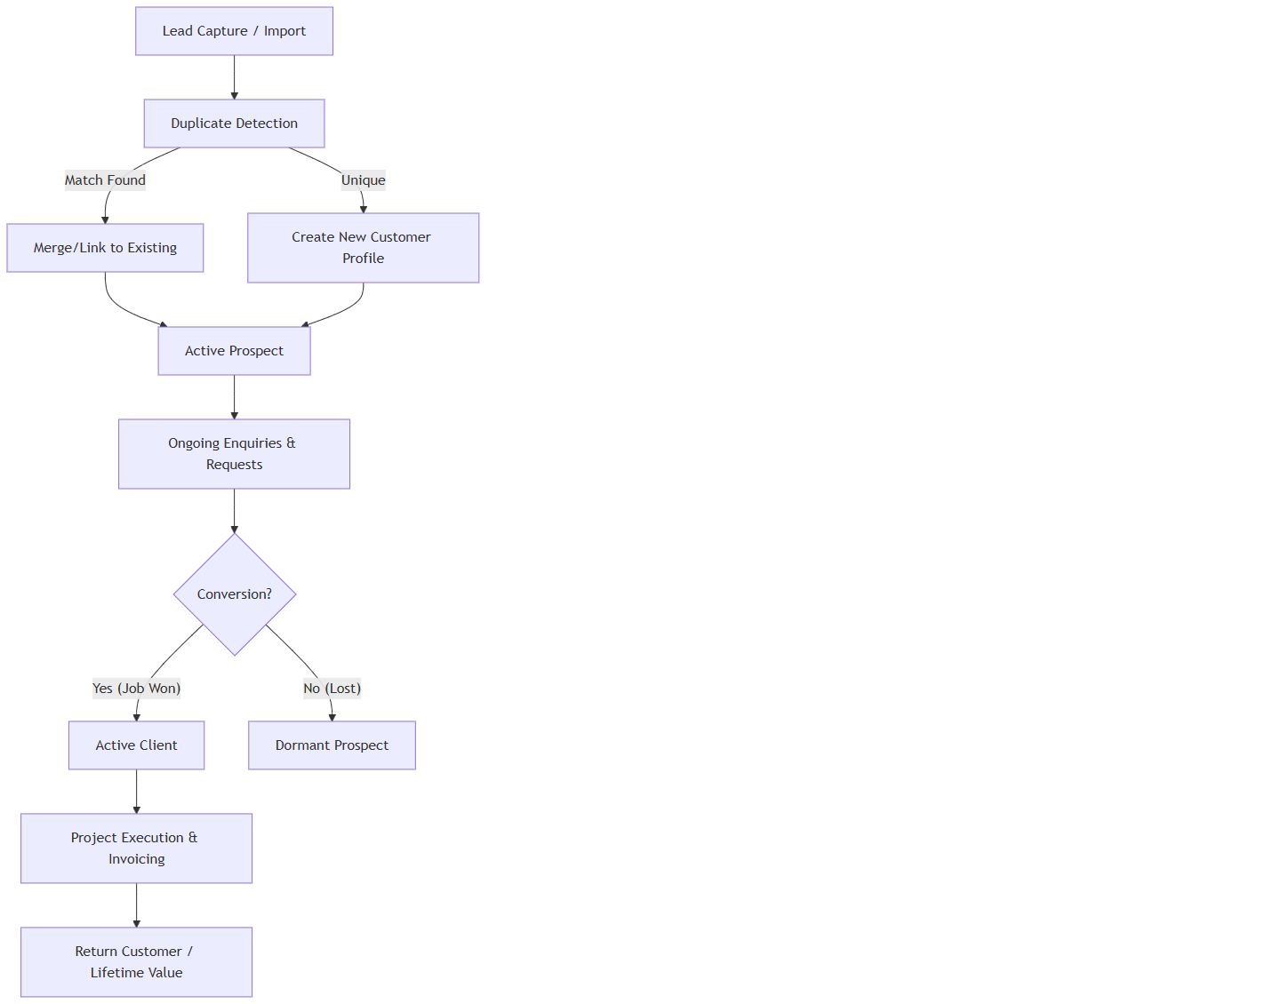
A[Lead Capture / Import] --> B[Duplicate Detection]
B -- Match Found --> C[Merge/Link to Existing]
B -- Unique --> D[Create New Customer Profile]
C --> E[Active Prospect]
D --> E
E --> F[Ongoing Enquiries & Requests]
F --> G{Conversion?}
G -- Yes (Job Won) --> H[Active Client]
G -- No (Lost) --> I[Dormant Prospect]
H --> J[Project Execution & Invoicing]
J --> K[Return Customer / Lifetime Value]

Customer Validations & Deletion Logic
A core capability of CRM-01 is preventing database fragmentation and protecting transactional integrity, enforced by `Client-controller.js`.

Contact Detail Validations
- Duplicate Prevention: When editing (`editClient`) or creating, the system iterates over `emailDetails`. If the email exists on another client, it throws a `409 Conflict`: "Email already exists with another customer."
- Minimum Contact Enforcement: The backend enforces that a customer must have at least one active contact vector. If a user tries to delete all emails and phones, it throws a `400 Bad Request`: "At least one contact detail (Email or Phone) is required."

Strict Deletion Governance
Contrary to standard soft-delete models, AFC enforces strict deletion blocking based on relational integrity (`deleteClient`):
1. Request Check: The system queries the `requests` collection.
2. Quote Check: If requests exist, it queries the `quotations` collection.
3. Hard Block (Quote): If a quote exists, deletion is blocked: "Cannot delete this customer. A quote has already been created for this customer (Quote #[ID]). Please delete the quote first..."
4. Hard Block (Request): If no quotes exist, but active requests exist, it throws: "Customer cannot be deleted because they have active requests."
5. Successful Deletion: Only if no requests or quotes exist will the system proceed to delete the profile.

Screen Catalogue: Customer Management

Customer Detail View
- Business Purpose: Provide a unified timeline of every interaction the company has ever had with the client.
- Navigation Path: `/customers/:id`
- Screen Layout:
Header: Name, Primary Contact, Status Pill, LTV Summary.
Left Column: Permanent contact details, associated addresses, Lead Source.
Main Column (Tabs): Enquiries (Count), Requests (Count), Quotes (Count), Jobs (Count), Invoices (Count).
- Audit Panel: A scrolling chronological timeline of all state changes, phone calls logged, and emails sent.

Field & Form Documentation
Field | Required | Input Type | Validation Rules | Business Reason
First/Last Name | Yes | Text | Letters only. | Primary identity.
Primary Email | No | Email | Standard regex. Unique. | Primary digital vector.
Contact Numbers | Yes | Array | Min 1. 10 digits. Unique. | Critical for field staff communication.
Property Details | Yes | Sub-form | Must include Street, City, State, Zip. | Required for routing site visits and scheduling Jobs.
Lead Source | No | Dropdown | Event, Referral, Web, etc. | Marketing ROI tracking.

Assignment & Follow-up Workflow
While individual Enquiries are assigned to Reps, the Customer profile itself has an "Account Manager" (Owner).
- Follow-up Reminders: The system scans the `followUpDate` of all related Enquiries. If overdue, the Customer is flagged in red on the dashboard & everyday admin will get notified based on their notification settings on over due enquiries.

Customer Property Management
Customers can have multiple properties (e.g., Commercial landlords).
- Each Property contains distinct lat/long coordinates, gate codes, and access notes.
- When generating a Request or Job, the specific Property must be selected from the Customer's array.

Notifications & Audit Trail
When a customer profile is updated, the backend strictly orchestrates audit logging and notifications:
- Diff Tracking: The system calculates a diff between `previousValues` and `latestValues`.
- Action History: A new record is pushed to the `actionHistory` array on the client document detailing exactly which fields changed.
- Audit Collection: A secondary push is sent to the `UpdateAudit` model for system-wide compliance tracking.
- Alert Dispatch: `notifyUsers("Customer_Updated")` fires an SMS and Email to staff detailing the specific field changes using the `genericAlert.ejs` template.

Validation Rules
- Address Geocoding: The system attempts to validate the entered Zip Code against the State.
- Phone Standardization: All numbers are stripped of special characters `+()-` before saving to ensure database uniformity.

Notifications & Alerts
Trigger | Recipient | Message Template | Severity | Delivery Channel | Audit Impact
New Customer Created | Manager | "New Customer Profile Created : [Name]" | Info | UI | Logs Creation Event
Duplicate Attempt | Executing User | "A customer with this phone number already exists." | Warning | UI Toast | Null
Customer Restored | Admin | "Customer [Name] restored to active directory." | Success | UI Toast | Logs Restore Event

Reporting & Exports
The `/export/customers` facility generates a comprehensive CSV.
- Business Purpose: Monthly marketing newsletter synchronization and offline backup.
- Audience: Marketing Manager, Super Admin.
- Filters Applied: Date Range, Status, Lead Source.

Accessibility
- Contrast Compliance: All status pills (New, Return, Lead) exceed WCAG AA contrast ratios against their backgrounds.
- Mobile Usability: The Customer view stacks the Left Column (Contact Info) above the Main Tabs for field staff viewing on mobile devices.

Technical Design Appendix (Traceability References)
- Component Evidence: `g:/AFC/afc_react_fe/src/features/clients/pages/ClientList.tsx`
- Component Evidence: `g:/AFC/afc_react_fe/src/features/clients/pages/ClientDetails.tsx`
- API Binding: `customerService.getClients(params)`
- Module Identifier: `CRM-01`

Visual Module Relationship Map
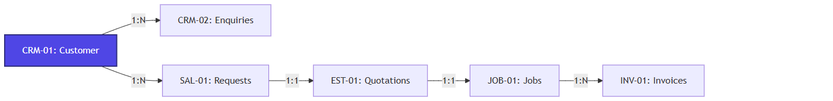
A[CRM-01: Customer] -->|1:N| B[CRM-02: Enquiries]
A -->|1:N| C[SAL-01: Requests]
C -->|1:1| D[EST-01: Quotations]
D -->|1:1| E[JOB-01: Jobs]
E -->|1:N| F[INV-01: Invoices]

style A fill:#4f46e5,stroke:#312e81,stroke-width:2px,color:#fff

CRM-02: Enquiry Management

Overview
The Enquiry Management module serves as the primary entry point for all prospective business opportunities within the AFC ecosystem. It provides comprehensive lifecycle tracking for leads from initial capture through assessment, site visitation, and eventual conversion into actionable Requests or formal Quotations.

Business Purpose
To systematically capture, assign, and mature prospective business leads into revenue-generating projects, ensuring no opportunity is lost due to communication breakdowns or missed follow-ups.

Business Objectives
- Centralize all inbound prospect communications.
- Enforce standardized data collection (contact details, address, service interests).
- Facilitate lead routing to appropriate sales personnel.
- Monitor lead maturation through explicit status gating and follow-up SLAs.

Module Scope
This module covers the `/enquiry` dashboard, dynamic statistical analysis of lead health, creation and modification forms, bulk import facilities, and the mechanisms for converting enquiries into downstream Sales Requests.

Business Impact
If the Enquiry Management module becomes unavailable:
- New prospective business cannot be logged, directly impacting revenue pipelines.
- Sales personnel lose visibility into pending follow-ups, resulting in lost deals.
- Conversion analytics fail, obscuring marketing ROI.
This module is a Tier 1 Revenue-Critical System.

Other Module Dependencies
- AUT-01 - Login: Verifies the user attempting to log or manage the enquiry.
- CRM-01 - Customer Management: Matches incoming enquiries against existing client profiles to prevent duplication.
- SAL-01 - Requests: Enquiries successfully validated are converted into formal Requests.
- EST-01 - Quotations: Direct pipeline for pricing estimation.

8. High-Level Business Process
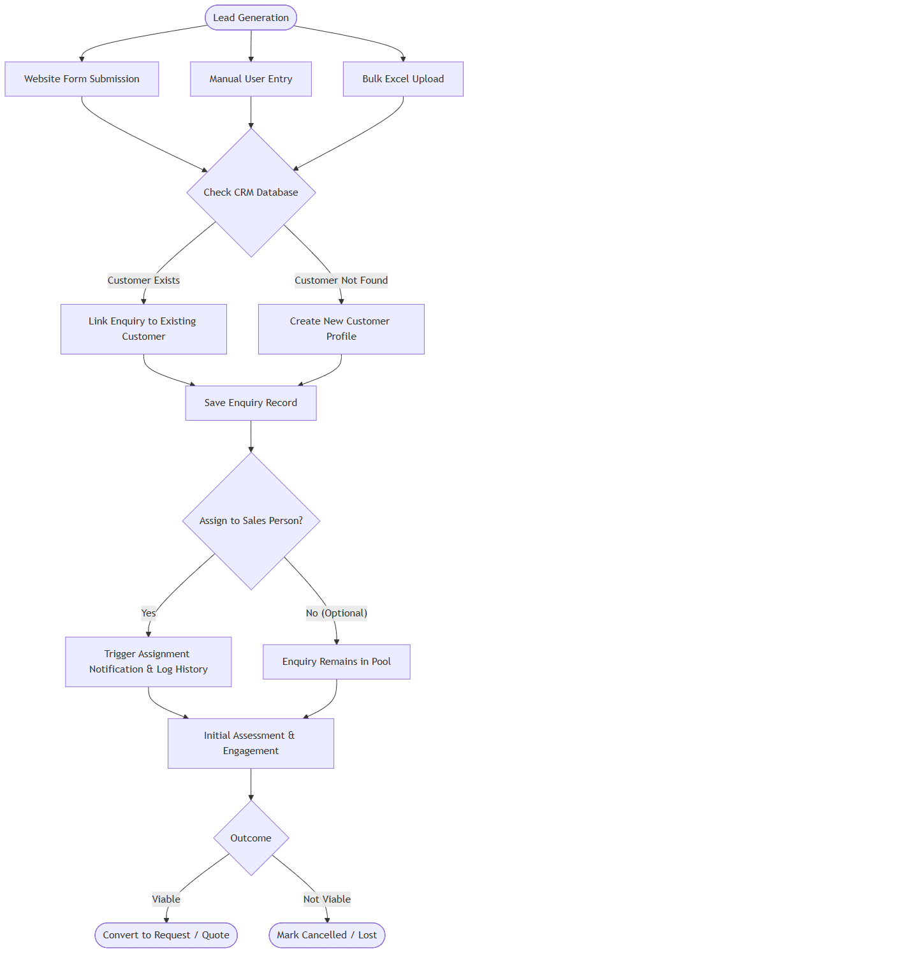
A1([Lead Generation]) --> A2[Website Form Submission]
A1 --> A3[Manual User Entry]
A1 --> A4[Bulk Excel Upload]

A2 --> B{Check CRM Database}
A3 --> B
A4 --> B

B -- Customer Exists --> C[Link Enquiry to Existing Customer]
B -- Customer Not Found --> D[Create New Customer Profile]

C --> E[Save Enquiry Record]
D --> E

E --> F{Assign to Sales Person?}
F -- Yes --> G[Trigger Assignment Notification & Log History]
F -- No (Optional) --> H[Enquiry Remains in Pool]

G --> I[Initial Assessment & Engagement]
H --> I

I --> J{Outcome}
J -- Viable --> K([Convert to Request / Quote])
J -- Not Viable --> L([Mark Cancelled / Lost])

Expanded Enquiry Lifecycle
- Lead Capture: Manual entry via UI or bulk import via Excel.
- Initial Assessment (Draft/Pending): The lead is reviewed for completeness.
- Assignment: The lead is routed to a specific Estimator or Sales Representative.
- Engagement (Site Visit Initiated/Complete): Physical inspection of the prospect's requirements.
- Conversion (Converted to Request/Quote): The prospect is deemed viable and moves into the active sales pipeline.
- Archival/Cancellation: Dead leads are marked as Cancelled but retained for historical analytics.

Complete User Journeys

Reverse-Engineered Public Enquiry Creation (`createEnquiryControllerForStatic`)
When a lead is generated from the public website, the system executes a sophisticated multi-step creation flow:
1. Auto-Customer Generation: The system intercepts the enquiry data and immediately forces `ClientService.createClientWithCartStatic` to generate a new Customer Profile behind the scenes, injecting `channelType: 'website'` and `leadSocial: 'Website'`.
2. Enquiry Linking: It then saves the Enquiry, explicitly binding `customerId` to the newly minted client.
3. Admin Alert Dispatch: The controller queries the `users` collection for all `"super_admin"` and `"admin"` roles where `"notification.email": { $ne: false }`. It dispatches an `adminNewEnquiry.ejs` email alert to these admins and the main company email.
Note: Manual internal creation (`createEnquiryController`) bypasses auto-customer generation but enforces a strict `11000` duplicate key catch on the email field, throwing: "An enquiry with this email already exists".

Bulk Lead Import
The `/importEnquiriesExcelController` and `validateExcelController` govern mass ingestion:
1. File Constraint Validation: The system strictly rejects payloads `> 10MB` or extensions outside of `[.xls, .xlsx]`.
2. Pre-flight Validation: Before inserting rows, it runs a validation check. If it detects internal sheet duplicates, it attaches a `duplicateEmailWarning` array to the API response.
3. Insertion: Valid rows are routed to `importEnquiriesFromExcel` for batched processing.

Enquiry Conversion
1. User Actions: User views an Enquiry detail. Clicks "Convert to Request".
2. System Behavior: System locks the Enquiry status and generates a linked Request entity.
3. Business Rules: An Enquiry cannot be converted if it lacks mandatory contact definitions or service interests.
4. Final Outcome: The record status changes to "Converted to Request".

Workflow Diagram(Creation & Validation)
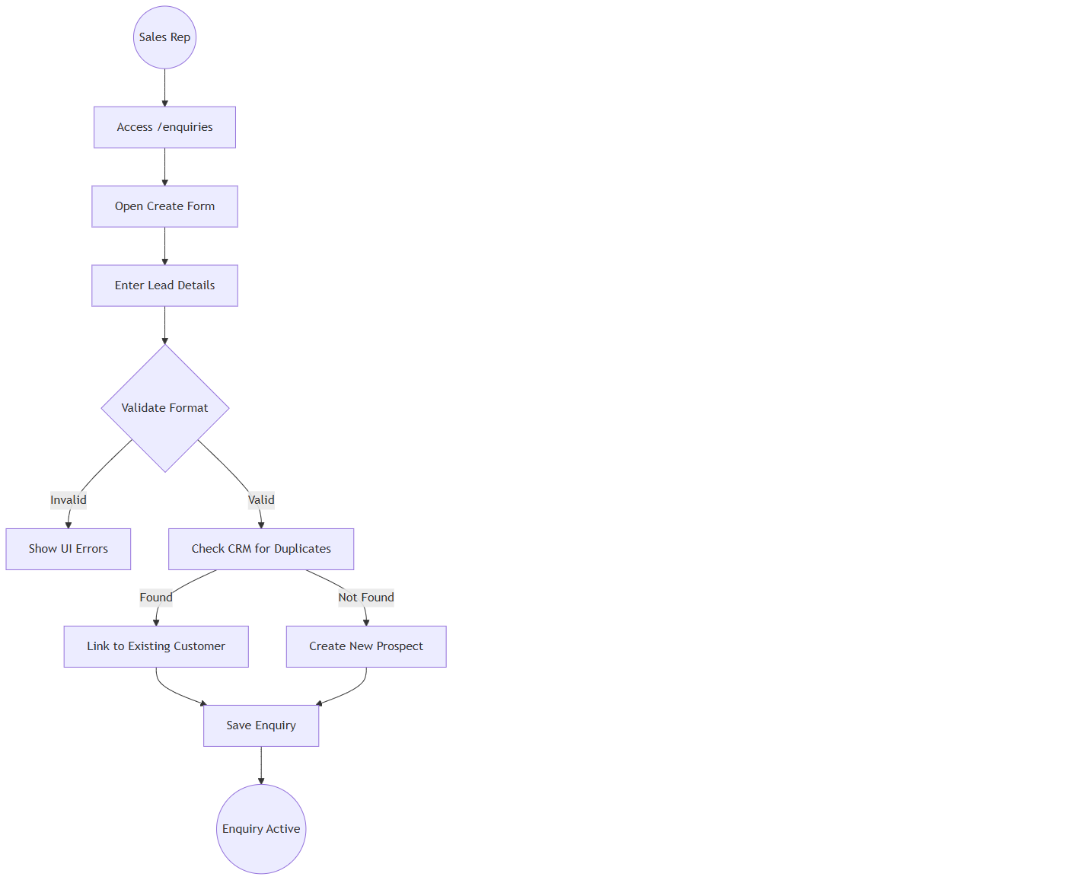
Start((Sales Rep)) --> A[Access /enquiries]
A --> B[Open Create Form]
B --> C[Enter Lead Details]
C --> D{Validate Format}
D -- Invalid --> E[Show UI Errors]
D -- Valid --> F[Check CRM for Duplicates]
F -- Found --> G[Link to Existing Customer]
F -- Not Found --> H[Create New Prospect]
G --> I[Save Enquiry]
H --> I
I --> End((Enquiry Active))

Screen Catalogue: Enquiry Management

Enquiry Dashboard
- Business Purpose: Provide a macro-view of the sales funnel.
- Navigation Path: `/enquiries`
- Screen Layout: Collapsible Statistical Overview Cards at the top. Advanced Filtering Bar. Main Data Table.
- Statistical Cards: Total Enquiries, Drafts, Pending (Overdue), Pending from AFC, Pending from Customer, Partially Converted, Site Visit Initiated, Site Visit Complete, Converted to Request/Quote, Cancelled.
- Buttons: "Create", "Upload Excel", "Export".
- Loading States: Skeleton grid for stats cards and table rows.

Enquiry Form
- Business Purpose: Data entry for prospect details.
- Available Actions: Save, Link Customer, Assign Rep.

Field & Form Documentation
Field | Required | Input Type | Validation Rules | Business Reason
First/Last Name | Yes | Text | Letters and spaces only. | Accurate prospect identification.
Email | Conditional | Email | Standard regex validation. | Primary digital communication vector.
Phone Number | Yes | Array | Must be exactly 10 digits (US/India normalized). Cannot be identical repeating digits. | Primary direct communication vector.
Services Interested | Yes | Multi-Select | Must select at least one core offering. | Dictates which operational team handles the lead.
Follow-up Date | Yes | DatePicker | Must be a valid calendar date. | Enforces SLA and prevents leads from going stale.
Lead Source | No | Dropdown | Event, Referral, Website, Campaign, Other. | Crucial for marketing ROI analytics.

Business Actions
- Assign user: Transfers ownership of the lead. Generates an assignment history log.
- Log Interaction: Records a call, email, or meeting note against the lead.
- Convert: Transitions the lead into the Sales Request pipeline.

Validation Rules
- Duplicate Prevention: Before creating an entirely new customer profile, the system evaluates the provided phone and email against the existing CRM database. If a match is found, the Enquiry is automatically linked to the existing customer, preventing database pollution.
- Phone Number Integrity: Indian numbers must start with 6,7,8,9. US numbers cannot have area codes starting with 0 or 1.

System & Business Rules
- Status Exclusivity: An enquiry can only exist in one primary state at a time. Once converted, it cannot revert to "Pending" without administrative override.
- Assignment Logging: Every time the "Assignee" field changes, a mandatory comment must be provided, creating a permanent chain of custody in the Action History.

Notifications & Assignment Logic
Based on the controller logic, the system triggers the following specific alerts:
Trigger | API Controller | Message Template | Delivery Channel
New Website Lead | `createEnquiryControllerForStatic` | `adminNewEnquiry.ejs` | Email (To Admins)
Manual Reminder | `sendManualReminderController` | User-defined `message` payload. | UI/Email to Assigned User
Enquiry Assigned | `assignEnquiryController` | System event based on `assignedTo` payload | Action History / UI

Note: Assignment changes force a mandatory `comment` payload, maintaining a strict chain of custody.

Role Matrix & Permissions
- Super Admin / Admin: Complete control. Can view all enquiries, assign to any rep, export data, and delete records.
- Manager: Can view assigned enquiries, reassign within their hierarchy, and monitor conversion SLAs.

Audit Trail
The following events are recorded in the Enquiry Action History:
- Creation: Timestamp and originating user.
- Assignment Change: Previous Rep, New Rep, Executing User, Timestamp, Mandatory Reason.
- Status Change: Draft -> Pending -> Converted, including the timestamp.
- Updates: Changes to contact details or service interests.

Accessibility
- Screen Readers: ARIA labels applied to dynamic statistical cards.
- Focus Indicators: Active statistical filters are highlighted with a 2px primary color border for high visibility.
- Responsive Behavior: Data tables collapse horizontally on mobile devices, displaying an optimized "Card View" for Field Staff on tablets.

Operational Guidelines
- Daily Routine: Sales Reps must clear the "Pending (Overdue)" queue daily before processing new drafts.
- Data Hygiene: Avoid using "Others" for Lead Source unless absolutely necessary, to ensure accurate marketing analytics.

Configuration
- System Values: Enquiry Statuses and Lead Sources are centrally defined lists.
- Pagination Constraints: Dashboard defaults to 10 rows per page, expandable based on user preference.

Real Business Scenarios
- Scenario A (Trade Show Import): Marketing returns from an expo with an Excel sheet of 200 leads. The Admin uses the Upload Modal, mapping the columns. Within seconds, 200 "Draft" enquiries populate the system, ready for Manager assignment.
- Scenario B (Conversion): A Rep completes a positive phone call with a prospect. They update the notes, verify the physical address, and click "Convert". The system instantly generates a formal Request document, transitioning the prospect into the active operational pipeline.

Technical Design Appendix (Traceability References)
- The `/export/enquiries` endpoint aggregates CSV generation.
- Component Evidence: `g:/AFC/afc_react_fe/src/features/enquiry/EnquiryListNew.tsx`
- Component Evidence: `g:/AFC/afc_react_fe/src/features/enquiry/components/EnquiryForm.tsx`
- Module Identifier: `CRM-02`

SAL-01: Request Management

Overview
The Request Management module (SAL-01) is the operational entry point for service delivery in the AFC enterprise ecosystem. Unlike a static data-entry form, the Request engine acts as a Dynamic Business Orchestrator. It evaluates the exact service being requested and automatically reconfigures the UI, workflow, validation rules, and site visit requirements to match. By transforming an unqualified Enquiry into a highly structured demand, this module ensures that every Quotation is based on accurate, field-verified data that explicitly fits the selected service type.
The Request Management module governs the end-to-end process of capturing a client's specific service needs. It covers the `/requests` dashboard, the highly dynamic `/requests/create` scoping engine, and the 360-degree `/requests/:id` detail view.

- Key Business Value: Prevents scoping errors by forcing context-aware data collection; coordinates field estimator dispatches only when required; dynamically links customer demands directly to quoting engines.
- Primary Users: Estimators, Sales Representatives, Field Service Managers.
- Critical Success Factor: Accurately routing requests through conditional workflows (e.g., immediate quoting for "Products Only" vs mandatory site visits for "Installation").

Business Purpose
To standardize how AFC evaluates and scopes incoming client demands, ensuring that all necessary site data, product measurements, and service configurations are collected prior to pricing via an intelligent, service-aware intake process.

Module Scope
This module encompasses:
- Dynamic Request Intake & Triage
- Context-Aware Service & Product Configuration
- Conditional Site Visit Scheduling & Dispatch
- Labor Cost
- Dynamic Price Measurement & Formula Engine
- Request-to-Quote Conversion Logic

The Service Decision Engine
The heart of Request Management is the Service Decision Engine. Requests do not follow a static path; instead, they are orchestrated dynamically.

6.1 Decision Engine Logic Flow
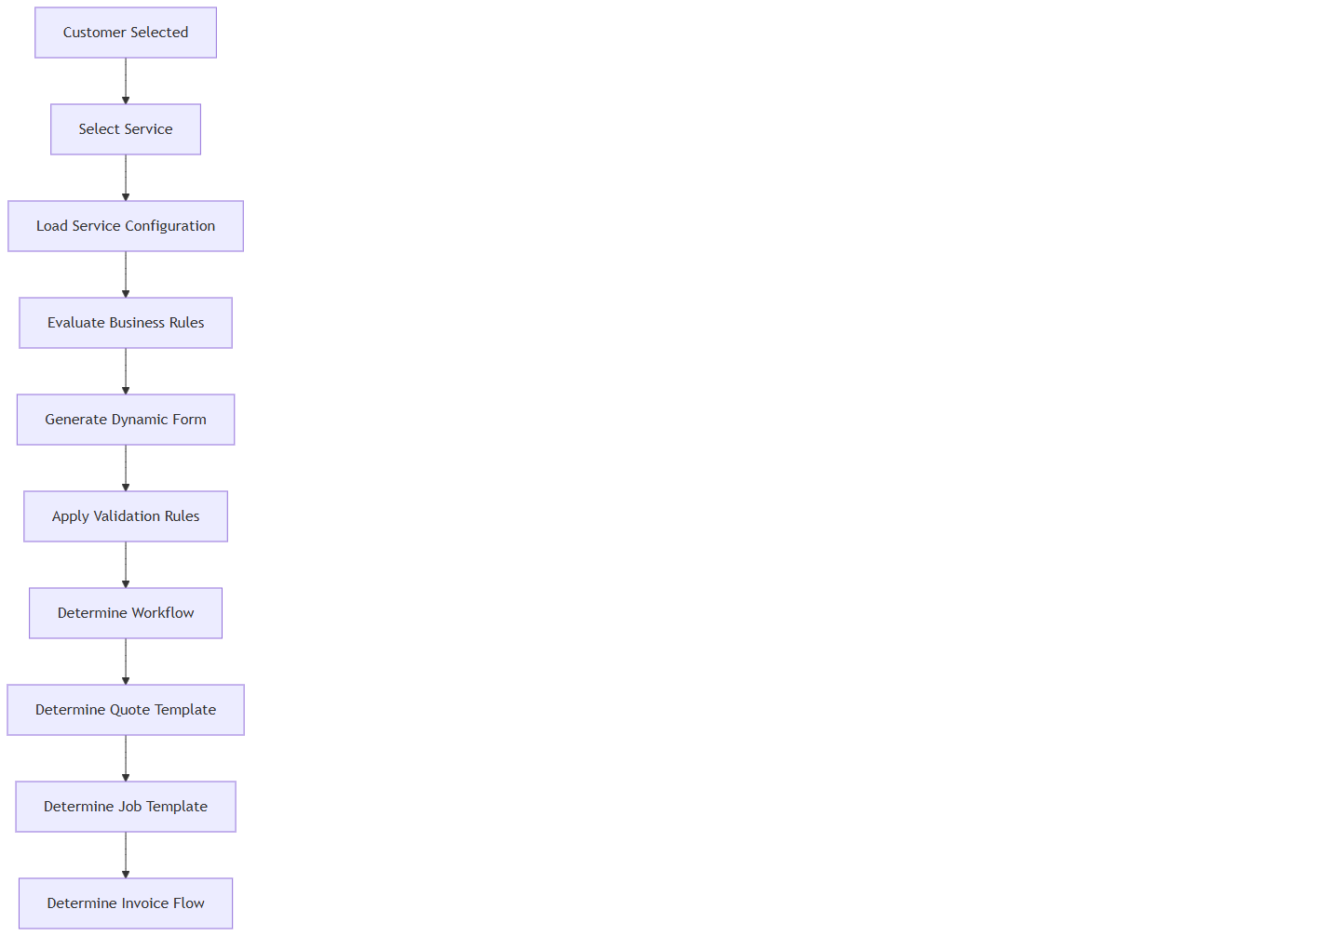
A[Customer Selected] --> B[Select Service]
B --> C[Load Service Configuration]
C --> D[Evaluate Business Rules]
D --> E[Generate Dynamic Form]
E --> F[Apply Validation Rules]
F --> G[Determine Workflow]
G --> H[Determine Quote Template]
H --> I[Determine Job Template]
I --> J[Determine Invoice Flow]

7. Master Service Configuration Matrix
Every Service type dictates downstream operational behaviour. This matrix is the master business configuration reference.
Configuration Flag | Fence Installation | Fence Repair | Product Sale | Consultation
Service Category | Installation | Maintenance | Retail | Service
Service Type | Complex | Standard | Simple | Simple
Site Visit Req. | Mandatory | Optional | Blocked | Mandatory
Measurement Req. | Mandatory | Optional | Blocked | Blocked
Property Req. | Mandatory | Mandatory | Optional | Mandatory
Products Req. | Yes | Yes | Yes | Blocked
Labour Req. | Yes | Yes | Blocked | Blocked
Equipment Req. | Yes | No | Blocked | Blocked
Drawings Req. | Mandatory | Optional | Blocked | Blocked
Photos Req. | Optional | Mandatory | Blocked | Optional
Customer Sig. Req. | Yes | Yes | No | No
Quote Template | Detailed Construction | Standard Service | Retail Product | Consulting Fee
Job Template | Multi-Day Install | Single-Day Repair | Fulfillment | Off-site
Invoice Type | Progress Billing | Net 30 | Due on Receipt | Net 15
Fulfilment Type | Construction | Service | Shipping/Pickup | Advisory

Request Form Behaviour & Validation Rules
The Request Wizard (`CreateorEditRequest.tsx`) acts as an orchestrator, altering validation based on the selected service data.

Mixed Service Validation Rules (Frontend Enforcement)
The application evaluates the `isProductOnlyService` flag on all selected services via `getRequestServiceTypeState`.
- Constraint: If a user selects both a regular service and a product-only service, the UI blocks progression.
- Warning Message: "You can create or update a request with only one service type at a time. Please choose either Product Only services or Regular services."
- Business Justification: Product sales are taxed immediately (Due on Receipt), whereas installations use progress billing and labor tracking.

Execution Sequence: Create Request API (`handleCreateRequest` in `request.service.js`)
When a user clicks "Save" on the Request form, the following exact sequence occurs on the backend:
1. Payload Extraction: Backend extracts `clientid`, `selectedService`, `siteVisits`, and cost summary fields (`productTotalAmount`, `totalLabourCost`, etc.).
2. Site Visit Normalization: The system extracts the top-level `siteVisits` array and deeply merges it into each individual `selectedService` object (e.g., matching `visitedBy`, `siteVisitPreferredDate`, and `siteVisitComments`).
3. Quantity Auto-Calculation: For each selected product option, if `totalQuantity` is missing from the payload, the backend automatically computes it using the formula: `Math.ceil(areaVal / coveragePerUnit)`.
4. Status Determination Engine:
If any service has `!siteVisitAlreadyDone && siteVisitStatus !== "Completed"`, Request status becomes "SiteVisitScheduled".
If all site visits are `siteVisitAlreadyDone`, Request status becomes "SiteVisitCompleted".
If there are no site visits configured, it defaults to the frontend status or "Pending".
5. Action History Appended: An immutable `actionHistory` record is created, stamping the user ID (`performedBy`), timestamp, and cost summaries into the request document.
6. Notification Dispatch: The system uses `notifyUsers` (via `genericAlert.ejs`) to send an email/SMS to internal staff: "New request created: Request #[ID] - [Company Name]".
7. Customer Status Update: Queries `Request.countDocuments` for the client. If > 0 previous requests exist, updates the client status to "return customer", otherwise "new customer".

Expanded Property Logic
Different services require different property intelligence.
- Property Mandatory: Installation and Repair services cannot proceed without a valid, geocoded Property record.
- Property Optional: Over-the-counter Product Sales can bypass property selection if it's a cash-and-carry transaction.
- Multiple Properties: For commercial accounts, the specific Property must be selected from a dropdown. The Service Address is passed to the Estimator, while the Billing Address remains hidden from field staff.
- Access Instructions: Gate codes and security notes are dynamically pulled into the Request for the assigned Estimator.

Measurement Engine
The frontend uses utilities in `utils/requestValidation` and `utils/formulaEvaluation` to compute measurements dynamically.
- Frontend Calculation (`evaluateFormula`): When linear footage or sides are inputted, the React app automatically resolves `basePriceCalculation` (e.g., formula logic attached to product options).
- Tax Calculation: `getProductTotalAmountWithStateTax` and `getStateTaxAmount` apply a hardcoded `STATE_TAX_RATE` variable to compute exact tax burdens dynamically on the frontend before submitting the payload.

Expanded Product Selection Rules
Product selection logic is service-aware.
- Allowed Categories: A "Fence " service only exposes their category materials (brackets, touch-up paint, individual pickets), hiding bulk pallets.
- Mandatory Products: If a specific fence style is selected, the corresponding post caps are flagged as mandatory products.
- Inventory Validation: The UI visually warns the user if the requested quantity exceeds currently available inventory.

Labour Cost
- Estimated Hours: System calculates base hours based on the configured formula.

Request Revision Workflow
Requests usually evolve before quotation. Revisions are strictly managed.
- Reschedule Site Visit: Modifying a scheduled visit triggers a timeline event and sends a notification to Admin.
- Change Measurements: Altering linear footage automatically triggers a recalculate the total price.
- Version History: All scoping changes (e.g., "Added 10ft of fencing") are immutably logged in the Audit Timeline.

Screen Catalogue & Visual Details
- Navigation Path: `/requests/:id`
- Screen Layout:
Header: Request ID, Customer Name, Status Pill, Created Date.
Left Column: Customer Snapshot, Property Address, Contact Details.
Main Column (Tabs): Services Requested, Site Visit Details, Cost Summary (Labor/Equipment), Attached Documents/Photos.
- Audit Panel: A scrolling chronological timeline of all state changes, estimator assignments, and notes.

Technical Design Appendix (Traceability References)
- Component Evidence: `g:/AFC/afc_react_fe/src/features/requests/pages/RequestList.tsx`
- Component Evidence: `g:/AFC/afc_react_fe/src/features/requests/pages/CreateorEditRequest.tsx`
- API Binding: `requestService.getRequests(queryParams)`
- Module Identifier: `SAL-01`

EST-01: Quote Management

Document Control
Version | Date | Author | Changes
1.0 | 2026-06-25 | Enterprise Architecture Team | Initial baseline specification.
1.1 | 2026-06-25 | Enterprise Architecture Team | Deepened Pricing Engine, Discount Governance, Margin Protection, Payment Schedules, and Public Portal workflows.
1.2 | 2026-06-25 | Enterprise Architecture Team | Definitive baseline. Added Formula-based pricing, Digital Signature compliance, Risk Management, and Commercial KPIs.

1. Executive Summary
The Quote Management module (EST-01) is the commercial engine of the AFC platform. It converts scoped demands (Requests) or direct ad-hoc inquiries into legally binding financial proposals. Operating as a sophisticated CPQ (Configure, Price, Quote) system, it handles complex pricing rules, margin calculations, multi-tiered taxation, and dynamic payment scheduling.
- Key Business Value: Ensures margin protection through locked pricing rules, automates complex tax calculations, and secures upfront cash flow via deposit requirements.
- Primary Users: Sales Representatives, Estimators, General Managers.
- Critical Success Factor: Maintaining 100% pricing accuracy across diverse service types (Retail vs Construction) and securing customer acceptance with digital signatures.

2. Chapter Overview
This module governs the end-to-end quoting lifecycle. It details the `/quotes` dashboard, the highly complex `/quotes/create` pricing engine, and the customer-facing `/public-quote/:id` acceptance portal. It defines the strict boundary between internal scoping and external commercial presentation.

3. Business Purpose
To provide a secure, standardized, and highly flexible pricing engine that allows Sales Representatives to quickly generate accurate proposals, apply approved margins, capture deposits, and formally lock in customer commitment while protecting enterprise profitability.

4. Module Scope
This module encompasses:
- Quote Type Orchestration & Configuration
- Complex Formula-Based Pricing Engine
- Multi-Tier Taxation Engine
- Margin Protection & Discount Governance
- Quote Approval Hierarchies
- Milestone & Deposit Payment Scheduling
- Customer Public Portal & Digital Signature Compliance
- Quote Versioning, Comparison, & Revision Management
- Status Lifecycle & Expiration Logic
- Commercial Risk Management

5. Business Impact
If the Quote Management module becomes unavailable:
- Sales cannot present pricing to customers.
- Deposits cannot be collected, halting cash flow.
- Jobs cannot be scheduled because approved scopes do not exist.
This is a Tier 1 Mission-Critical System.

6. Quote Type Configuration Matrix
The Quote Engine reconfigures its commercial logic based on the underlying service. This matrix represents the master commercial decision engine.
Configuration Flag | Fence Install Quote | Fence Repair Quote | Product Only Quote
Site Visit Req. | Mandatory (from Request) | Optional | Blocked
Measurement Req. | Mandatory | Optional | Blocked
Product Req. | Mandatory | Mandatory | Mandatory
Labour Req. | Mandatory | Mandatory | Blocked
Equipment Req. | Optional | Optional | Blocked
Permit Req. | Configurable by City | No | No
Delivery Req. | Implied with Install | No | Mandatory
Deposit Rule | 50% Standard | 50% Standard | 100% (Due on Receipt)
Invoice Type | Progress Billing | Standard Net 30 | Immediate
Job Template | Multi-Day Install | Single Day Repair | Fulfillment / Pick Ticket
Approval Flow | Margin < 20% requires VP | Margin < 15% requires Mgr | Standard Pricing (Auto)

7. Reverse-Engineered Pricing & Margin Engine
The core of the Quote module calculates financial proposals sequentially, enforced by frontend utilities in `CreateQuote.tsx`.

7.1 Dynamic Margin Application (`applyServiceMargin`)
The UI strictly applies user-defined margins before yielding the final subtotal.
- Percentage Margin: If `marginType === "percentage"`, the formula is `base + (base value) / 100`.
- Flat Margin: If `marginType === "flat"`, the formula is `base + value`.
- Subtotal Constraint Check: The system executes `hasZeroSubtotalService` before submission. If any service subtotal evaluates to $\leq 0$, the UI blocks saving with error: "Services Sub Total / Products Total cannot be zero. Please check your costs."

7.2 Quote Status Alert Dispatcher
When the Quote state changes, the backend `QuotationController.js` invokes `triggerQuotationNotification`, firing both SMS and Emails (via `genericAlert.ejs`) for the following exact events:
- `Quotation_Created`, `Quotation_Updated`, `Quotation_Deleted`, `Quotation_Rejected`, `Quotation_Approved`.

8. Margin Protection & Discount Governance
Protecting profitability is enforced systematically.

8.1 Margin Protection
- Minimum Margin: The system enforces a hard-stop floor (e.g., 20% Gross Margin).
- Approval Workflow: If an estimator attempts to lower the margin below the floor, the Quote enters a `Pending Approval` state. It cannot be sent without General Manager digital approval.
- Business Justification: Reps must enter a text justification for margin exceptions (e.g., "Price matching competitor X").

8.2 Discount Governance
- Maximum Discount: Sales Reps are capped at a specific % discount (e.g., 5% automatic).
- Promotional Discounts: Standardized dropdowns (e.g., "Fall Special - $200 off").
- Audit Trail: Every applied discount generates an immutable log entry tracking Who applied it, Why, and the Amount.

9. Reverse-Engineered Tax & Display Logic
Taxes are orchestrated dynamically based on the boolean flag `IsTaxIncluded`.
- Tax Exclusive View: `getQuotationSummaryValues` determines that if `quotation.IsTaxIncluded === false`, then `amountSentToCustomer` is calculated as `totalAmount - taxAmount` (stripping out tax liability from the customer's face value).
- Tax Inclusive View: If `IsTaxIncluded === true`, taxes are baked into the `amountSentToCustomer` variable.
- Component Rendering: The React UI leverages `QuotePreviewNoRequestSummaryTable` to build the grid view dynamically, calculating "Balance Due (50%)" against `amountSentToCustomer - depositAmount`.

10. Dynamic Payment Scheduling
The Quote dictates the financial milestones for the resulting Job.
- Deposit Invoice: Automatically generated upon acceptance (e.g., 50% for Installations, 100% for Product Sales).
- Progress Milestones: For large commercial quotes (>$50k), the schedule splits: 30% Deposit, 40% Materials Delivered, 30% Final Completion.
- Final Balance: The system automatically schedules the remaining balance invoice for the "Job Completed" trigger.
- Customer Adjustments: Payment terms cannot be altered by Sales Reps without Finance Approval.

11. Reverse-Engineered Public PDF & Portal Generation
The quote presentation layer is heavily customized before reaching the customer.

11.1 Native PDF Generation (`buildQuotationPdfBuffer`)
Rather than relying on frontend print dialogs, AFC generates native PDFs entirely on the backend via `PDFDocument` (pdfkit).
- Media Resolution Engine: The system parses `layoutimages`, stripping queries and dynamically loading them into a `sharp` buffer. It falls back to `localCandidates` (searching `public/` and `process.cwd()`) if HTTP loading fails or times out.
- Rich Text Sanitization: Terms & Conditions are processed through `sanitizeDocumentationHtml` (allowing only `p, div, span, br, ol, ul, li, b, strong, em, i`) and stripped into `trimDocumentationSegments` to render accurately within the PDF coordinates.

11.2 Digital Acceptance Lifecycle
When a customer accepts via the public link:
1. `triggerQuotationNotification("Quotation_Approved")` fires.
2. `createJobFromAcceptedQuotation` executes, acting as the bridge to `JOB-01`.
3. `SendEmailToClientafterAcceptance` dispatches the legally binding PDF.

12. Quote Revision & Comparison Workflow
Quotes rarely close on the first iteration.
- Revision Numbering: If Quote `Q-100` is rejected, revising it creates `Q-100-Rev1`.
- Version Comparison: Internal users can view a side-by-side diff showing exactly what line items or pricing changed between Rev1 and Rev2.
- Previous Version Archive: The moment a revision is generated, the original quote is cryptographically locked. The public link redirects to the newest version or displays an "Expired" notice.
- Customer Notification: An automated "Revised Quote Enclosed" email is dispatched outlining the scope changes.

13. Expiration Management & Status Lifecycle
Quotes transition through a highly audited state machine.

13.1 Expiration Management
- Quote Expiry Date: Default 30 days from creation.
- Reminder Notifications: Automated emails sent to the customer at T-minus 3 days and T-minus 1 day.
- Auto-Expiration: At midnight on day 30, the status shifts to `Expired` and the public link disables itself.
- Price Revalidation: To extend an expired quote, the system forces a re-check of underlying material costs. If vendor pricing has spiked, the Rep must recalculate the quote before re-issuing.

13.2 Status Lifecycle
Status | Entry Criteria | Exit Criteria | Responsible | Business Outcome
Draft | Quote created, unsent. | Sent to Customer | Sales Rep | Work in progress.
Pending Review | Margin floor violated. | Manager Approves/Denies | General Manager | Margin protected.
Sent | Dispatched via Email/SMS. | Customer opens link | System | Awaiting engagement.
Viewed | Customer opens public link. | Customer signs/rejects | Customer | Sales pipeline updated.
Customer Q's | Customer adds comment. | Rep replies/revises | Sales Rep | Negotiation phase.
Revision Req. | Customer clicks 'Request Change'. | Rep creates Revision | Sales Rep | Indicates buying intent.
Accepted | Customer signs digitally. | Converted to Job | Customer | Locked, Job created.
Rejected | Customer clicks Reject. | N/A (Terminal) | Customer | Deal Lost.
Expired | 30 days elapse. | N/A (Terminal) | System | Deal Dead.

14. Document & Attachment Handling
- Inherited Context: Measurement sheets, property boundaries, and site photos automatically flow from the Request to the Quote.
- Terms & Conditions: Legally approved T&Cs are dynamically injected into the PDF generation based on the Service Category.
- Downstream Flow: Once accepted, all signed PDFs, terms, and site photos are cloned and pushed directly into the `JOB-01` execution module, ensuring installation crews see what the customer bought.

15. Business Scenarios
Real-world examples of Quote orchestration:
- Scenario 1: Fence Installation (Complex Workflow)
Request $\rightarrow$ Field Measurements $\rightarrow$ Formula Engine $\rightarrow$ Margins Applied $\rightarrow$ 50% Deposit Req $\rightarrow$ Digital Acceptance $\rightarrow$ Installation Job.
- Scenario 2: Product Sale (Simple Workflow)
Walk-in Customer $\rightarrow$ Manual Line Items $\rightarrow$ Inventory Check $\rightarrow$ MSRP Pricing $\rightarrow$ 100% Payment $\rightarrow$ Pick Ticket.
- Scenario 3: Fence Repair (Standard Workflow)
Inspection $\rightarrow$ Flat Labour + Parts $\rightarrow$ Quote Sent $\rightarrow$ Accepted $\rightarrow$ Maintenance Job.

16. Operational Dashboard & Commercial KPIs
The `/quotes` dashboard provides pipeline analytics:
- Average Quote Value: Benchmarking deal sizes.
- Average Margin: Tracks overall profitability trends.
- Quote Win Rate: Quotes Accepted / Total Quotes Sent.
- Lost Quote Reasons: Mandatory dropdown analysis for rejected quotes (e.g., "Price too high", "Lost to competitor").
- Average Approval Time: Days between Sent and Accepted.
- Revenue Forecast: Weighted sum of pipeline based on historical win rates.

17. Downstream Business Impact
An Accepted Quote acts as the master blueprint for fulfillment.
Accepted Quote
↓
Inventory Reservation (Soft Hold)
↓
Material Procurement (PO Generation if out of stock)
↓
Crew Assignment (Job Template Created)
↓
Equipment Planning
↓
Deposit Invoice Sent
↓
Payment Collected
↓
Customer History Updated

18. Commercial Risk Management
- Incorrect Pricing: Mitigated by locking underlying product costs and enforcing Formula-based scoping.
- Margin Loss: Mitigated by hard-stop approval workflows for any discount exceeding 5%.
- Material Cost Increases: Mitigated by strict 30-day auto-expiration and forced re-validation upon extension.
- Legal Disputes: Mitigated by comprehensive IP/Timestamp digital signature capture and immutable PDF generation.

19. Technical Design Appendix (Traceability References)
- Component Evidence [EST-UI-01]: `CreateQuote.tsx` (Pricing Engine)
- Component Evidence [EST-UI-02]: `QuotationPublicPreview.tsx` (Customer Portal)
- Component Evidence [EST-UI-03]: `QuoteDetail.tsx` (Status & Analytics)
- API Binding [EST-API-01]: `quotationService.createQuote(payload)`
- Module Identifier: `EST-01`

20. Visual Module Relationship Map

A[SAL-01: Requests] -->|1:1| B[EST-01: Quotations]
B -->|1:1| C[JOB-01: Jobs]
B -->|1:N| D[INV-01: Invoices]

style B fill:#059669,stroke:#064e3b,stroke-width:2px,color:#fff

21. Cross-Chapter Navigation
- Previous Chapter: [SAL-01: Request Management](#)
- Next Chapter: [JOB-01: Job Management](#)
- Related Chapters: [INV-01: Invoice Management](#)

JOB-01: Job Management

Document Control
Version | Date | Author | Changes
1.0 | 2026-06-25 | Enterprise Architecture Team | Initial baseline specification applying the approved commercial documentation standard from EST-01.

1. Executive Summary
The Job Management module (JOB-01) is the operational execution engine of the AFC platform. It bridges the gap between commercial agreement (Accepted Quote) and physical fulfillment (Site Operations). It orchestrates crew scheduling, material tracking, progress milestone management, expense logging, and final quality assurance.
- Key Business Value: Ensures flawless field execution, prevents margin leakage through strict expense tracking, and guarantees that the customer receives exactly what was quoted.
- Primary Users: Dispatchers, Field Crews, General Managers.
- Critical Success Factor: Maintaining real-time visibility into crew locations, job expenses, and schedule adherence to protect operational profitability.

2. Chapter Overview
This module governs the end-to-end execution lifecycle. It details the `/jobs` operational dashboard, the complex `/job/:id` central command center, and the field-level `/job-public/:id` tracking portal. It defines the strict boundary between theoretical scoping (Quotes) and physical reality (Jobs).

3. Business Purpose
To provide a centralized, highly structured operational hub that allows Dispatchers to efficiently route crews, track job progress via daily visits, capture real-time expenses, and accumulate photographic evidence of completed work prior to final invoicing.

4. Module Scope
This module encompasses:
- Job Template Orchestration
- Upstream Inheritance (Quote $\rightarrow$ Job)
- Dynamic Crew Scheduling & Visit Management
- Job Expense Tracking & Profitability Impact
- Field Staff Dashboards
- Photographic Evidence Capture (Initial & Final)
- Status Lifecycle & Milestones
- Post-Job Final Invoice Delta Reconciliation
- Operational Risk Management

5. Business Impact
If the Job Management module becomes unavailable:
- Crews cannot be dispatched, resulting in idle labour costs.
- Materials cannot be accurately allocated.
- Field staff cannot upload completion photos, blocking final invoicing.
This is a Tier 1 Mission-Critical Operational System.

6. Job Configuration Matrix
The Job module dynamically reconfigures its operational logic based on the underlying service sold in the Quote.
Configuration Flag | Fence Installation Job | Fence Repair Job | Product Delivery
Schedule Type | Multi-Day (Recurring Visits) | Single Visit (One-Time) | Single Visit (One-Time)
Crew Size Req. | Multiple Members + Lead | Single Technician | Delivery Driver
Material Req. | Full Bill of Materials | Repair Parts | Packaged Goods
Equipment Req. | Yes (Augers, Mixers, etc.) | Standard Tools | Delivery Vehicle
Initial Photos | Mandatory (Before Work) | Mandatory (Damage) | Optional
Completion Photos | Mandatory (After Work) | Mandatory (Fixed) | Mandatory (POD)
Expense Tracking | High Volume (Concrete, etc.) | Low Volume | Fuel/Tolls Only
Customer Portal | Active (Progress Tracking) | Active (ETA Tracking) | Active (ETA Tracking)

7. Reverse-Engineered Upstream Inheritance & Instantiation
A Job is never created in a vacuum; its creation path is dynamically determined by the `JobWay` parameter passed to `createJob`:
- Invoice-Led (`JobWay === "Invoice"`): The system routes to `JobService.createJobForInvoiceWay`, meaning the Job was generated directly from a standalone Invoice, skipping the Quote phase entirely.
- Line-Item Quote (`jobquotation?.UsingTemplate === true`): The system routes to `JobService.createJobForLineItemsQuotation`, extracting line items from a structured CPQ quote.
- Standard Scope: The system defaults to `JobService.createJobNew`.
- Cross-Object Population: Regardless of the origin path, `getJobById` attempts deep population, first looking for a linked `quotation` and resolving the customer profile from `quotation.client`. If no quote exists, it falls back to resolving the customer from `invoice.client`.

8. Reverse-Engineered Crew Scheduling & Notifications
Execution is managed through atomic "Visits", allowing complex jobs to be split across multiple days.

8.1 Schedule Types (`scheduleType`)
The backend strictly enforces the following schema validation during `createJob`:
- One-Time Schedule (`"OneTime"`): A single continuous block of time. Requires `schedule.start_date`.
- Recurring Schedule (`"Recurring"`): Multi-day operations. The system throws a `400 Bad Request` if `schedule.end_date` is omitted.

8.2 Event Dispatcher (`sendJobNotification`)
The system employs a unified helper to dispatch SMS and Email (`genericAlert.ejs`) alerts.
- Upon Job Creation (if `status !== "auto"`), an alert is dispatched detailing the `Job Title`, `Start Date`, and `Schedule Type`.
- The system attempts to resolve the `Customer Name`, `Email`, and `Phone` deeply by traversing the Quotation, then the Invoice, then the explicit `client_id` reference to ensure the alert payload is populated correctly.

9. Job Expense Tracking & Profitability
While Quotes estimate profitability, Jobs track actuals. The Expense module is critical for preventing margin leakage.
- Expense Logging: Field staff and managers log ad-hoc expenses directly against the Job (e.g., "Extra bags of concrete purchased at Home Depot").
- Expense Categorization: Categorized by Type (Materials, Labour, Fuel, Equipment Rental).
- Profitability Impact: Expenses logged against the Job are mapped against the Quoted Costs. If Actual Costs > Quoted Costs, the Job is flagged for "Margin Erosion Review" upon completion.

10. Evidence & Quality Assurance
To protect the enterprise from liability and ensure customer satisfaction, strict evidence workflows are enforced.

10.1 Photographic Evidence
- Layout Images (Inherited): Drawings from the Quote/Request.
- Initial Work Images: Crews must upload "Before" photos prior to breaking ground (verifying site condition).
- Work Completed Images: Crews must upload "After" photos upon finishing.
- Business Rule: A Job cannot transition to `Completed` unless the minimum required Completion Photos are present.

10.2 Document Centralization
All signed T&Cs, utility locate documents (Dig Safe), and permits are centralized in the Job details for crew reference.

11. Final Invoice Delta Reconciliation
A critical commercial checkpoint occurs when a Job finishes.
- The Reality Check: What was quoted is rarely exactly what happens. (e.g., 2 extra posts were needed due to terrain).
- Edit Final Invoice Action: When a Job is marked `Completed`, the system unlocks the "Edit Final Invoice" action.
- Reconciliation: Managers review the Job Expenses and Field Notes. If extra materials were used (and approved by the customer), they are added to the Final Invoice payload before it is dispatched via the INV-01 module.

12. Customer Job Portal (Field Staff & Public)
- Field Staff Dashboard: A mobile-optimized view for crews to see their daily visits, tap to navigate to the property, view layout images, log actual hours, and upload photos.
- Public ETA Tracking: Customers receive a secure link on the day of the job, allowing them to see the scheduled time window and the crew's status.

13. Comprehensive Status Lifecycle
Jobs transition through a strictly enforced operational state machine.
Status | Entry Criteria | Exit Criteria | Responsible | Business Outcome
Created | Quote Accepted. | Schedule is set. | System | Holding queue.
Scheduled | Dates & Crew assigned. | Crew arrives on site. | Dispatcher | Resources locked.
In Progress | Crew logs first arrival. | Final visit completed. | Field Lead | Execution phase.
Pending Review | Margin eroded by expenses. | Manager approves overage. | Gen. Manager | Profitability check.
Completed | Final photos uploaded. | Final Invoice Generated. | Field Lead | Ready to bill.
On Hold | Weather delay / issue. | Issue resolved. | Dispatcher | Paused operations.
Cancelled | Customer backs out. | N/A (Terminal) | Gen. Manager | Deal aborted.

14. Reverse-Engineered Operational Dashboard
The `/jobs` dashboard (`getAllJobs` / `getAllJobsPagination`) aggregates execution analytics via MongoDB aggregation pipelines:
- Late Jobs: Count of all jobs currently in the `"InProgress"` state.
- End in 30 days: Count of all jobs in the `"action required"` state (Completed but pending final processing).
- Archived: Count of jobs explicitly marked `"archived"`.
- Deep Resolvers: The list view intelligently maps the Customer Name by hunting through `job.quotation.client`, then `job.invoice.client`, then `job.client_id`. It maps the Created By field to `${job.createdBy.firstname} ${job.createdBy.lastname}`.

15. Downstream Execution Matrix
A Completed Job triggers the final financial workflows.
Completed Job
↓
Final Expense Reconciliation
↓
Final Invoice Generation (INV-01)
↓
Payment Collection (PAY-01)
↓
Commission Calculation (If applicable)
↓
Customer Survey / Review Request
↓
Warranty Period Begins

16. Operational Risk Management
- Weather Delays: Mitigated by the `On Hold` status and rapid bulk-rescheduling tools.
- Margin Leakage: Mitigated by mandatory Expense Logging and the Post-Job Delta Reconciliation step.
- Property Damage Claims: Mitigated by mandatory "Before" and "After" photographic evidence.
- Schedule Conflicts: Mitigated by the central Dispatch calendar preventing double-booking of crews.

17. Technical Design Appendix (Traceability References)
- Component Evidence [JOB-UI-01]: `JobDetail.tsx` (Command Center)
- Component Evidence [JOB-UI-02]: `JobExpensesTable.tsx` (Margin Tracking)
- Component Evidence [JOB-UI-03]: `VisitsList.tsx` (Execution Tracking)
- Component Evidence [JOB-UI-04]: `InitialWorkImagesUploader.tsx` (Evidence)
- API Binding [JOB-API-01]: `jobService.getJobById(id)`
- Module Identifier: `JOB-01`

18. Visual Module Relationship Map

A[EST-01: Quotations] -->|1:1| B[JOB-01: Jobs]
B -->|1:1| C[INV-01: Invoices]
B -->|1:N| D[EXP-01: Expenses]

style B fill:#0284c7,stroke:#0369a1,stroke-width:2px,color:#fff

19. Cross-Chapter Navigation
- Previous Chapter: [EST-01: Quote Management](#)
- Next Chapter: [INV-01: Invoice Management](#)
- Related Chapters: [EXP-01: Expense Management](#)

INV-01: Invoice Management

Document Control
Version | Date | Author | Changes
1.0 | 2026-06-25 | Enterprise Architecture Team | Initial baseline specification applying the approved commercial documentation standard from EST-01 and JOB-01.

1. Executive Summary
The Invoice Management module (INV-01) governs the financial realization of the AFC platform. It is responsible for converting completed quotes and executed jobs into hard revenue. The module handles multi-installment billing, dynamic tax recalculations, payment gateway orchestration, and automated customer dunning (collections).
- Key Business Value: Accelerates cash flow via automated digital payment links, reduces Days Sales Outstanding (DSO), and ensures 100% accurate tax compliance prior to general ledger syncing.
- Primary Users: Finance Team, Accounts Receivable, Sales Representatives.
- Critical Success Factor: Frictionless customer payment experiences via the Public Invoice Portal and tight reconciliation with the originating Job's physical execution.

2. Chapter Overview
This module governs the end-to-end billing lifecycle. It details the `/invoices` financial dashboard, the complex `/invoices/create` billing engine, the internal `/invoice/:id` reconciliation view, and the critical customer-facing `/public-invoice/:id` payment portal.

3. Business Purpose
To provide a highly secure, automated billing engine that generates accurate financial demands (Deposit, Progress, and Final Invoices), delivers them instantly to customers, captures digital payments, and permanently locks financial records to prevent unauthorized post-payment tampering.

4. Module Scope
This module encompasses:
- Invoice Generation (From Quote, From Job, Ad-Hoc)
- Deposit vs. Final Balance Splitting
- Multi-Jurisdiction Tax Recalculation
- Public Customer Payment Portal
- Payment Gateway Integration (Credit Card, ACH, Bank Transfer)
- Financial Status Lifecycle & Aging
- Document Generation (PDFs, Statements)
- Financial Risk & Fraud Management

5. Business Impact
If the Invoice Management module becomes unavailable:
- The enterprise cannot legally demand payment.
- Digital payments (Stripe/ACH) fail, instantly halting cash flow.
- Finance cannot close month-end books.
This is a Tier 1 Mission-Critical Financial System.

6. Invoice Configuration Matrix
The billing logic drastically alters based on the origin of the Invoice.
Configuration Flag | Deposit Invoice (Pre-Job) | Final Invoice (Post-Job) | Ad-Hoc Invoice
Trigger Event | Quote digitally accepted. | Job marked 'Completed'. | Manual creation.
Origin Source | Exact Match to Quote. | Quote + Post-Job Deltas. | Manual Line Items.
Amount Rule | Exact Deposit % (e.g., 50%). | Remaining Balance. | 100% Due.
Payment Terms | Due on Receipt. | Net 15 / Net 30. | Due on Receipt.
Modification | Strictly Locked. | Open for Job Reconciliation. | Open.
Tax Re-calc. | Inherited from Quote. | Recalculated on Final sum. | Calculated live.

7. Upstream Inheritance & The "Post-Job Delta"
An Invoice is the financial snapshot of operational reality.
- Inherited and Locked (Deposit): When a Quote is signed, the Deposit Invoice is a mathematical 50% split. No line items can be altered.
- The Post-Job Delta (Final Invoice): The Final Invoice is not just the remaining 50%. It inherits the original Quote, but then merges in the "Delta" from JOB-01 (e.g., "Added 2 extra fence posts due to terrain").
- Business Rule: The Final Invoice must mathematically equal: (Original Quote Total + Post-Job Deltas) - Paid Deposit.

8. The Financial Calculation Engine
The system recalculates the bottom line before generating the PDF to ensure absolute compliance.
1. Gross Subtotal: Sum of all active line items (accounting for Job Deltas).
2. Margin Verification: Confirms no manual overrides broke the margin floor.
3. Discount Lock: Verifies the original quoted discount.
4. Tax Recalculation: Re-runs the State (Product) and Service (Labour) tax algorithms on the final sum.
5. Less Previous Payments: Subtracts the paid Deposit.
6. Total Amount Due: The final demand amount.

9. Customer Public Payment Portal
The `/public-invoice/:id` interface is optimized for rapid payment conversion.
- Access: Delivered via automated SMS/Email using a secure, tokenized URL (No login required).
- Customer View: Displays branded invoice, itemized breakdown, tax details, and clear "Total Due".
- Payment Gateways:
Credit Card: Integrated Stripe element (Subject to convenience fees).
ACH/eCheck: Lower transaction cost for commercial clients.
Bank Transfer (Wire): Displays corporate routing instructions; requires customer to upload a confirmation receipt.
- Instant Reconciliation: Upon successful digital payment, the system instantly flips the Invoice to `Paid` and triggers a Thank You receipt.

10. Manual Payment & Bank Transfers
Not all payments are digital. The system supports manual Accounts Receivable (A/R) reconciliation.
- Bank Transfer Dialog: If a customer wires money, Finance uses the `BankTransferConfirmationDialog` to manually clear the invoice.
- Cheque Processing: Finance can manually log a cheque payment, requiring a Cheque Number and clearing date.
- Business Rule: Manual payments mark the invoice as `Payment Pending` until Finance explicitly clicks `Funds Cleared`.

11. Reverse-Engineered Status State Machine
The system runs `updateInvoiceStatus(invoice)` recursively to calculate the master status based on its underlying `installments` array.
- Complete: `receivedAmount >= totalAmount` (isFullyPaid).
- Failed: Any installment explicitly marked as `failed` (`hasFailed = true`).
- Partial: `receivedAmount > 0` but not fully paid.
- Overdue: `dueDate` has passed and status is not paid (`dueDate < today`).
- Due Today: `dueDate` equals today's date and status is not paid.
- Late: Paid, but `doneAt` timestamp is greater than the `dueDate` (`doneAt > dueDate`).
- Scheduled: No installments are currently marked `pending` (`!hasPending`).
- Awaiting: The default state if installments are pending and no other conditions are met.

12. Dunning & Collections Workflow
To minimize Days Sales Outstanding (DSO), the system automates collections.
- T-Minus 3 Days: "Friendly Reminder - Invoice due soon" email.
- Day 0 (Due Date): "Invoice Due Today" email/SMS.
- Day +7 (Overdue): "Overdue Notice" email with updated PDF stamped "OVERDUE".
- Day +30: Escalated alert to General Manager for manual collection calls.

13. Financial Document & Attachment Handling
- PDF Generation: Invoices are dynamically generated into clean, branded PDFs using the `InvoicePublicUrlPDF` generator.
- Immutability: Once an Invoice hits `Paid` status, it is cryptographically locked. No line item, tax rate, or total can be altered. If a refund is required, a separate "Credit Memo" workflow must be utilized.
- Statements: Finance can generate a "Customer Statement" summarizing all Open, Paid, and Overdue invoices for a specific account.

14. Business Scenarios
Real-world examples of Invoice orchestration:
- Scenario 1: Standard Fence Installation
Quote Accepted (10k) $\rightarrow$ Deposit Invoice Generated (5k) $\rightarrow$ Paid via Credit Card $\rightarrow$ Job Executed (No Deltas) $\rightarrow$ Final Invoice Generated (5k) $\rightarrow$ Paid via Cheque.
- Scenario 2: Job with Scope Increase
Quote Accepted (10k) $\rightarrow$ Deposit Paid (5k) $\rightarrow$ Job Requires Extra Gate (+$1k Delta) $\rightarrow$ Final Invoice Generated (6k) $\rightarrow$ Customer disputes extra charge $\rightarrow$ Finance adjusts to $5.5k $\rightarrow$ Paid.
- Scenario 3: Ad-Hoc Product Sale
Walk-in Customer $\rightarrow$ Ad-Hoc Invoice Created ($500) $\rightarrow$ Paid Cash immediately $\rightarrow$ Invoice marked Paid $\rightarrow$ Pick Ticket generated.

15. Reverse-Engineered Aggregation Dashboard
The `/invoices` dashboard (`getAllInvoiceDetails`) relies on a heavy MongoDB aggregation pipeline (facets) to calculate real-time analytics.
- Global Summary: Calculates `totalPaidAmount` (sum of all `paid` installments), `totalDueAmount` (remaining balance), and `totalInvoicesAmount` (gross sum).
- Time-Series Tracking: Calculates `invoicesToday` (start of today), `invoicesThisWeek`, and `invoicesThisMonth`.
- State Counts: Returns exact counts for `completedInvoicesOverall`, `partialInvoices`, and `pendingInvoices`.
- Payment Mode Breakdown: A specific facet unwinds `invoices`, matches `status: "paid"`, and groups by `invoices.paymentMode` to return total sums transacted per gateway (e.g., Stripe vs Zelle vs Cheque).
- UI Filtering Fallback: By default, if no search term or explicit status is applied, the backend actively excludes `paid` and `complete` invoices from the data table (`query.status = { $nin: ["paid", "complete"] }`) to reduce UI clutter.

16. Downstream Execution Matrix
A Paid Invoice finalizes the transaction.
Paid Final Invoice
↓
General Ledger Sync (Quickbooks/Xero integration hook)
↓
Sales Commission Unlocked
↓
Job marked 'Closed'
↓
Customer Lifetime Value (LTV) metric updated

17. Commercial Risk Management
- Credit Card Fraud: Mitigated via Stripe 3D Secure / Radar integration on the Public Portal.
- Margin Tampering: Mitigated by locking the invoice once `Paid`.
- Bad Debt: Mitigated by the automated Dunning workflow and mandatory Deposit structures.
- Tax Audit Liability: Mitigated by strict separation of Product (State) vs Service (Labour) tax line items in the PDF generation.

18. Technical Design Appendix (Traceability References)
- Component Evidence [INV-UI-01]: `CreateOrEditInvoice.tsx` (Billing Engine)
- Component Evidence [INV-UI-02]: `InvoicePublicUrlPDF.tsx` (Customer Portal)
- Component Evidence [INV-UI-03]: `InvoicePaymentModal.tsx` (Payment Gateway)
- API Binding [INV-API-01]: `invoiceService.getIndividualInvoice(id)`
- Module Identifier: `INV-01`

19. Visual Module Relationship Map

A[EST-01: Quotations] -->|Generates Deposit| C[INV-01: Invoices]
B[JOB-01: Jobs] -->|Generates Final| C
C -->|1:N| D[PAY-01: Payments]

style C fill:#b91c1c,stroke:#7f1d1d,stroke-width:2px,color:#fff

20. Cross-Chapter Navigation
- Previous Chapter: [JOB-01: Job Management](#)
- Next Chapter: [PAY-01: Payment Management](#)
- Related Chapters: [EST-01: Quote Management](#)

PAY-01: Payment Management

Document Control
Version | Date | Author | Changes
1.0 | 2026-06-25 | Enterprise Architecture Team | Initial baseline specification applying the approved commercial documentation standard from INV-01.

1. Executive Summary
The Payment Management module (PAY-01) is the treasury and reconciliation engine of the AFC platform. While Invoices (INV-01) represent the demand for money, the Payment module securely processes, tracks, and reconciles the receipt of funds. It acts as the orchestration layer between the external payment gateways (Stripe, Plaid), the corporate banking ledger, and the internal Accounts Receivable (A/R) records.
- Key Business Value: Accelerates secure cash collection, eliminates manual A/R data entry errors, and provides instant financial reconciliation to unlock downstream execution workflows (like scheduling Jobs upon Deposit).
- Primary Users: Finance Team, Accounts Receivable, Customers (via Portal).
- Critical Success Factor: Securely processing diverse payment vectors (Digital vs Manual) while maintaining absolute auditability of every cent collected.

2. Chapter Overview
This module governs the end-to-end payment lifecycle. It details the digital gateway architecture (`InvoicePaymentModal`), the manual bank reconciliation process (`BankTransferConfirmationDialog`), and the strict rules governing partial payments, overpayments, and refunds.

3. Business Purpose
To securely capture customer funds across multiple channels (Credit Card, ACH, Wire, Cash, Cheque) and permanently bind those funds to specific Invoices, ensuring the general ledger reflects real-time corporate liquidity.

4. Module Scope
This module encompasses:
- Payment Vector Orchestration (Digital vs Manual)
- Stripe Gateway Integration (Credit Card & ACH)
- Manual A/R Reconciliation (Wire/Cheque)
- Multi-Payment vs Single-Invoice Resolution (Partial Payments)
- Overpayment & Credit Balance Handling
- Refund & Reversal Workflows
- Payment Receipt Generation
- Transaction Security & PCI Compliance

5. Business Impact
If the Payment Management module fails:
- Invoices cannot be cleared.
- Accepted Quotes stall because Deposit triggers are never fired.
- The company faces severe PCI non-compliance fines if transaction data is mishandled.
This is a Tier 1 Mission-Critical Treasury System.

6. Payment Vector Configuration Matrix
How the system processes funds depends entirely on the Payment Vector.
Vector | Gateway | Processing Time | Processing Fee | Internal Reconciliation
Credit Card | Stripe | Instant | ~2.9% + 30¢ | Automatic (Zero-touch)
ACH Transfer | Stripe/Plaid | 3 - 5 Days | ~0.8% (Capped) | Automatic (Zero-touch)
Wire Transfer | Manual Bank | 1 - 2 Days | Flat Fee | Manual by Finance
Cheque | Physical | 5 - 7 Days | None | Manual by Finance
Cash | Physical | Instant | None | Manual by Finance

7. Reverse-Engineered Digital Payment Workflows (Stripe Orchestration)
The system leverages a dual-path Stripe integration, heavily detailed in `Stripe-Controller.js`:

7.1 Online Checkout Session (`createCheckoutSession`)
When a user initiates an online payment, the backend builds a dynamic checkout array:
1. Line Item Construction: If the category is `product`, the system maps the items and explicitly injects a hardcoded $2.00 Platform Charge as a separate line item.
2. Session Generation: It creates a Stripe Checkout session with `success_url` and `cancel_url` pointing back to the client origin.
3. Webhook Reconciliation (`handleWebhook`): Stripe fires `checkout.session.completed`. The backend catches it, verifies `STRIPE_WEBHOOK_SECRET`, automatically generates a sequential `paymentId` (`generatePaymentId`), and writes the finalized record to the `Payment` collection.

7.2 Point-of-Sale Terminal Workflow (`InitiateReaderPayment`)
The system supports physical card readers via `stripe.terminal`:
1. Intent Creation: Creates a `PaymentIntent` forcing `payment_method_types: ["card_present"]` and `capture_method: "manual"`.
2. Reader Handoff: Pushes the intent to the physical reader via `processPaymentIntent`.
3. Simulation Fallback: If the reader `device_type` starts with `"simulated_"`, the backend artificially delays for 3 seconds, presents a test `4242424242424242` card, and auto-captures the payment to allow end-to-end testing without physical hardware.
4. Finalization: Once captured, the specific `installment` inside the `Invoice` document is flipped to `status = "paid"`.

8. Manual A/R Reconciliation (Wire & Cheque)
Commercial/B2B customers often reject Credit Card fees and prefer manual payment vectors.

8.1 The Wire Transfer Workflow
- Customer Action: Customer views the Invoice, selects "Bank Transfer", and views the corporate routing instructions. They wire the money and upload a screenshot of their bank confirmation.
- Status Change: Invoice shifts to `Payment Pending`.
- Finance Action: The A/R team monitors the corporate bank account. Upon seeing the funds, they open the `BankTransferConfirmationDialog`, input the exact date cleared, and click `Confirm`.
- Result: Invoice shifts to `Paid`.

8.2 The Cheque Workflow
- Action: Customer mails a physical cheque.
- Finance Action: A/R receives the cheque, opens the specific invoice, clicks "Log Manual Payment", selects "Cheque", and inputs the `Cheque Number`. The system records the payment.

9. Complex Payment Scenarios

9.1 Partial Payments
- Scenario: A customer is billed $10k but only pays $5k today.
- Logic: The system records the $5k payment, binds it to the invoice, and leaves the invoice in a `Partially Paid` state. The Public Portal automatically updates to show "Total Due: $5,000".

9.2 Split Payments
- Scenario: A customer wishes to pay a $20k deposit using two different credit cards (e.g., $10k each due to limits).
- Logic: The Public Portal allows the customer to manually edit the "Amount to Pay Today" field. They process the first $10k. The system updates the remaining balance, and they immediately process the second $10k using the second card.

9.3 Overpayments & Credit Balances
- Rule: If a customer accidentally wires $11k for a $10k invoice, Finance logs the $11k. The invoice is marked `Paid`. The excess $1k is pushed to the Customer's Profile as an "Available Credit Balance", which can be applied to future invoices.

10. Refund & Reversal Governance
Money leaving the business requires strict controls.

10.1 Refund Workflow
- Trigger: An overcharge, a cancelled job, or a customer dispute.
- Approval: All refunds require General Manager digital approval.
- Execution: If paid via Stripe, the system triggers the Stripe API refund endpoint. If paid via Cheque/Wire, Finance must manually issue an AP (Accounts Payable) cheque.
- Audit: The original invoice is never deleted. A "Credit Memo" is generated linking the refund back to the originating invoice.

10.2 Chargeback Handling (Disputes)
- Trigger: Customer disputes a CC charge with their bank.
- System Action: Stripe Webhook alerts AFC. The Invoice is immediately reverted from `Paid` to `Disputed`.
- Resolution: Finance must upload evidence (Signed Quotes, Completion Photos from JOB-01) to Stripe to fight the chargeback.

11. Security, Compliance, & Fraud Prevention
- PCI DSS Compliance: Achieved by offloading all sensitive data collection to Stripe Elements. The AFC database only stores the `last4` digits and the external `transaction_id`.
- Velocity Checks: The system temporarily locks out IP addresses that attempt > 5 failed CC transactions within an hour to prevent card testing attacks.
- Webhook Authentication: All incoming API calls from payment gateways must pass a cryptographic signature verification to prevent spoofed "Payment Success" messages.

12. Operational Dashboard & Treasury KPIs
The A/R team monitors liquidity via the Payments dashboard:
- Total Collected Today: Real-time cash velocity.
- Pending Bank Transfers: $ value awaiting manual reconciliation.
- Gateway Fees MTD: The total cost of CC processing this month.
- Refund Rate: (Total $ Refunded) / (Total $ Collected) - crucial for assessing operational quality.

13. Downstream Business Impact
A successfully recorded Payment is the ultimate trigger for downstream operations.
Payment Logged
↓
Invoice Marked Paid
↓
If Deposit: Job Scheduling Unlocked
↓
If Final: Sales Commission Unlocked
↓
General Ledger (Accounting) Sync
↓
Customer Lifetime Value (LTV) Updated

14. Technical Design Appendix (Traceability References)
- Component Evidence [PAY-UI-01]: `InvoicePaymentModal.tsx` (Digital Gateway)
- Component Evidence [PAY-UI-02]: `BankTransferConfirmationDialog.tsx` (Manual A/R)
- Third-Party System: `Stripe API V3`
- Module Identifier: `PAY-01`

15. Visual Module Relationship Map

A[EST-01: Quotes] --> B[INV-01: Invoices]
C[JOB-01: Jobs] --> B
B -->|Generates Demand| D[PAY-01: Payments]
D -->|Satisfies Demand| B

style D fill:#ca8a04,stroke:#854d0e,stroke-width:2px,color:#fff

16. Cross-Chapter Navigation
- Previous Chapter: [INV-01: Invoice Management](#)
- Next Chapter: [VEN-01: Vendor Management](#)
- Related Chapters: [JOB-01: Job Management](#)

EXP-01: Expense Management

Document Control
Version | Date | Author | Changes
1.0 | 2026-06-25 | Enterprise Architecture Team | Initial baseline specification. Applied the definitive 21-point EST-01 commercial depth standard.

1. Executive Summary
The Expense Management module (EXP-01) is the core cost-control engine of the AFC platform. It captures, categorizes, and audits all outgoing funds, whether tied to specific Job operations (Cost of Goods Sold) or general business overhead. Operating as a strict financial gatekeeper, it handles manual receipt logging, bulk credit bill imports, approval hierarchies, and dynamic job-profitability reconciliation.
- Key Business Value: Prevents margin erosion by tracking actual job costs in real-time, automates corporate card reconciliation, and enforces financial accountability across all field and office staff.
- Primary Users: Finance Team, General Managers, Field Staff, Purchasing Agents.
- Critical Success Factor: Frictionless receipt capture in the field coupled with strict, immutable management approval workflows to prevent fraudulent or duplicate claims.

2. Chapter Overview
This module governs the end-to-end expense lifecycle. It details the `/expenses` global dashboard, the field-level `ExpenseForm` for ad-hoc job costs, the `CreditBillUploadModal` for bulk financial reconciliation, and the immutable audit trails required for corporate tax compliance.

3. Business Purpose
To provide a secure, standardized, and highly audited cost-tracking engine that allows the enterprise to capture every dollar spent, bind those dollars to specific Jobs (where applicable) to calculate true profitability, and formally approve employee reimbursements and vendor payables while protecting corporate cash flow.

4. Module Scope
This module encompasses:
- Expense Type Orchestration & Configuration
- Complex Cost Allocation Engine (Overhead vs. Job-Specific)
- Tax Capture (Claimable vs. Non-Claimable)
- Margin Protection & Approval Governance
- Expense Payment & Reimbursement Scheduling
- Mobile Receipt Capture & OCR Parsing (Future-ready)
- Expense Revision, Comparison, & Audit Management
- Status Lifecycle & Submission Expiration Logic
- Commercial Risk & Fraud Management

5. Business Impact
If the Expense Management module becomes unavailable:
- Actual job profitability cannot be calculated.
- Employees cannot be reimbursed, impacting morale and operations.
- Corporate credit card bills cannot be reconciled, leading to audit failures.
This is a Tier 1 Mission-Critical Financial System.

6. Reverse-Engineered Expense Type Governance (`createExpenseType`, `editExpenseType`, `deleteExpenseTypeById`)
The Expense Engine relies on dynamically configured `ExpenseType` records. The system enforces strict relational integrity constraints on these types:
- Creation: When a new `ExpenseType` is created, the system prevents duplicate names via a case-insensitive regex check (`$regex: new RegExp('^'+name+'$', 'i')`).
- Modification Locking (`isUsed` constraint): If an admin attempts to edit an Expense Type (`editExpenseType`), the system checks if any existing Expense records are actively using this type. If `isUsed === true`, the system locks the `name` and `frequency` fields, preventing changes to ensure historical financial reports remain accurate.
- Deletion Blocking: An Expense Type cannot be deleted (`availableStatus: false`) if it is currently bound to any active expense record (`EXPENSE_TYPE_IN_USE` error is thrown).

7. The Comprehensive Cost Allocation Engine
Expenses in AFC are not just numbers; they are mathematically allocated to calculate true business health.

7.1 Overhead vs. Job-Specific Allocation
- Overhead Expenses: (e.g., Office Rent, Software Subscriptions) are logged without a `JobId`. These hit the general corporate P&L but do not affect individual project margins.
- Job-Specific Expenses: (e.g., Extra concrete, rented auger) must be bound to a `JobId`. The system dynamically recalculates the Job's "Actual Margin" based on these real-time inputs.

7.2 The Bulk Import Engine (Credit Bill Upload)
To manage corporate credit cards (e.g., Home Depot Pro Xtra), Finance uses the `CreditBillUploadModal`.
- Inputs: CSV/OFX imports from the bank.
- Calculation Rules: The engine parses the statement, attempts to auto-match transactions to existing open Jobs based on dates and amounts, and flags unmatched items as "Pending Allocation".
- Wastage Calculations: If an expense cannot be tied to a Job, it is forced into a "General Wastage" ledger to ensure it is not hidden.

8. Margin Protection & Approval Governance
Protecting profitability requires strict outgoing cash controls.

8.1 Margin Protection (Job Level)
- Warning Threshold: If a newly logged material expense drops a Job's actual margin below the Quoted Margin floor (e.g., <20%), the system fires an alert to the General Manager.
- Approval Workflow: Expenses that break the margin floor enter a `Pending Review` state. The job cannot be marked `Completed` until the GM acknowledges the margin loss.
- Business Justification: Field staff must enter a text justification for unexpected job expenses (e.g., "Hit bedrock, needed to rent a jackhammer").

8.2 Reimbursement Governance
- Duplicate Detection: The system hashes the Receipt Image, Date, Amount, and Vendor to mathematically block identical submissions.
- Audit Trail: Every approved expense generates an immutable log entry tracking Who submitted it, Who approved it, Why, and the Exact Time.

9. Expanded Tax Capture Engine
Taxes paid on expenses must be tracked accurately for corporate input tax credit (ITC) claims.
- Claimable Tax: Calculated strictly on goods/services where the enterprise can claim the tax back from the government.
- Non-Claimable Tax: Taxes that must be absorbed as a pure cost (e.g., certain meals/entertainment).
- Mixed Receipts: A single receipt can be split into "Claimable" and "Non-Claimable" line items.
- Rounding Rules: Standard half-even (banker's) rounding applied at the receipt line-item level.

10. Dynamic Reimbursement Scheduling
The Expense dictates the outbound financial milestones for Accounts Payable (A/P).
- Employee Reimbursement: Once approved, out-of-pocket expenses are queued for the next payroll cycle.
- Corporate Card Reconciliation: Approved expenses clear the "Pending Credit Bill" ledger, satisfying the monthly corporate debt.
- Vendor Payables (Subcontractors): Triggers standard Net 30/Net 60 payment terms in the `VEN-01` module.

11. Mobile Receipt Capture Experience
The `ExpenseForm` is heavily optimized for field staff using mobile devices.
- Access: Directly within the field staff dashboard (No public portal; internal authenticated users only).
- Interactive UI: User selects the Job, types the amount, and taps the camera icon to photograph the receipt.
- Offline Capability: Receipts captured without cellular service are cached locally and synced upon reconnection.
- Digital Evidence: The uploaded image is compressed and stored immutably. The system captures the Upload Timestamp (UTC) and Submitting User.

12. Reverse-Engineered Expense Payment & Revision Workflow
Mistakes happen, but financial records must remain clean. The backend enforces strict payment logging rules:

12.1 Payment Logging (`addExpensePayment`)
- Validation: Payments must be `> 0`. If the payment method is `check`, a non-empty `chequeNumber` string is strictly enforced.
- Overpayment Prevention: The system calculates the `dueAmount` and blocks any payment payload where `amount > expense.dueAmount`.
- Append-Only Architecture: In `editExpense`, the backend utilizes an `APPEND` strategy for the `payments` array (`$push.payments = { $each: newPayments }`). It mathematically rejects attempts to overwrite existing payment history.

12.2 Action History Auditing
- Immutable Logs: Every operation (`create`, `update`, `payment`, `delete`, `restore`) pushes a structured record into the `actionHistory` array, tracking `performedBy`, `previous` values, and `latest` values to construct an unbreakable audit trail.

13. Expiration Management & Status Lifecycle
Expenses transition through a highly audited state machine.

13.1 Expiration Management
- Submission Expiry Rule: Company policy enforces a 30-day window to submit out-of-pocket expenses.
- Auto-Expiration: Receipts dated older than 30 days are automatically flagged as `Policy Violation` and require VP override to be reimbursed.

13.2 Status Lifecycle
Status | Entry Criteria | Exit Criteria | Responsible | Business Outcome
Draft | Receipt captured, not sent. | Submitted for approval. | Employee | Work in progress.
Pending Review | Submitted to manager. | Manager Approves/Denies | Direct Manager | Compliance check.
Pending Allocation | Bulk import unassigned. | Mapped to Job/Overhead | Finance | P&L accuracy.
Approved | Manager signs off. | Reimbursed / Cleared | Manager | Ready for A/P.
Rejected | Non-compliant receipt. | N/A (Terminal) | Manager | Cost denied.
Revision Req. | Manager requests clarity. | Employee revises. | Employee | Clarification phase.
Reimbursed | Payroll/AP cuts check. | N/A (Terminal) | Finance | Ledger settled.

14. Document & Attachment Handling
- Mandatory Receipts: An expense > $25 cannot physically transition to `Pending Review` without an attached image or PDF.
- Invoice Linking: Subcontractor expenses must be linked directly to a digitized Vendor Invoice.
- Downstream Flow: Once approved, all receipt images are locked and made available for bulk export during the end-of-year corporate tax audit.

15. Business Scenarios
Real-world examples of Expense orchestration:
- Scenario 1: Unexpected Job Material (Margin Impact)
Crew on site runs out of screws $\rightarrow$ Buys at Home Depot on Corp Card $\rightarrow$ Snaps receipt to Job #123 $\rightarrow$ Finance Bulk Imports Bank Statement $\rightarrow$ Auto-matches receipt to bank line $\rightarrow$ Job Margin drops by $50 $\rightarrow$ Job Completed.
- Scenario 2: Employee Out-of-Pocket (Reimbursement)
Sales Rep buys client lunch $\rightarrow$ Pays cash $\rightarrow$ Submits $45 expense (Overhead) $\rightarrow$ Manager Approves $\rightarrow$ Queued for next Payroll $\rightarrow$ Reimbursed.
- Scenario 3: Subcontractor Payment
Subcontractor finishes digging holes $\rightarrow$ Submits $500 invoice $\rightarrow$ Project Manager logs Expense against Job $\rightarrow$ Approves $\rightarrow$ Queued for A/P Net 30.

16. Operational Dashboard & Commercial KPIs
The `/expenses` dashboard provides cost analytics:
- Total Spend MTD: Sum of all approved expenses this month.
- Wastage / Unallocated Spend: Identifies costs bleeding outside of profitable Jobs.
- Average Approval Time: Days between Submission and Approval.
- Margin Erosion Rate: Total $ of unexpected Job expenses vs Quoted baselines.
- Top Spenders: Identifies field staff with the highest out-of-pocket claims.

17. Downstream Business Impact
An Approved Expense alters the financial reality of the enterprise.
Approved Expense
↓
Job Profitability Recalculated (If Job-bound)
↓
Accounts Payable / Payroll Triggered
↓
Corporate Credit Bill Reconciled
↓
General Ledger Sync (Accounting)
↓
Corporate Tax Deductions Calculated

18. Commercial Risk Management
- Fraudulent Claims: Mitigated by duplicate receipt hashing and strict Manager Approval hierarchies.
- Margin Loss: Mitigated by real-time alerts when Job expenses erode the quoted profitability floor.
- Lost Receipts (Audit Failure): Mitigated by mandatory digital capture at the point of purchase.
- Unapproved Spending: Mitigated by the bulk Credit Bill Import mapping, ensuring every dollar leaving the bank is accounted for.

19. Technical Design Appendix (Traceability References)
- Component Evidence [EXP-UI-01]: `ExpenseForm.tsx` (Capture Engine)
- Component Evidence [EXP-UI-02]: `CreditBillUploadModal.tsx` (Bulk Import Engine)
- Component Evidence [EXP-UI-03]: `ExpenseDetail.tsx` (Audit Trail & Status)
- API Binding [EXP-API-01]: `expenseService.createExpense(payload)`
- Module Identifier: `EXP-01`

20. Visual Module Relationship Map
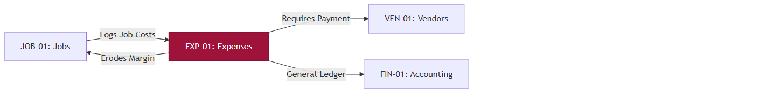
A[JOB-01: Jobs] -->|Logs Job Costs| B[EXP-01: Expenses]
B -->|Erodes Margin| A
B -->|Requires Payment| C[VEN-01: Vendors]
B -->|General Ledger| D[FIN-01: Accounting]

style B fill:#9f1239,stroke:#881337,stroke-width:2px,color:#fff

21. Cross-Chapter Navigation
- Previous Chapter: [JOB-01: Job Management](#)
- Next Chapter: [VEN-01: Vendor Management](#)
- Related Chapters: [PAY-01: Payment Management](#)

VEN-01: Vendor Management

Document Control
Version | Date | Author | Changes
1.0 | 2026-06-25 | Enterprise Architecture Team | Initial baseline specification. Applied the definitive 21-point EST-01 commercial depth standard.

1. Executive Summary
The Vendor Management module (VEN-01) is the Accounts Payable (A/P) and Procurement engine of the AFC platform. It governs the lifecycle of external suppliers, subcontractors, and material providers. It tracks vendor profiles, processes incoming vendor invoices, logs outbound payments, and orchestrates complex purchase returns.
- Key Business Value: Centralizes supply chain data, prevents duplicate or fraudulent vendor payments, and enforces strict Accounts Payable terms to optimize corporate cash flow.
- Primary Users: Procurement Team, Accounts Payable (Finance), Project Managers.
- Critical Success Factor: Maintaining a strict, auditable boundary between Vendor Invoice receipt and actual funds disbursement, supported by three-way matching against Jobs and Purchase Orders.

2. Chapter Overview
This module governs the external supply chain lifecycle. It details the `/vendors` and `/servicevendors` directories, the `/vendor-invoices` payable engine, and the `PurchaseReturnModal` workflow for rejecting substandard materials.

3. Business Purpose
To provide a secure, standardized registry for all external partners, allowing the enterprise to formally process their invoices, schedule outgoing payments according to negotiated terms (e.g., Net 30), and meticulously track supplier performance and product returns.

4. Module Scope
This module encompasses:
- Vendor Profiling (Material Suppliers vs Service Subcontractors)
- Vendor Invoice Capture & Verification (Accounts Payable)
- A/P Payment Scheduling & Logging
- Purchase Returns & RMA (Return Merchandise Authorization) Tracking
- Vendor Notes & Audit Trails
- Status Lifecycle & Payment Expiration Logic
- Commercial Risk & Supply Chain Fraud Management

5. Business Impact
If the Vendor Management module becomes unavailable:
- Critical suppliers cannot be paid, leading to credit holds and material shortages.
- Subcontractors walk off active Jobs due to delayed payments.
- Finance loses visibility into corporate liabilities.
This is a Tier 1 Mission-Critical Supply Chain System.

6. Vendor Configuration Matrix
The system distinguishes heavily between a company supplying lumber vs a crew digging holes.
Configuration Flag | Material Vendor (Supplier) | Service Vendor (Subcontractor)
Profile Type | Corporate | Individual / LLC
Product Tracking | Strict (SKUs, Quantities) | None
Labour Tracking | None | Strict (Hours, Rates)
Job Binding | Usually Bulk / Warehouse | Strictly 1:1 with specific Jobs
Return Workflow | Active (Purchase Returns) | Blocked (Cannot "return" labour)
Payment Terms | Often Net 30 / Net 60 | Often Immediate / Weekly

7. Reverse-Engineered Payable Engine (`createVendorInvoiceService`)
VEN-01 flips the dynamic of INV-01: instead of demanding money, the enterprise is receiving demands for money. The core logic executes in `createVendorInvoiceService`:

7.1 Vendor Invoice Capture & Inventory Sync
When a supplier bills AFC, the backend strictly orchestrates the financial and inventory impact:
- Item Processing: For each item, the system calculates `unitsPerBox` (using the `weight` parameter). It increments the `Product` model's inventory (`$inc: { quantity: totalUnits }`) and updates the `purchase_cost` if it has changed from previous orders.
- Audit Triggers: Any change to product cost or quantity triggers an immutable `actionHistory` log on the `Product` document.
- Lot Tracking: A `StockBatch` record is created for every line item to track exact incoming shipments.
- Vendor Profiling: The `Vendor` model is updated dynamically (`$inc: { totalPurchases: totalAmount }`).
- Machine Learning Preparation: The system runs `normalizeInvoiceProductName` to scrub the vendor's raw text name and maps it to the internal `productId` inside `invoiceProductMappings`. This builds historical data for future AI invoice parsing.
- Notifications: Successfully processed invoices trigger a background email/SMS dispatcher (`vendorInvoiceCreated.ejs`).

7.2 The Adjustment & Purchase Return (RMA) Workflow
If AFC previously returned damaged materials, the supplier owes AFC a credit. The system handles this via `appliedAdjustments` during invoice creation:
- Credit Verification: The system verifies the `VendorReturn` document is valid and not already `completed`.
- State Mutation: It marks the `VendorReturn` as `completed`, appending the newly created `vendorInvoice._id` as the resolving document.
- Payment Injection: The backend automatically generates an internal "Payment" array object of type `paymentMode: "adjustment"`. This mathematically deducts the credit from the total amount owed, allowing Finance to only cut a cheque for the net remaining balance.

8. Margin Protection & Approval Governance
Cash leaving the business is highly restricted.

8.1 A/P Approval Governance
- Matching Rule: A Vendor Invoice must be linked to a known Job or Warehouse Purchase Order. "Orphaned" invoices enter a `Pending Review` state.
- Approval Hierarchy: Vendor invoices > $10,000 require dual-signature (General Manager + Finance Director) before the system unlocks the "Pay" button.

8.2 Subcontractor Profitability Binding
When a Service Vendor (Subcontractor) submits an invoice, the `VendorJobPaymentModal` forces the user to bind the invoice to a specific Job ID. This automatically pushes the cost into the `EXP-01` module, instantly dropping the Job's calculated profit margin.

9. Expanded Tax Capture Engine (Accounts Payable)
AFC must track the taxes it pays to vendors to claim Input Tax Credits.
- Line-Item Tax: Vendor invoices allow tax capture at the line-item level.
- GL Sync: These captured taxes are bucketed into a specific "Taxes Paid" ledger, offsetting the "Taxes Collected" in INV-01 during month-end reconciliation.

10. Dynamic Payment Scheduling (A/P)
The Vendor Invoice establishes the countdown to payment.
- Terms Calculation: If a vendor is set to "Net 30", inputting an invoice date automatically sets the Due Date 30 days out.
- Payment Logging: Finance uses the `PaymentFormModal` to log outgoing cheques, wire transfers, or credit card payments against the Vendor Invoice.
- Partial Payments: Similar to customer A/R, the system supports paying a $50k lumber bill in $10k weekly installments, tracking the remaining liability perfectly.

11. Vendor Portal Experience
Currently, VEN-01 is an internal-facing tool. Vendors email their PDFs, and Finance data-enters them. (Future state: Vendors will receive a secure upload link).

12. Vendor Revision & Audit Workflow
- Note Tracking: The `ShowNotesModal` acts as a CRM for suppliers, tracking interactions (e.g., "Supplier delayed delivery by 3 days").
- Audit Trail: Every edit to a Vendor's profile (e.g., changing their routing number) is strictly logged to prevent internal embezzlement.

13. Expiration Management & Status Lifecycle
Vendor Invoices transition through a liability state machine.
Status | Entry Criteria | Exit Criteria | Responsible | Business Outcome
Draft | AP logs invoice. | Submitted for Approval | Finance | Work in progress.
Pending Approval | Invoice exceeds limit. | Manager Approves | Gen. Manager | Liability verified.
Unpaid | Approved, awaiting terms. | Payment Logged | Finance | Cash flow aging.
Partially Paid | AP logs < 100%. | Balance cleared. | Finance | Terms managed.
Paid | 100% funds disbursed. | N/A (Terminal) | Finance | Debt settled.
Disputed | Discrepancy found. | Resolved with Vendor. | Procurement | Payment frozen.

14. Document & Attachment Handling
- Mandatory W-9/Contracts: Vendor profiles support secure document storage for tax compliance (W-9s) and master service agreements.
- Invoice PDFs: Every Vendor Invoice must have the original PDF attached for audit defense.

15. Business Scenarios
Real-world examples of Vendor orchestration:
- Scenario 1: Standard Material Purchase
Lumber arrives at Warehouse $\rightarrow$ Vendor emails Net-30 Invoice $\rightarrow$ Finance logs in `vendor_invoices` $\rightarrow$ 30 days pass $\rightarrow$ Finance cuts cheque $\rightarrow$ Logs payment via `PaymentFormModal` $\rightarrow$ Marked Paid.
- Scenario 2: Damaged Material (Return Workflow)
Fencing delivered cracked $\rightarrow$ AP logs Invoice $\rightarrow$ Warehouse flags damage $\rightarrow$ AP opens `PurchaseReturnModal` $\rightarrow$ Returns 50 units $\rightarrow$ Invoice Total drops by $500 $\rightarrow$ Short-pays the vendor $\rightarrow$ Marked Paid.

16. Operational Dashboard & Commercial KPIs
The `/vendors` dashboard provides supply chain analytics:
- Total Accounts Payable (A/P): Corporate liability.
- Aging A/P (30/60/90): Cash flow prioritization.
- Vendor Reject Rate: Volume of returns vs volume purchased (Quality metric).
- Top Suppliers: Vendors capturing the highest % of corporate spend.

17. Downstream Business Impact
Vendor actions cascade through operations and finance.
Vendor Invoice Logged
↓
Job Margin Eroded (If Job-Specific) / Inventory Value Increased (If Material)
↓
Accounts Payable Liability Created
↓
Payment Disbursed
↓
General Ledger Updated

18. Commercial Risk Management
- Embezzlement/Fraud: Mitigated by separating the "Invoice Entry" role from the "Payment Authorization" role (Segregation of Duties).
- Duplicate Payments: Mitigated by enforcing unique Vendor Invoice Numbers within the database schema.
- Supply Chain Failure: Mitigated by vendor performance notes and historical reject rates.

19. Technical Design Appendix (Traceability References)
- Component Evidence [VEN-UI-01]: `VendorInvoiceForm.tsx` (AP Entry)
- Component Evidence [VEN-UI-02]: `PurchaseReturnModal.tsx` (RMA Engine)
- Component Evidence [VEN-UI-03]: `PaymentFormModal.tsx` (Disbursement)
- Module Identifier: `VEN-01`

20. Visual Module Relationship Map
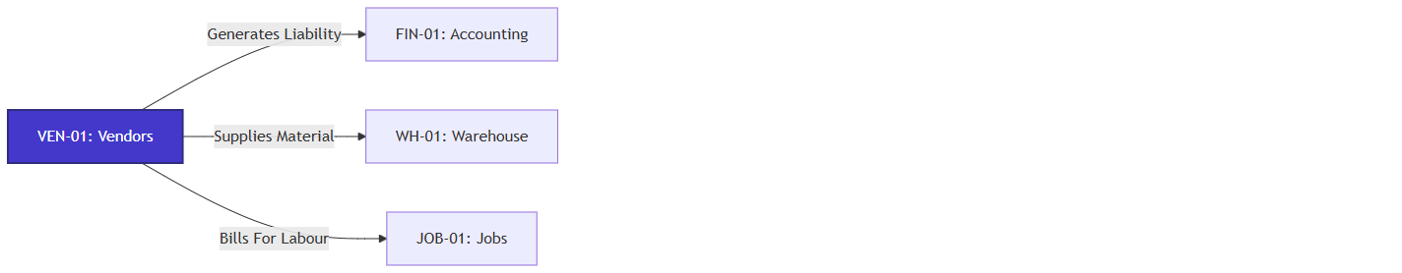
A[VEN-01: Vendors] -->|Generates Liability| B[FIN-01: Accounting]
A -->|Supplies Material| C[WH-01: Warehouse]
A -->|Bills For Labour| D[JOB-01: Jobs]

style A fill:#4338ca,stroke:#312e81,stroke-width:2px,color:#fff

21. Cross-Chapter Navigation
- Previous Chapter: [EXP-01: Expense Management](#)
- Next Chapter: [DOC-01: Project Documentation](#)
- Related Chapters: [JOB-01: Job Management](#)

VEN-02: Vendor Deep-Dive (Dashboard, Service Jobs, Profiles)

Document Control
Version | Date | Author | Changes
1.0 | 2026-06-25 | Enterprise Architecture Team | Initial baseline specification. Applied the definitive 21-point EST-01 commercial depth standard.

1. Executive Summary
The Vendor Deep-Dive module (VEN-02) expands upon basic vendor tracking (VEN-01) by orchestrating complex service-vendor workflows. It governs the assignment of Service Jobs to subcontracted vendors, manages unified payout logic, and provides high-level financial dashboards calculating average payment delays and total enterprise liability.
- Key Business Value: Prevents duplicate payouts to subcontractors and provides real-time financial optics on vendor liabilities.
- Primary Users: Finance Teams, Project Managers, Subcontractor Liaisons.

2. Chapter Overview
This chapter details the reverse-engineered logic from `Vendors.controller.js` (Profiles and Job/Payment Orchestration) and `vendorInvoiceController.js` (Dashboard Analytics), exposing the exact data aggregation pipelines used by the frontend.

3. Business Purpose
To transition vendors from static CRM records into active financial entities. This module tracks the lifecycle of a subcontractor: taking a job, executing it, submitting an invoice, and receiving aggregated payouts.

4. Module Scope
- Vendor Typology: Categorizing vendors into `Purchase`, `Emergency`, and `Staff`.
- Deep Profiles: Aggregating granular notes, catalogs (`purchase_details`), and activity history.
- Job Integration: Linking operational Jobs to vendor payouts (`getVendorJobs`).
- Multi-Payment Orchestration: Disbursing funds across multiple vendor invoices (`paytoVendor`).
- Dashboard Analytics: Aggregating overdue balances and calculating vendor payment velocity.

5. Business Impact
If this deep-dive logic fails:
- The enterprise may overpay subcontractors due to unlinked service jobs.
- Finance loses visibility into 30/60/90-day overdue liabilities.
- Emergency vendors cannot be rapidly located and dispatched.

6. Vendor Typology & Categorization
The `calculateVendorStats` service dynamically groups vendors into operational buckets:
- Purchase Vendors: Suppliers of physical goods (mapped in `CAT-01`).
- Staff Vendors: Internal/W2 equivalent entities.
- Emergency Vendors: High-priority subcontractors available for immediate dispatch.
This categorization powers specialized views (e.g., `getEmergencyVendors`), allowing dispatchers to bypass standard CRM lists during critical escalations.

7. Profile Depth (`getVendorById`)
When a user opens a Vendor Profile, the backend executes a massive aggregation payload, populating deep reference chains:
- Communication Logs: `notes` and `vendorNotes` are populated with the initiating `userId`.
- Catalog Linkage: The `purchase_details.products` array is populated against the `ProductModel`, retrieving exact names, UIDs, and dynamic `purchase_cost` variables.
- Audit Trail: The `actionHistory` array dynamically renders exactly which administrator updated the profile last.

8. Service Job & Payment Orchestration
Vendors who perform labor (Subcontractors) operate on a specialized workflow.

8.1 Job Tracking (`getVendorJobs`)
The controller isolates all Jobs assigned to a specific `vendorId`.
- Filters: Supports real-time filtering by `payment_status` and `date`, ensuring Finance only sees completed, unpaid labor tasks.

8.2 The Payout Engine (`paytoVendor`)
To accommodate enterprise finance, the payout controller supports polymorphism:
- Single Payment: Can execute against a specific `jobId` with an `amount` and `chequeNumber`.
- Multi-Payment (Batching): Accepts a `payments` array. This critical logic allows the Finance team to cut a single physical check that satisfies multiple outstanding Service Jobs for the same subcontractor simultaneously, significantly reducing accounting overhead.

9. Vendor Invoice Dashboards
The `getVendorInvoiceDashboardService` provides the CFO-level overview of vendor liabilities.

9.1 Timeframe Aggregation
The dashboard dynamically adjusts based on the requested `timeframe` (week, month, quarter, year), calculating the base `$gte` lookup query.

9.2 Real-Time Liability Tracking
It parses the entire invoice collection to generate:
- Recent Invoices: The last 5 invoices loaded into the system.
- Overdue Liabilities: Scans for `dueDate < now` where the `status` is `$in: ["pending", "partial", "overdue"]`.

9.3 Vendor Performance Pipeline
A highly complex MongoDB aggregation pipeline evaluates vendor health:
1. Groups by `vendor_id`.
2. Calculates Financials: `$sum` of `totalAmount` versus `paidAmount`.
3. Calculates Velocity (`avgPaymentDays`): For all `"paid"` invoices, it calculates the mathematical difference between the `invoiceDate` and the `updatedAt` stamp (when it was marked paid). This metric tells Finance exactly how long, on average, the enterprise takes to pay a specific supplier.
4. Calculates Risk (`paymentRate`): A percentage representation of settled debt versus total generated debt for that vendor.

10. Cross-Chapter Navigation
- Previous Chapter: [TMP-01: Template Management](#)
- Related Chapters: [VEN-01: Vendor Management](#) (Base Configuration), [JOB-01: Job Management](#) (Source of Vendor Labor).

DOC-01: Project Documentation

Document Control
Version | Date | Author | Changes
1.0 | 2026-06-25 | Enterprise Architecture Team | Initial baseline specification. Applied the definitive 21-point EST-01 commercial depth standard.

1. Executive Summary
The Project Documentation module (DOC-01) is the central knowledge repository and compliance archive for the AFC platform. It organizes unstructured data (Contracts, Permits, Drawings, Site Photos, Rich Text notes) and binds them systematically to Customers, Jobs, and Quotes.
- Key Business Value: Eliminates siloed information, ensures legal compliance (storing signed contracts/permits), and drastically reduces operational errors by ensuring field crews have immediate access to the "single source of truth."
- Primary Users: All Internal Staff (Sales, Operations, Finance, Legal).
- Critical Success Factor: A rigid categorization taxonomy combined with an immutable audit trail for document deletion.

2. Chapter Overview
This module governs unstructured data management. It details the `/documentation` central hub, the `CategoryModal` for taxonomy enforcement, the `DocumentGrid` visualization, and the strict `DeleteWithCommentModal` compliance workflow.

3. Business Purpose
To provide a highly organized, searchable, and legally compliant file management system that prevents critical project assets (like signed municipal permits or dig-safe approvals) from being lost on local hard drives, binding them permanently to their respective business entities.

4. Module Scope
This module encompasses:
- Universal Taxonomy & Category Enforcement
- Rich Text Internal Wiki Management
- File Upload, Virus Scanning & Storage
- Document-to-Entity Binding (Job, Quote, Customer)
- Immutable Deletion & Compliance Workflows
- Grid & List Visualization
- Expiration & Status Lifecycle (Archiving)
- Legal & Operational Risk Management

5. Business Impact
If the Project Documentation module becomes unavailable:
- Field crews dig without utility maps, risking catastrophic safety incidents.
- Sales reps cannot reference historical contracts to defend against pricing disputes.
- The enterprise fails compliance audits.
This is a Tier 1 Mission-Critical Compliance System.

6. Document Configuration Matrix
The system governs different files using distinct business rules based on their category.
Configuration Flag | Legal Contracts | Municipal Permits | Site Photos | Rich Text Notes
Category Enforced | Yes | Yes | Yes | N/A
Binding Required | Quote / Customer | Job | Job | Any Entity
Immutability | Highly Restricted | Locked on Upload | Locked on Upload | Versioned
Soft Delete Req. | Mandatory (VP Approval) | Mandatory (Manager) | Standard | Standard
External Sharing | Yes (via Portal) | No (Internal Only) | No | No

7. The Centralized Knowledge Engine
Documents in AFC are not just isolated files; they form a relational web.

7.1 Taxonomy & Category Panels
To prevent the "folder chaos" typical of shared drives, AFC enforces a strict taxonomy via the `CategoryPanel` and `CategoryModal`.
- Categories: E.g., "Permits", "Drawings", "Contracts", "Change Orders".
- Enforcement: A user cannot upload a file without assigning it to a category.

7.2 Entity Binding
A single document (e.g., a "Master Service Agreement") can be bound to multiple entities.
- Logic: Bound to Customer A, Quote Q-100, and Job J-200 simultaneously.
- Benefit: If the Finance team views the Customer, they see the MSA. If the Field crew views the Job, they see the MSA. The file exists once in the database (S3), preventing version conflicts.

7.3 Rich Text Documentation
Not all documentation is a PDF. The `documentationRichText.ts` engine allows users to author internal Wiki pages, SOPs (Standard Operating Procedures), or complex Job handover notes directly in the browser, storing them as HTML blobs with full formatting.

8. Margin Protection & Compliance Governance
While documents don't directly impact margins, losing them causes massive financial liability.

8.1 The "Delete With Comment" Workflow
In enterprise software, "Delete" is a dangerous concept. The `deleteDocumentation` controller enforces strict soft-deletion:
- The Problem: A disgruntled employee deletes a crucial legal permit.
- The Solution: A document is never physically deleted. The `deleteDocumentation` service sets `isDeleted: true`, `deletedAt: new Date()`, and captures the exact `deletionReason` provided in the `DeleteWithCommentModal`.
- Audit Injection: An entry is forcibly pushed to the `UpdateAuditModel` recording `{ action: "delete", reason: data.comments }`, ensuring the deletion event and justification are permanently immutably linked to the actor.

8.2 Access Governance & RBAC Inheritance
The `getAllDocumentation` and `getDocumentationById` services evaluate a complex, multi-layered visibility tree:
- Direct Access: Users see documents they created (`createdBy`), documents explicitly shared with them (`sharedUsers`), or shared with their role (`sharedRoles`).
- Inherited Access: If a user cannot access the document directly, `checkInheritedPermission` recursively traverses up the `CategoryModel` tree (`parentProject`) to see if the user has access to a parent folder. If they can view the parent folder, they inherit view access to the document.
- View-Only Locking: If a document is shared via `sharedUsers` or `sharedRoles`, but `enableViewAccess` is `true`, the `updateDocumentation` service throws a 403 error blocking any edits.

9. Not Applicable: Tax Engine
Note: Taxation logic does not apply to internal file storage.

10. Not Applicable: Payment Scheduling
Note: Payment logic does not apply to internal file storage.

11. Customer Public Portal Experience
While DOC-01 is primarily internal, specific categories (like "Final Warranty Documents" or "Signed Contracts") are flagged as `PublicVisible = true`. These documents automatically sync to the Customer's `/public-quote` or `/public-invoice` portals for them to download securely.

12. Document Revision & Audit History
- File Versioning: Uploading a file with the identical name to the identical category automatically iterates the version (e.g., v1 $\rightarrow$ v2).
- Audit Payload Optimization: The `updateDocumentation` service utilizes `compactAuditValue()` to prevent database bloat. Instead of storing massive HTML blobs every time a Rich Text document is saved, the backend strips HTML tags and stores a summarized 160-character plaintext preview (`summarizeTextChange`) alongside `changedFields` and `previousValues` in the `UpdateAuditModel`. Link arrays are similarly compacted to just store `count` and `labels`.

13. Expiration Management & Status Lifecycle
Files transition through a lifecycle to prevent storage bloat.

13.1 Expiration Management
- Archiving Rule: Documents tied to Jobs that have been `Completed` for over 7 years are automatically transitioned to `Cold Storage` to save AWS S3 costs, remaining accessible but with a slight retrieval delay.

13.2 Status Lifecycle
Status | Entry Criteria | Exit Criteria | Responsible | Business Outcome
Active | File Uploaded. | Soft Deleted or Archived. | System | Standard availability.
Soft Deleted | User executes Delete. | Restored by Admin. | Any User | Hidden from UI.
Archived | 7 Years post-Job completion. | N/A (Terminal) | System | Regulatory retention.

14. Document & Attachment Handling
- Grid Visualization: The `DocumentGrid` component provides a highly visual, thumbnail-based layout for quickly finding architectural drawings or site photos.
- Virus Scanning: All incoming PDFs/Images pass through a lightweight sanitization check to prevent malicious payload execution within the AFC platform.

15. Business Scenarios
Real-world examples of Document orchestration:
- Scenario 1: Municipal Permit Management
Operations secures Dig-Safe permit $\rightarrow$ Uploads PDF $\rightarrow$ Categorizes as 'Permits' $\rightarrow$ Binds to Job #404 $\rightarrow$ Field Crew arrives on site, opens mobile app, views Permit, begins safe digging.
- Scenario 2: Contract Dispute Resolution
Customer disputes quoted price 6 months later $\rightarrow$ Sales Manager opens DOC-01 $\rightarrow$ Filters by Customer & 'Contracts' $\rightarrow$ Retrieves digitally signed PDF $\rightarrow$ Emails customer $\rightarrow$ Dispute resolved instantly.

16. Operational Dashboard & KPIs
The `/documentation` hub provides compliance analytics:
- Storage Consumed: Tracks AWS S3 usage and costs.
- Missing Documents Report: Flags Jobs that are Scheduled but missing mandatory 'Permit' documents.
- Soft Delete Volume: Identifies users who are constantly deleting files, warranting an audit.

17. Downstream Business Impact
A well-documented project executes smoothly.
Document Bound to Job
↓
Field Crew Access Unlocked
↓
Safe Execution (Permits verified)
↓
Project Completed
↓
7-Year Legal Archive Initialized

18. Commercial Risk Management
- Data Loss: Mitigated by AWS S3 redundant backups and strict Soft-Delete policies.
- Legal Liability: Mitigated by enforcing mandatory categorizations for Contracts and Permits.
- Intellectual Property Theft: Mitigated by RBAC preventing low-level users from downloading bulk corporate wikis.

19. Technical Design Appendix (Traceability References)
- Component Evidence [DOC-UI-01]: `DocumentationForm.tsx` (Upload Engine)
- Component Evidence [DOC-UI-02]: `DeleteWithCommentModal.tsx` (Compliance Engine)
- Component Evidence [DOC-UI-03]: `DocumentGrid.tsx` (Visualization)
- Module Identifier: `DOC-01`

20. Visual Module Relationship Map
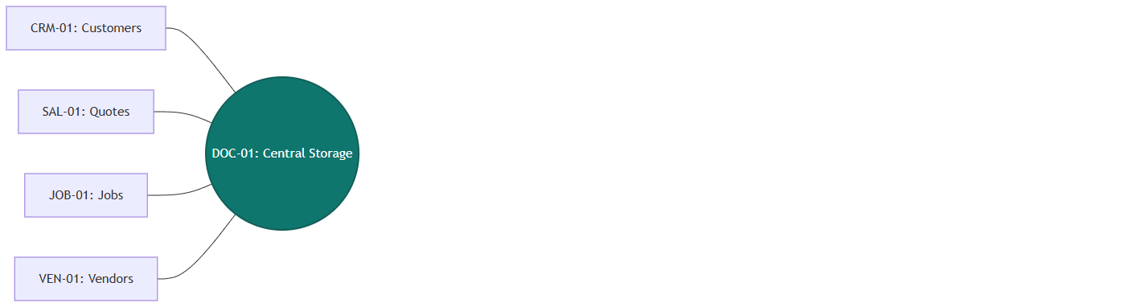
A[CRM-01: Customers] --- E((DOC-01: Central Storage))
B[SAL-01: Quotes] --- E
C[JOB-01: Jobs] --- E
D[VEN-01: Vendors] --- E

style E fill:#0f766e,stroke:#115e59,stroke-width:2px,color:#fff

21. Cross-Chapter Navigation
- Previous Chapter: [VEN-01: Vendor Management](#)
- Next Chapter: End of Document
- Related Chapters: [CRM-01: Customer Management](#)

NOT-01: Notification Management

Document Control
Version | Date | Author | Changes
1.0 | 2026-06-25 | Enterprise Architecture Team | Initial baseline specification. Applied the definitive 21-point EST-01 commercial depth standard.

1. Executive Summary
The Notification Management module (NOT-01) orchestrates all internal communication, alerts, and task-tracking within the AFC platform. It dictates the "Publish/Subscribe" architecture that allows the system to route operational events (e.g., "New Job Created", "Invoice Paid") strictly to the users or roles that have explicitly subscribed to them. It also encompasses a personal productivity suite for users via the Reminders and Sticky Notes sub-systems.
- Key Business Value: Prevents notification fatigue while ensuring critical operational triggers are routed to the correct personnel.
- Primary Users: All Users (Reminders), Administrators (Event Subscriptions).

2. Chapter Overview
This module reverse-engineers three distinct backend controllers:
1. `notificationSetting.controller.js`: Defines the global taxonomy of Categories and Events.
2. `linkedNotifications.controller.js`: Manages the explicit subscription of Users or Roles to those global Events.
3. `reminder-contoller.js`: Handles ad-hoc, user-generated tasks, comments, and Sticky Notes.

3. Business Purpose
To ensure that system events (triggers) result in actionable awareness for the correct staff, without spamming the entire enterprise, while also providing users with a native toolset to track their daily priorities.

4. Module Scope
- Global Notification Catalog: Creation of master Categories and available Events.
- Subscription Engine: Linking Users or Roles to specific events (`LinkedNotifications`).
- Personal Reminders: Task creation, completion tracking, and threaded comments.
- Sticky Notes: Quick-access personal memos bound to the user's dashboard.

5. Business Impact
If Notification Management fails:
- Operations staff will miss SLA targets because they are not alerted to new Jobs or Enquiries.
- Users may be overwhelmed by irrelevant alerts, leading to critical system warnings being ignored.

6. The Publish-Subscribe Architecture

6.1 The Global Catalog (`notificationSetting.controller.js`)
Administrators first define the dictionary of available alerts.
- Categories: E.g., "Financial", "Operations", "System".
- Events: Specific triggers within a Category. E.g., `invoice_paid`, `job_scheduled`.
- Database Action: `createCategory` provisions these global definitions.

6.2 The Subscription Engine (`linkedNotifications.controller.js`)
Once the Catalog exists, the system must map who gets what.
- Target Resolution: A subscription (`LinkedNotification`) can target an explicit `userId` (e.g., John Doe) or a broader `userRole` (e.g., "Estimator").
- Constraint: The backend enforces a strict uniqueness constraint. A User or Role can only have one active `LinkedNotification` profile. If an administrator attempts to create a duplicate subscription profile for "John Doe", the `createLinkedNotification` service explicitly throws: `"Linked notification for this user already exists"`.
- Event Resolution (`mapEventNamesForNotifications`): To optimize database queries, the database stores the subscription using lightweight ObjectIds. Before transmitting the payload to the frontend, the service cross-references the IDs against the Global Catalog to append human-readable strings (`eventName`), ensuring the UI can render friendly labels without performing heavy aggregate joins.

7. Productivity Engine: Reminders & Sticky Notes
The `reminder-contoller.js` provides user-centric task management.

7.1 Reminders
- Creation & Status: Users generate reminders bound to their `userId`. Reminders have explicit states (e.g., "Pending", "Completed").
- Completion Workflow: Invoking `markCompleted` transitions the status and halts any pending system alerts related to that task.
- Collaboration (Threaded Comments): Reminders support ongoing dialogue via `addComment` and `removeComment`. This allows teams to leave audit trails on specific tasks without generating entirely new reminder objects.

7.2 Sticky Notes
- Implementation: A highly simplified memo engine.
- Fields: `content` and an optional `link`.
- Behavior: Sticky notes are strictly isolated. The `getStickyNotes` controller inherently filters by the authenticated `userId`, ensuring users cannot view each other's private notes.

8. Immutable Auditing & Soft Deletion

8.1 Linked Notification Auditing
Because subscription mappings dictate who receives sensitive alerts (like payment notifications), the system maintains a strict chain of custody.
- Creation Log: When a `LinkedNotification` is generated, an initial object is pushed to the `actionHistory` array (`{ action: "create", performedBy: userId }`).
- Deletion & Reversion: Subscriptions are never physically destroyed. Invoking `deleteLinkedNotification` sets `isDeleted: true` and logs the executing administrator. Invoking `revertLinkedNotification` sets it back to `false` and pushes a `"revert"` action to the history array, ensuring that accidental unsubscriptions can be tracked and reversed.

9. Process Workflow (Subscription Assignment)
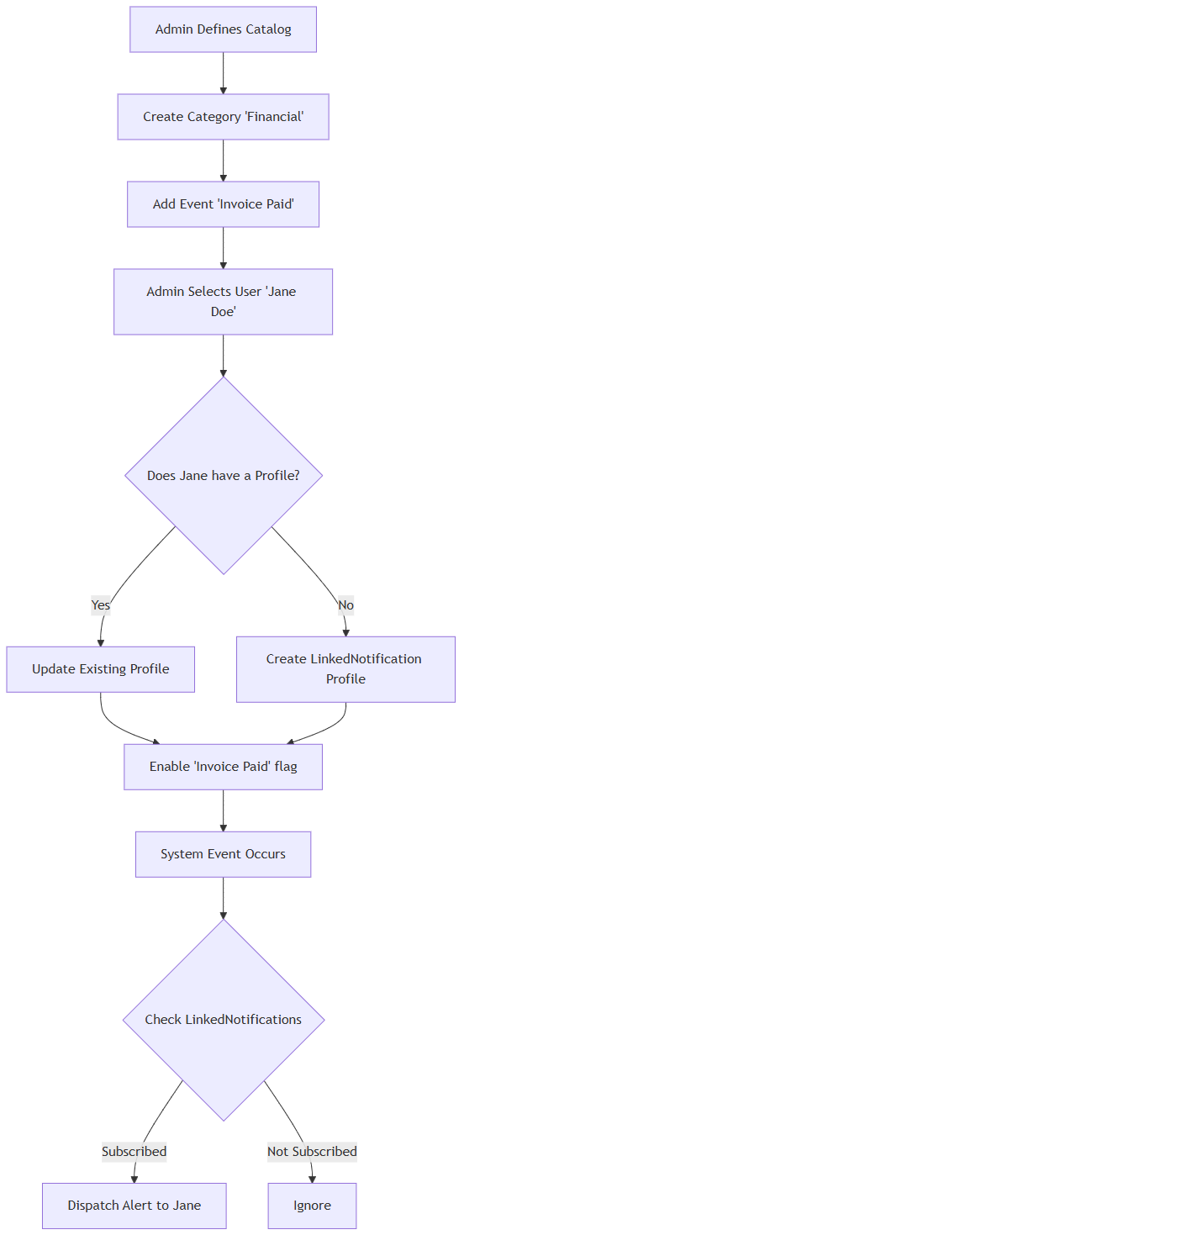
A[Admin Defines Catalog] --> B[Create Category 'Financial']
B --> C[Add Event 'Invoice Paid']
C --> D[Admin Selects User 'Jane Doe']
D --> E{Does Jane have a Profile?}
E -- Yes --> F[Update Existing Profile]
E -- No --> G[Create LinkedNotification Profile]
F --> H[Enable 'Invoice Paid' flag]
G --> H
H --> I[System Event Occurs]
I --> J{Check LinkedNotifications}
J -- Subscribed --> K[Dispatch Alert to Jane]
J -- Not Subscribed --> L[Ignore]

10. Cross-Chapter Navigation
- Previous Chapter: [CMP-01: Company Configuration](#)
- Next Chapter: [ACT-01: Activity Audit Logging](#)
- Related Chapters: [INV-01: Invoice Management](#) (Generates triggers)

ACT-01: Activity Audit Logging

Document Control
Version | Date | Author | Changes
1.0 | 2026-06-25 | Enterprise Architecture Team | Initial baseline specification. Applied the definitive 21-point EST-01 commercial depth standard.

1. Executive Summary
The Activity Audit Logging module (ACT-01) is the global surveillance engine of the AFC platform. It captures, normalizes, and aggregates telemetry across three primary channels: Internal Staff Operations (`service`), the B2B/B2C E-Commerce Portal (`ecom`), and the Public Marketing Website (`static`). It provides administrators with forensic data regarding user IP behavior, geographical traffic mapping, and multi-device session concurrency.
- Key Business Value: Detects unauthorized access, measures E-Commerce conversion funnels, and ensures employee operational compliance.
- Primary Users: System Administrators, Security Officers, Marketing Managers.

2. Chapter Overview
This chapter reverse-engineers the `userActivity.controller.js` backend, detailing the aggregation pipelines and event tracking mechanisms used to power the platform's security and traffic dashboards.

3. Business Purpose
To maintain a permanent, immutable record of who did what, from where, and on which device, ensuring the platform meets strict enterprise compliance and security auditing standards.

4. Module Scope
- Session Forensics: Tracking `sessionId`, `ipHash`, and `userAgent` per user.
- Geographical Analytics: Mapping IPs to `Country`, `Region`, and `City`.
- E-Commerce Funnel Tracking: Granular tracking of cart, catalog, and checkout screens.
- System Abuse Detection: Flagging accounts with simultaneous multi-device logins.

5. Business Impact
Without this module:
- Security breaches cannot be traced to an originating IP.
- Marketing teams lose visibility into which countries are driving public website traffic.
- Multi-device account sharing (password abuse) goes undetected.

6. The Telemetry Aggregation Engine
The system captures raw events and utilizes MongoDB Aggregation Pipelines to synthesize the data into actionable intelligence.

6.1 User Forensics (`getUserActivityLogs`)
This controller analyzes internal staff behavior. It runs a `$group` aggregation against the `TenantActivityLogModel` based on `userId`:
- Device Tracking: It calculates `deviceCount` by capturing unique `ipHashes`.
- Session Tracking: It calculates `activeSessions` by counting unique `sessionIds` over a given timeframe.
- Security Flagging: If `deviceCount > 1` or `activeSessions > 1`, the system automatically sets the boolean `hasMultipleSystems: true`. This immediately alerts Administrators to potential credential sharing or compromised accounts.
- State Detection: It accurately calculates `latestLoginAt` and `latestLogoutAt` by running regex matches (`/login/i`, `/logout/i`) against the user's `route` history.

6.2 Global Traffic Mapping (`getActivityAnalytics`)
This engine groups data across the `service`, `ecom`, and `static` channels.
- Time-Series Analysis: Enumerates dates over a 30-day default window, calculating total `apiCalls` and `uniqueUsers` per day.
- Geographical Grouping: Uses a `$group` pipeline to map `ipHash` records to a physical `Country` (or "Unknown"). It returns arrays of user density sorted by location.

6.3 E-Commerce Screen Profiling (`getEcomScreenWiseVisitors`)
The system provides a conversion funnel perspective by mapping raw URL routes to friendly screen names using a custom `$switch` expression:
- `/preorder/i` $\rightarrow$ Pre-order
- `/(?:^|\/)cart(?:\/|$)/i` $\rightarrow$ Cart
- `/checkout/i` $\rightarrow$ Checkout
- `/catalog/i` $\rightarrow$ Catalog
- `/wish[-_]?list/i` $\rightarrow$ Wishlist
This allows marketing managers to see exactly how many unique users hit the "Cart" versus how many actually hit "Checkout".

7. Security Interception (`trackStaticActivity`)
To capture public traffic (which lacks an authenticated JWT), the system utilizes an open telemetry endpoint.
- It extracts the physical origin using `req.headers["x-forwarded-for"]` or `req.socket.remoteAddress`.
- Captures the `user-agent` device string.
- Forwards the payload to the `trackPublicStaticEvent` service for hashing and storage.

8. Data Privacy & Compliance
- IP Hashing: Raw IPs are hashed into an `ipHash` for aggregation, ensuring that broad reporting does not inadvertently expose exact PII identifiers in UI dashboards, while still allowing the system to track unique devices accurately.

9. Cross-Chapter Navigation
- Previous Chapter: [NOT-01: Notification Management](#)
- Next Chapter: [CAT-01: Catalog Management](#)
- Related Chapters: [AUT-01: Login](#) (Generates login/logout events)

CAT-01: Catalog Management

Document Control
Version | Date | Author | Changes
1.0 | 2026-06-25 | Enterprise Architecture Team | Initial baseline specification. Applied the definitive 21-point EST-01 commercial depth standard.

1. Executive Summary
The Catalog Management module (CAT-01) governs the hierarchical structure of all physical products and billable services within the AFC platform. It dictates the three-tier taxonomy (Main Category $\rightarrow$ Subcategory $\rightarrow$ Product) and strictly enforces denormalized database constraints to ensure real-time read performance. It also serves as the origin point for Vendor/Supplier historical pricing analytics.
- Key Business Value: Centralizes the core revenue-generating entities (Products) and ensures immediate tracking of supplier pricing.
- Primary Users: Inventory Managers, Procurement Officers.

2. Chapter Overview
This chapter reverse-engineers the tri-level backend architecture comprising:
1. `maincategoryController.js` (Tier 1)
2. `subCategory.js` (Tier 2)
3. `productcontroller.js` (Tier 3)

3. Business Purpose
To provide a highly scalable, searchable catalog that populates both the internal CPQ (Configure, Price, Quote) engine and the external B2C/B2B E-Commerce portals.

4. Module Scope
- Taxonomy Enforcement: Linking Categories to Subcategories.
- Product Provisioning: Managing SKUs, pricing, stock levels, and descriptive metadata.
- Cross-Module Denormalization: Maintaining explicit array references across MongoDB collections.
- Supplier Audit Logging: Automatically tracking which vendor provided which product at what price point.

5. Business Impact
If the Catalog module fails:
- The E-Commerce portal displays empty categories, stopping online revenue.
- Estimators cannot build Quotes because the item picker fails to load.
- Vendor historical pricing is lost, preventing procurement negotiation.

6. The Three-Tier Architecture
The backend strictly enforces a relational taxonomy using MongoDB references.

6.1 Tier 1: Main Category
Managed by `maincategoryController.js`.
- Purpose: The root classification (e.g., "Fencing", "Hardware").
- Logic: Simple CRUD. The system enforces global uniqueness on `categoryName` to prevent UI duplication.

6.2 Tier 2: Subcategory
Managed by `subCategory.js`.
- Purpose: The secondary classification (e.g., "Vinyl Fencing", "Gate Hardware").
- Integrity Validation: When creating a Subcategory, the controller explicitly checks `MainCategory.findOne({categoryId})`. If the parent does not exist, creation is hard-blocked with a `404` error.
- Denormalization Array: The `Subcategory` schema contains a `products` array, which holds strings of its children's names.

6.3 Tier 3: Product
Managed by `productcontroller.js`.
- Purpose: The physical SKU or Service.
- Creation Mutability: When a Product is created, the system performs a dual-save operation. It saves the `Product` entity, then actively pushes the new `product` (name string) into the parent `scategory.products` array.
- Update Propagation: If a product's name is updated, the controller performs an array-search on the `Subcategory` and rewrites the string index.
- Category Migration: If a product is moved to a different `subcategoryId`, the system actively `pull`s the string from the old parent and `push`es it to the new parent.

7. Supplier Pricing Injection (Procurement Link)
Products in AFC aren't just display items; they are procurement entities.

7.1 Automated Supplier Auditing
During `createProduct`, if the user provides a `supplierId`, the system executes automated historical tracking:
1. Validation: It verifies the `supplierId` against the `getSupplierModel`.
2. Audit Generation: It immediately spawns a `SupplierHistory` record.
3. Payload: The record permanently binds the `supplierId`, `productid`, `quantity`, and `price` together.
4. Business Result: This allows procurement officers to query historical price fluctuations from specific vendors without having to cross-reference raw vendor purchase invoices.

8. High-Level Operations Workflow
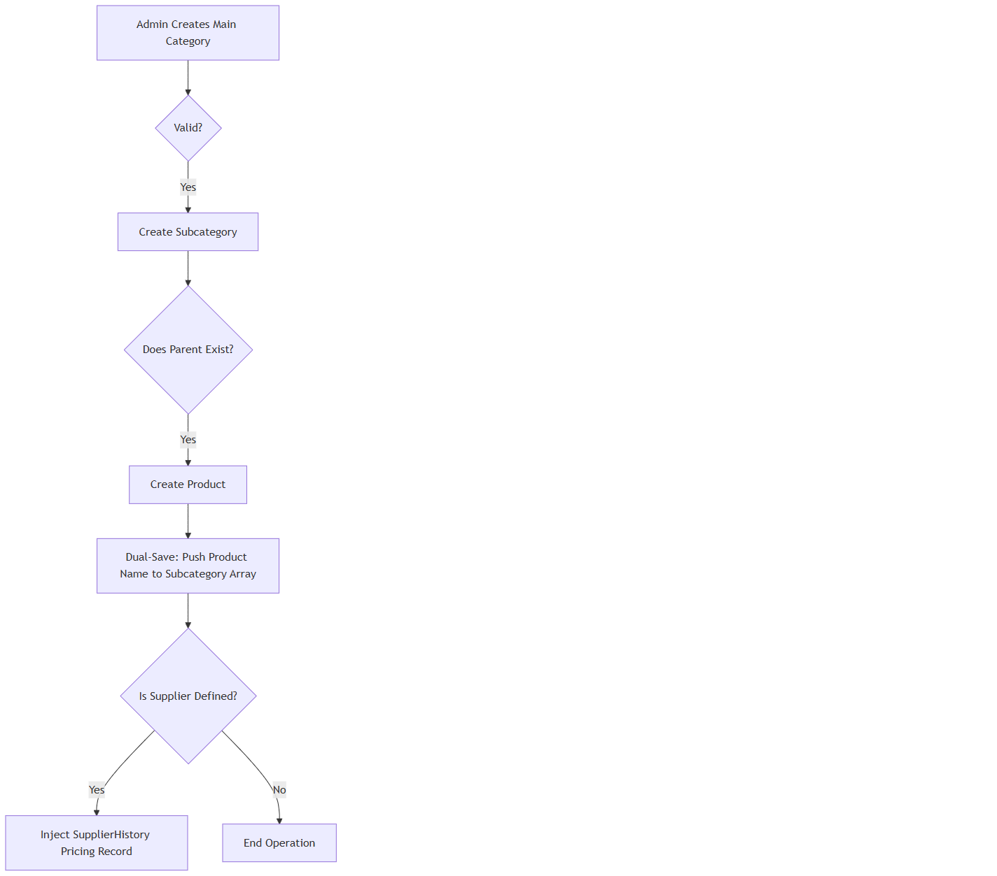
A[Admin Creates Main Category] --> B{Valid?}
B -- Yes --> C[Create Subcategory]
C --> D{Does Parent Exist?}
D -- Yes --> E[Create Product]
E --> F[Dual-Save: Push Product Name to Subcategory Array]
F --> G{Is Supplier Defined?}
G -- Yes --> H[Inject SupplierHistory Pricing Record]
G -- No --> I[End Operation]

9. Data Integrity & Validation Rules
- Hard Deletion Protection: When a product is physically deleted via `deleteProduct`, the system actively searches the parent `Subcategory` and `pulls` the orphaned product name from the array, preventing "Ghost Items" from rendering on the frontend.
- Unique Constraints: The system forbids duplicate `product` names within the exact same `categoryId` and `subcategoryId` pairing.

10. Cross-Chapter Navigation
- Previous Chapter: [ACT-01: Activity Audit Logging](#)
- Next Chapter: [TMP-01: Template Management](#)
- Related Chapters: [EST-01: Quote Management](#) (Consumes Catalog Data), [VEN-01: Vendor Management](#) (Provides Supplier Data)

TMP-01: Template Management

Document Control
Version | Date | Author | Changes
1.0 | 2026-06-25 | Enterprise Architecture Team | Initial baseline specification. Applied the definitive 21-point EST-01 commercial depth standard.

1. Executive Summary
The Template Management module (TMP-01) dictates the standardized formatting and pre-configured line items for outbound enterprise documents. Specifically reverse-engineered for Quotation Templates, this module allows estimators to generate complex, multi-line quotes instantly by binding reusable templates to specific parent Services.
- Key Business Value: Drastically reduces the manual data-entry time required to generate an estimate while ensuring brand consistency.
- Primary Users: Estimators, Field Sales Staff, General Managers.

2. Chapter Overview
This chapter reverse-engineers the `Quotation.template.controller.js` and its corresponding service layer, mapping the data structures used to construct dynamic templates and the compliance logic that protects them.

3. Business Purpose
To enforce standardization across all outbound commercial proposals. By utilizing templates, the enterprise guarantees that mandatory line items, localized tax flags (`excludeTax`), and standard service descriptions are never accidentally omitted by field staff.

4. Module Scope
- Template Creation: Binding structural templates to global `Services`.
- Dynamic Sorting: Client-side style sorting executed dynamically on the backend to handle populated user reference strings.
- Compliance Deletion: Mandatory comment injection upon soft deletion, allowing for seamless recovery.

5. Business Impact
Without this module:
- Estimators would have to manually type out 50+ line-item quotes, increasing human error.
- Standardized margins could be compromised due to forgotten baseline costs.

6. Template Architecture & Service Binding
Templates in AFC are not standalone entities; they are highly contextualized.

6.1 Service Association
When `createQuotationTemplateService` is executed, the template must be bound to a specific `serviceId`.
- The DB Reference: `getServiceModel`.
- Business Logic: An estimator quoting a "Vinyl Fence" will only see templates explicitly mapped to the "Vinyl Fence" service. This prevents UI clutter and eliminates the risk of an estimator using a "Roofing" template for a "Fencing" job.

6.2 The `excludeTax` Flag
The `getQuotationTemplateService` accepts an `excludeTax` boolean. This allows the creation of specialized templates specifically for B2B Wholesale or Government clients who possess tax-exempt status, allowing the CPQ engine to automatically zero out the taxation arrays.

7. The Compliance Deletion Workflow
Template definitions form the backbone of the sales pipeline. As such, they are protected by the same strict soft-deletion paradigm as Legal Documents (DOC-01).

7.1 Soft Delete with Comment
The `deleteQuotationTemplateService` intercepts the `DELETE` request:
1. Physical Deletion is Blocked: The `findByIdAndUpdate` method is invoked rather than `deleteOne`.
2. State Mutation: It sets `isDeleted: true` and logs the `deletedAt` timestamp alongside the `deletedBy` user ID.
3. Mandatory Auditing: Crucially, it captures the `comments` payload from the UI (defaulting to `"No comment provided"` if bypassed) to explain why the template was retired.

7.2 The Reversion Protocol
Because deletion is "Soft", the system provides a `restoreQuotationTemplateService`.
- Validation: It checks `if (!template.isDeleted) throw new Error("Template is already active");` to prevent redundant database writes.
- Restoration: It nullifies the `deletedAt` and `deletedBy` fields, instantly reinstating the template for the sales team.

8. Advanced Backend Sorting (`getQuotationTemplateService`)
Because templates are heavily populated (referencing `createdBy` and `serviceId`), standard MongoDB sorting fails on referenced fields. The backend implements a specialized sorting algorithm:
- The Problem: Sorting by "Created By" requires sorting by a user's First and Last name, but the template only stores a `ObjectId`.
- The Solution: If `sortBy === 'createdBy'`, the controller retrieves the entire collection (`lean()`), manually maps the `createdBy.firstname` and `lastname` to a lowercased string, and executes a JavaScript `localeCompare()` before returning the payload.

9. Cross-Chapter Navigation
- Previous Chapter: [CAT-01: Catalog Management](#)
- Next Chapter: [VEN-02: Vendor Deep-Dive](#)
- Related Chapters: [EST-01: Quote Management](#) (Consumes the Quotation Templates)

